Design and Validation of a Force Measurement System
for the Analysis of Airfoil Lift and Drag Characteristics

Niall Manning BEng

This thesis is submitted to Dublin City University as fulfilment of the requirement for the qualification of
Masters in Engineering (MEng)

Supervisor:
Dr. Joseph Stokes

School of Mechanical & Manufacturing Engineering,
Dublin City University,
Ireland.

September 2010

Declaration

I hereby certify that this material, which I now submit for assessment on the programme of study leading to the award of Masters in Mechanical & Manufacturing Engineering (MEng) by research is entirely my own work, that I have exercised reasonable care to ensure that the work is original, and does not to the best of my knowledge breach any law of copyright, and has not been taken from the work of others save and to the extent that such work has been cited and acknowledged within the text of my work.

Signed: ____________________________________

I.D. No.: 52058499

Date: ____________________

Acknowledgements

I would like to thank my supervisor Dr. Joseph Stokes of the School of Mechanical and Manufacturing Engineering, Dublin City University, for all his guidance and assistance throughout the duration of my research. His availability to meet with me whenever I encountered any problems and regarding the helpful advice given, was invaluable in helping me to complete the work.

I would like to thank the various members of staff in the school, in no particular order, for their help with different aspects of my research. Firstly, thanks to: Mr. Michael May, Mr. Alan Meehan and to Mr. Martin Johnson in relation to the manufacture and set-up of the equipment that was required for experimental testing. I would like to also extend my thanks to: Mr. Jim Barry, Mr. Chris Crouch, Mr. Cian Merne, Mr. Michael Tyrrell and to Mr. Eoin Touhy for their help with various parts of my work. Thanks to Mr. Keith Hickey for his assistance with all my software and computing queries. The help given by Dr. Harry Esmonde with the set-up of the wind tunnel instrumentation was also much appreciated. For his input and advice given in relation to this research thesis, I would like to thank Dr. Brian Corcoran.

I am grateful to the Irish Research Council for Science, Engineering and Technology (IRCSET). Without their funding this research would not have been made possible.

Thanks to my parents, Damien and Pauline, for all their encouragement that helped me to do my best throughout the duration of the research. Also, thanks to my brother Daragh, my sister Katie, other family members and my friends for their support.

Nomenclature

Symbol Description SI Unit

F Force N
c Airfoil Chord (where 0.25c is the ¼ chord point) m
τ Shear Stress N/m²
M_{C/4} Moment at the 0.25c point Nm
L Lift Force N
D Drag Force N
R Force Vector Sum of the Lift and Drag Forces N
V, V∞, U∞ Free-stream Velocity m/s
ρ Density kg/m³
A Planform Area m²
C_{D} Drag Coefficient -
C_{L} Lift Coefficient -
C_{P} Pressure Coefficient -
q Dynamic Pressure kg/ms
E_{K} Kinetic Energy J
m Mass kg
ΑOA, α Angle(s) Of Attack º
μ Dynamic Viscosity Pa$∙$s
ν Kinematic Viscosity m²/s
b Airfoil Span m
α_{L=0} Angle of Zero Lift º
C_{Lmax} Maximum Lift Coefficient -
L/D Aerodynamic Efficiency or Lift to Drag Ratio -
NACA National Advisory Committee on Aeronautics -
Ma Mach Number -
Re Reynolds Number -
P_{S} Static Pressure Pa
P_{T} Total Pressure Pa
S Strouhal Number -
f Vortex Shedding Frequency Hz
h, d Frontal Height of Airfoil m
DR Drag Reduction Agents -
MDF Mechanical Degradation in Flow -
V Voltage V
R Resistance (or Resistor – R₁, R₂, etc.) Ω
V_{OUT} Output Voltage V
V_{EX} Excitation Voltage V
k, S_{G} Strain Gauge Factor -
ε Strain -
α Resistive Temperature Coefficient of Gauge Grid K⁻¹
β Linear Thermal Expansion Coefficient K⁻¹
Σ_{T} Thermally Induced Strain -
DSI Digital Strain Indicator -
DAQ Data Acquisition -
L, l Length m
σ Stress Pa
Z Section Modulus m³
I Moment of Inertia m⁴
c Distance from neutral axis of a beam to its top or m
bottom surface (beam thickness $÷$ 2)
E Young’s Modulus Pa
P_{G} Power Dissipated W
P_{D} Power Density W/m²
V_{AMP} Voltage Supply to Amplifier Circuit V
S_{C} Circuit Sensitivity V
V_{O} Output Voltage V
PCB Printed Circuit Board -
ZAR Zero Adjustment Range V
C Capacitor -
VR Variable Resistor or Potentiometer -
T Transistor -
BS Bridge Supply -
IP Amplifier Input -
OP Amplifier Output -
SFDR Spurious Free Dynamic Range -
S Frontal Area of Airfoil m²
C Frontal Area of Wind Tunnel Test Section m²
R² Correlation (Data Linearity) Coefficient -
L_{R}(L_{L}) Lift Output due to Lift Force Applied -
L_{R}(D_{L}) Lift Output due to Drag Force Interaction -
D_{R}(L_{L}) Drag Output due to Lift Force Interaction -
D_{R}(D_{L}) Drag Output due to Drag Force Applied -
K_{ij} Interaction Coefficient -
F_{R} Output Reading with no Interaction Correction -
F_{L} Output Reading with Interaction Correction -
Ra Average Surface Roughness μm

Table of Contents

Declaration I
Acknowledgements II
Nomenclature III
Abstract VIII
1.1 Aims 1
1.2 Chapter Overview 3
Chapter 2 – Literature Review 4
2.1 Aerodynamics 4
2.1.1 Reference Axes 4
2.1.2 Airfoil Nomenclature 5
2.1.3 Force Components acting on an Airfoil 6
2.1.4 Lift Generation and the Coanda Effect 8
2.1.5 Aspect Ratio and Induced Drag 11
2.1.6 Aerodynamic Efficiency 14
2.1.7 National Advisory Committee on Aeronautics - NACA 16
2.1.8 The Use of Wind Tunnels in Aerodynamic Design 17
2.2 Fluid Mechanics 18
2.2.1 Incompressible & Inviscid Flow 18
2.2.2 Reynolds Number – Laminar and Turbulent Flow 19
2.2.3 Bernoulli’s Equation & Velocity Measurement 20
2.2.4 Boundary Layer Development 21
2.2.5 Flow Separation, Vortices & Wake Formation 24
2.2.6 Use of Dimples to delay Flow Separation 29
2.3 Recent Research into New Drag Reduction Techniques 31
2.3.1 Passive Control 31
2.3.2 Active Control 43
2.4 Recent Numerical Developments of Drag Calculation 48
2.5 Alternative Drag & Lift Force Measurement Techniques 49
2.6 Strain Gauge Theory 52
2.7 Internal and External Strain Gauge Balances 57
Chapter 3 – Experimental Equipment and Procedures 61
3.1 Airfoil Profiles Tested 62
3.2 Airfoil Surface Modification Process 65
3.2.1 Application of Dimples 65
3.2.2 Surface Roughness Value 67
3.3 Testing Methodology 69
3.3.1 Phase 1 Testing 69
3.3.2 Phase 2 Testing 71
3.4 Wind Tunnel Set-Up 77
3.4.1 Wind Tunnel 77
3.4.2 Blockage Ratio 85
3.5 Force Measurement Systems Overview 87
3.6 System 1 Design 90
3.7 System 2 Design 98
3.7.1 Design of Main Balance Assembly 98
3.7.2 Design of the Flexures 105
3.7.3 Selection of Strain Gauges 108
3.7.4 Instrumentation and Data Acquisition Set-Up 110
3.8 Application of Strain Gauges 116
3.9 Calibration 119
3.9.1 System 1 120
3.9.2 System 2 121
3.10 Wind Tunnel Operation and Force Measurement Procedures 123
3.10.1 Insertion and Removal of Test Models 123
3.10.2 DAQ Set-Up and Derivation of Force Values 125
3.11 Smoke Flow Visualisation Set-Up 129
Chapter 4 – Results & Discussion 136
4.1 Wind Tunnel Testing Parameters 136
4.1.1 Wind Tunnel Velocity 136
4.1.2 Reynolds Number Calculations 137
4.1.3 Blockage Ratio Effect Calculations 139
4.2 Surface Roughness Measurement 141
4.3 Calibration 142
4.3.1 System 1 142
4.3.2 System 2 142
4.4 Phase 1 Test Findings and System 1 Errors 148
4.5 Improved Performance of System 2 153
4.6 Phase 2 Single Airfoil Testing Results 154
4.6.1 Baseline Results – NACA 0024 and NACA 0006 154
4.6.2 Modification Test Results - NACA 0024 159
4.6.3 Modification Test Results - NACA 0024 with End-Plates 172
4.6.4 Baseline & Modification Test Results – NACA 0006 178
4.7 Phase 2 Split Flap Airfoil Testing Results 181
4.7.1 Baseline Results – NACA 0024 Flap 181
4.7.2 NACA 0024 Split Flap Test Results 183
4.7.3 Baseline Results – NACA 0006 Flap 190
4.7.4 NACA 0006 Split Flap Test Results 192
4.8 Phase 2 Smoke Flow Visualisation Photography 196
Chapter 5 – Conclusions & Recommendations 202
5.1 Conclusions 202
5.2 Recommendations 208
5.3 Conference Attendance and Presentations 209
References 210
Appendices 216
Appendix A – Recent Numerical Developments of Drag Calculation 216
A.1 Object Perspective 216
A.2 Fluid-Flow Perspective 217
Appendix B – Airfoil Dimensions 220
Appendix C – Strain Gauge Specifications 221
Appendix D – Material Properties 223
Appendix E – System 2 Flexure Design 225
Appendix F – Strain Gauge Amplifier Circuitry 228
Appendix G – Data Acquisition Card Specifications 231
Appendix H – Data Acquisition Software Set-Up 232
Appendix I – Force Interaction Graphs 235

Abstract

Design and Validation of a Force Measurement System
for the Analysis of Airfoil Lift and Drag Characteristics

Niall Manning

One of the aims of this research was to reduce the flow separation and therefore the pressure drag generated by a wing section, through the adding of surface modifications. The modifications consisted of roughening the surface of polystyrene airfoils using a sand blasting technique, which resulted in a dimpled surface. This idea originated from the design of a golf ball, as the dimples are known to delay flow separation which allows the ball to travel further. In relation to wing design, there has been very little research available that either proved or dismissed the theory of using a roughened airfoil surface to reduce the pressure drag created by flow separation. Therefore three types of airfoils were tested, the NACA 0006, 0024 and 4424 profiles. Different levels of surface roughness, created by the dimples, were applied to various portions and sides of the airfoils. These were in turn tested on the three airfoil types, including a series of tests with a split flap configuration and the use of end-plates to reduce the induced drag component. The wind tunnel testing was conducted up to a flow velocity of 23m/s, which led to a maximum Re of 321,227 and 588,141 for the single and split flap airfoil testing respectively.

The overall research was split into two phases, where in each phase a force measurement system was designed in conjunction with a series of experimental tests. Therefore, during Phase 2 of the research, a new external strain gauge balance (System 2) was developed specifically for the DCU wind tunnel and with the nature of the testing in mind. This followed on from the previous design (System 1) which had certain measurement errors and design inadequacies. Aside from the improved mechanical design of System 2, strain gauge amplifier circuits and a data acquisition system were also developed. The resulting set-up was very sensitive and stable, which was necessary for the low drag and lift forces involved, with a sensitivity of 0.71N/V corresponding to a minimum load response of approximately 0.0007N, with respect to the slightly more sensitive drag measurement. Therefore, the design of the force measurement system was the main aim of this research.

As a result, it was necessary to validate the design with extensive experimental testing, which formed the secondary aim of the research. The resulting dimples patterns tested promoted less flow separation in particular tests, however these dimples were also found to have a negative effect on lift generation. An important finding also was that in some of the tests the dimple patterns created an increase in the lift force. In addition, large aerodynamic instabilities were observed in tests where dimples were applied to the frontal sections (<0.33c point) of the airfoils, on their low pressure side. By adding a high level of surface roughness (high Ra) via the dimples, to the middle and last 1/3rd sections on the low pressure (flow separation) side of a NACA 0024 airfoil, from 10° angle of attack onwards the drag force generated compared to the baseline (unmodified smooth airfoil) decreased. However, the lift force also decreased from approximately 8° onwards and at 20° there was a drag decrease of 11.15% and a lift decrease of 8.46%. This therefore led to an overall marginal increase in the aerodynamic efficiency of 3.13%. Overall, the effects varied depending on the airfoil test configuration, the surface modification and the angle of attack. A smoke flow visualisation system was also developed and photographs were captured to provide a further analysis of some of the experimental results.
Chapter 1 – Introduction

Experimental testing in wind tunnels is an essential analysis technique in the design of aircraft wing sections. As part of this, it is necessary to utilise a force measurement system to characterise the aerodynamic performance of a given wing design, hence here lies the main focus of this research. Secondly, it can be observed that all wing sections on modern aircrafts are generally as smooth as possible. In contrast, the design of a golf ball incorporates dimples which are known to reduce drag and increase the flight distance of the ball. This reduction in drag is achieved through a reduction in flow separation, which due to its shape, is a major contributor to the overall drag generated. Therefore, if these dimples decrease the drag generated by a golf ball, then this raises the hypothesis as to why they are not seen on current wing designs. There has been very little research conducted that either proves or dismisses this theory in relation to wing design. So part of this research will investigate the nature of flow separation, along with wind tunnel testing of different dimple patterns applied to airfoil test models. This allowed conclusions to be drawn in order to validate the overall design of the force measurement system and to assess if such dimple patterns can reduce drag by delaying flow separation, in airfoils similar to that experienced by golf balls and the like.

1.1 Aims

There are four key aims identified within this research project. There are defined as follows:

- To study the nature of flow separation and recent research of drag reduction techniques similar to this work, from an in-depth literature review. In addition, strain gauge theory and balance design principles were researched in order to effectively design the force measurement system.

- To design and develop a highly accurate external strain gauge balance and data acquisition system.

- To validate this design by conducting baseline experimental tests with airfoils in a wind tunnel. Also, it was assessed whether dimples can reduce the baseline drag values of the airfoils by delaying flow separation.

- To analyse these experimental results in conjunction with the theory covered in the literature review. Following this, it would be possible to draw conclusions as to potential applications of this technique, if proven successful.

Therefore, the four main aims were set out in a chronological order for the progression of the research. In summary, the overall aim of this research was to design and develop a force measurement system for the aerodynamic testing of airfoils. As part of the validation of the design, it was investigated whether a dimpled surface on an airfoil can reduce the level of flow separation generated. After obtaining a series of drag and lift baseline experimental results from a wind tunnel, test models were modified by adding dimples through a sand blasting technique to increase their surface roughness. By experimenting with many different modifications, based on the degree of surface roughness achieved and with respect to their location on the airfoils, any possible decrease in drag compared to the baseline results could be observed for various airfoils (NACA 0006, 0024 and 4424) and angles of attack (AOA). The effects of these modifications on lift generation were also examined.

1.2 Chapter Overview

- Chapter 2 is a Literature Review which encompasses the background research and aims to introduce topics such as aerodynamics, fluid mechanics and the nature of flow separation in particular. This chapter also covers in detail recent research into new drag reduction techniques and includes theory regarding strain gauge measurement.

- Chapter 3 concentrates on the experimental and procedure background of the research. This covers the work involved with the design, set-up and calibration of the experimental equipment. This equipment includes the wind tunnel and the two different strain gauge balances/instrumentation set-ups (Systems 1 and 2) developed during the two separate phases of the overall research. Chapter 3 also covers the manufacture of the airfoil test models, the application of the dimples, the testing methodology, experimental errors due to the blockage ratio and the set-up of the equipment involved with the smoke flow visualisation photography.

- Chapter 4 analyses the experimental results obtained from the wind tunnel testing. These results are presented and discussed in relation to the theory covered in Chapter 2.

- Chapter 5 addresses the conclusions observed from this research and recommends future work which can be conducted in this field.

Chapter 2 – Literature Review

2.1 Aerodynamics

2.1.1 Reference Axes

In Figure 2.1 the reference axes about which all forces and moments act on an aircraft are illustrated. The three force components are: the side force, the lift force and the drag force. As can be seen by the x, y and z axes, these three forces act at right angles to each other. The position where the z-axis crosses with both the x and y axes is the centre of gravity of the aircraft and it is about this point where all the forces and moments act [1]. The three moments acting on the aircraft are pitch, yaw and roll. These encompass the three basic movements that an aircraft can make. Therefore, it can be seen that there are a total of six aerodynamic forces and moments which can act on an aircraft or on any object moving through the air for that matter.

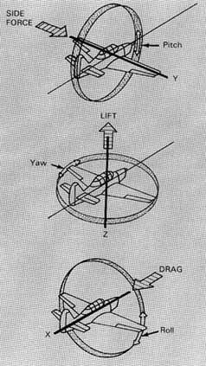

Figure 2.1: Aircraft reference axes [2].

2.1.2 Airfoil Nomenclature

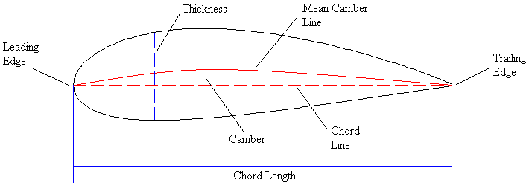
Figure 2.2: Parameters used to describe the profile of an airfoil

As can be seen in Figure 2.2, the overall shape of an airfoil is dictated by several characteristics, as described below [1]:

Mean Camber Line - This line is described by the loci of points situated halfway between the upper and lower surfaces of the airfoil.

Chord Line - This is the straight line connecting the leading and trailing edges of the airfoil. The length of this line is the chord (c) of an airfoil. In the case of symmetric airfoils, which have no camber and are therefore symmetric about the mean camber line, both the chord and the mean camber line will be identical. As can be seen in Figure 2.2, the portions of the airfoil above and below the chord are not mirror images of each other so therefore the airfoil is cambered.

Camber - The camber of an airfoil is the maximum distance between the mean camber line of the airfoil and its chord line.

Leading Edge - This is the forward extremity of the airfoil and is located at one end of the chord line.

Trailing Edge - This is the rearward extremity of the airfoil and is located at the other end of the chord line.

Thickness - This refers to the maximum thickness of the airfoil. For the majority of airfoils, this point is usually located approximately at the 0.25c (1/4 chord point) in from the leading edge. Just like the centre of gravity of the aircraft discussed in relation to Figure 2.1, at this point on the airfoil the aerodynamic centre can be found. It is about this point where all the forces and moments appear to act.

Span - Figure 2.2 represents a 2-D drawing or side view of an airfoil. However, the width of an airfoil is referred to as the span. The relationship of the ratio between the chord length and the span leads to a term known as the aspect ratio, which will be discussed later.

2.1.3 Force Components acting on an Airfoil

The drag force acting on an airfoil will always act parallel to the airflow in which the airfoil is moving through [3]. On the other hand, the lift force acts in a direction perpendicular to the direction of the air flow [3]. Therefore, these are in effect x and y force components when the airfoil is modelled in a Cartesian format with the origin located at the aerodynamic centre of the airfoil. The six aforementioned aerodynamic forces and moments acting on an airfoil are due to only two basic sources: shear stress distribution due to viscous effects and pressure distribution due to normal stresses over the airfoil [3].

The viscous effects are due to the viscosity of the air which in turn has an effect on the frictional force generated over the airfoil. Air would have a very low resistance to being deformed by the shear stress due to its very low viscosity. The surface of the airfoil will experience a ‘tugging’ force in the direction of the airflow, in other words the frictional force generated due to viscosity. This force acts tangential to the surface and is defined as the shear stress, τ [3]. The pressure distribution acts on the airfoil perpendicular to the surface at a given point, these are therefore defined as normal stresses [3]. The pressure at a particular point on an airfoil is dependent on the air flow velocity. As each action has an equal and opposite reaction, the flow near the surface of the airfoil experiences a retarding force. The result of this is the slowing of the flow velocity in the region close to the surface [3]. This in turn effects the development of the boundary layer, which is a crucial aspect of drag generation (discussed later).
Therefore, if the pressure force and the shear stress which are distributed over the complete airfoil surface, acting perpendicularly and tangentially to the surface respectively, are integrated there will be a resultant moment (M_{c/4}) and aerodynamic force (R) [3]. These two force/moment components can be seen in Figure 2.3 and they act through the aerodynamic centre, hence c/4 meaning the 1/4 chord point (0.25c).

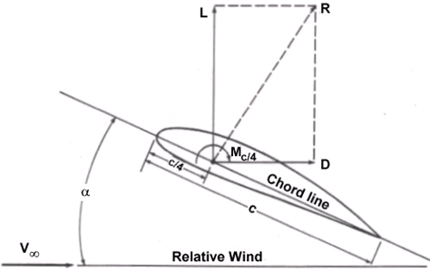
Figure 2.3: The resultant moment M_{c/4} and aerodynamic force R [4].

In addition, R can be further split into two components as can be seen in Figure 2.3. The lift force (L) will be the component of R perpendicular to V∞, which is the air velocity. The drag force (D) will be the component of R parallel to V∞. The drag force exerted on a body can be calculated by the following formula [3]:

D = ρV²AC_{D} Equation 2.1

Where: ρ is the density of the air, A is the planform area (chord length by the span) of the airfoil, C_{D} is the coefficient of drag of the airfoil and V is the velocity of the airfoil. If the drag force is known, the drag coefficient can be calculated by manipulation of Equation 2.1:

C_{D} = D / ρV²A Equation 2.2

The dynamic pressure over the airfoil (q) is equal to 0.5ρV² and it forms part of Bernoulli’s equation. The dynamic pressure represents the kinetic energy (E_{K} = 0.5mV²) of a unit volume of air (m is mass in kg derived from one cubic meter of air) [3]. The lift force can be calculated using a very similar method, except the only difference is that a value of the coefficient of lift, C_{L}, must be known [3]:

L = ρV²AC_{L} Equation 2.3

The calculation of C_{L} is achieved in the same manner as Equation 2.2. The lift force varies approximately linearly with the density of the fluid [3]. In addition, the lift coefficient varies approximately linearly with the angle of attack (AOA or α) of the wing up to the stall point [3]. The stall point is the AOA at which the maximum amount of lift force is generated and if the airfoil goes beyond this point, the lift will dramatically decrease. This phenomenon is based around flow separation and vortex shedding which will be discussed later.

2.1.4 Lift Generation and the Coanda Effect

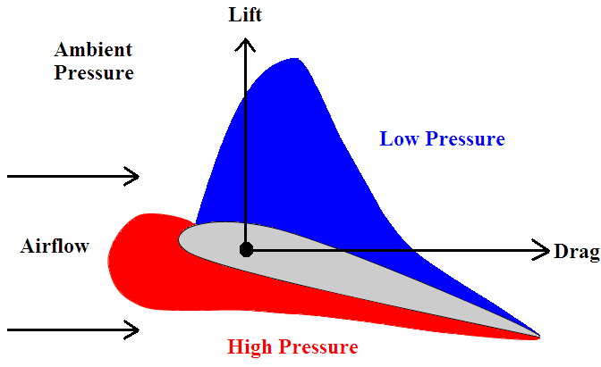
Figure 2.4: Diagram of pressure distribution above and below an airfoil.

For the generation of lift, there exists a difference in pressure between the top and bottom surfaces of an airfoil, as illustrated in Figure 2.4. The reason as to why there is this difference in pressure is due to a difference in the velocity of the airflow flowing above and below the wing [3]. There will be a higher velocity of airflow over the top of the wing and therefore a lower pressure according to Bernoulli’s equation. The opposite is true for the flow below the wing, with a lower velocity and higher pressure. The exact application of Bernoulli’s equation will be discussed later. Therefore, the higher pressure beneath the wing will create an upward force, forcing the airfoil to move from a region of high to low pressure. This can also be described as a suction force acting on the top of the airfoil [3]. Again, this lift force will appear to act through the aerodynamic centre and acts perpendicularly to the free-stream airflow. Free-stream flow refers to the airflow that is sufficient distance away from the airfoil not to be disturbed as it moves through the air. As the difference in pressure between the upper and lower surfaces is greatest over the front part of the airfoil (as can be seen in Figure 2.4), most of the lift force is generated in this region [5].

However, there has been a recent trend to design airfoils to give a more constant low pressure region over the entire top surface. This more uniform distribution of low pressure and lift provides both structural and aerodynamic advantages [5]. When airflow reaches the leading edge of an airfoil it is forced to change direction and follow the shape of the airfoil [5]. In Figure 2.5, the flow streamlines around an airfoil are illustrated. On the left of Figure 2.5, it can be seen that the free-stream airflow streamlines are parallel to each other, then change in direction, and follow the top and bottom surfaces of the airfoil. Both the top and bottom surfaces of the airfoil cause the airflow to change in direction, with usually a greater amount occurring on the top surface [5].

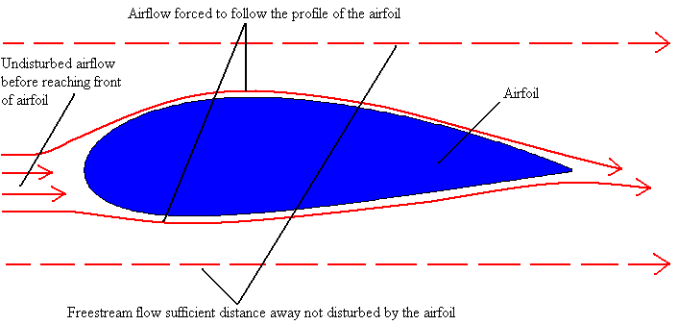
Figure 2.5: Diagram illustrating the turning of the airflow around an airfoil.
It has been discussed that the pressure difference and the directional change in the flow streamlines creates the lift, but a further explanation is required as to what actually causes this flow vector adjustment in order for it to follow the path of the airfoil’s surfaces. This can be explained by the Coanda Effect and this principle is illustrated in Figure 2.6.

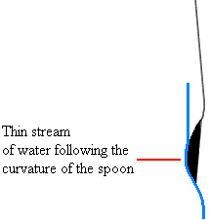
Figure 2.6: A thin stream of water following the curvature of a spoon illustrating the Coanda Effect.

Henri Coanda, a Romanian aeronautical engineer established the principle that if a stream of fluid flows over a solid surface that bends away from it, it will tend to follow the curvature of the surface [5]. This effect is caused by the dynamic viscosity (μ) of the fluid which causes the flow to ‘stick’ to the surface. Viscosity is related to the density of a fluid, the more dense the higher the viscosity. Even though air has a very low viscosity the air particles will tend to follow a curved surface also, such as an airfoil. Therefore, the viscosity of a fluid which can be measured by different types of viscometers, will define the viscous force generated by that fluid. However, in many situations it is necessary to relate the ratio of the viscous force of a fluid to its inertial force. This ratio is defined by the kinematic viscosity (ν) and it is the density of the fluid which characterises the inertial force [1]:

ν = $\frac{μ}{ρ}$ Equation 2.4

There is a popular misconception amongst elementary aerodynamics information sources known as ‘equal-transit time’ [5]. This concept puts forward the theory that the air flow over the top surface has to travel further. In turn, this means that in order for the flow above and below the airfoil surfaces to meet at the trailing edge at the same time, the flow above must travel quicker resulting in lower pressure according to Bernoulli’s Equation. This theory has been proved incorrect over the years and in reality the extent of the low pressure found on most airfoils means that the airflow is travelling much faster than this theory would imply [5].

However, it is the fact that the viscosity of the flow, the Coanda Effect, will cause the flow closely or ‘stick’ to the surfaces and the flow has to turn to a greater extent when flowing around the top surface. As a result, from the conservation of mass theorem, the flow streamlines will decrease in size due to the constriction of flow through the large turning effect and they will increase in velocity [3]. As the flow streamlines increase in velocity they will create a region of lower pressure. It is this principal generation of low pressure above the airfoil which can be explained as the mechanism for lift generation.

2.1.5 Aspect Ratio and Induced Drag

The aspect ratio is an important design factor of a wing as it will have a direct effect on the lift and drag characteristics of a wing section. It is defined as the ratio of the span squared to the wing area [6]:

Aspect Ratio = $\frac{b^{2}}{S}$ Equation 2.5

Where: b is the span of the wing and S is the wing area.

Equation 2.5 is used for wing sections that vary in chord length along their span. The wings on modern commercial airplanes have a longer chord length at their root section (the end connecting with the fuselage) and a shorter chord at their tips. Wings with this design are known as swept wings and the degree of sweep determines the lift and drag characteristics of the wing [7]. Figure 2.7 shows the factors which determine the aspect ratio of a wing.

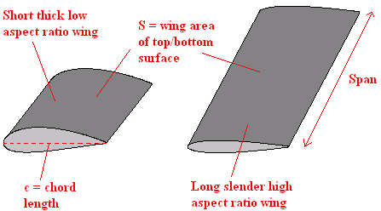
Figure 2.7: Diagram of two wings of different aspect ratio.

As opposed to swept wings, the wings illustrated in Figure 2.7 are rectangular as both ends of the wing have the same chord length. With rectangular wing sections the aspect ratio is easier to calculate as it is simply the span divided by the chord length [6]. It was found in early wind tunnel tests that the rates of change of lift and drag coefficients with the angle of attack were strongly affected by the aspect ratio [6]. Wings with low aspect ratios were found to have lower lift curve slopes and generated less lift and higher drag at high AOA [6].

A very important factor which is directly affected by the aspect ratio is what is known as induced drag. Induced drag is created by the pressure difference between both wing surfaces, which causes flow around the wing tips from the high pressure side to the low pressure side [7]. This flow around the wing tips is illustrated in Figure 2.8.

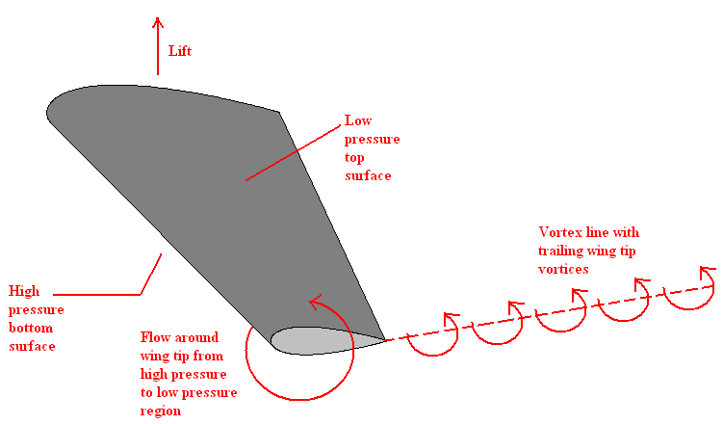
Figure 2.8: Diagram showing the flow around the wing tips which creates trailing vortices.

The wing tip vortices as shown in Figure 2.8, which trail behind the wing, are known as the ‘downwash’ [7]. The kinetic energy associated with this downwash has to be supplied by the wing in the form of work on the air and this induces a drag force on the wing [7]. In other words, the downwash has the effect of tilting the undisturbed air downwards, which causes a local induced increase in the AOA with additional drag (induced) occurring [7]. The downwash also occurs towards the wing root but it is strongest at the wing tips [7]. Therefore, the induced drag is a consequence of the lift developed and for this reason it is also known as drag due to lift [7]. An important point is that the minimum induced drag increases with the square of the lift [7]. In terms of wing design, the aspect ratio should be as high as structurally possible as the induced drag decreases with increasing aspect ratio [7].

However, larger wings obviously will weigh heavier which leads to the requirement of stronger supports connecting the wing to the fuselage, which in turn leads to further weight. This creates a design paradox where even larger wings are required to create extra lift for this increased weight. However, winglets can be used to reduce wing tip vortices and these devices are relatively light. Such winglets are illustrated in Figure 2.9. These winglets can be seen on modern commercial and military aircraft and they vary in size and shape depending on the flow conditions over the wing.
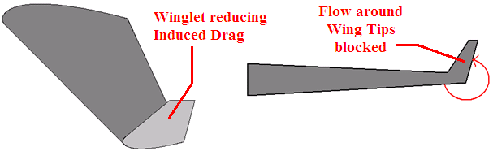
(a) (b)
Figure 2.9: (a) Diagram of a wing section with a winglet at its tip which reduces the induced drag, (b) Diagram looking at the leading edge of the wing.

2.1.6 Aerodynamic Efficiency

While wing sections are designed to be as streamline as possible, a particular drag force will always exist. This drag force will increase as the α of the wing increases. The fact that the drag force increases greatly as α increases is the major reason why an aircraft stalls when the rate of climb is too high. Not only does the drag force increase significantly, but the lift force generated also decreases as the drag force slows the aircraft down. As α increases, so too does the coefficient of lift (C_{L}). It can be seen that C_{L} varies linearly with α in Figure 2.10. C_{L} is represented by the vertical axis and α is represented by the horizontal axis. It can be seen that the linear part of this graph crosses the horizontal axis at a negative value of α. This is because the point at which the airfoil produces no lift is at a negative α, not at 0º. In Figure 2.10 this negative α_{L=0} (zero lift α) point is the case for cambered airfoils and this point is usually located between -1º and -2º [1]. However, airfoils with no camber (symmetric) should not produce lift at 0º [1]. As α increases, the flow starts to separate from the wing and a high drag force is generated. Stall occurs where the linear part of the graph ends, as indicated in Figure 2.10. Flow separation will be further discussed in Section 2.2.5. The drag increases to a point where the wing cannot create enough lift to keep the aircraft airborne. The higher the coefficient of lift is prior to stall the better, as the stalling speed will be lower [3].

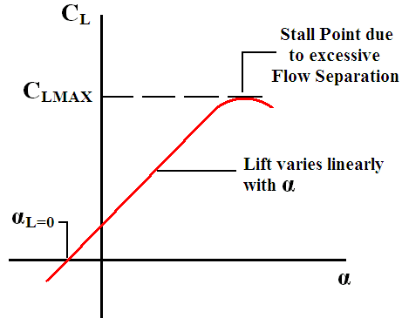
Figure 2.10: Diagram illustrating the linear relationship of the lift coefficient with the angle of attack up to the stall angle of an airfoil.

It is desirable for an airfoil to generate the greatest amount of lift possible while at the same time producing as little drag as possible. The higher this lift to drag ratio is, the more efficient the design of the airfoil. This equation can be described as [3]:

Aerodynamic Efficiency = = ρV²AC_{L} / ρV²AC_{D} = Equation 2.6

The principle of aerodynamic efficiency can be further illustrated by the design of a wing on a glider aircraft. As there is no form of propulsion on a glider, in order to increase the range of a glider’s flight it is not enough just to increase the lift force of the wing. By reducing drag as much as possible also, thereby maximizing the above ratio, this ensures that the glider will have a longer range. In terms of aircraft design, a high aerodynamic efficiency would also help to reduce fuel consumption. It is common for modern wing designs to have lift to drag ratios of 100:1 [1]. Using Equation 2.6 an L/D curve can be plotted and the highest point on the curve, which is known as (L/D)_{MAX}, will be the most efficient α [7].

2.1.7 National Advisory Committee on Aeronautics - NACA

The National Advisory Committee on Aeronautics, NACA, was established in 1915 [3]. This committee is responsible for the majority of theoretical data available on airfoils today. The investigation of a large group of related airfoils was made in the NACA variable-density wind tunnel at Gottingen during the period from April 1931 to February 1932 [8]. These tests involved studying the effects of varying properties of an airfoil such as the camber and thickness and how this in turn affects the lift and drag characteristics [8]. These experiments were carried out using wing test models that spanned from one side wall of the wind tunnel to the other [3]. Therefore, the airfoils analysed did not have wing tips, thereby ignoring the effects of wing tip vortices and induced drag as previously discussed. As a result, the data collected from these tests are referred to as infinite wing data [3]. These studies by NACA contributed to the large development of aircraft wing sections, propellers, turbine and helicopter rotor blades used today. The NACA database of airfoils contains hundreds of designs and they are named in terms of their profile. There are different classes of NACA airfoils, however the 4-digit class will be discussed here. This class of airfoil was used in the experimental testing and the exact profiles used will be discussed in Section 3.1. The 4-digit class is described in the form of NACA pmxx, where [6]:

- p represents the maximum value of camber as a percentage of the chord length.
- m defines the distance out from the leading edge for the maximum camber along the chord and in tenths of the chord.
- xx represents the maximum thickness of the airfoil as a percent of the chord length.

Therefore, in the case of the NACA 4412 airfoil, if it has a chord length of 1m the maximum thickness of the airfoil will be 12% of 1m, which is 12cm. The airfoil will have a maximum camber value of 4% of the chord length and this would be 4cm. Finally, this maximum camber will be located 4/10ths, 40cm, along the chord from the leading edge. The mean line of the airfoil is used to describe the upper and lower co-ordinates in a vertical direction, which describes the shape of the airfoil. This mean camber line is therefore used to describe the thickness distribution of the airfoil from the leading edge to the trailing edge. Therefore, the upper-surface and lower-surface co-ordinates of the airfoil can be described as a function of the distance from the mean camber line. Equations can be used to create hundreds of data points with respective x and y coordinates relative to the leading edge origin. These data points therefore define the shape of the airfoil and the equations used are described in NACA literature.

2.1.8 The Use of Wind Tunnels in Aerodynamic Design

The American Air Force has several wind tunnels including one at Wright-Patterson AFB in Ohio and one at Arnold Engineering Development Centre, Tennessee [5]. The US Navy also has tunnels at the David Taylor Naval Ship R&D Centre in Carderock, Maryland and the Naval Ordnance Laboratory at White Oaks, Maryland [5]. In addition, all of the major aeronautical and automotive corporations worldwide have at least one wind tunnel. An example of a sport that greatly benefits from wind tunnel testing is Formula One. Most Formula One teams have one or more wind tunnels and these are used intensively. Without this facility their ability to continuously develop their cars and remain competitive would be almost impossible. Wind tunnels are not exclusively used for the design of cars and aircraft, but also in the design of buildings. As there is a requirement for new skyscrapers to be taller and incorporate more features, their ability to resist motion due to strong winds becomes even more important.

Frank H. Wenham who was a Council Member of the Aeronautical Society of Great Britain, is generally credited with designing and operating the first wind tunnel in 1871 [2]. Wenham had tried several simple experiments, but his unsuccessful experiences led him to urge the Council to raise funds to build a wind tunnel. The wind tunnel was 3.66m in length and 0.46m² in cross-sectional area [2]. A fan upstream of the test models, driven by a steam engine, propelled air down the test section. Wenham mounted various shapes in the tunnel and measured the lift and drag forces acting on these shapes.

With the advent of the wind tunnel, aerodynamicists finally began to understand the factors that controlled lift and drag generation, but they were still confused by the effect of model scale [2]. The problem with this was whether the experimental results obtained with a scale model could be applied to the real full sized aircraft. Almost all wind tunnel tests were and still are performed with scale models, because wind tunnels capable of handling full sized aircraft are too expensive to build and operate. In a set of experiments in 1883, Osborne Reynolds demonstrated that the airflow properties over a scale model would be the same for the full scale object if a certain flow parameter were the same in both cases [2]. This factor, now known as the Reynolds Number, is a basic parameter in the description of all fluid flow scenarios.

2.2 Fluid Mechanics

A fluid, such as water or air, deforms under the action of shearing forces as previously discussed. Analysing a fluid at rest is relatively straightforward, however when a fluid flows over a solid surface shear forces are created. This leads to the nature of the flow being more complex. This section will describe in detail the various mechanics involved with fluid flow and what effect they have on the flow around an airfoil in particular.

2.2.1 Incompressible & Inviscid Flow

A flow can be defined as being incompressible if its density (ρ) remains constant [3]. This applies when the velocity of the fluid is less than 30% of the speed of sound [3]. Although in reality no flow can be truly incompressible, many aerodynamic problems can be modelled as incompressible. Not only is there little or no loss in accuracy, but the analysis can be greatly simplified [3]. Aerodynamic forces acting on an airfoil depend on the compressibility of the air. As an airfoil moves through the air, the air particles are forced to flow around the airfoil, as described before. If the airfoil is travelling at a speed less than 30% of the speed of sound, the speed of sound in air being 343m/s at 20ºC, the density of the air can be assumed to remain constant [3]. When an object is travelling at a very high speed, a great deal of energy is required to compress the air and change its density [3]. The compressibility of air at a given speed can be defined by the following formula [3]:

Fluid Compressibility = Equation 2.7
Equation 2.7 is also known as the Mach Number (Ma) [3]. When the molecules in a flow move, they transport their mass, momentum and energy from one point to another. As a result, properties such as mass diffusion and thermal conduction exist in airflow [3]. In reality all flows contain these properties and are called viscous flows as a result. When a fluid has no resistance to shear stress it is known as an inviscid fluid [3]. Just like the assumption of incompressibility, many flow scenarios can be modelled with the effects of viscosity ignored. Such inviscid flows can be modelled with little or no loss in accuracy and greater simplicity [3].

2.2.2 Reynolds Number – Laminar and Turbulent Flow

The Reynolds Number (Re), developed by Osborne Reynolds in 1883, is a measure of the ratio of inertia forces to viscous forces in a flow [3]. This number can be used when analysing an object as to whether the flow around it is laminar or turbulent, as follows [3]:

Re = Equation 2.8

Where: V is the velocity (m/s) that the fluid is travelling (or object velocity), l is the length (m) of the object and µ is the dynamic viscosity (Pa$∙$s) of the fluid.

Equation 2.8 is quite adaptable to different fluid flow scenarios. This is so as V can be either the velocity of the fluid or the velocity of an object moving through the fluid. In terms of wind tunnel testing, V would be the airflow velocity as the test model would be stationary in the tunnel. Also, if the flow is through a pipe, l would be the internal diameter of the pipe with a different symbol such as D in its place. The top of the equation, ρVl, is a measure of the inertial forces in the fluid while µ is the viscous force of the fluid [3]. For an airfoil in free-stream flow, a Re of less than 500,000 signifies that the flow around the airfoil is laminar [9]. However, typically a value of 1,000,000 signifies turbulent flow and any value in between these represents a transition region from laminar to turbulent flow [9]. Therefore, from Equation 2.8, turbulent flow occurs where the inertial forces overpower the viscous forces of the fluid. As a result the velocity vectors of the fluid are carried off from the viscous flow direction, resulting in random, unsteady flow [3]. A further description of laminar and turbulent flow will be given in Section 2.2.4.

As mentioned in Section 2.1.8, tests conducted in a wind tunnel can be said to be valid for the full-scale object if the value of Re is the same in both cases. Therefore, once the value of Re is calculated for the full-scale object, several factors can be adjusted to achieve the same value for the wind tunnel tests. The density of the airflow, its velocity and the size of the object can be altered to achieve this. Changing the density of the airflow is only possible however with the use of a variable-density wind tunnel [7].

2.2.3 Bernoulli’s Equation & Velocity Measurement

The early part of the eighteenth century saw great advances made in the area of theoretical fluid dynamics. Daniel Bernoulli in the 1700’s investigated the forces evident in a moving fluid [3]. There are many different forms of this equation, but as this research is dealing with incompressible flow the following equation can be utilised [3]:

P_{S} + $\frac{1}{2}$ρV² = P_{T} Equation 2.9

Where: P_{S} is the static pressure, V is the velocity of the fluid and P_{T} is the total pressure which is regarded as a constant. Thus, Equation 2.9 is in the form of: Static Pressure + Dynamic Pressure = Total Pressure.

The total pressure will remain constant in steady uniform flow, however will vary over time inside a wake (region of separated flow) where the velocity is fluctuating over time due to the high level of turbulence [10]. In addition, Equation 2.9 is similar to the equation for the conservation of momentum [3]. It is possible to use a Pitot-Static tube in conjunction with an inclined manometer to measure the total pressure (P_{T}) and the static pressure (P_{S}) in a wind tunnel. Once this has been conducted and as the density will be known, the calculation of the velocity at a particular point in a wind tunnel can be calculated by re-arranging Equation 2.9 for V (velocity) and solving [3]. The density will be known as in the case of a non-pressurised tunnel, it will be equal to the density of air at sea level, assuming of course the tunnel is not in a room a great deal above sea level.

When a fluid is at rest, the motion of all the particles is random and the pressure of the fluid is regarded as the static pressure [11]. However, when the fluid is in motion, there exists an ordered momentum of the random moving particles through collisions of the particles [11]. The pressure associated with the momentum of the ordered motion of the fluid is called the dynamic pressure. It can be seen that the dynamic pressure component of Equation 2.9 is similar to the equation for kinetic energy, with mass replaced by density [11]. If the velocity slows from one point in a flow stream to another, there will be a change in pressure [3]:

P₁ + ρV₁² = P₂ + ρV₂² Equation 2.10

Equation 2.10 relates velocity and pressure changes from one point in a fluid stream to another. Therefore, if the velocity increases from one point to another, there will also be a pressure decrease between both points in the fluid stream.

2.2.4 Boundary Layer Development

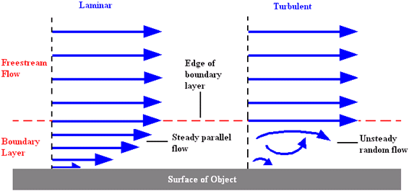
Figure 2.11: Diagram illustrating the different boundary layer conditions for laminar and turbulent flow.

As an object moves through the air, the fluid in contact with the surface of the object adheres to it and as a result has the same relative velocity as the object. These molecules in turn slow down the molecules just above them by the molecules colliding off them [11]. As one moves away perpendicularly from the surface, the velocity of the air molecules gradually increases as the effect of friction from the object reduces. Therefore, there is a thin layer of fluid near the surface where the velocity ranges from zero at the surface to free-stream velocity at the edge of the boundary layer. The thickness of the boundary layer is affected by the Re and therefore a laminar or turbulent boundary layer may exist [11]. As can be seen in Figure 2.11, for a laminar boundary layer the velocity increases gradually out from the surface and the velocity vectors are parallel to each other. As for the turbulent boundary layer, there is a more rapid increase in velocity and as a result the boundary layer is thinner, although this aspect is not illustrated in Figure 2.11. However, in the turbulent boundary layer the motion of the air molecules are not parallel to each other but are random in order. An important note is that fluid flow just above the top of the boundary layer reacts with it as if it is a solid surface. Therefore, a thick boundary layer caused by flow separation actually increases the effective thickness of the airfoil [11]. Reduction of boundary layer thickness and delaying flow separation are key factors involved with the reduction of drag. These principals form the basis of this research and are further discussed in Section 2.2.5.

One of the most difficult problems in the prediction of drag is concerning the transition of laminar to turbulent flow. Quite often transition is considered to be an issue that is limited to low Re flight vehicles, such as gliders and single-engine propeller aircraft [12]. This problem also applies to smooth models tested in wind tunnels under quite low Re, for example Re < 10,000 [12]. When considering a commercial airplane for example which travels at high velocities, it would be incorrect to assume that the boundary layer is automatically turbulent [12]. In fact, the majority of aircraft manufacturers do not add a design feature on the wings with regards to laminar flow control to delay transition [12].

During in-flight tests on a B737-100 airplane, infrared thermography was used and this indicated extended regions of laminar flow even at cruise conditions [12]. In Figure 2.12 the transition pattern is highlighted with the test conducted at an AOA of 3.1º at a Ma of 0.68 (approximately 840km/h) at 32,700 feet [12]. In Figure 2.12, the white area marks the region of the slat (frontal section of wing) exposed to laminar flow with the grey area representing the turbulent flow. This test proves that the fully turbulent flow assumption should be applied with caution, even when considering high Re flight applications [12]. Therefore, while a high Re (such as Re > 1 × 10⁶) will indicate turbulent flow, the boundary layer in such scenarios will be laminar unless the flow is tripped into turbulence by surface roughness or by a sudden change in curvature [12].

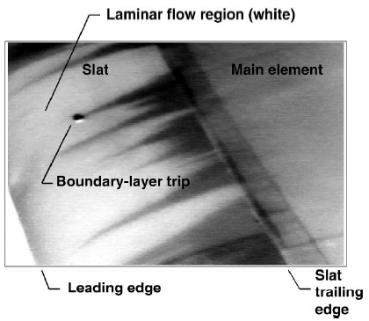
Figure 2.12: Infrared thermography highlighting the flow located approximately at 50% of the span of the wing [12].

The value of C_{D} at low AOA is mainly a function of Re and the extent of the laminar boundary layer [13]. It is moderately affected by the airfoil thickness ratio, with an increase in the thickness increasing the drag coefficient [13]. On the other hand an increase in the camber has far less of an effect on the drag coefficient [13]. However, an increase in camber has a strong effect on the lift coefficient as was discussed in Section 2.1.6, with regards to α_{L=0}, C_{Lmax} and the stalling angle.

2.2.5 Flow Separation, Vortices & Wake Formation

(a) Flow Separation

The reduction of the thickness of the boundary layer as a result of delaying flow separation is an important concept for drag reduction. The flow separation over a wing section results in not only the loss of lift and the increase of drag, but in addition generates aerodynamic noise, reduces aerodynamic stability and decreases aerodynamic efficiency leading to higher fuel consumption. When the airflow first reaches an airfoil, it forms a stagnation point at its leading edge [3]. At this stagnation point the flow is greatly reduced in speed and a region of high pressure is formed. From this point onwards, the flow accelerates thereby forming a boundary layer [3]. As fluid moves over an airfoil, it is gradually slowed down by the skin friction forces caused by the resulting shear force generated by the shear stress at the surface [3].

In addition to the frictional forces, the adverse pressure gradient (high moving into low pressure) generated by the gradually slowing flow over the airfoil also contributes to the velocity reduction. As the AOA is further increased, the flow in the boundary layer reduces in velocity to a point where the kinetic energy of the fluid is too low to overcome this adverse pressure gradient. At this point the flow separates from the airfoil and flow reversal occurs. The separated shear layer is inviscidly unstable and vortices are formed due to the Kelvin–Helmholtz mechanism [3]. These vortices that are created are referred to as Von Karman Vortex Shedding [3]. This is illustrated in Figure 2.13. As the fluid flow a greater distance vertically out from the airfoil possesses enough energy to continue moving forward, a swirling of the fluid is generated. This resulting swirling fluid, or vortices, is known as a wake. The separation of a fluid from an object’s surface can be reduced if the object is well streamlined, just like an airfoil.

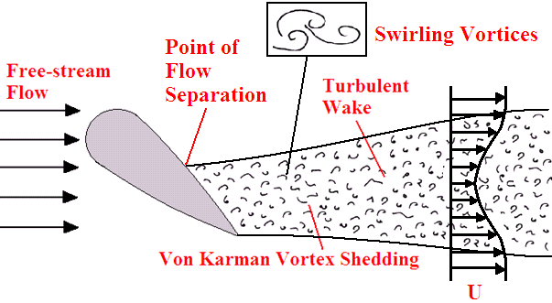
Figure 2.13: Illustration of flow separation from an airfoil at a high AOA with the resulting vortex shedding.

It can be seen in Figure 2.13 that the velocity profile across the wake (U) varies in velocity. The flow will be at its slowest at the centre of the wake and increase in velocity as it moves towards the free-stream flow at the edges. When viewing the wake in a 3-D sense, its centre point with respect to the horizontal and vertical planes is usually where a peak in turbulence, velocity deficit and energy loss is found [10]. At the separation point, the skin friction coefficient reaches a value of zero and the wall shear stress vanishes, as the flow is essentially not in contact with the surface [14]. There is now a large pressure difference acting on the airfoil with high pressure at the front and a low pressure region at the rear of the airfoil where the flow has separated. This type of drag is known as pressure or form drag and is different to viscous (skin friction) drag [7]. When a laminar boundary layer separates however, the flow may re-attach as a turbulent boundary layer some distance downstream [7]. The region of separated flow that has re-attached is known as a separation bubble, which grows rapidly in size as the AOA of the airfoil is increased [7]. The reason as to why this occurs is because the free-stream flow above the airfoil mixes with the top of the separated layer and adds extra flow energy to the separated flow [7]. As a result, the flow then has the energy to re-establish a boundary layer at the surface. At a particular AOA, which depends on the airfoil and flow conditions, the separated layer will fail to re-attach to the airfoil [7]. This will in turn create a greater amount of pressure drag, such as the case that is illustrated in Figure 2.13.
However, an important aspect which also has an effect on the point of flow separation is the thickness of the airfoil. Flow separation occurs near the leading edge of thin airfoils, with thin airfoils being classed as having less than 12% thickness-chord ratio [7]. On the other hand flow separation tends to occur near the trailing edge with thick airfoils, that being airfoils of 12% thickness-chord ratio or more [7]. Therefore, thin airfoils have a characteristic known as leading edge stall and thick airfoils are referred to having trailing edge stall. With the case of thin airfoils, if the flow starts to separate it will do so at the leading edge and may form a separation bubble or remain fully detached, depending on the flow scenario. However, thick airfoils which experience trailing-edge stall have the feature that as the AOA is increased, the point of flow separation will progressively move towards the leading edge due to the increasing adverse pressure gradients. Therefore, the severity of the flow separation will increase.

With a pressure drag, also known as Form drag, there will be a large pressure difference between the front and rear of the airfoil due to flow separation [3]. This is much more detrimental than viscous (skin friction) drag when dealing with a blunt object such as a sphere or an airfoil at a relatively high AOA. The addition of pressure and viscous drag is called the profile drag of a two-dimensional body or parasite drag for a three-dimensional body [3]. For a given airfoil, it is possible to calculate the induced drag from a set of equations and the profile drag can then be found by subtracting the theoretical induced drag from the total drag found from wind tunnel tests [15]. However, these different elements of total drag may be found depending on the nature of the wind tunnel force measurement technique. Therefore, the total drag generated on an airfoil is the addition of the pressure, viscous and the induced drag. However, a fourth form of drag exists at transonic and supersonic speeds, which arises from the radiation of energy away from the body in the form of pressure or shock waves [3]. This formation of shock waves leads to what is known as wave drag [3]. Depending on the geometry of the object and the profile of the shock wave, heat transfer may occur from the shock wave to the body or from the shock wave to the air surrounding it [3]. As this research is concerned with subsonic flow, a more detailed discussion of shock wave formation is outside the scope of this section. Therefore, these different drag components are summarised in Figure 2.14.

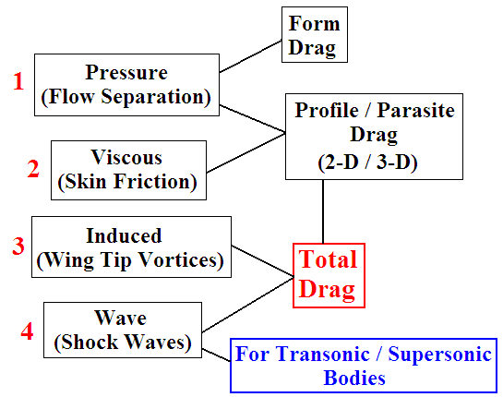
Figure 2.14: Summary of the four individual components of drag that can add to give the total drag force experienced by a body.

For an object of large frontal area such as an airfoil at a high AOA, the pressure drag can be reduced by a turbulent boundary layer [3]. It is delayed by the larger kinetic energy associated with a turbulent boundary layer, thus this boundary layer type is more desirable. With a streamlined object, such as an airfoil at 0° AOA or a flat plate, skin friction contributes mostly to total drag instead, with a laminar flow profile more desirable here. Thus, the lower kinetic energy of the fluid will create less skin friction drag [3].

(b) Vortices & Wake Formation

When analysing a bluff body such as a cylinder, or in relation to this research an airfoil at a high AOA, the Re has a large impact on the flow and formation of vortices. As can be seen in Figure 2.15, Case 1 illustrates the flow moving at a Re of less than one past a cylinder. In this scenario there will be no wake evident and the streamlines are symmetrical [10]. As the Re value is increased above 1 in Case 2, the streamlines separate from the body and a pair of stationary vortices, known as Floppl vortices, are formed [10].

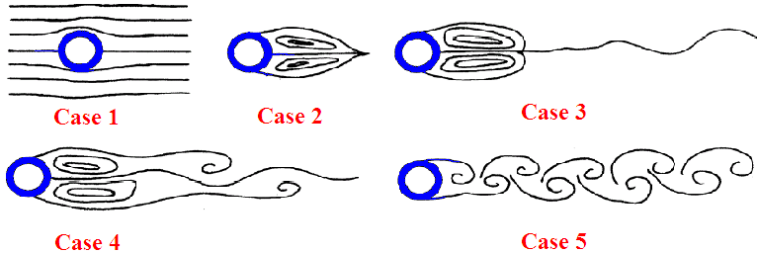
Figure 2.15: The development of vortex structures behind a cylinder as the Re increases.

These vortices in Case 2 are closed loops, however as Re is increased these vortices stretch in length and elongate further downstream as in Case 3. Typically, for Re > 40, they detach from the rear of the object and trail away in a shedding pattern [10]. This is illustrated in Case 4 for Re approximately equal to 40 and in Case 5 the Re of the flow increased beyond this [10]. Therefore in Case 5, fully formed vortices that are counter-rotating with respect to the flow are trailing (shedding) the cylinder. This scenario is known as Von Karman vortex shedding as discussed earlier and its frequency is related to the Strouhal Number, S [10]:

S = $\frac{d*f}{U_{∞}}$ Equation 2.11

Where d represents the diameter of the object, or in the case of an airfoil, it would represent its frontal height. The f symbol is the frequency of the vortex shedding and U∞ is the free-stream velocity. The Strouhal Number (S) is a non-dimensional expression of the ratio of the vortex shedding frequency to the characteristic flow frequency [10]. Upon comparing the S to the Re of flow past a cylinder for example, S increases as the value of Re increases up to 1 × 10³ [10]. At this point the value of S is approximately 0.22 and its value slightly decreases as Re is increased beyond 1 × 10³ [10].

As a wake is highly turbulent it will exhibit a lot of fluid mixing between the different vertical layers, as the particles move in chaotic patterns. The velocity in the wake will be lower than it is in the free-stream with respect to the direction of the free-stream flow [10]. This is so as the particles in the turbulent wake have their kinetic energy utilised in the spiralling motion of the vortices, rather than being concentrated into parallel streamlines as in the free-stream flow. Therefore, the energy loss from the linear motion of the free-stream is converted into the random moving vortex structures [10]. It would be correct however to state that some of the energy loss from the free-stream flow by the formation of wakes is also converted into sound and heat transfer effects. Energy being converted in heat becomes particularly evident at transonic and supersonic speeds as shock waves start to form. As discussed before, the formation of regions of separated flow will create aerodynamic noise. This is a design concern for car manufacturers for example, as reducing the aerodynamic noise will improve the overall noise levels within the car.

2.2.6 Use of Dimples to delay Flow Separation

A sport that benefits from the effect of surface modifications to reduce drag is golf. The dimples on a golf ball, regarded as a rough surface, create a turbulent boundary layer at the front of the golf ball. As a result, the dimples can also be referred to as ‘turbulators’ [16]. As the air molecules in the turbulent boundary layer have more kinetic energy, the flow separation is delayed as the particles have enough momentum to counteract the effects of the adverse pressure gradient. Therefore, the flow separation is delayed to a region further along the golf ball or perhaps eliminated. The effect of such surface modifications are illustrated in Figure 2.16. The ball in Figure 2.16(a) is smooth, with an early separation point and a high drag force. However, the ball in Figure 2.16(b) has a rough ‘dimpled’ surface just like a golf ball, thereby delaying flow separation and producing less drag. As discussed earlier, in this scenario a turbulent boundary layer is more desirable as the pressure drag is a much larger component of the overall drag force (compared to the skin friction drag). Therefore, the dimples create turbulence, delay separation and reduce the overall drag as a result.

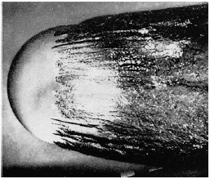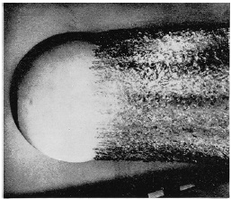
(a) (b)
Figure 2.16: (a) This is the smooth ball with an early separation point, (b) this shows the dimpled ball with a delayed separation point and reduced drag [16].

Although turbulence increases skin friction drag, this is very small in comparison to the large reduction in the pressure drag. It can also be observed that the smooth ball in Figure 2.16(a) produces a larger wake with more vortex shedding. This along with early flow separation causes larger drag forces. In contrast, the thinner delayed wake in Figure 2.16(b) reduces the pressure differential between the front and rear of the ball. The difference between the high pressure at the front of the ball and the low pressure at the rear is reduced, thereby reducing the pressure drag. Except under special circumstances, laminar boundary layers can only exist for relatively short distances in a region in which the pressure increases in the flow direction [7]. Therefore, by creating a turbulent boundary layer further upstream of where the flow previously separated will create a greater resistance to flow separation.

In terms of the current research, this forms the hypothesis of dimpling airfoils and thereby increasing their surface roughness in order to give the previously separated molecules enough kinetic energy to have a delayed point of flow separation. Therefore, while it is expected that the dimples increase the skin friction drag, it is the aim of the research that a reduction in the larger pressure drag component will result in an overall total drag reduction. While the dimples on a golf ball are usually circular smooth indentations, this research will involve the testing of smaller irregular indentations made by a sand blasting technique, onto airfoil test models.

2.3 Recent Research into New Drag Reduction Techniques

There have been various forms of research conducted during recent years into developing new methods of drag reduction. These techniques researched include for example using AC current and plasma discharges, rotating surfaces, blowing jets and surface modifications for example in order to delay flow separation. This section will discuss such techniques in detail, analyse their advantages and disadvantages and discuss how they relate to the current research.

There are essentially two control methods for reducing flow separation: passive and active control. Active control involves continuous adjustment of a variable that affects the flow based on measurements of quantities of the flow field. This often requires the use of a feedback system, which has sensors and other electronic equipment to adjust the particular variable. This requires auxiliary power thereby adding weight to the object in question and can affect the overall design of the object due to the presence of the respective components. On the other hand, passive control usually involves some kind of design modification, such as different surface patterns, to the object itself. The advantage of this control technique is that it will have a much smaller effect on the overall design or concerning the weight added to the object. Therefore, as a dimple effect is added to the surface of the airfoils in this research, these modifications are considered as a passive control method to reduce flow separation. While the passive techniques may be more relevant to the current work, it was worthwhile researching and discussing active techniques for a broader understanding of recent drag reduction research. Therefore, this section will discuss recent drag reduction developments under these two main categories.

2.3.1 Passive Control

In the research carried out by Whitmore et al. [17], the roughness of the front section and top side (referred to as the forebody) of a model representing a ‘blunt’ shape of a space shuttle’s re-entry capsule was modified. The roughness was altered by adding micro-machined overlays to the surface [17]. The current generation of re-usable space shuttles all have large base areas compared to those of conventional aircraft. Based on the original lifting-body concept, the shuttle is essentially a large wing on the base side. However, this base side leads to large regions of separated flow, resulting in large negative base (rear) pressure coefficients. As a result, space shuttles have low lift-to-drag ratios resulting in very steep landing glide slopes [17]. The aim of this research work was to investigate the theory that as the forebody surface roughness increases, thus that the base pressure drag decreased [17].

The work carried out by Whitmore et al. [17] was based on the previous research conducted by Hoerner in 1965. Hoerner found a correlation between the base pressure drag and the skin friction drag generated on the forebody. Hoerner hypothesised that as the forebody drag increased, the boundary layer thickness on the forebody increased as it moves towards the rear of the body [17]. This increase in thickness reduced the effectiveness of the ‘jet pump’ which was caused by the shearing of the external flow (free-stream flow) on the separated flow just behind the body (base pressure drag) [17]. Therefore, by increasing the forebody surface roughness, which increases the skin friction drag and therefore the boundary layer thickness, this thicker boundary layer acts as an insulator between the separated flow behind the body and the external flow field.

In Figure 2.17(a), bodies with a large amount of flow separation occurring on one surface lie on the steep portion of a Hoerner’s curve [17]. As a result, a small increment in forebody frictional drag should result in a large decrease in the base drag. Therefore, in the work by Whitmore et al. [17] it was necessary to optimise the level of surface roughness on the forebody so that there was a minimum increase in frictional drag with the largest reduction in base drag, a compromise in other words. The surface overlays used to ‘roughen’ the forebody consisted of a parallel bar grid pattern, achieved by etching grooves into the material [17]. The parameters used to describe the profile of the overlays tested can be seen in Figure 2.17(b).

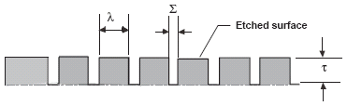
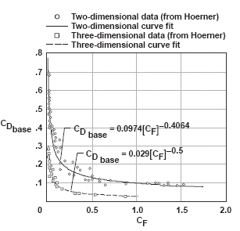
- (b)
Figure 2.17: (a) Graph of the Base Drag Coefficient to the Friction Coefficient published by Hoerner in 1965, (b) Side view of the micro-machined surface overlays used to ‘roughen’ the surface of the test model [17].

The model tested in the research by Whitmore et al. [17] was a cylinder at a wind tunnel velocity of 28m/s, which based on the length of the model resulted in a Re of 2.25 $×$ 10⁵. The cylinder had a semi-spherical front section and a flat rear section, as can be seen in Figure 2.18. The wind tunnel turbulence intensity levels were large enough such that the flow was turbulent upon reaching the leading edge of the model [17]. This would be the case for the high Re flow flowing over a space re-entry capsule travelling at very high velocity. The test measurements were performed by surface pressure probes in the model which allowed integration over the model to provide the drag forces [17]. In addition, the drag was measured by wake velocity profiles by using a traversing Pitot-Static probe [17].

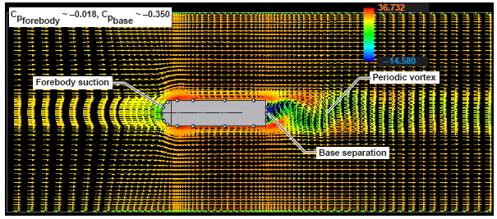
Figure 2.18: 2-D CFD simulation representative of a plan view of the wind tunnel test conditions [17].

The test model as can be seen in Figure 2.18, from a plan view, was approximately 100mm in length and 115mm in height [17]. Several different levels of surface roughness were tested by altering the Σ (spacing between bars), τ (bar height) and λ (bar width) parameters of the surface overlays in Figure 2.17(b). A maximum drag reduction through optimising the additional friction drag and reduced pressure drag was found to be approximately 15% [17]. When the drag reduction of 15% was scaled to a typical re-entry capsule, drag savings of 45,000N was found to be possible [17].

Therefore, while the aim of the research carried out by Whitmore et al. [17] was based around the idea of pressure drag reduction through surface modifications, there were several aspects in which this differed from the current research presented in this thesis. Firstly, the addition of the surface overlays and the mechanism by which the pressure drag would hopefully be reduced is different. As discussed earlier, the overall effect of the increased frictional drag and thicker boundary layer would provide a reduction in the shearing effect of the external free-stream flow on the separated flow behind the model. This is different to the proposed technique in the current research, where the dimples will directly create a turbulent boundary layer and add kinetic energy to the previously separated flow. Therefore, it could be said that this would have a more direct affect on the properties of the momentum of the boundary layer and its ability to overcome adverse pressure gradients. This is different to the cushioning effect of the thickness of the boundary layer with regards the external free-stream flow interacting with the separated wake region. In addition, the grooves that were tested by Whitmore et al. [17] were different to the dimple patterns tested in this research.

The presence of an object in front of another object can affect the drag produced by the latter. A passive control technique was developed by Igarashi and Terachi [18], through the placement of a small rod upstream of a flat plate which was perpendicular to the flow. The rod was positioned in various places and at various angles in front of the plate and the rod’s diameter was also altered. The maximum reduction of the drag coefficient achieved was approximately 25% compared to the drag without the rod in place. This technique achieved a drag reduction as the wake from the rod altered the pressure distribution around the plate [18]. Also it was found that as the Re increased, the amount of vortex shedding emanating from the control rod increased thereby leading to a larger delay of flow separation on the plate [18]. As it was due to this vortex shedding striking the plate which caused the drag reduction, a larger flow separation zone behind the rod lead to a more turbulent flow over the plate [18]. In addition to this it was found that the larger the control rod the larger the reduction in drag experienced by the plate as the size and intensity of the vortices reaching the plate increased [18]. Due to the drag mechanism being created by the separated flow from the rod which is unsteady by nature, the lift and drag forces experienced by the plate fluctuated over time and were time-averaged as a result [18].

Omni-directional reductions in drag were also achieved for a circular cylinder subjected to cross-flow by attaching cylindrical rings along its span [19]. The addition of the rings in the research by Nakamura and Igarashi [19] reduced the drag force by 18% even though the projected area of the cylinder increased, due to the addition of the rings. Also, due to the suppression of vortex shedding the fluctuating lift forces were reduced [19]. In addition, different diameter rings were tested with their span-wise width and their pitch varied. The optimum level of drag reduction was then found by altering these parameters. The cylinder had an aspect ratio of 20 and was positioned perpendicular to the flow. It was found that, in addition to altering the parameters of the rings, the level of drag reduction increased with an increase of the Re [19]. This effect is similar to that observed by Igarashi and Terachi [18], where an increase in the Re led to a reduction of flow separation. However, the largest Re that was tested in the research by Nakamura and Igarashi [19] was 38,000, which was quite low and indicated a very smooth laminar flow. If this flow were at a higher velocity such that the flow over the cylinder was turbulent with a high Re, the effectiveness of the rings may decrease due to the already higher kinetic energy flow type.

Experimental and numerical studies were carried out analysing the turbulent flow over dimpled surfaces. The research carried out by Lienhart et al. [20] in addition to the work of Whitmore et al. [17] are the closest of these passive techniques discussed, in relation to the research presented in this thesis. The shallow dimples tested by Lienhart et al. [20] were distributed regularly over the wall of a plane channel with a large aspect ratio. However, unlike the research presented in this thesis, the analysis by Lienhart et al. [20] was concerned with reducing frictional drag and not pressure drag. The effect of the shallow dimples on viscous drag was assessed by measuring the resulting pressure drop in the channel. In addition to the investigations on the internal flows, the external flow was also analysed and boundary-layer profiles were measured using a Pitot-tube rake [20]. This research follows on from the work carried out by Russian scientists ten years earlier, Alekseev et al. (according to [20]), who discovered that dimples may be useful for drag reduction. This former research found that the skin-friction drag of a turbulent flow over surfaces with a regular arrangement of shallow dimples caused a drag decrease of 20%. Following this work however, no clear explanation was given as to why the dimples caused this decrease in skin-friction drag [20].

In this more recent research by Lienhart et al. [20] two types of dimple patterns were tested. One pattern had a diameter of 15mm and depth of 0.75mm and the larger dimples had a diameter of 47mm and depth of 2mm. The smaller dimple pattern tested was a great deal larger in diameter than the dimples tested by Alekseev et al [20]. It was proposed by Alekseev et al. (according to [20]), that the dimpled surface reduced drag by an interaction of the boundary-layer flow in the wall vicinity and the outer flow. From the Computational Fluid Dynamics (CFD) simulations conducted in the research by Lienhart et al. [20], it was observed that inside the dimples the wall shear stress and therefore the velocity gradient decreased. At the front edge of the dimple this led to a very small re-circulation region and at the rear edge of the dimple large values of wall shear stress were observed. Therefore, it can be concluded that the dimples led to a modified pressure distribution compared to the case of a smooth surface. However, it was also found that there is a slight decrease in the average shear force and an increase in the pressure force which approximately cancelled each other out [20].

Therefore, from the CFD simulations carried out it was found that the dimples did not decrease the drag, but actually slightly increased it by approximately 2-4% depending on the dimple pattern and the simulation type conducted [20]. These numerical results were then verified by experimental results. Therefore, while the shear stress decreased slightly, there was a slightly larger increase in the pressure force which led to the slight increase in drag observed [20]. Even though the dimple patterns that were tested in the research presented in this thesis were much smaller than the ones tested by Lienhart et al. [20], it is generally acknowledged that they would lead to an increase in skin-friction drag. Therefore, it is expected that at low AOA the overall drag may increase as the viscous drag dominates due to very little if any flow separation occurring. However, it is hoped as the AOA increases and higher levels of flow separation and pressure drag are created, thus becoming far more dominant than the viscous drag, that the dimples will add kinetic energy to the previously separated flow in the boundary layer and decrease the overall drag.

Another drag reduction technique is through using what is known as drag reduction (DR) agents. These DR agents are typically high molecular mass polymers, such as polyisobutylene and polystyrene, and are used in applications such as: oil pipelines, fire fighting, transport of slurries, sewer systems, cooling systems, airplane tank filling and even in biomedical systems involving blood flow [21]. They are used at very low concentrations, 10 to 50ppm (parts per million), to accelerate the flow in various fluid flow scenarios which can result in a drag reduction of over 50% [21]. In fact at every major airport around the world DR agents are used in aircraft refuelling. Without the use of these agents, the refuelling would actually take approximately twice as long [21].

The visco-elasticity and altered rheology of the polymer solution, compared to the previous fluid, were identified as the characteristics that resulted in the drag reduction [21]. As the smallest turbulent eddies in the flow are much larger than the polymer molecules added themselves, the mechanism of drag reduction operates at the continuum level and not at spatial levels where a single polymer molecule could interact directly with a turbulent eddy [21]. However, a drawback of such DR agents is that they experience mechanical degradation in turbulent flow which reduces their ability to reduce drag, known as mechanical degradation in flow (MDF) [21]. Thus, these agents are more suited to laminar flow profiles and higher viscosity fluid flow, such as oil compared to water, as the MDF is higher for lower viscosity fluids.
The flow structure behind a NACA 0012 airfoil covered with a V-shaped micro-riblet film (known as MRF) was investigated experimentally by Lee and Jang [22]. These results were compared to a smooth airfoil of the same size. The chord length of the airfoils were 75mm and the tests were conducted up to a maximum Re of 51,400. Figure 2.19 illustrates the properties of the micro-riblet film tested by Lee and Jang [22], however a magnified illustration of the actual film tested. At a wind velocity of 3m/s the drag force on the MRF covered airfoil was approximately 6.6% lower than that of the smooth airfoil [22]. However, at 9m/s the MRF caused an increase of the drag force by approximately 9.8% [22]. Therefore, the film reduced the skin-friction drag at the lower flow velocity, however as the Re increased the riblets were found to increase the viscous drag. Again, this research by Lee and Jang [22] was focused on analysing the effect of surface modifications on viscous and not pressure drag.

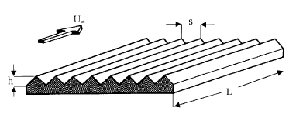
Figure 2.19: Diagram illustrating the MRF with their various size properties and orientation with respect to the airflow [22].

Ideal groove sizes depending on the nature of the flow were also investigated [22]. The parameters optimised included the spacing between the grooves and the height of the riblet tips for such V-shaped grooves [22]. An explanation for the drag reducing property of the riblets was that they restricted the span-wise movement of longitudinal vortices [22]. In other words the riblets dampen the cross-flow velocity fluctuations thereby reducing the momentum transfer and the shear stress. It is when the riblets were spaced close enough together they did not allow large stream-wise vortices to settle inside the riblet valleys [22]. It is this suppression of the near-wall vortex generation and the damping of the vortices that reduced the overall drag created by the object [22].

In this current research, this principle forms the basis for the possible drag reducing mechanism of the dimples. The dimples are essentially depressions as opposed to protrusions such as the riblets. The valleys of the grooves of the riblets are similar to the depressions of the dimples, so the drag reducing mechanism should be similar. However, the issue in relation to the current research is concerning the size of the dimples and whether they are too small to effectively suppress the near-wall vortex generation and the span-wise momentum transport of these vortices. For example the MRF tested by Lee and Jang [22] were of the scale of two hundred V-grooves over an area of 6cm by 6cm. The height of each groove was 176.8µm and the spacing between the groove tips was 300µm. Also, the width of the valley between the grooves was 50µm. Therefore, while these are groove patterns and obviously different to the dimple patterns tested in this research, their width of 300µm (0.3mm) was similar to the average diameter of the dimples in this research.

The airfoils were tested by Lee and Jang [22] at 0° AOA, so the drag reduction of the riblet film was achieved by reducing skin friction drag as opposed to pressure drag. It was found from these tests that the riblets were only effective at lower airflow velocities as they increased the drag as the Re increased. It was found that at a fixed flow speed, increasing the riblet spacing decreased the drag reduction effect of the riblet surface [22]. From the smoke flow visualisation carried out, an increased drag of the smooth airfoil was identified by the smoke filaments becoming thicker and also having a half loop shape due to active span-wise momentum transport [22]. Also, the increase of the drag force was seen to increase the size and amount of the vortices formed behind the airfoil. Also, these vortices were not located at the wake centre due to reduced vertical momentum transport [22]. For the MRF airfoil the case was opposite. Therefore, the MRF grooves caused strong vertical movement toward the wake centre-line and reduced the size of the vortex formation region [22]. However, with the MRF airfoil tested at higher speeds the riblet grooves acted as a surface roughness and stream-wise vortices interact with each other [22]. This in turn enhanced the turbulent kinetic energy and the Reynolds shear stress leading to an increasing drag force [22].

In the “protrusion height theory” developed by Bechert et al. [23], it was believed that the ideal design for riblets is such that they have y⁺ value of 3 to 5. The equation for calculating the y⁺ value was as follows [23]:

y⁺ = $\frac{y*μ_{t}}{v}$ Equation 2.12

Where: µ_{t} is the kinematic viscosity, y is the vertical height of the riblets and v is the velocity of the flow.

In general over the last couple of decades, plenty of research activity has been conducted on the use of riblets for viscous drag reduction. From results taken from wind tunnels and flight tests, they confirm the effectiveness of riblets from low to moderate supersonic speeds. Skin friction drag reduction in the range of 5-8% have been measured on airfoils at low AOA and in mild adverse pressure gradients [24]. In flight tests the riblet provided a reduction in drag as long as the local angle between the surface streamlines and riblet orientation is relatively small, in the order of <10º [24]. However, there is only limited data available on wing-body configurations that show that the total drag reduction of approximately 2-3% is likely [24]. In the context of commercial aircraft, depending on its size, skin friction drag accounts for about 40-50% of the total drag during cruise conditions [24]. Different shapes including: triangular, rectangular, trapezoidal, saw-tooth and scalloped cross-sections have been investigated experimentally. Initial studies commenced in the early 1980’s by Walsh at NASA Langley Research Centre (according to [24]). The research was devoted to optimising the riblet size and shape for a maximum drag reduction for a given flow scenario. Following these initial studies, other riblet shapes such as L-shaped riblets were analysed by Tang and Clark (according to [24]) and shark-skin shape riblets by Bechert et al. (according to [24]), leading onto the research previously discussed by Lee and Jang [22].

Riblets with symmetric v-grooves, height equal to spacing, with adhesive backed film manufactured by the 3M company in the USA, have been widely investigated [24]. Maximum viscous drag reduction in the range of 4-8% were measured [24]. Wallace et al. (according to [24]) showed that wall shear stress is increased near the groove peaks but appreciably reduced in the valley leading to a net drag reduction. A total drag reduction of a little less than 2% was reported by Szodruch (according to [24]), based on fuel consumption measurements in flight tests in the Mach number range of 0.77-0.79 on an Airbus A-320 aircraft, with a riblet coverage of about 70%. While a total drag reduction of 2% sounds small, this could in turn lead to huge savings in fuel costs over a year.

However, there are certain issues such as the cost of the riblet films, time and cost of installation, the need for maintenance and the performance degradation due to aging riblets and dirt build up. Also, a major consideration is the orientation of the riblets with respect to the airflow. This in many ways is different to the use of dimples, which may not have this orientation problem due to their similar profile in any direction.

An alternative passive control method is known as passive ventilation of the wake of bluff bodies. As the drag of bluff bodies is determined mainly by the pressure drag caused by flow separation as previously discussed, minimising the size of the wake generated is an important feature for the reduction of drag. Therefore, in this research by Grosche and Meier [25], the drag reduction was achieved by a bypass channel made by a central bore through the body. Figure 2.20 illustrates this duct through the spherical shaped test model. Typically a straight circular duct tested would have had a cross-sectional area of less than 3% of a bluff body cross-sectional area [25]. Essentially, this duct provides a flow through the body from the stagnation point at the front of the body to the near-wake region in the separated flow area at the rear [25].

Bypass flow has two main effects, firstly the addition of the vented air into the wake causes a pressure increase in the wake and this reduces the pressure differential between the front and rear of the body, thereby reducing the pressure drag [25]. The other effect is that the channel provides an addition of momentum from what is known as the “jet flow” [25]. As this jet flow is driven by the pressure difference it aligns the free shear layers of the wake to itself and draws them closer to the surface of the body [25]. As a result, this leads to a more streamlined shape of the external flow field which results in a lower pressure drag. From testing different shaped vents in spheres in a wind tunnel, Grosche and Meier [25] found that drag reductions of 50% were achieved for supercritical Re, with tests carried out to a maximum Re of 4.5 × 10⁶. However, for subcritical Re with laminar flow separation, the drag reduction was found to be not as great. This was explained to be the case as the bypass flow cannot compensate for the much larger separation area associated with laminar separation at low Re [25].

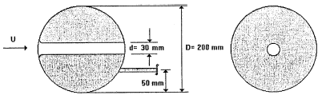
Figure 2.20: Diagram of the central bore used through the sphere in order to reduce the pressure drag caused by flow separation [25].
Therefore, one of the main disadvantages is that the size of the venting duct is very dependent on the Re of the flow. Also, when one considers the application of this technique to an airfoil, in theory its fundamental principal should also work. However, the main problem would be with the duct itself as it approaches the thinning trailing edge of the airfoil. Perhaps it could be practical if the duct was to be bored upwards from the leading edge stagnation point diagonally towards the upper surface of the airfoil near the trailing edge. It could then ventilate outwards and add momentum into the low pressure separated flow region at this point. However, its location would depend highly on the point and degree of flow separation.

It is also possible for researchers to look at nature for inspiration of new drag reduction ideas. Shark skin consists of a grain like surface, much like sand paper and studies have shown its ability for the reduction of drag. The degree of the surface roughness varies depending on the part of the shark’s body. Therefore, it can be said that through millions of years of evolution, this feature has developed to enable a shark along with its overall body shape to swim as efficiently as possible. Bionic non-smooth surfaces (BNSS) derived from this feature, were tested by Tian et al. [26], and were shown through CFD simulations to reduce the drag on bodies of revolution. This research leads on from the earlier work by Won et al. (according to [26]), who highlighted the ability of such a surface modification to reduce flow separation along surfaces in a channel. Also, leading edge tubercles which grow on the skin were found to delay the stall on humpback whales flippers by Miklosovic et al. (according to [26]). Speedo (according to [26]) also developed a swim suit that was worn by athletes in the Athens Olympics in 2004 with the same texture as shark skin. Through tests it was found to reduce the frictional force by 4% as the swimmer moves through the water (according to [26]).

A new type of electric wire for overhead transmission lines was developed to reduce the drag force under a typhoon weather condition. The unique configuration of the low drag wire was actually conceived in association with the dimples found on a golf ball by Eguchi et al. [27]. This new wire is cylindrical in shape like normal wires but contains 12 small semi-circular grooves that are spirally engraved on the surface. The drag reduction mechanism of what is in effect a roughened cylinder was caused by the turbulent transition promoted by the semi-circular spiral grooves [27]. From smoke flow photography tests it was found that free shear layer oscillations were occurring over the grooves at a lower frequency compared to the case of a smooth wire with separated flow [27]. In addition, inside the grooves a circulating vortex flow under this free shear layer was observed [27]. This free shear layer oscillation was explained as being self-induced and is known as a cavity tone phenomenon [27]. This theoretical model indicated that the instability of the free shear layer tended to increase as its thickness reduced or as the Re was increased [27].

2.3.2 Active Control

Several studies over the years have demonstrated the ability of plasma actuators to control airflow over airfoils for velocities up to approximately 30m/s. The plasma actuator consists of a dielectric barrier discharge actuator which is made of two metallic electrodes separated by a dielectric device [28]. The application of a sine AC high voltage between both of these electrodes generates a weakly ionized plasma discharge which in turn induces an electric wind [28]. This electric wind is placed parallel to the wall in the direction of the flow over the airfoil [28]. Therefore the actuator induces airflow reattachment or even complete elimination of flow separation, by adding momentum to the flow through the plasma discharge.

However, more recent research has shown that a 110m/s detached airflow can be reattached by the plasma actuation technique. All of the studies revealed that this control technique was most effective at the higher AOA and also when the actuation was located at the leading edge of the airfoil [28]. Previous research of this technique was unable to identify if the delay in flow separation was due to the momentum added by the plasma discharge itself, or due to the laminar to turbulent transition created by the discharge at the leading edge of the airfoil [28]. In a study by Jolibois et al. [28], a NACA 0015 airfoil was tested with this actuator and it showed the ability of the dielectric barrier plasma discharge technique to effectively control the flow around the airfoil (conducted at a Re of 400,000). The plasma discharge was able to fully reattach the flow for AOA up to 17º.

Similar to the work by Jolibois et al. [28], is the use of an electro-hydrodynamic (EHD) actuator. These actuators produce ionisation of the flowing air and add localised momentum to the flow through a collision process of the migrating charged particles with the neutral particles present in the flow field [29]. In between these electrodes across the span of the airfoil a homogenous luminescence can be seen were the surface is covered by a thin film of ionised air [29]. This ionised film of air is produced by a DC potential difference between the electrodes. In the research carried out by Sosa and Artana [29], the effect of the EHD actuator on the aerodynamic performance of a NACA 0015 airfoil was analysed. The testing was carried out at a Re ≤ 50,000 and a maximum flow velocity of 5m/s [29]. The airfoil tested had a chord of 200mm and a span of 450mm [29]. From this it was found from surface pressure readings that previously separated flow remained attached with the activation of the EHD actuator. Smoke flow visualisations were also carried out to validate the surface pressure distribution measurements.

The experiments indicated that for low Re numbers, the effects of the actuation of the plasma sheet depended on the power supplied to the actuator [29]. It also depended on the relative distance between the actuator and the flow separation point. Also, the power consumption of the actuator increased greatly as it moved away from the separation point which, depending on the airfoil geometry and flow conditions, may be more beneficial in terms of reducing flow separation. These aspects were also true for the plasma actuator developed by Jolibois et al. [28]. Therefore, a disadvantage of this technology that must be factored into any application is the power consumption of the actuator. In other words, would the high levels of power that may be required be justified by a relatively large reduction in drag. Another disadvantage is that in the case of a laminar boundary layer separation, with a laminar separation bubble being formed and reattachment in the form of a turbulent boundary layer, these actuators are quite ineffective at reducing drag [29]. However, the advantages of the actuators are that they have no moving parts with a very short response time and a relatively good efficiency of power to energy conversion [29].

Various forms of vortex generators have been tested over the years to control flow separation and this technique was previously discussed in the passive drag reduction category. However, recently vortex generators have been tested in an active control sense. In 1998, Osborn et al. [30] tested what is known as a high-frequency deployable micro vortex generator system (or HiM-VG) experimentally. This system produced an oscillatory flow field at frequencies ranging from 30 to 70Hz and it was found to be very effective in reducing flow separation on the upper surface of a deflected flap [30].

Following on from this research, in 2008 Shan et al. [31] carried out similar research testing both an active and a passive vortex generator. However, in this case the frequency of the sinusoidal forcing of the active generator was chosen close to the natural frequency of separation. In this research, the subsonic flow over a NACA 0012 airfoil subject to a 6º AOA was analysed [31]. To start with, the introduction of the passive vortex generator was found not to alter the frequency of separation, however it did partially eliminate it and reattached the majority of the separated shear layer to the airfoil. The size of the separation zone prior to testing the passive vortex generator was reduced by more than 80% [31]. On the other hand, the flow control with the active vortex generator was found to be even more effective with the separation zone disappearing completely.

However, a problem with this research was that the AOA analysed was relatively small. Therefore, the flow separation control did not produce a significant reduction in the drag force due to the low level of resulting flow separation. It would have been more beneficial to investigate the effects of both the active and passive vortex generator at higher AOA, where more flow separation would have been evident, leading to a relatively higher amount of possible drag reduction. Also, compared to the previous work of Osborn et al. [30], this research was focused on a numerical investigation as opposed to an experimental analysis. Therefore, this research may have its own uncertainties as it was not validated against any experimental work.

Another type of active flow separation control is the use of the rotational movement of a component connected to the object in question. In the research by Beaudoin et al. [32], an actuator was used to control the rotational velocity of a cylinder on a geometry representing a backward-facing step at a Re of 20,000. The cylinder was located at the edge of this step and was found to effectively control the flow separation. The process by which this works is based on if a cylinder rotates it will inject air particles at a high velocity into the region where flow separation is occurring. Therefore, the tangential velocity of the cylinder is known as the ‘injection velocity’, as it is the velocity at which the particles are shot into the region in question [32]. Generating such a transverse force through the rotation of a part is referred to as the Magnus effect after the discoverer of this effect [32]. Through flow visualization, it was found that the size of the low pressure region behind the body decreased and therefore a reduction in drag was achieved [32]. The diameter of the cylinder was 10mm and the rotational frequency could reach 250Hz, which corresponds to a tangential velocity of approximately 7.5m/s [32]. Figure 2.21 shows two images, (a) the device without the cylinder rotating and (b) with the cylinder at a rotational frequency of 250Hz.

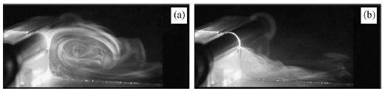
Figure 2.21: In these two images the free-stream velocity was 2m/s with (a) representing no rotation of the cylinder, and (b) representing the cylinder rotating at a frequency of 250Hz or 15,000rpm [32].

It was also found that the faster the rotation of the cylinder, the lower the drag force [32]. This is logical as the faster the rotation, the higher the velocity of air molecules travelling from the cylinder into the region of flow separation. The idea of using a rotating cylinder in this research originated from the idea of a “moving wall” to reduce relative velocities at flow boundaries [32]. This original research goes back to the work of Modi et al., in 1991, and up to more recent work by Patnaik and Wei in 2002, leading to this research by Beaudoin et al., in 2006, according to [32].

A large-eddy simulation (LES) of turbulent flow separation by You and Moin [33] over a NACA 0015 airfoil was carried out to highlight the effectiveness of jets as a separation control technique. This analysis was conducted at a Re of 896,000 and there was a small slot applied across the entire span from which the jets blew/sucked in air from a cavity inside the airfoil. The simulation results were compared to the 2005 experimental data of Gilarranz et al. In both of these works, the jet actuation effectively delays the onset of flow separation and causes an increase in the lift coefficient of 70% (according to [33]). The idea of using suction to control flow separation goes all the way back to one year after the first powered flight, where Prandlt developed the concept of the boundary layer a proposed the suction technique.

The application of jets to control flow separation was based on their ability to add momentum to the boundary layer as with many other active and passive techniques discussed so far. The jets in this case provide an addition of vertical structures to the boundary layer, which in turn increase its momentum and delays the point of flow separation [33]. The additional vertical structures also promoted boundary layer mixing and as a result momentum was exchanged between the boundary layer and the free-stream flow [33]. In the suction technique, the low momentum flow in the boundary layer was removed by the suction and this prevented downstream flow separation [33]. On the other hand, the technique of blowing air tangentially into the boundary layer increases the kinetic energy of the flow, and this also prevented downstream flow separation [33]. The advantage of this active method was that in comparison to passive and active vortex generators, this did not introduce a drag penalty when the flow was attached. It must be noted though that there are many variables used to control such a jet. These variables include parameters such as: the amplitude, frequency and location of the actuation, much like the issues with the plasma and EHD actuators previously highlighted [33].

Thus, this concludes the discussion on passive and active flow separation control techniques recently developed. Firstly, a quick summary of the main findings of the active technology research will be given. While many of these techniques can be very effective in delaying or even eliminating flow separation in particular scenarios, most of the techniques share similar disadvantages. The addition of the respective components required in most active techniques will thus add weight to a wing section in which they are installed. Also, the addition of this equipment may have implications to the overall wing design. This is so as it may reduce the storage capacity of the fuel in the wing as the equipment will occupy a portion of the internal structure of the wing. This is also in addition to the fact that the wing profile may have to be altered, which may in turn add a drag penalty itself or a small loss in the lift coefficient. There is also the aspect of the electrical power required to operate this equipment and this may affect the overall fuel consumption of an aircraft. Also, there may be serious safety concerns regarding the installation of such electrical equipment in the wing section of a commercial airliner. Therefore, these aspects plus the issues concerning device location with respect to the changing flow scenarios and the levels of power supply required, must be compared to the advantages of improved aerodynamic efficiency that a particular technique may offer.

However, the discussion on passive methods would be more applicable to this research. While dimpled surfaces have been tested, there exists very little research in relation to two aspects. Firstly, any research conducted into the use of dimples appears to be concerned with the reduction of skin friction drag, such as that by Lienhart et al. [20], as opposed to reducing the pressure drag caused by flow separation. Secondly, this aspect is particularly true in relation to airfoil research, where the aim would be to reduce flow separation through the addition of dimples to the surface. While Whitmore et al. [17] tested groove patterns and their effect on pressure drag reduction, the mechanism by which they were explained to work and the surface modification type itself is of course different to the current research. Therefore, from reviewing recent research critically and thoroughly, this validates the novelty of the work presented in this thesis.

2.4 Recent Numerical Developments of Drag Calculation

During recent years, the process of evaluating an aerodynamic design has progressed greatly due to rapid developments in computational simulation software. Through the use of CFD, analysing designs is starting to supersede experimental techniques in terms of time required and accuracy. The following section will briefly present recent numerical developments in drag calculation, which have lead to more complex equations that require the use of such software in order to be utilised. While the research discussed in this thesis is based around experimental testing methods only, it is the presentation of such equations compared to the empirical drag equation described in Section 2.1.3, that illustrates the knowledge base gained from this Literature Review chapter. Therefore, the equation developed by van Dam [34] will be highlighted, which follows on from developments by other researchers over the last few decades before CFD software was as sophisticated as it is now. In Appendix A, a thorough explanation of how this equation was derived is presented. However, Equation 2.13 that was developed by van Dam [34], is used for drag prediction in the Reynolds-Averaged Navier-Stokes solver model in CFD software.

D = $\frac{p_{∞}}{R}$ ∫∫ Δs dS_{Exit} + $\frac{ρ_{∞}}{2}$ ∫∫ (ψξ) dS_{Exit} Equation 2.13

Where: the first integral represents the sum of the viscous and wave drag forces (Δs), the second integral represents the induced drag component, Ψ is known as the cross-flow stream function, ξ is the stream-wise trailing vorticity and R is the gas constant [34].

Equation 2.13 developed by van Dam [34] in 1999 was based on the works, in chronological order, by: Maskell (1973), Wu et al., Weston, van der Vooren and Slooff, Nikfetrat and van Dam, Brune, van Dam et al., Janus and Chatterjee, Cummings et al. and Kusunose (1998), according to [34].

2.5 Alternative Drag & Lift Force Measurement Techniques

For the experimental testing conducted in this research two separate external strain gauge balances (referred to as Systems 1 and 2) were used to measure the aerodynamic forces. In Sections 2.6 and 2.7, a discussion will be presented on strain gauge theory and an introduction to strain gauge balances, respectively. However, this section will briefly highlight some of the other main techniques used for the measurement of lift and drag forces in wind tunnel testing.

It is possible to relate the degree of energy loss from the free-stream inside the wake to the drag force imposed by the air on a test model [10]. By integrating the velocities in the wake across several points it is possible to equate this energy loss from the free-stream into the total drag force acting on an airfoil, for example [10]. This follows on from theory previously covered with regards to wake formation and vortex shedding, where the drag force is created by an energy loss through the formation of a wake. This technique is known as the integral momentum method and a Pitot-Static tube is used to measure the pressures at various points in the wake. From using Bernoulli’s Equation, it is possible to calculate the velocity at a point in the wake (U) and therefore the velocity deficit in the wake (U₁) can be written as [10]:

U₁ = U∞ - U Equation 2.14

Where U∞ is the free-stream velocity. As one moves away from the centre of the wake, U converges to U∞. The total drag (D) can then be found by considering the conservation of momentum theory in a control surface representing a vertical plane with respect to the free-stream flow [10]:

D = hρ $\int_{-∞}^{+∞}{U}$(U∞ -$U$) dy Equation 2.15

Where h is the frontal height of the airfoil. If Equation 2.14 is re-arranged for U (where U = U∞ - U₁) and substituted into Equation 2.15, the resulting equation is found [10]:

D = hρ $\int_{-∞}^{+∞}{U_{1}}$(U∞ -$U_{1}$) dy Equation 2.16

Therefore, the velocity deficit (U₁) is integrated across various points in a vertical plane (dy), which leads to the calculation of drag [10]. Generally the greater the velocity deficit in the wake and therefore the greater the energy loss, the larger the drag force. As mentioned in Section 2.2.5, it is possible to calculate the induced drag from a set of equations and the profile (pressure and viscous) drag can then be found by subtracting the calculated induced drag from the total drag found from the integral momentum method [15]. The probe used in this process is usually placed a particular distance behind the trailing edge in terms of the chord length of the airfoil (or length of the particular object being tested). However, this location varies depending on the model being tested, the airflow conditions and most importantly the amount of flow separation and therefore size of wake present [10]. In addition, by recording the fluctuating velocities of the flow in the wake over a period of time, it is possible to analyse the power spectrum of the recorded signal through the use of Fast Fourier Transform (FFT) functions [10]. Therefore, the frequency of the peaks identified in the power spectrum can be correlated as the vortex shedding frequency [10]. The frequency of the vortex shedding can reveal a good deal of information regarding the nature of the flow separation and the effect of any drag reduction technique being tested.

Another method of calculating drag and lift forces is through the use of pressure readings along various points on the test model itself. It is possible to install a number of pressure ports inside the test model and these can record the pressure differential between the upper and lower surfaces of an airfoil for example. Therefore, a decrease in pressure at particular pressure ports would be indicative of a region of flow separation [10]. It is also possible to integrate the pressure readings across both the upper and lower surfaces of the airfoil and calculate the lift force [10]. In addition to the previous methods of measuring aerodynamic forces in wind tunnel testing, it is possible to determine the velocity of the flow at a point by a technique known as ‘Hot-Wire Anemometry’. This involves the measurement of velocity with the use of a thin wire positioned perpendicular to the flow. Therefore, this technique can be used to measure the free-stream velocity in a test section, the velocity deficit in the wake of a test object and the free-stream turbulence intensity level [35]. Figure 2.22 illustrates the size of the measuring element of a typical hot-wire anemometer.

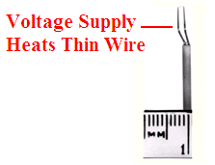
Figure 2.22: Picture illustrating the typical size of the measuring element of a hot-wire anemometer [36].

The wire is heated by a supply voltage and the anemometer maintains it at a constant temperature. However, as airflow moves over the wire it will cool down as a result. Therefore, in order for the anemometer to maintain the wire at a constant temperature, the voltage supply must increase to compensate for the heat loss of the wire. Through measuring the increase in voltage as a result of the heat loss from the wire, this can be related to the velocity of the fluid. This is possible to calculate through the use of King’s Law. This equation relates the voltage applied to the wire (V) and the velocity of the airflow (U) [10]:

V² = V₀² + B''$\sqrt{U}$ Equation 2.17

Where: V₀ is the voltage across the element under zero flow conditions and B'' is a constant determined form the calibration process of the anemometer.

Therefore, the rate of the heat loss to the fluid is equal to the electrical power supplied to the element (V²/R), where V is the voltage drop across it and R is its resistance [10]. Usually in place of the V₀² term in Equation 2.17 is a constant known as A'', which takes into account any conductive heat losses from the wire to the wire supports as air flows over it [10]. However, unless very high accuracy is required, this constant can be place by the V₀² term. Also, the $\sqrt{U}$ term which can also be written as U^{0.5} has been found through experimental testing to be closer to U^{0.45} [10]. This is so as the value of this exponent changes varying on the device itself and also with respect to the velocity of the airflow over the element. Therefore, as no universal calibration is available each anemometer must be calibrated for best results, thus allowing the determination of the constant B''. However, if care is taken during usage and if calibrations are performed at frequent intervals, an accuracy of better than 1% can even be achieved for the measurement of flow in turbo-machinery [10].

2.6 Strain Gauge Theory

If a metal wire is stretched, it will become slightly thinner and longer and this results in an increase in its electrical resistance. This is so as the smaller the cross-section of a metal wire, the higher its electrical resistance. On the other hand, if the wire is placed under a compressive force, it will become slightly thicker and will shorten. This will of course lead to a decrease in its electrical resistance. If the stresses exerted on the wire are kept within the elastic limit of the material, it can be used as a measuring element for a physical force [37]. This is possible as the amount of applied force can be calculated from measuring the change in resistance of the metal wire. This principle forms the fundamental operation of a strain gauge. A strain gauge is essentially comprised of a very thin metallic wire arranged in a grid formation [37]. The strain gauge is fixated to the object being tested. Therefore, when the object experiences a force, the surface onto which the strain gauge is adhered to will deform slightly, as will the gauge. When an excitation voltage is applied across both ends of the wire, known as the strain gauge terminals, any change in the resistance of the wire due to an applied force can be measured. An overview of a strain gauge is illustrated in Figure 2.23.

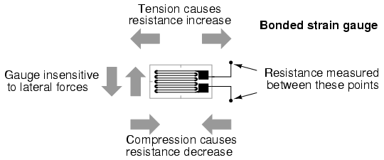
Figure 2.23: Diagram illustrating the change in resistance due to an applied force [38].

These very thin strips of metallic foil, typically about 0.025mm in diameter, are deposited onto a non-conductive substrate material known as the carrier [37]. It is the back of this carrier that is fixated to the surface being tested with the use of a special adhesive. The term ‘bonded gauge’ is given to such a strain gauge and the object being tested is usually known as the ‘test specimen’. Therefore, as the test specimen experiences a strain, this will in turn cause the metallic strips on the strain gauge to either stretch or compress, depending on the nature of the force applied. By measuring the corresponding very small change in the output voltage signal due to the very small change in resistance, it is possible to equate this to a force [37]. This would be possible from a calibration procedure which would be conducted before the experimental testing begins. To create an electrical circuit, the strain gauge is wired to other resistors which forms what is as known as a Wheatstone bridge circuit. There are various forms of such a circuit, with the Kelvin bridge circuit being another [37]. The Wheatstone bridge type will be used in this research.

There are essentially three main variations of a Wheatstone bridge circuit: a quarter bridge, half bridge and a full bridge circuit. The difference between the three circuits is the amount of strain gauges used in the place of the resistors. A quarter bridge has one gauge with three resistors, a half bridge has two gauges and two resistors and a full bridge has four active gauges in the place of the resistors that comprise the circuit. As full bridge circuits were used in the measurement of the lift and drag forces in the experimental testing, this format of circuit will be discussed. In addition, this configuration of circuit has advantages over the other two, such as improved sensitivity and linearity as discussed below.

Therefore, in Figure 2.24 an example of a full bridge strain gauge circuit can be seen. The four resistors (R₁, R₂, R₃ and R₄) are replaced by strain gauges, which in this example are mounted on a beam which is experiencing a bending strain. In this scenario a force is being applied at one end of the beam and it is constrained in all degrees of freedom at the other end. Therefore, the upper surface of the beam would be in tension due to the nature of the applied force and the bottom surface would be in compression. In this set-up where a full bridge circuit can be utilised to measure the bending strain of the beam, it would be necessary to mount two gauges on the upper surface and two on the bottom surface. Following this, R₁ and R₄ in the circuit will be in tension, leading to an increase in resistance from before. The opposite is the case for R₂ and R₃ mounted on the bottom surface.

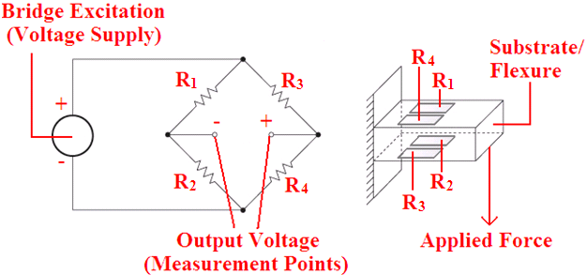
Figure 2.24: Illustration of a full-bridge circuit and an example of how it can be used in order to measure bending strain, adapted from [39].

Therefore from the circuit diagram on the left of Figure 2.24 it can be seen that its bottom half (R₂ and R₄) will contain gauges experiencing opposite strains. The same is true for R₁ and R₃ on the top half of the circuit, which all together will cause the bridge to be unbalanced by the applied force through the changes in resistances of the gauges. The result of this allows for a measureable output voltage. This requires a precision voltmeter located at the centre of the bridge, which provides an accurate measurement of this imbalance [40]. The beam in Figure 2.24 is known as the ‘substrate’ onto which the gauges are fixated through a special adhesion process.

When there is no force applied to the beam (Figure 2.24), the four strain gauges will have equal resistance and therefore no voltage output will be detected from the circuit. The bridge circuit will be balanced as a result and this leads to the following equation with respect to the four strain gauges as in Figure 2.24 [40]:

= Equation 2.18

In Equation 2.18, R represents the nominal (un-deformed) resistance of the gauges as no force has been applied. Therefore, when a force is applied to the substrate, the strain gauge resistances will change and this will unbalance the bridge circuit [40]. The resulting non-zero output voltage is described by the following equation [40]:

V_{OUT} = V_{EX} ( - ) Equation 2.19

Where: V_{OUT} is the output voltage and V_{EX} is the input (excitation) voltage.

In Equation 2.19, the values of the four gauges will have changed slightly from their nominal resistance value as in Equation 2.18, due to the applied force. Therefore, if the bracket terms are multiplied out in Equation 2.19, the following equation is obtained [40]:

V_{OUT} = V_{EX} $\left(\frac{R_{1}R_{4}- R_{2}R_{3}}{\left(R_{1}+ R_{2}\right)(R_{3}+ R_{4})}\right)$ Equation 2.20

In Figure 2.24, the four gauges will either experience tension or compression effects. Therefore the four gauges will be subject to the following resistance value changes [40]:

R₁ and R₄ = R + ΔR (tension) Equation 2.21

R₂ and R₃ = R - ΔR (compression) Equation 2.22

Where: R is the unstrained nominal resistance value and ΔR is the change in resistance (increase/decrease) of the strain gauge.

Therefore, if Equations 2.21 and 2.22 are substituted into Equation 2.20 and it is multiplied out and tidied up, the following equation is obtained [40]:

V_{OUT} = V_{EX} $\left(\frac{ΔR}{R}\right)$ Equation 2.23

Each strain gauge has a property known as the gauge factor (k), which varies depending on the type of gauge. The gauge factor relates its change in resistance (ΔR) to its change in length (ΔL). The gauge factor is constant regardless of strain for a given strain gauge and can be expressed as follows [37]:

Gauge Factor = k = $\frac{(ΔR/R)}{(ΔL/L)}$= $\frac{(ΔR/R)}{ε}$ Equation 2.24

Following on from Equation 2.24, it is possible to re-arrange for strain:

Strain exerted on gauge = ε = $\frac{(ΔR/R)}{k}$ Equation 2.25

In relation to Equation 2.23, as the relationship of $(ΔR/R$) is equal to (V_{OUT}/V_{EX}), it is also possible to define strain as:

Strain exerted on gauge = ε = $\frac{(V_{OUT}/V_{EX})}{k}$ Equation 2.26

This therefore leads to the well known expression which relates the excitation voltage, gauge factor and strain to the output voltage [40]:

V_{OUT} = V_{EX} × k × ε Equation 2.27

One problem with strain gauge measurement is due to a difference in the thermal conductivity of the strain gauge foil grid in relation to that of the substrate. This can lead to what is known as a thermally-induced strain, as both elements expand and contract differently with respect to temperature changes. Temperature changes can arise from a change in the ambient temperature surrounding the test set-up or from the heating/cooling of the gauge itself based on changes of the V_{EX}. If the substrate material and the resistive element of the strain gauge have linear expansion coefficients of β_{S} and β_{G} respectively, then the gauge bonded to the substrate experiences a thermally induced strain (Σ_{T}) per 1ºC defined as [40]:

Σ_{T} = $\frac{α}{k}$ + (β_{S} - β_{G}) Equation 2.28

Where: α is the resistive temperature coefficient of the gauge foil.
However, strain gauge manufacturers produce what are known as self-temperature compensated gauges. The foil grid in these gauges have their linear expansion coefficients matched to a particular substrate material such as aluminium or mild steel for example. However, as mentioned earlier an advantage of a full bridge circuit is that it provides temperature compensation. This aspect eliminates errors which arise from temperature variations between the foil grid and the substrate.

2.7 Internal and External Strain Gauge Balances

A strain gauge balance is effectively a device which has surfaces machined on it in order to be sensitive to a particular applied load [41]. Strain gauges are in turn mounted onto these surfaces so that when a slight deformation is created in this surface from a particular aerodynamic load, this is converted into a measurable strain [41]. This is possible because as the strain gauge deforms slightly, along with the surface onto which it is mounted, its foils will be slightly stretched or compressed. This leads to a change in the cross-sectional area of the foils which in turn causes their resistance value to change slightly.

The measureable strain output is usually read by some type of Digital Strain Indicator (DSI). For more complex output signals that are changing rapidly over time, it is possible to record these signals by what is known as a Data Acquisition System (DAQ). This allows for the output signals to be time-averaged and the resulting aerodynamic force can be calculated as a result. This would be possible from the calibration process which is conducted with the balance prior to testing. Therefore, the output can be converted to a particular force or moment through pre-defined equations [41]. There are two main types of balances that are currently used in wind tunnel test measurement: internal and external balances. Internal balances are inserted directly into the test model in the wind tunnel as can be seen in Figure 2.25(b). The balance is inserted typically into the aft position of the test model and the balance and test model are supported by a streamline strut [41].

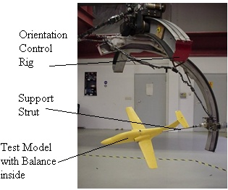
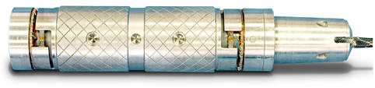

(a) (b)
Figure 2.25: (a) A close-up picture of an internal balance [42], (b) this shows the overall set-up [43].

An internal type of balance is also known as a sting balance [41]. This type of balance is usually constructed from one solid piece of high strength aluminium [41]. This can lead to particular advantages which will be covered later. The balance in Figure 2.25(a) has internal parts that will be sensitive to a particular force generated in the wind tunnel and strain gauges are mounted to these surfaces. Figure 2.26 illustrates the set-up of an external balance. External balances are used in situations where internal balances are not practical for various reasons. The external balance itself is located outside of the wind tunnel, as opposed to being inside the test model as in the case of the internal balance. The aerodynamic loads are transmitted from the test model through support strut(s) to the balance. The type of external balance in Figure 2.26 is known as a pyramidal balance due to its design configuration which isolates the forces and moments being measured [35].

Therefore, it can be seen that the test model is supported by a strut, as with the internal balance set-up, however the actual balance is located underneath the wind tunnel. This is the usual configuration for the external balance type, however other configurations are possible and these may be more effective for particular test conditions. The strut in this case transmits the loads generated from the test model to the balance, which in turn measures the desired forces and/or moments.

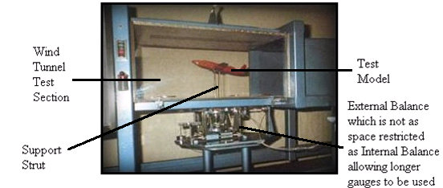
Figure 2.26: Set-up of an external balance [44].

There are particular advantages and disadvantages with each set-up and careful consideration must be given when deciding which set-up would be most suitable, according to the nature of the testing. As can be seen in Figure 2.26, as the space was not restricted as it would be in the case of an internal balance fitting into a test model, longer strain gauges can be used. This allows for a more sensitive measurement set-up and also the possible large amount of wiring is easier dealt with, compared to the case of an internal balance. However, with an internal balance, this set-up allows for the balance to be directly in line with the forces generated by the test model. On the other hand, external balances can be located a distance away. This is perhaps the greatest advantage of the internal design.

An external balance usually needs to be designed to be capable of separating the various aerodynamic forces/moments that are transmitted through the strut(s) in order to read one particular force or moment [35]. As there are potentially three aerodynamic forces and three aerodynamic moments acting on a model, this can prove to be a difficult task. However, on the other hand, an internal balance may be intrusive to the airflow around the model. This is particularly true for small test models, where an internal balance may lead to inaccuracies in results. Also, some test models may not suit this set-up such as airfoils, as the insertion of the balance into the rear of the airfoil would not be feasible. The main two advantages of external balances are its great resolving power and its ability to hold its calibration over very long periods of time [35]. As mentioned, one main disadvantage is the time and effort required to align or reduce the interactions between the six force/moment components. However, it is possible to calibrate the interactions and not align the balance through what is known as an interaction matrix method [35].

Therefore, this is the conclusion of Chapter 2 which was the literature review. In this chapter there were seven main parts: ‘Aerodynamics’, ‘Fluid Mechanics’, ‘Recent Research into New Drag Reduction Techniques’, ‘Recent Numerical Developments of Drag Calculation’, ‘Alternative Drag and Lift Force Measurement Techniques’, ‘Strain Gauge Theory’ and ‘Internal and External Strain Gauge Balances’. In addition, the last two sections of this chapter which covered theory on strain gauge circuits and introduced the balance devices in which they are installed, leads into the start of Chapter 3 (Experimental Equipment and Procedures). A detailed discussion on the design of the two strain gauge balances that were used in this research (Systems 1 and 2), along with all of the other aspects of the experimental testing, will be given in Chapter 3.

Chapter 3 – Experimental Equipment and Procedures

To start with a brief introduction will be given in order to explain the research methodology and the resulting layout of this chapter. The overall research was split into two separate parts and these are referred to as ‘Phase 1’ and ‘Phase 2’. Correspondingly during each phase there was a separate strain gauge balance and instrumentation set-up designed and used to measure the lift and drag forces. These were referred to as ‘System 1’ and ‘System 2’ respectively. The reason as to why System 2 was designed was in order to correct the measurement errors and to improve the performance of System 1. Therefore, Figure 3.1 illustrates a flow-chart of the overall research and it can be seen that System 2 was designed following on from the results obtained with System 1. The airfoil test models used in conjunction with the dimple patterns applied to them, with the two variables of location and degree (surface roughness), were central to both phases of the research.

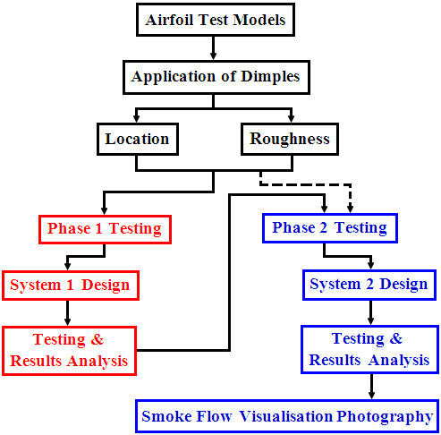
Figure 3.1: Flow-chart illustrating the various components of the overall research.

3.1 Airfoil Profiles Tested

There are hundreds of different wing profiles designed to date, so it was necessary to choose wing profiles that have well known aerodynamic properties. It was decided to use the NACA 4-digit series as their properties are well known. This NACA series of wing profiles have been used commercially for many years as aircraft wings/flaps, helicopter rotor blades and turbine blades to mention but a few applications.

For Phase 1 of the research (Figure 3.1 Red Zone) the following profiles were tested: a thin symmetric profile (NACA 0006), a thick symmetric profile (NACA 0024) and a thick cambered profile (NACA 4424). For Phase 2 (Figure 3.1 Blue Zone) it was decided that it was better to test the two symmetric profiles only, as this allowed a wider range of surface modifications to be tested. This enabled an evaluation of the dimple effect to reduce drag on wing sections that have different thickness values which, as discussed in the last chapter, affects the way in which the flow separation develops. In addition, from the Phase 1 testing, the two symmetric profiles showed more promising results as opposed to the cambered NACA 4424 profile.

Figure 3.2 shows a CAD drawing of the three separate profiles. As a result of the manufacturing process, the chord lengths and spans varied slightly between the airfoils. However, Figure 3.2 illustrates the maximum cross-section dimensions in millimetres of the models tested, with the span having a maximum value of 210mm.

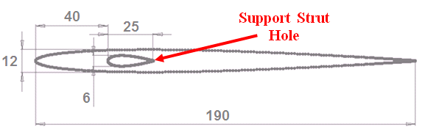
(a)
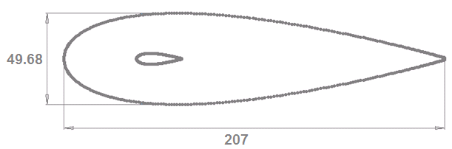
(b)
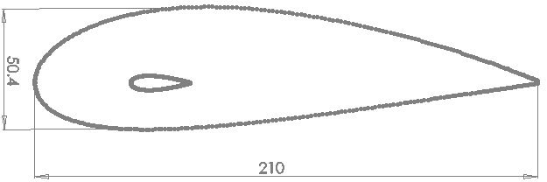

(c)
Figure 3.2: (a) CAD drawing illustrating the maximum cross-sectional dimensions of the NACA 0006 test models, (b) the corresponding dimensions for the NACA 0024 profile, (c) the corresponding dimensions for the NACA 4424 profile (units in mm).

A point to note is that the maximum 12mm thickness of the NACA 0006 airfoils would have equated to a chord length of 200mm. However, 10mm was trimmed off the original length as the airfoils were very fragile at their trailing edge and it would have been difficult to add dimple modifications without causing damage at this location. The location of the maximum thickness as indicated in Figure 3.2 occurred at approximately 30% of the chord length (0.3c), in from the leading edge [6]. The support strut hole was located at the aerodynamic centre of the airfoils (0.25c), as it was at this point where the drag and lift forces appeared to act through. The test models (8 of each profile initially produced at the start of the research), were cut to the required dimensions from high density polystyrene using an automated hot-wire cutting machine, by a CNC-milling company called ‘Made In Hollywood’ located in Dundalk, Co. Louth. This was so as this company specialised in manufacturing products from polystyrene foams and this allowed for a quick and very accurate production of the required test models. The polystyrene material was chosen as it was lightweight and the surfaces of the airfoils could be easily modified, with regards to adding the dimples through a sand blasting technique. However, when the support strut holes were cut through the airfoils the hot-wire cutter had to pass through one of the airfoil surfaces, which created a slot in the airfoils. It was deemed that the best position for this to occur was at the leading edge of the airfoil. Even though a filler material was later used to seal the slots, if this was located on the upper or lower surfaces of the airfoil it might have interfered with the modification process.

Therefore, following the manufacture and delivery of the airfoils, it was necessary to carry out additional work on each airfoil in order for them to be fully ready for testing. To start with the area around the slot was masked so that no damage would have been incurred to the surrounding parts of the airfoil, as can be seen in Figure 3.3(a). In order to seal the slot a ready-mixed polyfiller was used that provided a strong seal when set and it was also sand-able. When this filler material set, it was then sanded with fine grade sand paper to provide a smooth finish, as shown in Figure 3.3(b).

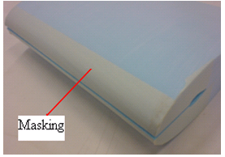
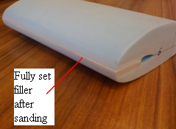

(a) (b)
Figure 3.3: (a) This photograph shows the slot after being masked, (b) the airfoil with the filler set and sanded.

In addition, as a result of the cutting process, the surfaces of the airfoils were slightly rough and a smoother finish was desired before they could be used as test models. Therefore, each airfoil was sanded initially with a medium P320 grade sand paper, and then finished with a very fine P600 grade. In Figure 3.4, a comparison can be seen between a fully prepared test model and an airfoil before any of this preparation work. It can be observed that a finished model was lighter in colour and this was as a result of the sanding process.

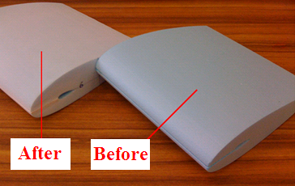
Figure 3.4: A comparison between a finished airfoil ready to be tested on the left and an airfoil before any preparation work on the right.

3.2 Airfoil Surface Modification Process

3.2.1 Application of Dimples

A sand blasting rig was used to create the dimples on the surfaces of the airfoils tested. There were two main aspects identified regarding the application of the dimples to the airfoils: their degree and their location. By degree, this signified what level of surface roughness the dimples created. It was possible to alter this parameter by changing the pressure of the sand blasting rig and/or the duration of the process. Several different degrees were achieved, but the two main ones tested were a high and a low roughness dimple effect. This was characterised by the average roughness value (Ra) and this aspect is discussed in the next section, with calculations presented in Chapter 4. The other factor was the location of the dimples. This was whether they were applied to both the top and bottom surfaces of an airfoil, or to different sections on the low pressure side of an airfoil only where flow separation may specifically have been occurring. For the application of the dimples to different sections on the low pressure (flow separation) side, locations such as the front, middle and rear were chosen. These different sections that were dimpled can be seen in Figure 3.5(a). The order in which the testing was carried out was planned to allow the maximum usage of each test model. The sections surrounding the area to be dimpled were masked with strong insulation tape, so that no damage from the sand blasting process was caused to other areas that were to be left smooth. Figure 3.5(b) shows a resulting modification after the tape was removed.

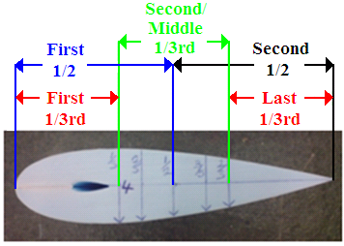
(a)
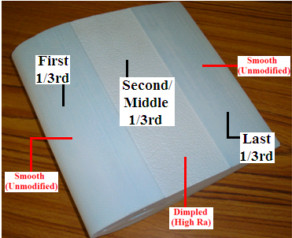
(b)
Figure 3.5: (a) Different sections were marked out on the sides of the airfoil prior to applying the protective tape, (b) this shows a resulting modification to the second/middle 1/3rd section.
The sand blasting rig that was used for the application of the dimples can be seen in Figure 3.6. This rig had a door which closed over and sealed the blasting chamber and there were two slots in this door through which the operators arms could be inserted, to control the blasting gun and hold the airfoil. The air supply to the sand blaster was powered by a generator which operated up to a maximum pressure of approximately 5 bar. However, all of the process parameters were kept constant between different modifications, with the spraying time being the only factor changed to achieve a higher surface roughness effect.

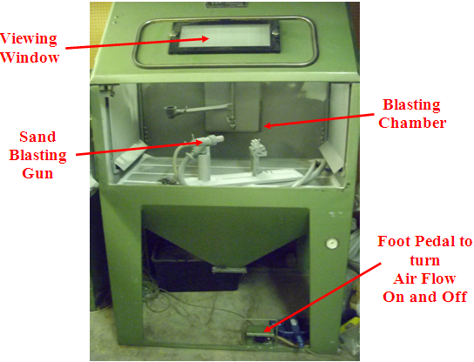
Figure 3.6: The sand blasting rig that was used to create the dimple modifications.

3.2.2 Surface Roughness Value

The degree of the surface roughness achieved by the dimples can be quantified. The study of surface roughness, known as metrology, has derived many different methods, equations and standards for defining the surface roughness of a component [45]. The standard that was used during the research was abbreviated as ‘Ra’ (arithmetic mean), the value of which symbolised the average roughness value of a surface [45]. In other words, the roughness was calculated based on the variation of the peaks and valleys along a surface (protrusions and depressions), with respect to a mean line [45]. For this a Laser Optical Profiler was used to obtain the Ra value for a sample corresponding to the highest degree of dimples tested.

The resolution of the Laser Optical Profiler resulted in an interval of 49.21 microns (0.049mm) between each measurement point along the surface of the sample. On the sample a section measuring 5mm by 5mm was scanned. In Figure 3.7 the plot obtained from the LabVIEW software used in conjunction with the profiler can be seen. The numbers on the axes are representative of the 5mm length and width of the section scanned. Therefore, in relation to the resolution of the measurement there would have been approximately 413 data points representative of an area of 1mm².

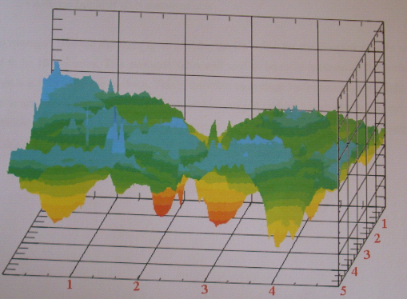
Figure 3.7: Plot obtained from the LabVIEW software of a 5mm by 5mm section scanned from the dimpled ‘high Ra’ specimen.

In order to compute the actual Ra value, three rows of data were extracted from the 100 by 100 matrix of data points. One row of measurement data points was taken from one side of the sample, one from the middle and another from the opposite side. Therefore, the Ra value was calculated for each row of data points and the average of these three values was taken to be the final Ra value. The equation used was as follows [45]:

Ra = $\frac{1}{N}\sum_{i=1}^{N}{\left|z-\overline{z}\right|}$ Equation 3.1
Where: N was the number of height measurements (100 in this case), z was the height of each measurement and $\overline{z}$ was the average height of all measurements (N).

3.3 Testing Methodology

3.3.1 Phase 1 Testing

In Table 3.1, all of the wind tunnel tests conducted during Phase 1 of the research (Figure 3.1 Red Zone) are listed in chronological order. There were two test models used for each of the three profiles selected (NACA 0006, 0024 and 4424). The majority of the experimental tests were conducted by adding dimple modifications to the low pressure surface of the airfoil, where flow separation occurred. The dimples were added to various locations, such as those detailed in Section 3.2.1, in addition to dimpling the full flow separation side. This was so as adding dimples to the other (high pressure) side of the airfoil would have only increased the viscous drag generated. In some tests however, a modification was applied to both sides of the airfoil to verify this and the ‘Airfoil Side’ column in Table 3.1 details this aspect. For each of the 24 tests conducted, drag and lift measurements were made in angle of attack (AOA) increments of 2º, from 0° to the respective stall angles of the three different profiles. The stalling AOA for these were approximately: 12º for the NACA 0006 profile, 18º for the NACA 0024 profile and 20-22° for the NACA 4424 profile [6].

 |  |  | Dimple Modification
Test No. | NACA Profile | Test Model No. | Location | Degree (Ra) | Airfoil Side
1 | 0024 | 3 | Unmodified – Baseline |  | -
2 | 0024 | 3 | Middle 1/3rd | High | Separation
3 | 0024 | 3 | Middle & Last 1/3rds | High | Separation
4 | 0024 | 3 | Full | High | Separation
5 | 0024 | 3 | Full | High | Both
6 | 0024 | 4 | Unmodified – Baseline |  | -
7 | 0024 | 4 | 1/2 to 3/5ths | High | Separation
8 | 0024 | 4 | 1/2 to 2/3rds | High | Separation
9 | 4424 | 6 | Unmodified – Baseline |  | -
10 | 4424 | 6 | First 1/2 | Low | Separation
11 | 4424 | 6 | Full | Low | Separation
12 | 4424 | 6 | Full | Med | Separation
13 | 4424 | 6 | Full | High | Separation
14 | 4424 | 6 | Full | High | Both
15 | 0006 | 1 | Unmodified – Baseline |  | -
16 | 0006 | 1 | Middle 1/3rd | High | Separation
17 | 0006 | 1 | Middle & Last 1/3rds | High | Separation
18 | 0006 | 1 | Full | High | Separation
19 | 0006 | 1 | Full | High | Both
20 | 0006 | 2 | Unmodified – Baseline |  | -
21 | 0006 | 2 | Full | Low | Separation
22 | 0006 | 2 | Full | Low | Both
23 | 4424 | 5 | Unmodified – Baseline |  | -
24 | 4424 | 5 | Second 1/2 | Low | Separation
Table 3.1: Experimental matrix table listing the details of all tests conducted during Phase 1.

3.3.2 Phase 2 Testing

Phase 2 of the experimental testing was split into two main parts:

- The NACA 0006 and NACA 0024 profiles were tested with various dimple patterns (low/high Ra and different locations) across a wide range of AOA, to fully investigate the effects on drag and lift – known as the ‘Single Airfoil Testing’. As part of this testing, end-plates were also used to analyse the effect of the dimples as a result of reducing the relatively large induced drag component associated with the airfoils.

- Both of these profiles were also tested in a split flap configuration in order to investigate the effect of adding dimples to an airfoil section with a flap. This was conducted by adding the dimples to both airfoils separately and to both at the same time to observe any interaction effects – known as the ‘Split Flap Airfoil Testing’.

In terms of the design of the end-plates they were semi-circular in shape and can be seen in Figure 3.8. They were constructed from thin sheets of clear PETG Copolyester, such that they would not have restricted the view if this set-up was used for smoke flow visualisation photography. These end-plates were also easily attached to and removed from the airfoils with screws and this was necessary in order to apply further dimple modifications between tests. The use of four screws was required on either side to prevent any gaps between the end-plates and the sides of the airfoil from occurring, particularly at the mid-chord point. Therefore, these screws and end-plates were expected to create an additional drag force, but dimple modification tests with these end-plates were compared against a relative baseline.

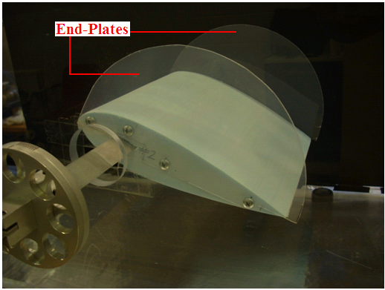
Figure 3.8: Photograph of the semi-circular end-plates used to reduce the induced drag.

As the majority of wing sections on aircrafts contain flaps, should a modification to an airfoil be proven successful it would be necessary to investigate any effect it would have on a smooth flap at its trailing edge. In addition, by adding dimple modifications to the flap itself, this may also have drag reducing benefits. In past research it has been shown that an object which is upstream of another can reduce the drag generated by the trailing object, through the turbulent flow and vortex shedding over the trailing object delaying its point of flow separation [18]. This property may be applicable to a wing and flap configuration, where flow that is tripped into turbulence by the dimples on the main wing section, reduces the pressure drag generated by the flap. The type of flap configuration that was tested is known as a split flap as previously mentioned and this is illustrated in comparison to a plain flap in Figure 3.9. However, as Phase 2 was an improvement of the Phase 1 research, the split flap and end-plate testing were conducted during Phase 2 only.

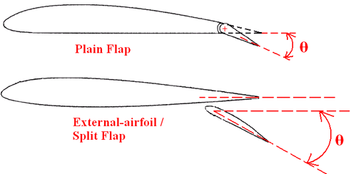
Figure 3.9: Comparison between a standard ‘Plain Flap’ and the ‘Split Flap’ configuration as tested in this research.

The type of flap that is the most widely used on commercial airplanes is known as a fowler flap [5]. When it is deployed it slides backwards and down and this extends the effective chord length of the overall wing section, thereby increasing its lift characteristics [5]. While this may have been somewhat difficult to construct and adjust, the plain flap type was also considered. However, the split flap was chosen due to its ease of construction. Unlike the plain flap which would have required a circular cut through the main airfoil for the leading edge of the flap to be located. The split flap configuration was simply achieved through the arrangement of two different airfoils, as seen in Figure 3.10.

Therefore, both the NACA 0006 and 0024 profiles were tested as the flap. In terms of the orientation of the flap in relation to the main section, the leading edge of the flap was positioned 35mm in from the trailing edge of the main airfoil (flap offset in Figure 3.10). Also, the minimum gap labelled in Figure 3.10 between both of these airfoils was maintained at 12mm. This gap was defined as the minimum perpendicular distance between both airfoils by lines tangential to each airfoil. In addition, the strut hole in the side of the main airfoil was sealed with tape so that it would not add any disturbances to the flow.

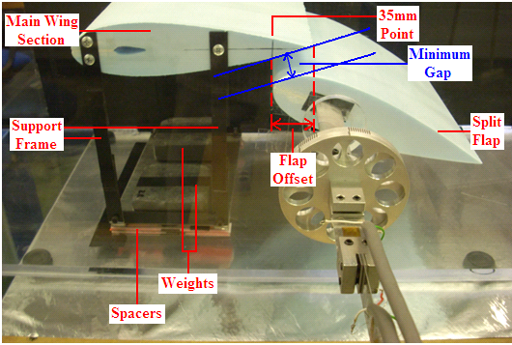
Figure 3.10: The experimental set-up of the NACA 0024 split flap configuration.

However, a problem arose when the AOA of the flap was increased as this 12mm gap decreased. Therefore, in order for this gap to remain constant which was important for the comparison of each test result, the height from the tunnel floor to the chord line of the main airfoil needed to be increased. The easiest and most time efficient method of doing this was to place spacers underneath the support frame, as illustrated in Figure 3.10. By using spacers that corresponded to a height difference due to a particular change in the AOA, they were easily inserted and removed from underneath the support frame base. In addition, as the flap had its AOA increased a small gap between its leading edge and the 35mm flap offset point (Figure 3.10) on the main airfoil resulted. Therefore, this was compensated for by marking a line on the main airfoil at the 35mm point and aligning both airfoils with respect to this after each AOA change. It was also necessary to place weights on top of the support frame base to prevent the main airfoil from moving during a test.

Another important point is that the drag and lift forces were measured from the flap airfoil only. If the main airfoil and flap were both joined together this would have created a counter-clockwise moment during testing, in relation to Figure 3.10, on the very sensitive balance (System 2). Therefore, it was decided it would be most practical to insert the balance strut into the flap airfoil only and to measure the forces from this airfoil. Following this, the main airfoil remained at 0º AOA and therefore it was only the AOA of the flap that was adjusted. This allowed for a thorough investigation of the dimple effect on the flap and on the main airfoil, through a wide range of AOA. Therefore, the airfoil test models (in both the Single and Split Flap Airfoil Testing) were tested with their AOA varying from 0º to 20º, which was past their typical stall angles previously defined in Section 3.3.1, with respect to the NACA 0006 and 0024 profiles used for the Phase 2 testing.

Therefore, in Table 3.2 all of the wind tunnel tests conducted during Phase 2 are listed in chronological order. The order in which the modifications were added to a particular test model was such that it maximised its usage. The ‘Airfoil Side’ column simply indicates to which side of the airfoil the modification was added to. Therefore, ‘Separation’ was the upper and therefore lower pressure side, with the ‘High Pressure’ side being the lower surface of the airfoil. The chord length and span of each test model used (Phase 1 and 2) are detailed in Appendix B. In relation to the details on the ‘NACA Profile’ and the ‘Test Model Number’, it can be seen which respective test numbers were conducted under the category of Single or Split Flap Airfoil Testing. In the ‘Test Model Number’ column, regarding the split flap testing, the F symbols refer to the flap airfoil and the M symbols refer to the main airfoil. Some of these airfoils (main and flap) were tested individually also.

 |  |  | Dimple Modification
Test No. | NACA Profile | Test Model No. | Location | Degree (Ra) | Airfoil Side
1 | 0024 | 1 | Unmodified – Baseline |  | -
2 | 0024 | 1 | First 1/3rd | High | Separation
3 | 0024 | 1 | First + Second 1/3rds | High | Separation
4 | 0024 | 1 | Full | High | Separation
5 | 0024 | 1 | Full | High | High Pressure
6 | 0024 | 1 | Full | High | Both
7* | 0024 | 2 | Unmodified – Baseline |  | -
8* | 0024 | 2 | Middle 1/3rd | High | Separation
9* | 0024 | 2 | Mid + Last 1/3rd | High | Separation
10* | 0024 | 2 | First 1/3rd  Mid + Last 1/3rd | Low  High | Separation  Separation
11 | 0024 | F1 | Unmodified – Baseline |  | -
12 | 0024  0024 | M1  F1 | Unmodified – Baseline  Unmodified – Baseline |  | -  -
13 | 0024  0024 | M1  F1 | Unmodified  Mid + Last 1/3rd | -  Low | -  Separation
14 | 0024  0024 | M1  F1 | Unmodified  Mid + Last 1/3rd | -  High | -  Separation
15 | 0024  0024 | M1  F1 | Full  Mid + Last 1/3rd | Low  High | Both  Separation
16 | 0024  0024 | M1  F1 | Full  Mid + Last 1/3rd | High  High | Both  Separation
17 | 0024  0024 | M1  F1 | Full  Full | High  High | Both  Both
18 | 0006 | F2 | Unmodified – Baseline |  | -
19 | 0024  0006 | M2  F2 | Unmodified – Baseline  Unmodified – Baseline |  | -  -
20 | 0024  0006 | M1  F2 | Full  Full | High  High | Both  Both
21 | 0006 | F2 | Full | High | Both
22 | 0024 | M2 | Unmodified – Baseline |  | -
23 | 0024 | M2 | Mid + Last 1/3rd | High | Separation
24 | 0024 | M2 | Mid + Last 1/3rd  Full | High  High | Separation  High Pressure
*Indicates if a test was conducted with end-plates attached to the airfoil.
Table 3.2: Details of all tests conducted during Phase 2 listed in chronological order.

3.4 Wind Tunnel Set-Up

3.4.1 Wind Tunnel

The experimental testing carried out as part of this research was conducted with the use of an in-house wind tunnel in DCU. The wind tunnel was an open circuit type with a closed test section. With the open circuit type of wind tunnel, the air flows in through the inlet (known as the contraction zone) and flows through the test section where the object being studied is positioned. Following this the air flow is allowed to expand in a controller manner through a diffuser section and flows out to the free air. The airflow basically follows a straight path all the way through the wind tunnel. This is in comparison to the other main type of wind tunnel known as a closed return wind tunnel (Prandtl or Göttingen type), where the air is re-circulated continuously rather than new air being drawn in [35]. Also, the test section of the DCU wind tunnel has solid boundaries (closed jet or NPL type) as opposed to an open jet or Eiffel type, which has no such walls [35]. One advantage of the open jet configuration would be that the airflow would not be constrained by any boundaries. This would eliminate any blockage effects which can exaggerate the true forces that would be acting on a test model if it were moving through open air.

The free-stream velocity measurements were made at the centerline (in relation to width and height) of the test section and in the exact location where an airfoil was located during testing. The device that was used for these measurements was a TSI Thermal Anemometer TA410 and this can be seen in Figure 3.11(a) with a close-up photograph of the measuring element in Figure 3.11(b). The flow velocity was displayed in units of m/s on the digital screen of the anemometer and the probe was inserted in through a hole located on the top of the test section. This device was used to calculate the wind tunnel velocities applicable for Phase 2 of the research, as certain modifications were made to the tunnel (at the end of Phase 1) which altered these velocities. However, for Phase 1 testing, the tunnel velocities were known from previous research where a Pitot-Static tube and manometer set-up was used for the measurements. The results from both of these sets of measurements will be discussed in Section 4.1.1.

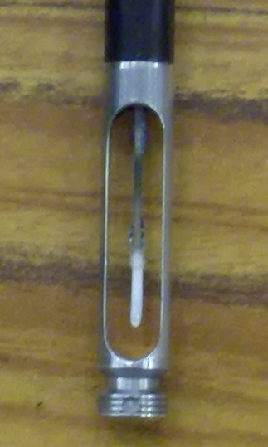
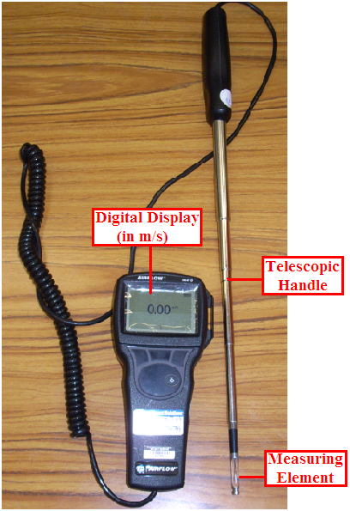

(a) (b)
Figure 3.11: (a) The thermal anemometer used for the velocity measurements, (b) a close-up photograph of the measuring element at the tip of the probe.

In Figure 3.12 two photographs that were taken from either end of the wind tunnel can be seen. Included are labels indicating the various parts of the wind tunnel. The fan (Ziehl-Abegg ZAC 710-43 short cased axial type with an external rotor motor) was located at the end of the diffuser section and the air was sucked through the wind tunnel test section, rather than being blown through it. A six bladed axial fan was chosen for this wind tunnel as it provided a compact flow with an efficiency of the order of 90% [46]. The fan generated a maximum airflow velocity of approximately 27m/s (97km/hr) before any modifications were made to the tunnel during Phase 2. This was in order to accommodate the new balance design (System 2) and to reduce the test section flow turbulence.
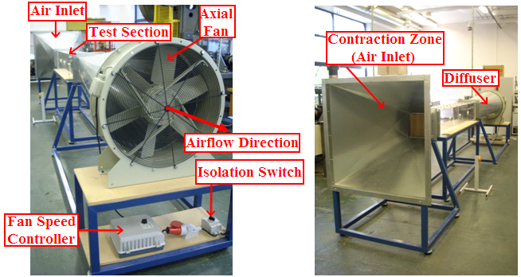
(a) (b)
Figure 3.12: (a) This shows the view from the air outlet (fan and diffuser section), (b) this photograph shows the view from the air inlet (contraction zone).

Initially, the air flow is sucked through the test section through a honeycomb mesh (approximately the same cross-sectional size as that of the test-section (0.3m by 0.3m) and 0.205m in length) to create a parallel steady flow. Honeycombs are effective for removing swirl and lateral velocity variations, as long as the flow yaw angles are not greater than 10º [46]. The optimum cell shape for a flow straightener mesh observed from tests conducted over the years is hexagonal and the optimum cell diameter depends on the flow conditions of a given wind tunnel [46]. These lateral components of turbulence are almost completely eliminated in honeycomb meshes where the cell length to the cell diameter ratio is 10 or greater [46]. The diameter of the hexagonal cells in the honeycomb mesh used in this research (Figure 3.13) was approximately 20mm, and the ratio of the cell length (205mm) to the cell diameter (20mm) was 10.25. In addition, the honeycomb cell walls are very thin with a value of 0.15-0.20mm approximately, therefore the overall mesh would have created as little blockage to the flow as possible.

However, for Phase 2 of the research, due to the accumulated wear and tear of removing and inserting the flow straightener section during test model changes, its outer periphery became damaged. An example of this can be seen in Figure 3.13(a), where the cells located at the edges of the mesh were no longer of hexagonal shape and instead were jagged and distorted. Therefore, these cells would only add to the free-stream turbulence in the test section as the flow through these cells will be not exiting in a clean parallel streamline fashion. As it was not possible to fix these cells properly, it was decided to seal these cells so that no air flow passes through them. Therefore, the modifications made to the honeycomb mesh can be seen in Figure 3.13(b).

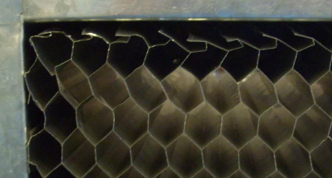
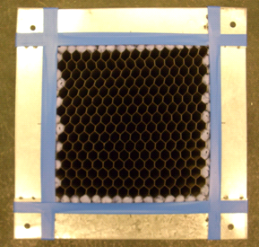
(a) (b)
Figure 3.13: (a) This picture highlights part of the damaged periphery of the honeycomb mesh from usage over the last few years, (b) the outsides of the mesh were taped off and cells partially covered by the tape were also sealed.

In addition, the contraction zone as labelled in Figure 3.12(b) had a contraction ratio of approximately 12:1, which also aided in creating very low flow turbulence [46]. The contraction zone produced a uniform flow and also reduced the inlet pressure and velocity losses, as the flow was gradually contracted into a cross-sectional area of that of the test section [46]. As for the diffuser section, in order for air flow to expand into a streamlined manner a boundary slope of 10º or less was required [46]. Thus the diffuser section in the wind tunnel had a slope of 9.8º to allow correct airflow expansion [35]. It was important to have a good degree of flow steadiness in the diffuser otherwise the pressure recovery would have fluctuated over time [46]. This would therefore result in fluctuations in the wind tunnel velocity and the aerodynamic forces acting on a test model [46]. This is undesirable as it would have created more difficulties regarding the measurement of the aerodynamic forces on a test model. Therefore, the possibility of flow separation within the tunnel and the turbulence which this would have created, was greatly reduced by the proper design of the diffuser section [46]. As can be seen in Figure 3.14 a wire mesh protected the fan from an object or part of an object becoming loose in the test section and being sucked into it.

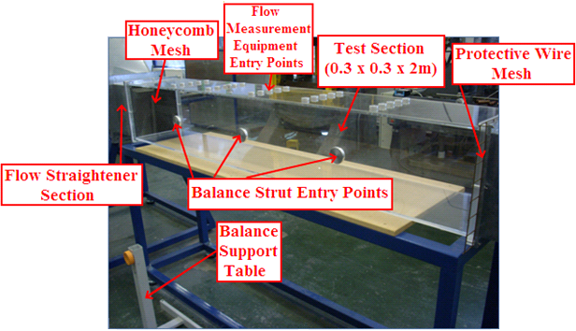
Figure 3.14: Picture of the wind tunnel test section.

In Figure 3.14, the point at which the strut that connected the strain gauge balance (for Systems 1 and 2) to the airfoil test model was inserted was through the 50mm diameter hole in the side wall, closest to the flow straightener section. The reason for this was because the flow will just have passed through the honeycomb mesh at this point and the flow will be more likely to be uniform, rather than further down the test section. In addition, in Figure 3.14 it can be seen that there was a support table to which the strain gauge balance was mounted. However, this was applicable to System 1 during Phase 1 of the research as System 2 utilised a different mounting mechanism. Following on from this there were some modifications made to the tunnel to reduce the flow turbulence and to accommodate System 2. The reason as to why the flow turbulence was reduced further during Phase 2 of the research was as a result of the increased sensitivity of the newly designed strain gauge balance (System 2). Therefore, as the drag force is proportional to the velocity of the airflow squared, less variation in the flow velocity through the test section will therefore result in a more steady measurement of drag [46].
Following on from this modification, the process of installing what are known as turbulence reduction screens was carried out. These screens usually consist of a thin wire mesh and also are usually positioned after the honeycomb mesh in a given wind tunnel [46]. However, as the honeycomb mesh was sized for and installed after the contraction zone and before the test section, it was necessary to place these screens before the honeycomb mesh in the contraction zone. The mesh screens, like the honeycomb cells, reduce the amount of flow turbulence in the test section. However, unlike the honeycomb mesh which reduced the lateral component of flow turbulence, these screens reduced its longitudinal component [46]. Therefore, the screens and the honeycomb mesh worked together to reduce the free-stream flow turbulence passing over the airfoils in the test section.

In general, the smaller the mesh cells of a screen, the greater the reduction in turbulence [46]. However, this would also have more of an impact on the flow velocity through the wind tunnel, therefore a compromise needs to be reached. Also, when multiple screens are used, if they are placed too close together the small wake that is formed as the flow moves through each screen does not have time to dissipate before reaching the next screen [46]. A minimum spacing of 500 times the screen wire diameter is recommended as a design guideline when screens are being placed in the settling chamber prior to the contraction zone [46]. However, as the current research wind tunnel did not contain a settling chamber, where usually a large honeycomb mesh and the turbulence reduction screens are located, the screens were instead positioned inside the contraction zone. The wire mesh screens used had a wire diameter of 0.8mm with square cells of size 12mm by 12mm.

Therefore, before any modifications were made to the honeycomb mesh or before installing any of the mesh screens in the contraction zone, the degree of flow turbulence in the test section was assessed. While it is possible to use a Pitot-Static tube to measure the average flow velocity, it would be necessary to data-log the fluctuations of the velocity over time due to the turbulence to calculate what is known as the turbulence intensity level. These fluctuations would be then related to the average velocity value which leads to a percentile value of the turbulence intensity [35]. However, as the equipment for conducting this technique was not available, an alternate analysis method was devised. By measuring the drag and lift of a smooth unmodified NACA 0024 airfoil at 0º AOA in the test section, the standard deviation of the output signals recorded by the data acquisition (DAQ) system (with System 2) was used to provide an insight into the level of the flow turbulence. Therefore, the fluctuations of the output signals would have been due to the flow turbulence, as no lift or flow separation would have been found to occur.

The values of the standard deviation before modifying the honeycomb mesh or installing the turbulence reduction screens, were 0.14N and 1.06N for the drag and lift output signals respectively. Firstly, after making the modifications to the honeycomb mesh the standard deviation values were reduced to 0.12N for the drag and 0.82N for the lift. As it was not known initially how many turbulence reduction screens should be used and what the spacing between each should have been, the process of inserting and arranging the screens was carried out until the standard deviation values of the recorded signals were at their lowest value. After deciding on the final arrangement of the screens, the standard deviation values were reduced further to 0.1N and 0.51N for the drag and lift respectively. Overall, as a result of modifying the honeycomb mesh and inserting the screens, the standard deviation value of the drag measurement was reduced by 30% and by 52.2% for the lift. Therefore, these values signified the reductions in the different flow turbulence components which would have otherwise affected the drag and lift measurement. Therefore, the resulting configuration of the screens can be seen in Figure 3.15. It can be observed that there are four screens and these had approximately a 40mm spacing between each.

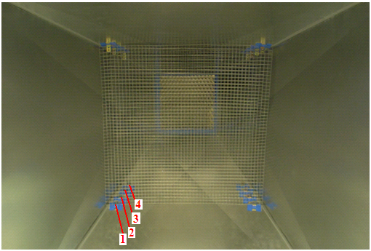
Figure 3.15: The resulting final arrangement of the four turbulence reduction screens inside the contraction zone.
In addition to modifying the honeycomb mesh and adding the turbulence reduction screens, during the Phase 2 experimental testing, the various joints in the wind tunnel assembly were sealed with insulating tape. This is illustrated in Figure 3.16 and by doing so it prevented any air flow losses through the test section, which in turn would have affected the flow velocity and the level of turbulence. In Figure 3.16(b) it can be seen that a wire mesh the same type as those installed inside the contraction zone, was fitted at the end of the test section to prevent any loose objects from being sucked into and damaging the fan. The protective mesh from Phase 1, as illustrated in Figure 3.14, was a good deal larger in cell size and it was preferable to use a finer mesh.

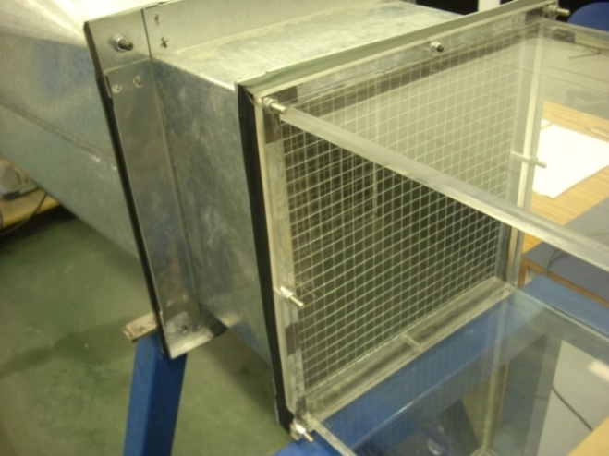
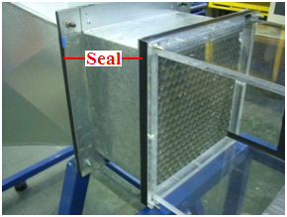
(a) (b)
Figure 3.16: (a) This photograph shows the sealing of the flow straightener section containing the honeycomb mesh with black insulating tape, (b) the end of the test section leading to the diffuser.

In relation to this aspect of sealing parts of the wind tunnel, due to System 2 having a much higher sensitivity, it was observed that air was being sucked in through the holes in the tunnel side walls through which the balance strut passed. The rapid acceleration of this flow through these holes as it joined the free-stream flow in the test section created additional turbulence. Therefore, these holes were covered with tape (Figure 3.17) as much as possible, only leaving a rectangular slot which would allow for the small deflections of the strut without any contact affecting the experimental results.

In relation to lowering the standard deviation values of the recorded drag and lift force signals as discussed earlier, this last modification further reduced these values to 0.09N and 0.38N respectively. This therefore equated to an additional standard deviation reduction of 14.3% for the drag and 25.6% for the lift. This brought the overall reduction, compared to the case before any modifications were made to the tunnel to reduce the flow turbulence, to 40% for the drag and 64.4% for the lift.

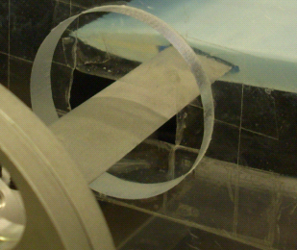
Figure 3.17: Addition of sellotape to the holes in the side walls which was found to cause a significant drop in test section flow turbulence.

3.4.2 Blockage Ratio

Even though a given wind tunnel set-up may have a highly accurate force measurement system, considerations must be given to any errors that may result from the test section flow quality. One principal effect is known as the ‘Blockage Ratio’. Blockage of air flow occurs in a wind tunnel where the test object is large in comparison to the width and height of the wind tunnel. This blockage effect can be defined in terms of a ratio, which is a relationship between the frontal area of the wind tunnel test section (C) and the frontal area of the test model (S) [35]. In terms of the experimental testing that was carried out in this research, this ratio would have been at its greatest when the airfoils were at their highest AOA. Both the chord length and the span of the airfoil can affect its effective frontal area. The blockage ratio can be calculated using the following formula [35]:

Blockage Ratio = Equation 3.2
Due to the small gap that existed between the tunnel walls and the wake emanating from the airfoils, in order to satisfy the continuity of flow and Bernoulli’s equation, the free-stream flow had to accelerate around the wake [10]. The reduction in pressure in this region drew the wake towards the walls of the tunnel. As a result, this increased its true size which led to an increase in the drag force acting on an airfoil [10]. Also, in the case where the wake was larger in size at the higher AOA, and as it was compacted into a tighter space than the size it would naturally have developed into, this increased its turbulence intensity [35]. Typically a drag measurement error of 20% can be observed at a 30% blockage ratio [35].

In addition, the proximity of the test section boundaries to the airfoils influenced the effective angle of incidence of the flow [46]. This aspect is known as ‘streamline curvature’, which affects the true AOA of airfoils, thus resulting in the airfoils having better lift-to-drag ratios [46]. The proximity of the tunnel walls to the sides of the airfoil can also increase the effect of the induced drag, as local flow separation can occur at the sides of the airfoils [35]. The static pressure can also vary along the test section, due to the boundary layer along the tunnel walls becoming thicker, which reduces the ‘effective frontal area’ of the test section [35]. Therefore, the pressure is lower towards the end of the test section and this would have drawn the airfoils in the flow direction. The effect of this was that it produced a small additional drag force which was known as ‘horizontal buoyancy’ [35].

Calculations of the blockage ratio relevant to the experimental testing will be presented in Section 4.1.3. In addition to this, another guideline states that the model span should be less than 0.8 of the width of the wind tunnel [35]. This consideration was taken into account during the manufacture of the test models. Therefore, as the width of the test section was 300mm, this guideline would have allowed a maximum model span of 240mm. However, the test models produced for the testing had a maximum span of 210mm (0.7 of the width), which was therefore well within the specification.

3.5 Force Measurement Systems Overview

As the principal aim of the research was to investigate the potential effect on drag reduction by adding dimples to a wing section, in addition to the effects on the lift force, it was necessary to have equipment capable of performing measurements to a high degree of accuracy and repeatability. While a great deal of testing was conducted during Phase 1 of the research, due to certain performance issues and measurement errors with System 1, a greatly improved design of System 2 was necessary. In this section, both designs will be briefly highlighted and Sections 3.6 and 3.7 will explain the design/operation of System 1 and System 2 in more detail respectively. In Figure 3.18 a comparison of the operational principals of both designs can be seen, with System 1 on the left and System 2 on the right.
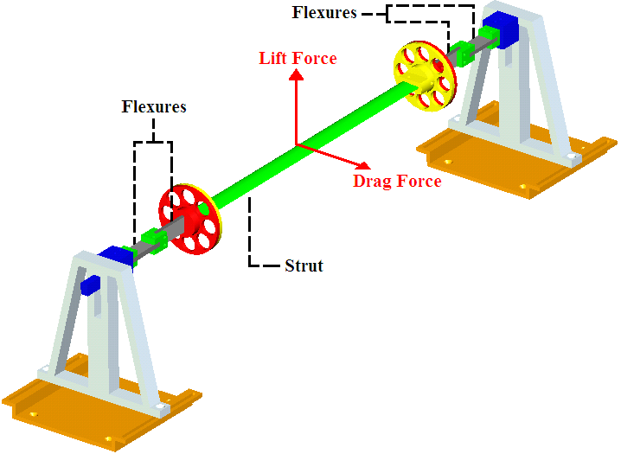
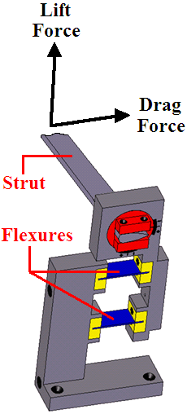
Figure 3.18: Operational comparison between System 1 on the left and System 2 on the right.

Therefore, in Figure 3.18 the first main difference that can be observed between both of the designs is that with System 2 the strut holding the airfoil is supported on both sides. With System 1, the loads were only transmitted to one end of the strut. Therefore, System 2 spanned the full width of the test section. A photograph of System 1 during calibration can be seen in Figure 3.19. The airfoil test model was located at the end of the strut, with the strut end located halfway across the span of the test model. The drag and lift forces were transmitted through the strut to the flexures, at which point strain gauges mounted to their surfaces created output strain readings. Data from a calibration process was then used to equate the output strain readings to an aerodynamic force. This strain gauge balance was designed to be used in two set-up orientations, one for measuring drag and one for measuring lift (further discussed in Section 3.6). System 1 was secured to a support table located to the side of the tunnel, however a different set-up was used for System 2 as will be seen.

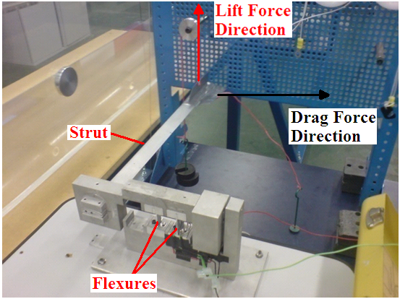
Figure 3.19: Photograph illustrating the strain gauge balance (System 1) used during Phase 1 of the research.

As previously mentioned, certain measurement errors and design inadequacies of System 1 led to the design of System 2. These improvements were not just from a mechanical design aspect, but a much more sophisticated instrumentation set-up was also developed, which led to a system of much higher accuracy, sensitivity and stability. In Figure 3.20(a) the loading mechanism on the flexures for System 2 can be seen. Therefore, there was a separate flexure on either side of the tunnel for measuring drag and lift. Taking the two drag flexures for example, split between these was a full bridge circuit as opposed to only the one full bridge circuit used in the case of System 1. Figure 3.20(b) shows the set-up of System 2 with respect to the wind tunnel test section.

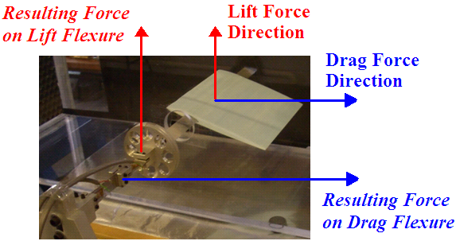
(a)
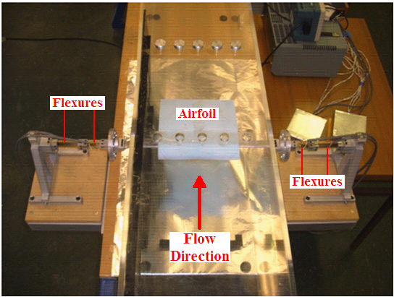
(b)
Figure 3.20: (a) Diagram illustrating the method by which the drag and lift flexures detected the separate force components, (b) a plan view of the test section showing the full width of System 2.
Both devices were capable of adjusting the AOA of an airfoil in the 0° to 20° range. However, another advantage with System 2 over the previous design was that the AOA of the airfoil could be adjusted in steps of 1° as opposed to 2°. Therefore, both Systems 1 and 2 fell into the category of external strain gauge balances, with the support strut inserted through the sides of the test models. This was determined as the most ideal balance configuration for the test conditions, as will be explained in more detail in relation to System 1 and System 2 design, in Sections 3.6 and 3.7 respectively.

3.6 System 1 Design

Before this device was designed it was decided that an external strain gauge balance set-up would be the most suitable configuration for this research, as an internal balance would interfere with the airflow leaving the airfoil. This would in turn have affected the wake produced by the airfoil and would inevitably produce uncertainties in the results. Apart from this, the main problem with using an internal balance would be due to it not being compatible with airfoil testing. The insertion of an internal balance through the trailing edge of an airfoil would not be practical and this problem is illustrated in Figure 3.21, as it effectively affects the airfoil profile under investigation.

Figure 3.21: Diagram highlighting the difficulty involved with using an internal balance for the testing of airfoils.

Although this internal ‘sting’ type of balance would have been a good deal smaller in cross section than the span of the airfoil, it would still have had a large impact on the flow leaving the trailing edge of the airfoil. The internal balance would also need to have been of certain cross-sectional size to allow for strain gauges to fit onto the strain members, which would have limited the sensitivity of the balance. Conversely an external balance allows a support strut to be inserted into the side of the airfoil, thereby having very little effect on the flow over the airfoil. Another advantage of the external type of balance is that there is no restriction on its size. This allows for longer strain gauges to be used along with longer strain members, which in turn increases the measurement sensitivity. Therefore, the external type of balance was the most practical for the test conditions and is why this type was chosen at the outset of the design of System 1 (and also utilised in System 2). The ‘elastic parallelogram’ formed the basis for the initial design. This concept was adapted from the popular design used for internal balances and Figure 3.22 illustrates the nature of its operation.

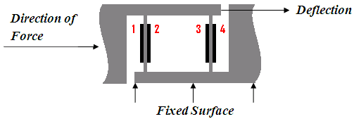
Figure 3.22: Diagram of the elastic parallelogram concept.

Strain gauges can be positioned according to the numbers on what are known as flexures. These would be sensitive to a particular force acting on the test model. The forces generated on the test model in the wind tunnel would be transmitted through a streamline strut, which would be inserted perpendicularly through the side of an airfoil. The airfoil is connected to this elastic parallelogram located outside of the wind tunnel. Therefore, the strain induced in the elastic elements would be detected by the strain gauges. The strain reading could then be converted into a force via calibration data. The main advantages of using flexures as the elastic force measuring members were as follows [35]:

- They can be designed to withstand loads in any direction.
- There was no lost motion between the coupled members.
- Flexures were essentially frictionless, thereby eliminating hysteresis effects.
- They were virtually wear-proof, therefore their characteristics remained constant over a long period. This allowed for greater repeatability of test results.

Therefore, once the balance was positioned exactly parallel to the airfoil in the wind tunnel, the force acting on the balance flexures would be exactly aligned with the direction of the drag force acting on the model. The initial design concept is illustrated in Figure 3.23.

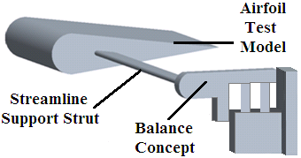
Figure 3.23: Initial design concept with the elastic parallelogram flexure set-up.

This external balance would then be secured to a rigid mounting surface. Therefore, while this initial design concept can only measure the drag force, the next step was to incorporate a method for measuring the lift force. If the elastic parallelogram was rotated clockwise by 90º, such as that shown in Figure 3.24, it would deflect due to the lift force and the effect of the drag force on the flexure would be cancelled out.

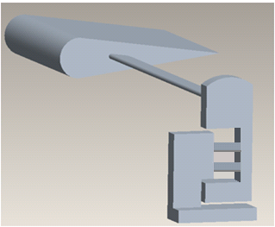
Figure 3.24: Revised design concept for the incorporation of lift measurement.

At this point it was decided that the support strut would replicate the profile of a NACA 0024 airfoil. A chord length of 25mm was chosen for the strut profile and this led to a maximum thickness of 6mm (24% of 25mm). As discussed in Section 3.1 the thinnest test model profile was the NACA 0006. Accordingly, the maximum thickness of these test models was 13mm and the dimensions of the strut allowed adequate clearance for the insertion into this profile. However, when considering the relatively low forces generated during the testing, this strut machined from Aluminium 6082-T6 was stiff enough as to not deflect during testing.

As well as eliminating slippage, as compared to a circular strut for example, this strut produced very little drag due to its aerodynamic shape and therefore had as little effect on the results as possible. The strut was inserted into the test models at their aerodynamic centre, located at the 0.25c point in from the leading edge and the point at which all of the aerodynamic forces appear to act through. Coincidentally, this was also very close to the point where the maximum airfoil thickness was located. Therefore, as can be seen in Figure 3.25, adequate clearance was given to around the hole for the strut.

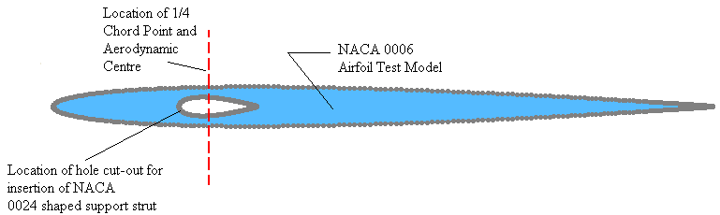
Figure 3.25: Diagram illustrating the location and size of the strut hole in the thinnest profile selected (NACA 0006) for the wind tunnel testing.

The next step was to design a method of measuring/changing the AOA of the test model and securing the strut to the balance. Therefore, it was decided that the trailing edge of the support strut would meet up with lines that indicated the AOA of the test model. The support strut was inserted into the airfoil such that its chord line was aligned correctly with the chord line of the test model. However, there was a requirement for two sets of AOA engravings, one for lift and one for the drag orientation set-ups. Therefore, the strut was inserted into a circular component which in turn could be rotated and locked into position for a particular AOA. This circular component can be seen in Figure 3.26 and it was locked into position by a screw from the top of the balance.

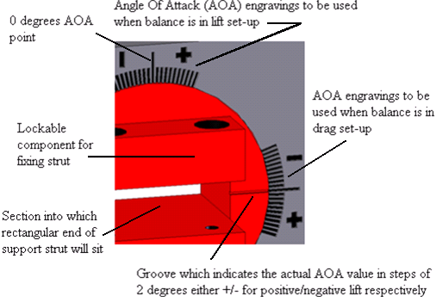
Figure 3.26: Diagram illustrating the AOA markings for the drag and lift set-ups.

Also as can be seen in Figure 3.26 there was a groove machined into the circular component which was exactly in line with the chord line of the strut, to correctly indicate the AOA of the test model. There were ten AOA markings at either side of the 0º point, which was indicated by the central longer marking, each marking represented a step of 2º thereby giving an AOA adjustment range of $±$20º. This range was adequate for the stall angles of the respective airfoil profiles which were detailed in Section 3.3.1.

Ordinarily, when the elastic parallelogram concept is used in internal balances, the flexures and the upper and lower surfaces of the parallelogram are machined from one solid piece of metal. Therefore, the next concept was the option of having detachable flexures in order to increase its versatility and the range of forces that could be measured. The concept for the insertion and removal of different flexures can be seen in Figure 3.27. The flexures slotted into ‘connection blocks’, one located at either end of each flexure. Two screws then secured each end of the flexure to each block. This assembly was then screwed into position in corresponding slots in the balance.

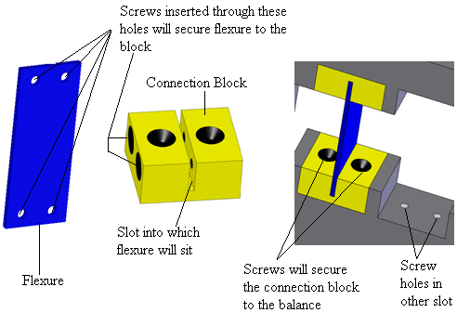

Figure 3.27: Final concept of flexure assembly.

At this point, a specific flexure thickness was required to match the size of the slots in the connection blocks. This was chosen as 1.5mm as a result of testing different flexure sizes. While the width of these connection blocks and the flexures were set at 20mm, the length of the flexures and their material could be adjusted to suit a particular testing set-up. In relation to the other components of the balance, as with the strut it was decided to machine these from Aluminium 6082-T6. On another point, it was noted that in the drag set-up once the strut was connected to the balance, there would be an offset strain created on the flexures. Therefore, it was decided that a counterweight would applied to correct this imbalance. This can be seen in Figure 3.28(a) which highlights the final design of System 1 in its drag set-up. Figure 3.28(b) illustrates the balance in its lift orientation and it can be seen that this counterweight was removed.
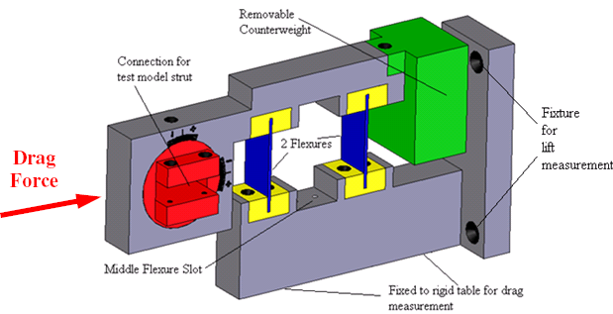
(a)
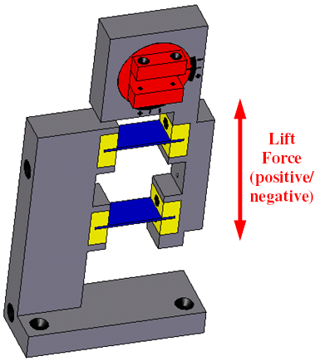
(b)
Figure 3.28: (a) Finalised design in its drag set-up, (b) balance in its lift set-up.
The strain gauge type that was used with this balance had a grid length of 8mm and a grid width of 2mm. Figure 3.29 illustrates one of these gauges and they also had a resistance of 120Ω. The full specifications of these gauges used are detailed in Appendix C.

Figure 3.29: Enlarged view of the 120Ω strain gauge type used with this balance.

The instrumentation that was used to read the outputs from the strain gauges was a Vishay P-3500 Digital Strain Indicator (DSI), which can be seen in Figure 3.30. The lead wires from the strain gauge circuitry were wired to terminals on the ‘Switch and Balance Unit’, which is on the right of Figure 3.30. This unit was then in turn wired accordingly to the DSI on the left from which the strain outputs were read from a LCD screen. These readings had units of micro-strain (με).

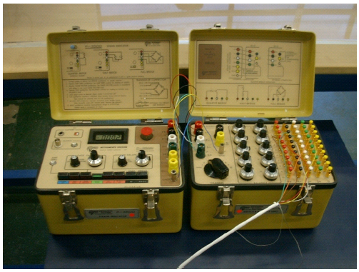
Figure 3.30: The DSI that was used in conjunction with the strain gauge balance.

3.7 System 2 Design

For Phase 2 of the research a new strain gauge balance and instrumentation set-up was designed, to correct some of the measurement errors with System 1 and to improve the sensitivity and stability of the force measurement system. One of the key design aims for System 2 was to greatly increase its accuracy, especially concerning the measurement of drag. Considering the tunnel airflow velocity and the size of the test section, which dictated the size of the airfoils, even the maximum drag forces generated were still quite small. Therefore, as the principal aim of the research was to observe any drag reductions due to the dimple effect, maximising the sensitivity of drag measurement was a priority. However, this aspect can create a problem where the drag measurement may also become sensitive to interactions with the larger lift forces. In addition, maintaining adequate output signal stability and recording these larger scale fluctuating outputs also required consideration. Therefore, this section will describe the process by which System 2 was designed in relation to these aspects and regarding correcting the design issues associated with System 1.

At this stage it is worth pointing out that the design and implementation of this much more sophisticated balance, not to mention the time required for the optimisation of the instrumentation set-up as will be discussed later, occupied a significant part (14 months approximately) of the overall research. As this was also true for System 1, however to a lesser extent (11 months approximately), it can be said that the overall research was concerned with creating a facility that could measure the aerodynamic forces, which otherwise did not exist, as much as it was involved with the actual testing of the dimple patterns and with other research aspects.

3.7.1 Design of Main Balance Assembly

As with the design of System 1 it was decided to use the concept of strain members that are subjected to bending forces. Firstly, from a mechanical design perspective it was necessary to design flexures that would have a lower flexural stiffness than those used with System 1. In other words, the flexures needed to be longer and thinner so that the maximum drag and lift forces would be much closer to their flexural yield strength. This section will focus on the overall balance assembly, with a further discussion on the flexure design presented in Section 3.7.2. As will be discussed in Sections 3.7.3 and 3.7.4, the other design elements for increasing the measurement sensitivity were concerned with the strain gauge selection and the DAQ set-up respectively.

One component that System 1 and 2 shared was the use of the same NACA 0024 support strut (415mm in length). However, as this section develops it will be seen that the methods by which it was supported and how it transmitted the forces to the flexures were different. Therefore, the first main error with System 1 was that it effectively operated as a cantilever set-up. This set-up meant that the strut was creating a moment on the flexures and therefore the lift and drag forces were not isolated properly. In order to solve this problem it was decided to incorporate a strut that spanned the full width of the test section. This strut would be supported on both sides of the tunnel and as a result would eliminate this cantilever effect.

The second main conclusion from the previous balance design was the need for two strain gauge bridges, one for lift and one for drag measurement. Therefore, while a design aim was to significantly reduce any interactions through the cross-coupling of the forces, any small interaction effects present with System 2 could be accounted for fully by an interaction matrix method from the calibration data. Also, in comparison to the previous design where the balance itself was rotated to be sensitive to a particular force, two sets of flexures with two separate strain gauge circuits aligned permanently with the respective forces was deemed more efficient.

While it would have been possible to design a device that can measure all six aerodynamic loading components, this would have led to a much more complex design with potentially more error sources. This was true not only from a mechanical point of view but also from a strain gauge, electrical wiring and instrumentation standpoint. However, it must be pointed out that the two principal forces that were desired to be measured during the testing were the lift and drag forces. The basic concept of System 2 (Figure 3.31) was a support strut assembly that served two main purposes. Firstly, these would securely hold the strut and test model in place in the wind tunnel and they would also measure the lift and drag forces transmitted from the strut. It can be seen that the components at either end of the strut contained the flexures that had strain gauges mounted onto them. This overall arrangement therefore eliminated the cantilever effect error and allowed for two separate bridges for the measurement of the lift and drag forces individually.

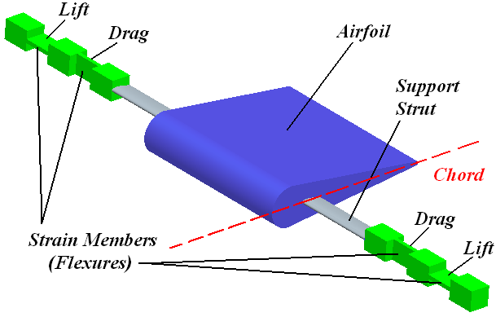
Figure 3.31: Diagram illustrating the initial design concept following on from the main errors with System 1.

The orientation of the lift/drag flexures in Figure 3.31 are actually the opposite to that of the final set-up (lift flexures closest to airfoil) and the reasoning behind this aspect will be discussed later. As two full bridge circuits were used separately to measure these two forces, the four strain gauges in each circuit were mounted between the two respective flexures (one either side of tunnel). Therefore, on each flexure there were two gauges, one on each surface. This of course follows on from the theory previously discussed in Section 2.6, where one gauge would be in tension and the other would be in compression as the flexure experienced a bending force. The next step was to incorporate a method of altering the AOA of the airfoil without affecting the alignment of the flexures.

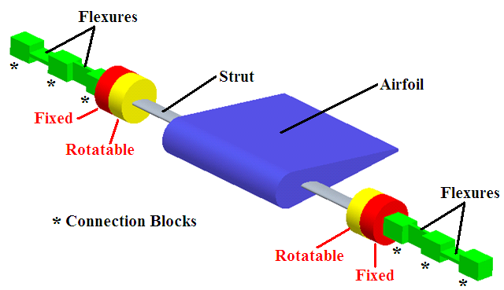
Figure 3.32: Design concept for the rotation of the airfoil through different AOA without affecting the alignment of the flexures.

Therefore, the AOA of the airfoil was adjusted by rotating the strut which was secured to the yellow coloured ‘rotatable’ components in Figure 3.32. As the flexures could not be connected directly to each other, ‘Connection Blocks’ as labelled in Figure 3.32 formed the linkages between the flexures and the AOA adjustment components. The AOA markings were inscribed along the outer surfaces of the red and yellow (AOA Indicator) components in Figure 3.32. Once the airfoil was set at the desired AOA, a screw was tightened in the AOA Indicator components which secured the airfoil at that AOA. Therefore, it was only these yellow components or the inner parts of the AOA Indicator that rotated along with the strut and airfoil. This therefore ensured that the lift and drag flexures constantly remained aligned with the respective forces acting on the airfoil.

As it was important to minimise any interaction effects between the measurement of both forces, this arrangement allowed for the drag flexures to be insensitive to the lift forces and vice versa for the lift flexures. This was so as the lift force acted on the effective width of the drag flexures and vice versa with respect to the drag acting on the lift flexures. Therefore, it was the plane in which the forces acted that allowed for the relevant flexures to be sensitive through their small thickness, yet very insensitive to the opposing force through their effective thickness (due to their width) in that plane. The mathematical modelling of the flexures with respect to this effect and the strain distribution acting on them will be covered in more detail in Section 3.7.2.
In relation to the AOA Indicator, highlighted in Figure 3.33, this was designed to adjust the AOA in 1° increments. Due to the required diameter of these components, circular cuts were made in these in order to reduce their weight. In addition, the two parts had a thickness of 6mm each. Therefore, it was possible to adjust the AOA in a range from 0° to 20°, which was adequate for the respective stall angles of the airfoil profiles. A protrusion from the fixed (red) part was inserted into a hole in the rotatable (yellow) part and as can be seen in Figure 3.33 two screws fixed the airfoil at a particular AOA.

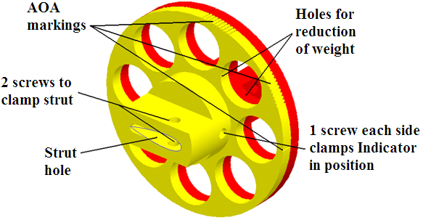
Figure 3.33: CAD drawing of the two parts which secured the strut in place and allowed for accurate AOA changes to be made without effecting the orientation of the flexures.

In relation to the diameter of the two parts (86mm), this value actually only achieved AOA markings in 2° increments. However, a resolution of 1º was made possible by splitting the AOA markings into two groups located in different locations around the circumference. One group of markings was used for the even AOA steps (2º, 4º etc) and another for the odd AOA steps (1º, 3º etc). In Figure 3.34 the technique by which the AOA was read is illustrated. The three grooves on the fixed part were used in conjunction with these AOA steps.

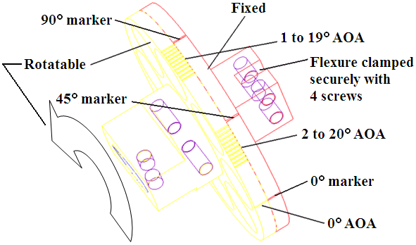
Figure 3.34: Illustration of the method by which the AOA was adjusted in 1º increments in the 0° to 20° range.

Therefore, in Figure 3.34 it can be seen that the 45° marker on the fixed part was used to make adjustments from 2° to 20° in 2° even increments. In addition, the 90° marker was used for the 1° to 19° range in odd 2° steps. This of course prevented these parts being larger in diameter which would have added weight to the system. Also, these markings were located on the respective components on each side of the tunnel. This was in order to prevent any misalignment or slight twisting of the relatively weak flexures. Similar to System 1 this balance had the feature of using interchangeable flexures. The advantages of this were that different sets could be used to suit different test conditions and also should a flexure become permanently damaged, it was possible to replace it. In addition, the process of applying the strain gauges to these flexures when out of the assembly allowed for easier handling. Therefore, while the flexures were designed specifically for the test conditions, the ability to replace these with different gauges also, allowed for great versatility regarding any future testing by other students with this balance. Therefore, another aspect that was needed to be addressed was the method by which both ends of the balance assembly were supported. This therefore led to the design that can be seen in Figure 3.35. As was seen previously in Figure 3.20(b), there was one of each of these overall assemblies located on either side of the test section.

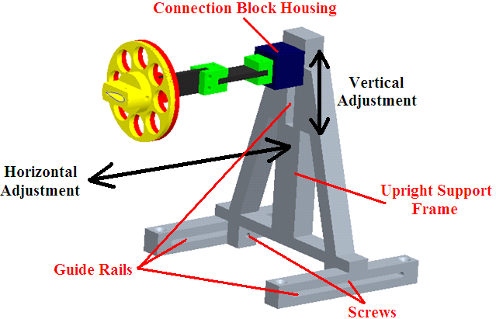
Figure 3.35: The evolution of the design led to the balance as illustrated in the above solid model drawing.

The support brackets onto which these sat were manufactured also for this set-up and therefore were not present for System 1. During the installation of these brackets to the tunnel frame, it was ensured that both sides of the balance would be secured level such that the flexures were correctly aligned with the lift and drag forces. The various parts of the balance, apart from the flexures, were manufactured from Aluminium 6082-T6. The mechanical properties of this material are listed in Appendix D. Therefore, the manufactured final design, following the selection and installation of the gauges and flexures, can be seen in Figure 3.36.

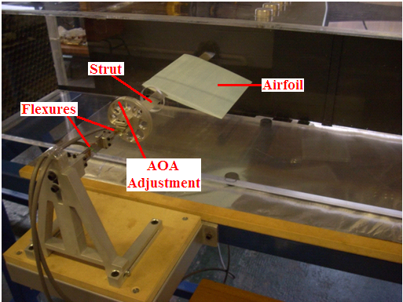
Figure 3.36: System 2 in operation during the testing of an unmodified NACA 0006 airfoil.

3.7.2 Design of the Flexures

The flexures consisted of rectangular strips of metal, which acted as the strain members and onto which the strain gauges were mounted. In this section, the method by which one set of flexures (for example drag) were highly sensitive to their primary (drag) force, yet at the same time very insensitive to their secondary (lift) force will be discussed. Following this it will be shown how the flexural stiffness of the flexures were chosen relative to the expected aerodynamic forces.

Firstly, it is worth pointing out that the flexures were tried in different set-ups, that is the drag flexures were positioned closest to the AOA Indicators/test section with the lift flexures closest to the upright support frames and vice versa. This was carried out by having loads applied to the strut in a similar fashion as to carrying out a calibration. During preliminary wind tunnel testing with quarter bridge circuits applied to the flexures, it was found that when the drag flexures were positioned closest to the strut they experienced more torsional effects, through rotation along their length. In other words the effects of the pitching moment fluctuating at high AOA in conjunction with the vortex shedding, had a larger effect on the longer drag flexures when in this position. In the same test set-up there was also a notable vibration of the lift flexures at higher AOA, due to the fluctuating pitching moment and lift force. Therefore, from this it was concluded that the flexures would be positioned such that the drag flexures were located closest to the support uprights, with the lift flexures closest to the AOA Indicators.

Regarding the modelling of the forces on the flexures in order to select suitable dimensions/material, it was observed that it would have been incorrect to model the flexures as cantilever beams. This was so as the load applied to the end of each flexure always acted parallel to the fixed support (end furthest from test section), even as the flexure deflects. Therefore, in relation to Figure 3.20(a), the force direction at the free ends of the flexures always acted parallel to the respective lift/drag force. As a result, the flexure loading mechanism was defined as a thin beam that was free and guided at one end and fixed at the other end [47]. This resulted in a loading scenario where the flexures were capable of withstanding twice the maximum load, for the same material and dimensions, compared to a cantilever set-up. In Appendix E, the equations used to calculate the dimensions of the final flexure sets used are presented. The material chosen for the flexures was Stainless Steel 304 and the mechanical properties of this material are listed in Appendix D.

Due to the loading profile on the flexures, in order to maximise the output level from the strain gauges, these were positioned as close as possible to the fixed support end of the flexures. This was so as the strain exerted on the flexures dropped off from its maximum value in a linear fashion towards their free end. Figure 3.37 highlights the relationship between the ‘effective thickness’ of the flexures, with regards to the primary and secondary forces acting on the flexures in different planes, which demonstrates how a flexure was insensitive to its respective secondary force.

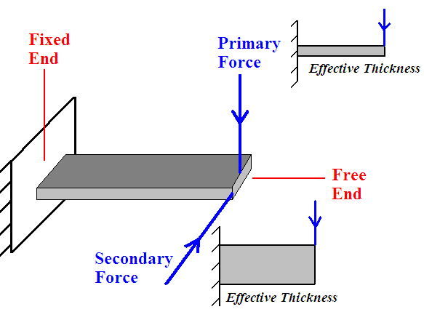
Figure 3.37: Diagram illustrating how the force direction affected a flexure, which led to a sensitivity that was highly influenced by the effective thickness of the flexure in that plane.

Figure 3.37 represents one of the lift flexures as an example, however with the force acting downwards. The deflection and consequently the strain exerted by a force on the flexure were primarily influenced by the effective thickness of the flexure in the plane in which the force was acting. Therefore, in this case the lift force is the primary force and the actual thickness of the flexure acts as the effective thickness in the lift force plane. However, for the secondary (drag) force, the effective thickness of the flexure is then the actual width of the flexure. This property of the thickness, with regards to the force direction, had the greatest influence on the strain exerted on a given flexure. This is discussed in further detail in Appendix E.

The thickness had a square relationship with the strain exerted on a flexure, for example by increasing the thickness by a factor of ten, this would decrease the strain exerted on the flexure by a factor of one hundred. As opposed to Figure 3.37 the actual thickness of the flexures used (0.6mm) was much smaller in relation to their width (20mm), thus reducing their sensitivity to the secondary forces. As the thickness of the flexures was the greatest parameter in relation to their strain sensitivity, the slots in the connection blocks being 5mm wide were more than sufficient. Therefore, in reality flexures much thinner than this would be required, as was the case for the testing conducted.
From the calculations presented in Appendix E, the length of the drag and lift flexures were determined to be 55mm and 35mm respectively (active strain lengths), and the corresponding force that would need to have been applied to the strut to cause failure to the drag and lift flexures (structural capacity) was 9.38N and 14.74N respectively. Therefore, while it was important that the flexures were as sensitive to strain as possible, the situation where they experience stresses close to their yield strength was avoided. The calculations conducted were based on the maximum forces observed during the Phase 1 testing. However, the wind tunnel velocity was reduced as a result of the modifications conducted to reduce the test section turbulence and this is discussed further in Chapter 4. Therefore, during the design of the flexures the maximum expected lift and drag forces were estimated from the Phase 2 velocity data, this led to an actual factor of safety during testing of 3.76 for the drag flexures and 1.72 for the lift flexures.

3.7.3 Selection of Strain Gauges

Due to the requirement for greatly increasing the measurement sensitivity with System 2, the measurement sensitivity was maximised by using strain gauges with different properties to those used with System 1. One of the most direct methods for increasing the measurement sensitivity was through increasing the excitation voltage (V_{EX}), supplied to the strain gauge circuits. Therefore, the strain gauges selected, in conjunction with the improved instrumentation set-up discussed in Section 3.7.4, allowed for this increase. A much higher level of signal amplification was used with System 2 (Section 3.7.4), which increased the measurement accuracy. However, creating much higher output signal levels required careful consideration of the signal stability in order to produce consistent and repeatable results. In addition to the low levels of forces produced during the testing, especially regarding the drag force, similar to other metals the stainless steel flexures had a maximum strain of only 0.11% (Appendix D).

It is generally true that the longer a strain gauge is, the wider the range of strain it will detect. However, as the peak strain occurred at the fixed end of the flexures and dropped off from this point, thus using a long gauge would have proved to be counterproductive. A gauge typically produces an output approximately equivalent to the average value of the strain along its length [37]. On the other hand, the higher the V_{EX} the greater the amount of heat produced by a gauge and a larger gauge grid would aid in the dissipation of the heat (to flexure primarily and also to air). If the heat was dissipated effectively, the output signal stability would have been affected. As a result, in relation to increasing the grid area it was desirable to increase its width more so than its length. Another important aspect that was considered was the resistance value of the gauges. As increasing the V_{EX} was a primary goal, in order for less heat to be generated by the gauges, high values of gauge resistance was chosen. This allowed for a much higher V_{EX} to be used without adversely affecting the stability of the output signals from the instrumentation. As mentioned previously, this aspect was important as measurement errors would have been introduced as a result.

In Chapter 4, calculations will be presented highlighting the improved characteristics of the strain gauges used with System 2, as compared to those used with System 1. The gauges chosen had a resistance value of 1000Ω, which were significantly higher than the 120Ω gauges used with System 1. In Figure 3.38, a comparison of the gauge types used with Systems 1 and 2 can be seen. The gauges chosen for System 2 (supplied by Omega Engineering Limited UK) had a grid size of 13mm in length by 8mm in width. This was in contrast to the strain gauges used with System 1, which had a grid size of 8mm in length by 2mm in width. Therefore, as mentioned previously in relation to increasing the size of the grid area (6.5 times greater) to aid in heat dissipation, there was a larger change in the width as opposed to the length in order to reduce the strain averaging effect. The full specifications of the gauge type used with System 2 are listed in Appendix C.

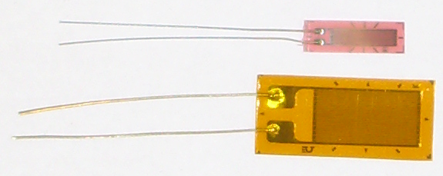
Figure 3.38: Picture illustrating the differences in size between the System 1 gauge type on the top, to the System 2 gauge type on the bottom.

Another consideration that was taken for the gauge type selected for System 2 was surrounding the gauge backing material (carrier) [48]. The polyimide E backing was chosen as it was tough, very flexible and had a high peel strength, as opposed to the slightly inferior polyester carrier associated with System 1. This resulted in the gauges being less prone to damage during installation. This backing type also had a very low elastic modulus and this minimised any possible reinforcement of the flexures due to the presence of the gauge [48]. As a result, it had virtually no effect on the strain produced and this aided in maximising the accuracy of the set-up. Regarding the gauge alloy selected, this was constantan for both gauge types. This alloy (45% nickel and 55% copper) had the best overall combination of properties, such as a relatively high gauge factor which remained virtually constant with respect to strain level and temperature [48]. In addition, the constantan foil had a good fatigue life which allowed for its properties to remain constant over time [48].

3.7.4 Instrumentation and Data Acquisition Set-Up

As mentioned in Section 3.7.3, the system sensitivity was primarily increased by increasing the V_{EX}. The DSI used with System 1 only provided a fixed V_{EX} of 2Vdc. Therefore, it was necessary to construct two strain gauge amplifier circuits, with one used separately for lift and drag measurement for System 2. In conjunction with this, a voltage power supply was used to provide the higher level of V_{EX} required. Due to the resulting very high sensitivity and fast response rate of the system, System 2 was able to detect very small changes in lift and drag and these forces changed rapidly over time during testing. As a result, it was necessary to implement a DAQ set-up to record and time-average the drag and lift forces. Therefore, this section explains the instrumentation used and the advantages associated with it, compared to the relatively less sophisticated set-up used with System 1.

The printed circuit boards (PCBs), amplifier chips (Figure 3.39(a) and (b) respectively) and the various separate resistors, transistors, diodes and capacitors required for the construction of the amplifier circuits were obtained from Radionics.

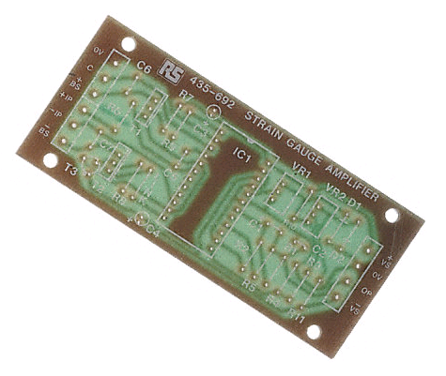
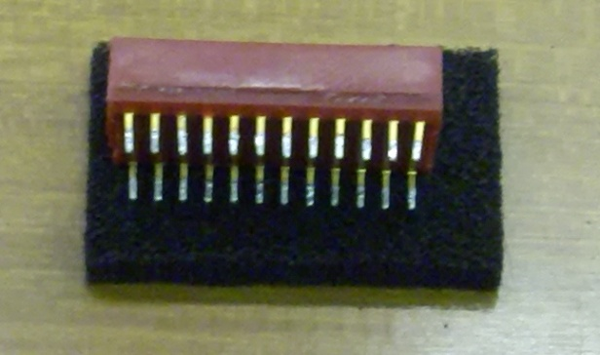

- (b)
Figure 3.39: (a) The PCB into which all of the various components were installed and soldered, (b) the 24 pin dual in line (DIL) amplifier chip which controlled the signals generated from the circuit.

The 24 pin amplifier chip fitted into the centre of the PCB, marked ‘IC1’, with the pins located in their correct arrangement. The characteristics of this chip were that it generated low noise levels, low levels of drift and that it acted as a linear direct current amplifier [49]. The maximum allowable V_{EX} was actually not dictated by the threshold of the gauges, but by the strain gauge amplifier circuits themselves. The maximum permissible voltage supply to the amplifier chip was $±$20V, therefore $±$19V was selected on the voltage power supply (V_{AMP}) for safety. With a V_{AMP} of $±$19V, as a result of the voltage drop due to the strain gauge amplifier circuitry, the actual V_{EX} supplied across each full bridge circuit (lift and drag) was 10Vdc. This was therefore 5 times higher than the V_{EX} supplied by the DSI used with System 1.

Another advantage with this resulting higher V_{EX} was that a higher signal to noise ratio was possible. Noise interference on the output could have been created by the other components in the instrumentation set-up and this would have affected the stability of the signals [48]. Therefore increasing the V_{EX} created a much higher level of output signal and any noise present would have been a much smaller fraction of the overall signal. This aided in creating an output with higher resolution and stability. The amplifier circuits also had a high input impedance, which ensured that there was negligible current flow produced through the lead wires, thereby minimising any lead resistance voltage drops [37]. The fully constructed strain gauge amplifiers allowed the adjustment of factors such as the gain and the zero output voltage point, independently for the lift and drag measurement. It was possible to adjust the gain by taking out two resistors from the PCB and replacing them with ones of higher or lower value. As a result, the gain range was adjustable from 3 to 60,000 and it was set at its default value of 1000 for the testing (Phase 2). Compared to System 1, this was much higher as the DSI only produced a fixed gain of 40.

Therefore, in addition to the higher V_{EX} increasing the output signal levels, this very large increase in the gain amplified these signals a large amount also. It was observed during the calibration of the system and throughout Phase 2 of the testing, that this increase was achieved in conjunction with a very stable output with virtually no drift. In Appendix F, details such as the specifications of the amplifier circuits, circuit diagrams and the equations for changing the gain and the zero adjustment range (ZAR) are listed. Therefore, the final set-up of the two strain gauge amplifier circuits can be seen in Figure 3.40. In addition to being able to control the zero output voltage point by adjusting the VR₂ potentiometer, the VR₁ potentiometer was used to set the bridge supply voltage.

This could have been used to decrease the voltage supply to the strain gauges in the case where too high of a fixed voltage supply was used to power the amplifier circuit. However, in this application the VR₁ potentiometer was adjusted to always allow the full flow of voltage supply to the gauges. The two copper plates which were connected to the two transistors (T₁ and T₂) were fitted as they alleviated the initial very small amount of drift observed on the output. Therefore, by acting as heat-sinks they drew heat away from these transistors and therefore away from the circuit.

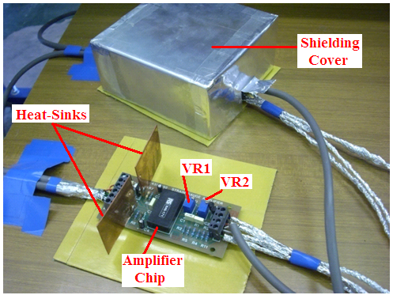
Figure 3.40: The completed strain gauge amplifier circuit.

Another aspect that can be seen in Figure 3.40 is the shielding of the circuits. The lead wires were individually wrapped in aluminium foil and grouped together to form a ‘faraday cage’ in order to prevent any possible magnetic loops between the wires, which would have caused noise interference. In addition, the two circuits were shielded with aluminium box covers, covered internally with insulating tape to prevent short circuits, while in use. Therefore, these steps were taken to prevent any interference between the lift and drag amplifier circuits and their respective wiring. On the left and right hand sides of the amplifier circuits, terminals were located into which the various inputs and outputs were wired as follows:

(a) Left of Strain Gauge Amplifier

This side of the PCB had the connections for the two inputs and the two outputs for one of the strain gauge circuits. These were the positive/negative bridge supply voltages (+BS and –BS) and the two positive/negative outputs from the gauge circuit (+IP and –IP). In addition, a short wire was used at these terminals to connect the +BS to the compensation terminal (C). This was a wiring aspect to do with the amplifier circuit, which allowed the full adjustment of the VR₁ and VR₂ potentiometers. The two cables containing the wiring that were fed into the left of the PCB were wired separately to a drag/lift flexure on either side of the balance, this due to the fact that a particular full bridge circuit (drag or lift) was split between a flexure on either side of the balance.

The lift and drag flexures located on the instrumentation side of the wind tunnel, referred to the side of the tunnel where the amplifier circuits, power supply and so on were located, contained the respective +BS wiring that went to each PCB. On the other hand the opposite side of the balance was fed by the respective two –BS wires, one into the left of each amplifier circuit. Therefore, each flexure which contained two gauges (one on either surface) were wired with either a + or – BS wire, a +IP wire and a –IP wire. Following on from this, the lift and drag full bridge circuits were wired corresponding to the circuit diagram in Figure 3.41(a). In Figure 3.41(b) the terminals corresponding to the left and right hand sides of the amplifier circuit can be seen. Therefore, in Figure 3.41(a) the two gauges fed by a +BS corresponded to those on the flexures (lift and drag) on the instrumentation side of the tunnel.

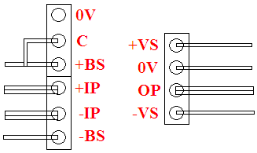
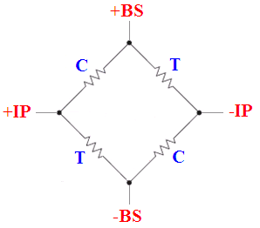
- (b)
Figure 3.41: (a) This illustrates the wiring of the two full bridge circuits, where C represents a gauge under a compressive force and T represents a gauge under a tensile force, (b) the terminals corresponding to the left and right hand sides of the amplifier circuit.

(b) Right of Strain Gauge Amplifier

The four input/output terminals on the right hand side of the amplifier circuit were connected as follows: one wire connected the +VS (positive voltage supply) to the positive output on the right (master) side of the power supply, 0V (ground) connected to the positive output on the left (slave) side of the power supply, OP (output) connected to the positive port for the respective drag or lift channel on the DAQ card (thick grey cable in Figure 3.40) and another from the OP to the oscilloscope (Channel 1 or 2 for drag and lift respectively) and the –VS (negative voltage supply) terminal was connected to the negative output on the left of the power supply.

In relation to the two channels on the DAQ card, the negative input was fed from the negative output on the right of the power supply. Also, from the same terminal on the power supply, two wires were separately connected into the respective cables going to the oscilloscope (Channel 1 and 2). Concerning the grounding between both sides of the dual power supply, a short wire was used to connect the positive output on the left to the negative sense terminal on the right hand side. As mentioned earlier, the positive output terminal on the left of the power supply fed the 0V terminal on the right of the amplifier circuits. Therefore, the overall complete instrumentation system set-up can be seen in Figure 3.42.

The voltage input to the amplifier circuits was supplied by a Thurlby Thandar Instruments 32V-3A Dual Power Supply. Apart from the DAQ set-up, the outputs from the amplifier circuits were also fed to a Tektronix TDS210 Two-Channel Digital Real-Time Oscilloscope. The oscilloscope allowed for the visual inspection of the output signals, in terms of their level and to observe the signal stability or any possible drift and noise interference effects. The DAQ card used was a National Instruments USB-6009 and the data was captured through LabVIEW SignalExpress 2009 software. This software was installed on an IBM Lenovo ThinkPad T60 laptop. The full scale measurement range of the DAQ card was 20V, with a 14-Bit resolution which was equal to 16,384 bits, thus dividing the full scale measurement range by the number of bits this resulted in a resolution of 1.22 × 10⁻³ V/bit (1.22mV/bit) [50]. The DAQ card also had a large dynamic range, which defined the noise level generated relative to the full input range [50]. The spurious free dynamic range (SFDR) of the card meant that the noise level created on the measurement signals was less than 0.0005% of the full input range [50]. More details on the specifications of the DAQ card are listed in Appendix G.

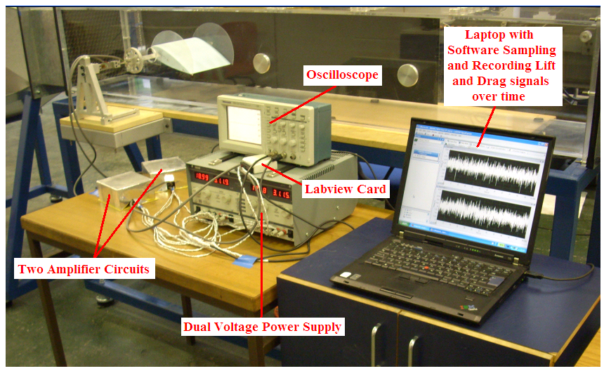
Figure 3.42: This photograph illustrates the final set-up of System 2, including the strain gauge balance and the instrumentation/DAQ set-up.

3.8 Application of Strain Gauges

Following the material and sizes of the drag and lift flexures being chosen, the next step was to apply the strain gauges to them. A good deal of care was given to this process, because if the bonding of the gauges to the flexures were not adequate certain errors would have occurred during testing, such as creep, offset strain and hysteresis effects. A thorough calibration process was later conducted which checked for such errors. While a similar process was conducted during both phases of the research, this section details the work carried out for the application of the gauges with respect to System 2.

The first step was to fully degrease the flexures with acetone, in order to remove any oil or dirt residue. Next, the surfaces were roughened slightly with very fine grade sand paper and this aided in the gauge bonding to the surface. After this process, it was necessary to mark out the points on the flexures as to where the strain gauges were to be positioned. This was necessary to ensure that the gauges were located in the same respective positions as each other and also to ensure the proper alignment of the gauges. If the gauges were positioned in such a way that their sides were not parallel to the edges of the flexures, there would have been an inaccuracy in the measurement due to an increase in the lateral strain sensitivity. Therefore, with a scribing tool two light lines were etched on the flexure that indicated the horizontal and vertical alignment points of the gauge. After this step, the surface of the flexure was cleaned a final time with acetone to remove any sanded particles or fingerprints. Following this, the fully prepared flexure and the strain gauge were laid on lint free paper. In Figure 3.43(a), the flexure can be seen with the two inscribed lines. These lines etched on the surface did not cause any strain measurement errors, as they were used for the alignment of the gauge carrier which was wider than the gauge grid.
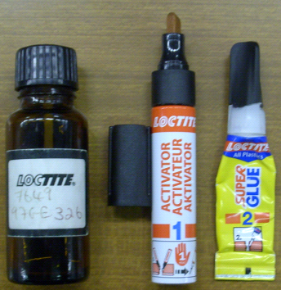
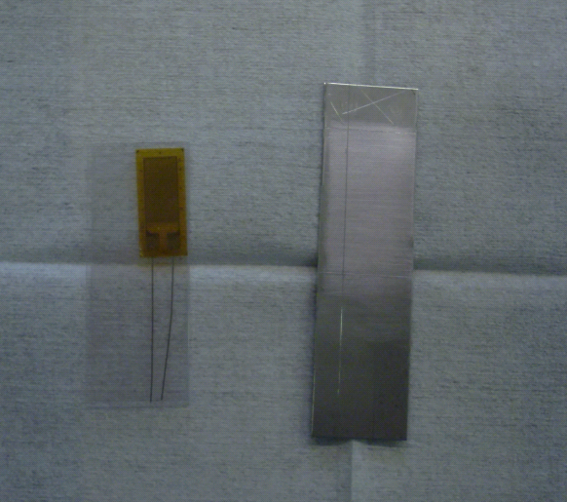
(a) (b)
Figure 3.43: (a) Photograph of one of the flexures fully prepared for bonding with the gauge in its protective film on the left, (b) these are from left to right: the pH solution, the activator and the cyanoacrylate adhesive.

Figure 3.43(b) illustrates the products that were used for the bonding of the strain gauges. Firstly, the area on the flexure to which the gauge was to be applied was coated with some pH solution and this maintained the correct surface acidity level for the bonding process. The next step was to prepare the gauge for bonding and in Figure 3.44(a) the process by which this was carried out can be seen. In order to allow the accurate alignment of the gauge and to prevent directly touching it, sellotape was applied over the top of the gauge, but did not cover the loose ribbon leads. Therefore, the strain gauge sat on an aluminium strip suspended between two weights and it was important that this strip was cleaned as thoroughly as the flexure itself. Once that the tape had been applied to the gauge the next step was to apply the activator, which was seen in Figure 3.43(b). This was in the form of a felt tip marker and it was spread over the surface of the flexure, resulting in a clear film. The Loctite activator and cyanoacrylate adhesive was used to bond the Polyimide E backed gauges to the stainless steel flexures, resulting in a very strong bond.

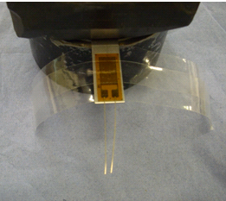
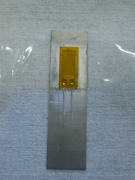

(a) (b)
Figure 3.44: (a) Photograph illustrating the placement of a gauge on an elevated cleaned surface which allowed for easier positioning of the tape and handling, (b) the flexure with the strain gauge bonded to it before the removal of the tape to check the bond quality.

After approximately 60 seconds (to allow for the activator to fully dry) a small drop of adhesive was applied to the surface. The sellotape with the gauge was then held at either end and oriented so that the strain gauge was directly aligned with the area to which it was to be applied. During the placement of the gauge onto the flexure air bubbles were prevented from being trapped under the gauge. Figure 3.44(b) illustrates the flexure and strain gauge at this point in the process.

The adhesive fully cured after a few minutes and following this the sellotape was carefully peeled back to ensure that the strain gauge was bonded firmly to the flexure. Therefore, this process was conducted for the 8 gauges in total that comprised the two full bridge circuits, and 24 hours was given before any loads were applied to the flexures. Thus, the next step once all the lead wires were soldered was to arrange these into groupings and wire these accordingly into the terminals on the left sides of the respective lift and drag strain gauge amplifiers, and then calibrate.

3.9 Calibration

The calibration that was conducted for Systems 1 and 2 had many purposes, such as to determine the balance sensitivity, stability and to check the repeatability of load data. Another important property that was checked was linearity and this was assessed through the deviation in the graph of the input load and the output reading from a straight line. The more linear that the relationship was, the more accurate the balance was in relating the output to the correct corresponding aerodynamic force. Through the calibration process it was also possible to assess any force interactions, whereby a load applied in the lift direction for example caused a change in the drag measurement output reading. However, due to the design of System 2, it was possible to use a force interaction matrix method to compensate for any small interactions that resulted. These interactions were significantly lower than those with System 1 which validated its effective design.

Even though achieving high sensitivity was one of the main goals when designing System 2, another important factor was stability as mentioned before. Having a highly sensitive system was only useful if the output readings, both under load and in the case where no load was applied, did not fluctuate over time. This could have occurred due to many factors such as: electromagnetic interference, inadequate heat dissipation from the gauges, an unsuitable excitation voltage and/or gain level which would have led to a poor signal to noise ratio. Also, if there was a change in balance sensitivity over time due to gauge bonding issues, the calibration data obtained prior to commencing the testing would no longer have been valid. Hysteresis was also checked during the calibration procedures of Systems 1 and 2. This was the degree of repeatability of the balance to give the same reading when measuring the same force. This aspect was checked by applying increasing loads to the maximum load value and then gradually removing all the weights individually. By recording the output at each load level and checking that the two sets of results were equal (increasing and decreasing loads), it was found from the calibration processes that no signs of hysteresis were evident.

Another source of error is known as strain gauge creep and this can generally occur if a load is applied to a balance suddenly [51]. Therefore, during the Phase 1 and Phase 2 testing with Systems 1 and 2 respectively, as the AOA and therefore the flow separation increased there would have been sudden force changes due to the fluctuating loads. This creep aspect had the potential of affecting System 2 more as the flexures were mechanically more sensitive than those in System 1, which led to a greater range of strain exerted on the gauges. At a given load the gauge output can decrease with time from an initial value, with the rate of decrease being larger for the first few seconds and then decreasing afterwards approaching an asymptotic value [51]. The magnitude of the change of the output with time is approximately proportional to the strain properties of the material to which the gauge is bonded [51]. This creep effect itself is the result of a partial relaxation of the bonding material used [51]. According to the tests conducted during the System 1 and 2 calibration processes it was observed that no creep effects occurred, that is when a load was applied to the balance the output remained constant when left for an extended period of time. However, during the Phase 1 and 2 testing, the fan speed was turned up in increments over a period of a several seconds, rather than being turned straight to full speed. By doing this, any possible risk of dynamic loading damage to the flexures/gauges would have been minimised.

3.9.1 System 1

For the calibration of System 1 a range of weights were applied through a pulley system (Figure 3.19). During the Phase 1 testing the strut was positioned such that its end was located at the midpoint of the span of the test models. Therefore, during the drag and lift force calibration the weights were applied to this portion of the strut in a distributed manner. Weights applied were in increments of 0.5N. In Figure 3.19 the balance was in its drag measurement set-up and this was then rotated onto its side as discussed in Section 3.6, for the calibration of the lift force. In addition, in Figure 3.19 it can be seen that the force was being applied in the lift direction and this was to check the force interactions. From this calibration procedure the output readings from the DSI during testing could be converted to a force through pre-defined equations. The results of this calibration will be discussed in Chapter 4.

3.9.2 System 2

As with the calibration conducted for System 1, care was again taken to ensure that the loads applied, which simulated the lift and drag forces, were aligned correctly with the balance. For the calibration the maximum loads that were applied were determined from the Phase 1 testing results. Therefore, loads were applied that exceeded the maximum expected forces by a small amount to ensure that the full range of drag/lift forces was covered. At the same time it was ensured that the maximum drag and lift loads applied during calibration were still within the elastic limits of the flexures. In Figures 3.45 and 3.46, the process of conducting the drag and lift calibration can be seen. Similar to the calibration of System 1, loads were applied to the strut in a distributed manner.

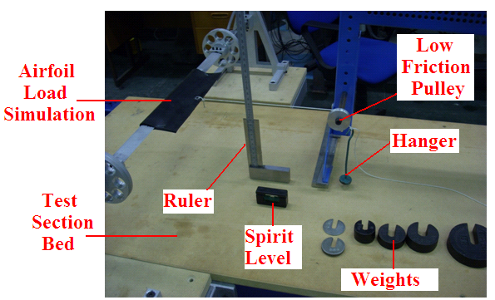
Figure 3.45: The set-up for the drag calibration.

Loads for System 2 were applied in increments of 0.1N for the drag calibration and 0.5N for the lift calibration. At a particular load, say 1.5N, this was removed before increasing it to 1.6N to check if there was any offset error (non-zero reading) occurring on the instrumentation. This was in conjunction with checking for any hysteresis effects for both the drag and lift calibrations, as previously mentioned. In relation to checking the stability and for drift errors of both the drag and lift outputs, a 1N load was applied separately during both calibrations and the set-ups were left static for an hour. At the end of the hour for both tests no change in the output reading was observed, thereby indicating that both circuit outputs were very stable.
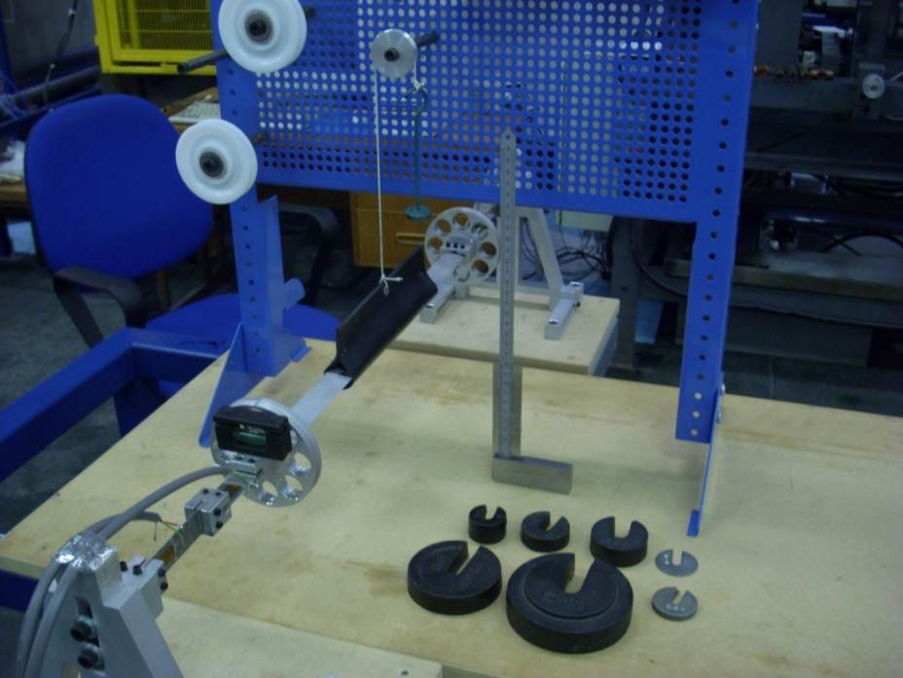

Figure 3.46: The lift calibration set-up.

During the lift and drag force calibrations, the very small outputs that were produced on the other respective (drag or lift) channels were recorded also. These results were therefore the force interactions which caused a slight change in the output from the particular secondary force. While this created a large measurement error with System 1, it was a great deal smaller with System 2 due to its effective design.

3.10 Wind Tunnel Operation and Force Measurement Procedures

In previous sections the design and set-up of all the equipment used in the experimental testing (Phase 1 and 2) have been discussed. In the following sections the procedures involved with using the Phase 2 equipment are covered. In relation to System 1, the insertion and removal of airfoils from the test section was more straightforward. This was so as the strut connection point in the balance could be loosened and the strut slid away from the test section. As a result, the test model was then removed from the end of the strut inside the test section. For the insertion of another airfoil, this process was simply reversed. In addition, the support table onto which System 1 was secured to could be rotated, which allowed for greater flexibility when making adjustments. However, with System 2 due to its necessary design, more components needed to be adjusted. In addition, System 1 did not use the more sophisticated instrumentation and DAQ software associated with System 2. Therefore, in Section 3.10.2 the process of how the software and instrumentation was used and how the voltage values recorded were converted into forces with the calibration data, are discussed. Also, as System 2 was developed to correct the measurement errors and performance inadequacies associated with System 1, this may remain as a permanent system that could be used by future students. As a result, the discussion focuses on System 2 in the following sections.

3.10.1 Insertion and Removal of Test Models

In order to place or remove a test model into/from the wind tunnel, the flow straightener (honeycomb) section and the contraction zone were slid back from the test section. Therefore, these two parts of the wind tunnel were left bolted together and the joint between both sections was sealed by insulating tape. This was an easier process than unscrewing the complete flow straightener section each time an airfoil change was required. This process is illustrated in Figure 3.47. In order to remove an airfoil and insert another one, the balance needed to be adjusted as previously mentioned. Firstly, a screw in the AOA Indicator on both sides of the balance was loosened. Following this, the screws securing the balance uprights to the guide rails were loosened and the uprights were carefully slid back (away from test section). This process was conducted carefully to ensure that no damage was caused to the flexures. At this point in order to remove the strut from the tunnel, one of the AOA Indicator components still attached to the ends of the strut needed to be removed. Therefore, the final step was to pull the strut and airfoil against the relevant side wall of the tunnel, thereby carefully removing the strut from the airfoil, and then the airfoil.

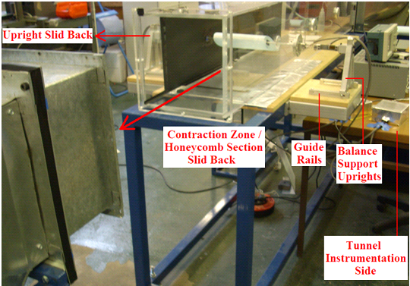
Figure 3.47: The contraction zone and honeycomb section were slid backwards for the removal/insertion of a test model.

Once an airfoil was set-up in the wind tunnel, the final step was to take measurements and position the airfoil such that its sides were equidistant to the tunnel walls. Following this, the two sides of the balance were set to a particular AOA, which usually was 0º for the start of a new test. With a spirit level, as in Figure 3.45, during the re-tightening process it was checked that the balance was aligned correctly.

3.10.2 DAQ Set-Up and Derivation of Force Values

Following on from this, the next topic to discuss was the process concerning the actual measurement of the aerodynamic forces with the DAQ system. The two strain gauge amplifiers required at least 5 minutes to warm up fully to a steady-state condition before readings could be taken. During this period the output drifted slightly, however after this the output readings on either the oscilloscope or recorded by the LabVIEW software remained very stable. It was initially thought that an output reading of approximately 0V would be used, through the adjustment of the VR₂ potentiometer with respect to Figure 3.40. However, it was observed from initial testing that this set zero point needed to be adjusted to a negative value. This was so as the maximum input voltage range of the DAQ card was -10V to +10V. The maximum output voltage from an initial setting of 0V, due to the lift force fluctuations, came close to 10V. Therefore, the VR₂ potentiometer on the lift strain gauge amplifier was adjusted to -5V approximately, to allow for the full output range of the lift force.

The next step was then to run the DAQ system in order to record the output on the drag and lift channels through the LabVIEW software. This was conducted with the wind tunnel turned off in order to get a ‘zero load’ output reading for comparison with the outputs recorded when the tunnel was turned on. This was necessary because over the duration of a test, the zero load output voltage would change slightly in value. However, this was not as a result of any errors associated with the system, but rather due to the slight changes in the temperature of the gauges as the flexures were loaded and unloaded during testing. Therefore, by recording the ‘zero load output’ and time-averaging the data, a voltage output value was obtained as a reference. This value was then subtracted from the corresponding time-averaged value obtained during an actual test. Therefore, this voltage output difference was used in conjunction with the calibration data to obtain an equivalent force.

When recording a signal over time in order to find a time-averaged value of a fluctuating output, as in the case of the drag and lift forces, the two variables that needed to be set were the sample rate and the sampling duration. The sample rate was the frequency at which the outputs from the drag and lift circuits were sampled (recorded), in terms of samples per second (Hz). The other parameter was how long to perform the data sampling process for, which determined the total number of samples recorded. Initially it was unsure as to what values both of these parameters should have been set at. Therefore, a NACA 0024 test model was set-up in the tunnel at 20º AOA, such that a high level of flow separation and vortex shedding were occurring. In addition, this was the highest AOA that the airfoils were tested to and at this point the highest rate of fluctuation in the lift and drag forces would have occurred. Therefore, if the system was set-up to satisfactorily time-average the lift and drag forces at this AOA, it would also have been adequate for the less fluctuating forces at the lower AOA.

Initially a fixed sample rate of 500Hz was selected. Tests were conducted with the airfoil subjected to forces in the tunnel and the sample time was increased in increments of 10 seconds. This process continued until the mean of the signal recorded remained approximately the same, even if the sampling time was further increased, to ensure that enough sampling time was being allowed to properly average all of the lift and drag fluctuations that occurred over time. Therefore, a sample time of 60 seconds was selected and a similar process was then carried out in relation to the sample rate. By increasing the sample rate to a point where a sufficient amount of data points were being taken, such that increasing it any further had no effect on the signal mean, led to the final sample rate being determined. This was selected as 3kHz (over the 60 seconds of data acquisition 180,000 samples were recorded).

Additionally, in relation to the sample rate, the fact that it was set at 3kHz meant that it was not too low for the effects of aliasing to occur [37]. Therefore, the signals recorded contained enough data points which allowed for a very accurate profile of the output signals from the amplifiers to be captured. For a validation of the overall set-up of System 2, it was possible to analyse the measurement noise and the stability of the recorded zero load output signals. As a guideline the standard deviation of the recorded signals (drag and lift channels) should be less than 0.010V [37]. The overall set-up produced standard deviation values that were usually between 0.003V and 0.004V during the experimental testing. Therefore, this validated the overall set-up in relation to the output signal stability and highlighted its consistency over time.

Following on from this, once the system had stopped recording the outputs under zero load conditions the signals would have looked similar to those in Figure 3.48. Therefore, this process of running the DAQ software before turning on the tunnel was conducted prior to each test at a different AOA. Immediately following this the wind tunnel was turned on and a few seconds was given before starting the recording process. This was to allow for the fan speed and the test section flow to reach equilibrium. Once the sampling time had elapsed the two recorded signals were displayed and the software would have indicated that the DAQ process had finished. At this point the tunnel fan was then turned off and the necessary AOA change was made to the airfoil, before repeating the above process for the next test.

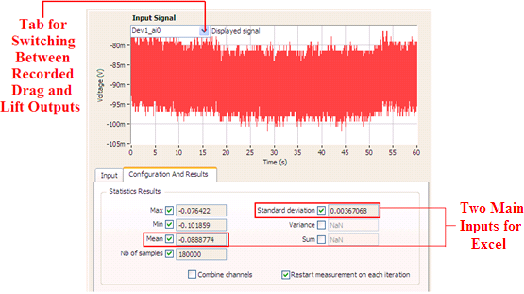
Figure 3.48: One of the voltage output signals (zero load) recorded before turning on the tunnel.

For a particular overall test of an airfoil and dimple modification, all of the DAQ signals recorded were saved to a “.seproj” file labelled with the test conditions for that airfoil. Therefore, prior to recording the output signals corresponding to a particular AOA, these were labelled with the AOA information and whether these signals were the zero load output signals or the signals corresponding to tunnel operation. The drag output signal from the testing of an unmodified NACA 0024 airfoil at 15º AOA can be seen in Figure 3.49, where on the bottom left of the Figure the recorded and saved signals from previous tests were observed. This therefore illustrates the signal analysis (Playback) part of the software, where the mean and standard deviation values were obtained. However, before switching from ‘Monitor/Record’ to the ‘Playback’ function, it was necessary to add a new step to the project from the ‘Add Step’ tab. Therefore, this was achieved by clicking: Add Step → Analysis → Time-Domain Measurements → Statistics. The steps that were taken to set-up the software are explained in further detail in Appendix H.

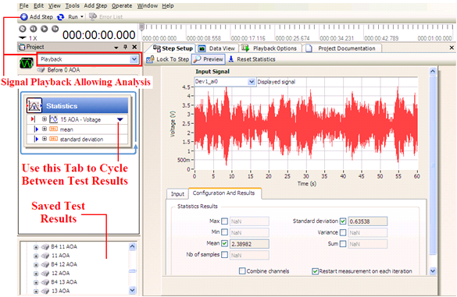
Figure 3.49: The signal analysis part of the software where the mean, standard deviation and other values could be obtained.

Once the mean and standard deviation values were measured, these values were then entered into an Excel spreadsheet. An example of a portion of such a spreadsheet can be seen in Figure 3.50. By calculating the difference between the zero load (tunnel off = OFF) mean voltage output and the corresponding non-zero load (tunnel on = 0°, 1°, etc) mean voltage output, the ‘Total Mean’ voltage output representative of a drag or lift force generated at a particular AOA could be obtained. This resulting value could then be related to a force from the calibration data discussed in Chapter 4.
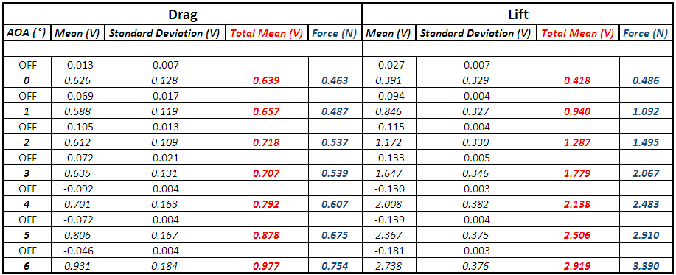
Figure 3.50: Typical Excel spreadsheet which was used to calculate the total voltage output corresponding to a lift or drag force at a particular AOA.

3.11 Smoke Flow Visualisation Set-Up

Flow visualisation can be divided into two main categories and the first category is surface flow visualisation. This is where the medium used is applied to the surface of a test model, such as tufts or oil flows [35]. The second category is off-surface techniques such as smoke flow or streamers and the smoke flow method was used in this research [35]. The process of smoke flow visualisation was achieved by injecting a fine stream of non-toxic smoke into the flow through the test section. As the smoke stream flowed through the tunnel it described the flow patterns around the airfoils. The presence of the smoke flowing through the wind tunnel does not affect the characteristics of the flow as the smoke is neutrally buoyant [35]. As the smoke particles were so fine their mass did not affect the momentum of the free-stream flow, or the development of the boundary layer on the airfoils. This allowed for a direct comparison between the results obtained with System 2 and the characteristics observed from the photography. While this process was conducted at the end of the Phase 2 testing, it was carried out in a relatively short period of time, and more shows an additional visual feature to the results. It could also be said that the overall experimental testing conducted in this research contained both quantitative (Systems 1 and 2) and qualitative (smoke flow) aspects.

Therefore, this smoke flow visualisation process was conducted with the wind tunnel fan turned to its lowest speed setting, which created a flow velocity through the test section of approximately 8.15m/s. Conducting the smoke flow visualisation tests at this low speed achieved the best results in terms of the quality of the photography. This was so as at higher flow speeds the smoke stream experienced degradation, known as mechanical degradation in flow (MDF) and the smoke stream became less visible as a result [21]. The smoke generator system was supplied by Aerotech A.T.E. (Aerodynamic Test Equipment) Limited in the UK. The oil flow to the tip of the probe through a supply line was provided by a pump and the oil flow rate was adjusted by a knob on the control unit. However, this knob needed to be turned on first before activating the voltage supply to the vaporiser tip in order to prevent any damage. The oil used that was added to the reservoir inside the control unit was ‘Shell Ondina EL’ oil and it was a medicinal quality mineral clear oil. Therefore, it was perfectly safe if the smoke was inhaled or if the oil came into contact with skin.

It was important that the voltage supply was increased slowly or else the 3 amp fuse located in the back of the control unit corresponding to the vaporiser would blow. In addition, when the unit was finished being used this knob was turned down slowly to zero first and the oil flow rate knob was left on for a few seconds. This allowed for some oil to flood the tip of the vaporiser and this prevented a carbon build-up. Therefore, by altering the oil flow rate and the voltage supply, a smoke output could be generated to suit particular test conditions. However, caution was required if the probe was used with an oil flow rate insufficient for the operating conditions, as the temperature of the vaporiser thus could rise above the ignition point of the oil. This could in turn result in a flame being produced at the vaporiser tip. The operational guideline was such that a transparent heat haze should not extend outwards for more than 12mm from the tip before condensing into visible smoke, and once the correct oil was used no ignition of the surrounding vapour loaded air would result, so there was no safety concern in this regard. Optimum conditions existed when the visible smoke plume started no further than 3mm from the vaporiser tip. The smoke generator control unit and the swan neck probe containing the vaporiser can be seen in Figure 3.51(a) and (b) respectively.

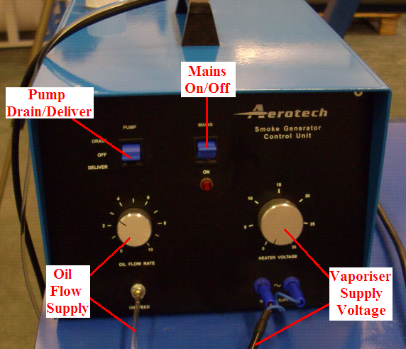

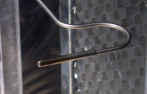

(a) (b)
Figure 3.51: (a) The control unit of the smoke generator, (b) the vaporiser tip at the end of the probe from which the smoke emanated.

While different set-ups were tested in order to maximise the quality of the smoke stream through the test section, the best result was achieved by inserting the probe tip directly into the honeycomb mesh at the start of the flow straightener section. By doing so a solid steady stream of smoke exited from one of the cells and flowed over the airfoil. This arrangement can be seen in Figure 3.52. As these tests were conducted at the lowest wind tunnel velocity the contraction zone was left detached. Tests that were conducted both with and without the contraction zone showed no visible difference in the smoke flow photography. In addition to this, tests conducted with System 2 showed very little difference in the values between the cases where the contraction zone was and was not attached.

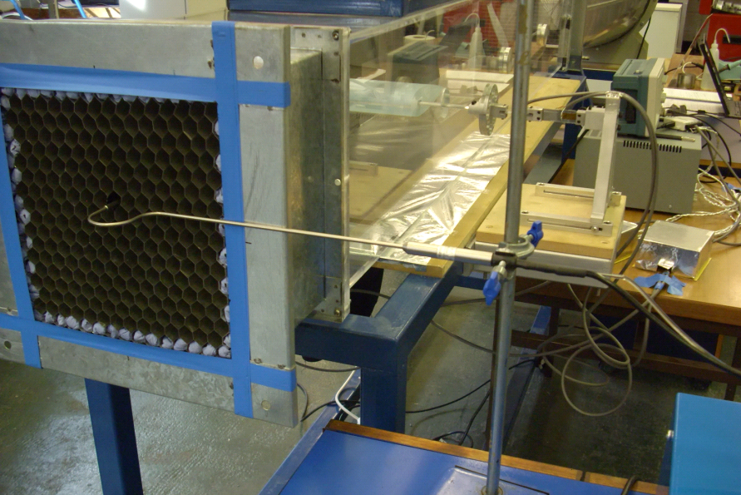

Figure 3.52: The insertion of the probe tip into the honeycomb mesh which achieved the best smoke stream flow quality.

Therefore, the probe tip was easily inserted into the start of the honeycomb mesh without having to seal any gaps that would have been present between the flow straightener section and the contraction zone. The added benefit of this was to do with the start-up phase of the smoke generator. As it was necessary to turn on the pump first so that flow was present at the tip of the vaporiser prior to turning on the voltage supply, if this probe was present in the honeycomb mesh many droplets of oil would have trickled into the cell in which it was inserted. Should the tunnel be turned on following this, the hot oil droplets that were not vaporised during the heat-up period would have been sucked through the test section. This would have caused surface damage to the test models and the test section would also have needed cleaning. Therefore, the method by which this start-up process was conducted was to create the proper smoke generation with the probe outside of the honeycomb mesh and then to insert it with the tunnel turned on.

However, even with this procedure the ‘oil flow rate’ and the ‘heater voltage’ were finely adjusted to ensure that no surplus oil was being drawn into the test section, while at the same time ensuring the density of the smoke stream was adequate. Therefore, these two values selected resulted in a pump speed setting of 3 and a heater voltage of approximately 22.5V. The speed setting numbers in Figure 3.51(a) for the pump were arbitrary values however. The probe which was held in position by a clamp was inserted into the honeycomb mesh such that the smoke stream flowed a small distance above the top of the airfoil. This allowed a smoke flow visualisation of the low pressure side of the airfoil and the entry point of the probe was adjusted depending on the AOA of the airfoil. Therefore, the overall set-up of the equipment used for the smoke flow visualisation photography can be seen in Figure 3.53.

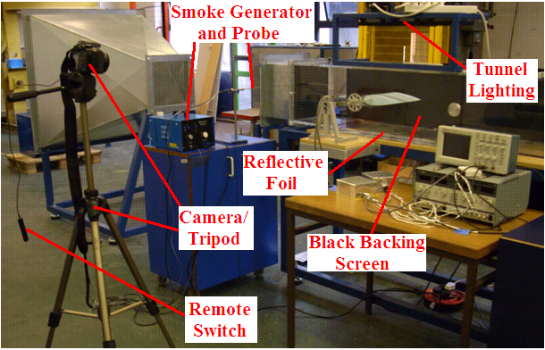
Figure 3.53: The overall set-up of the smoke flow visualisation equipment.

The camera that was used to capture the flow images was a Canon EOS-1000D 10.1 megapixel digital SLR. An additional lens (EF 50mm f/1.8 II) was purchased with it for this application. This lens had a larger aperture than the standard 18-55mm kit lens and this allowed for more light to enter the camera, which was necessary when taking photographs with a very quick shutter speed. This was beneficial as it was intended to use the quickest shutter speed (1/4000th of a second) in order to capture an ‘instantaneous’ photograph of the flow. If the standard lens was used, even with the strong tunnel lighting, this shutter speed would have resulted in under-exposed photographs. The camera was mounted on a tripod and this was aligned such that only a particular portion of the test section, containing the airfoil and some distance downstream of it, was in view.

In addition to the quick shutter speed used, a slower shutter speed of 1/200th of a second was used to produce photographs that resulted in a more solid and ‘fluid-like’ streamline of the smoke flow. This therefore allowed for a comparison between different images which resulted in different flow characteristics being observed. The camera settings took a good deal of experimentation with in order to produce optimal photographs. The shooting mode used was ‘Tv Mode’ and this allowed the setting of the shutter speed to be a priority. However, this mode also allowed for the adjustment of other camera settings. Therefore, the ISO speed (light sensitivity of the image sensor) was set at 1600, as this allowed for a very quick response to the light conditions in conjunction with the quick shutter speed that was used. The exposure was set to -1 and 2/3rds and this decreased the exposure of the images in order to have better detail between the contrasting white smoke and the black backing screen. The black backing screen used for this contrasting effect, which can be seen in Figures 3.53 and 3.54, was installed on the inside of the test section in order to eliminate any reflections that would otherwise have affected the photography.

The other feature of this set-up was the lighting rig which was required to sufficiently illuminate the test section from the top for the quick shutter speeds that were used. This rig consisted of three 500W fluorescent spot lamps which generated very strong lighting conditions and this can be seen in Figure 3.54. Whether the lights in the room were turned on or off had no noticeable effect on the quality of the photographs taken. As labelled in Figure 3.53, aluminium foil was placed underneath the test section. This was so in order to help increase the intensity of the lighting as some of the light would have been reflected back upwards.

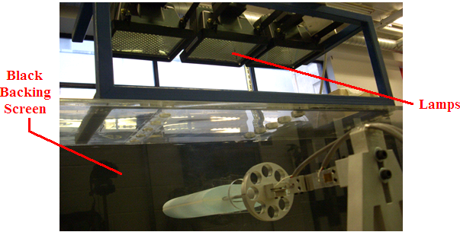
Figure 3.54: The lighting rig positioned on the top of the wind tunnel test section.

Chapter 4 – Results & Discussion

4.1 Wind Tunnel Testing Parameters

4.1.1 Wind Tunnel Velocity

In relation to Section 3.4.1, where the modifications that were made to the wind tunnel in order to reduce flow turbulence levels were discussed, these changes altered the flow velocity through the wind tunnel. The fan speed controller allowed for five speed changes in the air flow through the tunnel and each corresponding velocity value was known prior to making these modifications. The previous velocity measurements were made by using a Pitot-Static tube and manometer set-up and by using an air velocity meter (thermal anemometer). The five velocity readings gathered between these two devices showed very close agreement. With the two devices there were three separate readings taken at each fan speed setting, which also were close in agreement and these were averaged. Therefore, the resulting average values for the five speed settings measured by both devices and the average values between these results can be seen in Table 4.1 (results that were measured in previous research) [52].

Fan Speed Setting | Thermal Anemometer | Pitot-Static Tube /  Manometer | Average Values
1 | 11.16m/s | 10.64m/s | 10.90m/s
2 | 16.13m/s | 15.95m/s | 16.04m/s
3 | 19.90m/s | 19.35m/s | 19.63m/s
4 | 23.29m/s | 23.38m/s | 23.34m/s
5 | 27.05m/s | 27.45m/s | 27.25m/s
Table 4.1: Table detailing the averaged values for each measurement device and the final velocity readings taken as the average between these [52].

As the previous measurements of velocity conducted with anemometer in addition to a Pitot-Static tube and manometer showed close agreement [52], it was decided for the measurement of the new tunnel velocities that the use of one of the two devices would be sufficient. As it was mentioned above that with each device three runs were conducted at each speed setting which led to an average value, the fluctuations between the readings was slightly less for the anemometer and therefore was deemed to be slightly more consistent. In addition, as the differential pressure measurement reading from the manometer is conducted by observing the level of the fluid and reading a value from a scale, it could be argued that some human error may be present in the readings. As the reading from the anemometer is conducted by observing a value in m/s displayed on its digital screen, this level of uncertainty will be removed from the measurements. The anemometer, which had been recently calibrated, had an accuracy of $±$5% and a resolution of 0.01m/s. Therefore, the readings taken corresponding to the wind tunnel configuration during Phase 2 of the research, are presented in Table 4.2.

Fan Speed Setting | Velocity (m/s)
1 | 8.15
2 | 12.20
3 | 16.20
4 | 19.55
5 | 23.20
Table 4.2: Velocity values for the modified tunnel corresponding to the five fan settings.

When comparing the Phase 2 velocities to those from Phase 1, the velocity at each speed setting decreased by an average of 3.57m/s. Therefore, while the modifications reduced the flow turbulence through the test section, the screens in the contraction zone and the small reduction in the area through which flow could pass through the honeycomb mesh, directly reduced the flow velocity. However, the higher the fan speed setting the less the relative difference in the Phase 1 and 2 velocities. For example, at fan setting number 5 there was a decrease in velocity by 14.86% (4.05m/s) while at setting number 1 the decrease in velocity was 25.23% (2.75m/s). Therefore, the higher the flow velocity the lower the relative reduction compared to the previous values.

4.1.2 Reynolds Number Calculations

In the case of wind tunnel testing carried out in this research, it was necessary to determine if the flow was laminar, turbulent or in a transition between both states. The calculation of this value for a particular tunnel velocity aided in the analysis of the experimental results. A point to note is that in the case of the testing carried out in this research, the flow was modelled as incompressible. This was so due to the relatively low wind tunnel speeds used, which led to an assumption of constant air density (ρ), with little or no loss in the accuracy of the calculation of the Re values. Therefore, the value of the density was taken as the corresponding value at 20ºC which was the average temperature of the room in which the tunnel was located. Corresponding to the atmospheric pressure at sea level, the density would therefore have a constant value of 1.204Kg/m³ [35]. Another variable to be defined is the dynamic viscosity (μ) of the flow, which again at 20°C has a value of 1.8e⁻⁵Kg/m-s [35]. This is different to the kinematic viscosity (ν), which is the dynamic viscosity divided by the density and takes the form of 1/ν when relating the inertial forces to the viscous forces in the calculation of Re [35]. Therefore, by using Equation 2.8 with the variables defined above, the maximum Re representative of fan speed setting number 5 (23.2m/s) in Phase 2 of the research was:

Re = = 321,227

In this calculation, l was taken as the longest chord length from the test models that were used (0.207m for Phase 2 in Appendix B). Therefore, when considering this Re value the airflow around the test models was in the region below 500,000 and was therefore laminar [9]. While the majority of all tests conducted were carried out with the maximum flow velocity of 23.2m/s, some additional tests were carried out at lower fan speed settings. It is also worth pointing out that the smoke flow visualisation photography was conducted at the lowest fan speed setting. Therefore, the Re corresponding to each speed setting using the same values from the above calculation apart from V, can be seen in Table 4.3.

Fan Speed Setting | Velocity (m/s) | Re
1 | 8.15 | 112,845
2 | 12.20 | 168,921
3 | 16.20 | 224,305
4 | 19.55 | 270,689
5 | 23.20 | 321,227
Table 4.3: Calculation of the Re for each of the five wind tunnel velocities.
With regards to the split flap airfoil testing (Phase 2) the value of l was taken as 0.379m. This was so as the largest chord lengths of the main airfoil and flap used were both 0.207m. In terms of the orientation of the flap in relation to the main section, the leading edge of the flap was positioned 0.035m in from the trailing edge of the main airfoil. Therefore, with the flap at an AOA of 0° this would lead to an overall effective chord length of 0.207m + 0.207m – 0.035m, which was equal to 0.379m. Based on this value and V at 23.2m/s, this led to a maximum Re of 588,141. Therefore, this number signifies that the flow was just inside a transition region from laminar to turbulent flow [9].

4.1.3 Blockage Ratio Effect Calculations

As the tunnel test section was 0.3m by 0.3m, its frontal area (C) was 0.09m². The maximum value of the frontal area for a single airfoil set-up occurred when an airfoil was at 20º AOA. In terms of the largest airfoil tested, the NACA 0024 airfoil 207mm in chord length and 210mm in span was chosen for this assessment. By calculating the frontal height from a CAD drawing this led to a value of 83mm. Therefore, as the frontal height at 20º AOA was 83mm and the span (frontal width) was 210mm, this produced a frontal area (S) of 0.01743m². As the values of S and C were now known, it was possible to calculate the blockage ratio from Equation 3.2:

Blockage Ratio (%) = $\frac{0.01743}{0.09}$ = 0.1937 = 19.37%

A blockage ratio of 19.37% is less than the 30% guideline, at which value an error of approximately 20% would have been expected [35]. Since this value was only the case for the NACA 0024 airfoil at the maximum AOA of 20º, for the most part the values of the blockage ratio during the testing were a good deal less. While it could be argued that smaller airfoils could have been used to alleviate the errors that arose due to the blockage ratio, doing so would have generated lower drag and lift forces. In relation to the smaller drag forces this would have made an accurate measurement of any changes in drag more difficult, even with the highly sensitive set-up of System 2. Therefore, a compromise had to be made between the blockage ratio error and the measurement sensitivity. Even though the test conditions would have altered the true lift and drag values generated by the airfoils, in contrast to the case if they were in a larger test section, it was the relative (like with like) comparison between the test results that was deemed important.

In relation to the previously discussed components of the blockage error, the flow angularity may not have been exactly zero with respect to the 0º AOA indicator on the balance. As an example from the various tests that were conducted, it was observed that at 0º as indicated on the balance the typical lift force for a NACA 0024 airfoil read as 0.49N. Therefore, true 0º would have been located at approximately -1º AOA from the backward extrapolation of the increase in the lift force between 1º and 2º. This -1° offset of true 0° AOA (flow angularity error) is common in wind tunnel testing as a result of the contributing components of the blockage error [35]. While the strain gauge balance only had markings to indicate in the positive 0º to 20º AOA range, it was reasonable that this relatively small error was ignored as all tests were conducted on a comparative basis.

Regarding the split flap airfoil testing, as the main airfoil was maintained at 0º the additional blockage ratio of this airfoil was relatively easy to calculate. The frontal height of the airfoil was effectively the maximum thickness of the airfoil. As this was 24% of the chord length (207mm) for the NACA 0024 airfoil, the frontal area of this airfoil was 0.0497m (frontal height) by 0.201m (frontal width or span) which was equal to 0.0099m². In addition, it was necessary to consider the two weights and the two sets of spacers, in the case where they were all in place corresponding to 20º AOA as in Figure 3.10, in terms of their frontal areas. These two values were 0.0038m² and 0.0003m² respectively. However, the additional effect of the support frame was deemed to be negligible. Therefore by adding these respective frontal areas together, combined with the frontal area of the largest NACA 0024 airfoil tested as the flap at 20º AOA, this resulted in a total frontal area of 0.0315m². When this value was substituted into Equation 3.2, in relation to the frontal area of the tunnel test section, this resulted in a maximum blockage ratio of 34.97%. While this was a relatively high blockage ratio, which would have led to different drag and lift values than would have been applicable to testing with a negligible blockage ratio, it was the relative comparison between different surface modifications that was important to investigate.

It must be noted that the effect of the support strut was neglected in the calculation of the blockage ratios. Overall, it would have had a minimum effect on the blockage ratio value as it was quite small in frontal area compared to the airfoil. Due to its streamline shape any interference effects would have been small and equal for all tests. As a result of the insertion of the support strut into the quarter chord point of the airfoils, at 20º AOA there was a smaller gap to the bottom of the wind tunnel than that of the gap to the top. However, these gaps were still much more than the clearance to the sides of the tunnel. Therefore, in relation to the guideline where the model span should be less than 0.8 of the tunnel width [35], this was also adequately met in this case.

4.2 Surface Roughness Measurement

After averaging the three rows of data points the Ra value was found to be 107 microns (μm). This averaged value was a more accurate representation of the surface roughness, as the roughness was non-uniform across the sample. This corresponded therefore to an average surface roughness height of 0.107mm. This exact process was also conducted for a sample representative of an airfoil prior to being sanded, as discussed in relation to the preparation of the test models in Section 3.1. This led to a Ra value of 21 microns. Therefore, when the airfoils were dimpled with a ‘high Ra’ surface modification, they had over 5 times the surface roughness value of the airfoils prior to sanding. However, as a result of the high level of surface smoothness achieved by the sanding process with the very fine P600 grade sandpaper, it was not possible to accurately measure the Ra value of a corresponding sample with the profiler. As a result, for the purposes of this analysis and in relation to the P600 grade of sandpaper used, it was reasonable to assume that the Ra value of the sanded and fully prepared test models would have been significantly less than 21 microns [45].

4.3 Calibration

4.3.1 System 1

In Figure 4.1 it can be seen that the calibration process revealed a high linearity between the loading and output readings taken. These loads were in increments of 1N, as 0.5N would have been unnecessary due to the high linearity observed during an initial calibration. Therefore, in relation to Figure 4.1, it was only necessary to calibrate for the lift force. In Section 4.4, a further discussion will be presented on the reasons behind this and how the drag and lift forces were resolved during testing. This overall procedure was necessary due to certain measurement errors and design inadequacies associated with System 1.

Figure 4.1: Calibration graph for the lift force.

4.3.2 System 2

In relation to Section 3.9.2, where the calibration procedure for System 2 was discussed, the calibration results graph for the drag set-up can be seen in Figure 4.2. It can be observed that the data points illustrate a very high linearity and in the graph the trend-line equation can also be seen. This will be discussed in more detail in relation to the calculation of the aerodynamic forces from the output voltages recorded by the DAQ system.

Figure 4.2: The resulting graph from the drag calibration process.

Therefore, similar to the drag force calibration graph, the lift calibration graph can be seen in Figure 4.3. The cluster of data points at the start were due to the 0.1N incremental loading and from 1N onwards the force applied was in steps of 0.5N. Similar to the drag calibration, it can be observed that there was a very high linearity of the output with respect to the input. The corresponding trend-line equation can be seen also in Figure 4.3. The R² value (known as the square of the correlation coefficient) was an indicator of the linearity of the data points, with a value of 1 indicative of an excellent linear alignment. Therefore, in Figure 4.2 for the drag calibration, the R² value was only fractionally less than 1. However, in Figure 4.3 in relation to the lift calibration this value was exactly 1. These two respective values validated the overall linearity of the strain gauge balance over the range of forces applied.

Figure 4.3: The results graph of the lift force calibration.

The lightest calibration weight used (0.1N) resulted in an average of 140mV output for the drag measurement and an average of 85mV output for the lift measurement. In relation to the two calibration graphs, as a result of their very high linearity these ‘average’ values were calculated from data sets that had readings with very similar respective increments. Therefore, in order to convert an output voltage reading to a force in N, this was simply conducted by re-arranging the trend-line equations for x (load in N) and substituting in for y (output in mV).

Following on from the calibration data presented above, the next topic discussed was concerned with the force interactions. During the lift calibration the output from the drag strain gauge circuit was recorded at each load increment and vice versa for the drag calibration. The balance was designed with the proper alignment of the flexures and the secondary force insensitivity due to the respective flexure having a large effective thickness in the secondary force plane. However, it was very difficult to completely eliminate interaction effects between the measurement of these two forces. Therefore, the small amount of force interaction observed was accounted for by a force interaction matrix method [35].

The two force interactions were defined as: L_{R}(D_{L}) which was the lift force interaction recorded due to the drag force applied during the drag calibration, and D_{R}(L_{L}) was the drag force interaction recorded when applying the lift force during the lift calibration [35]. Therefore, the R subscript indicated the load read and the L subscript indicated the load applied. These two resulting interaction graphs are presented in Appendix I. Following this logic, the two main calibration graphs, Figures 4.2 and 4.3, were known as D_{R}(D_{L}) and L_{R}(L_{L}) respectively. In relation to L_{R}(D_{L}), even though the drag calibration was conducted in increments of 0.1N, in order to compare this to D_{R}(L_{L}), every 0.5N applied in the drag direction resulted in an increase of 8.29mV on average on the lift output. On the other hand, by applying the lift forces, the drag output reading decreased by 13.42mV on average for every 0.5N of lift force applied. Therefore, not only were the lift forces much larger than the drag forces, which led to an overall larger degree of interaction with respect to the drag output, the interaction was also larger (13.42mV vs. 8.29mV). This was due to the fact that the drag flexures themselves were more sensitive than the lift flexures, on account of their longer length. Consequently as with the excellent linearity of the drag and lift calibrations, the two force interaction graphs were also very linear with R² values close to 1. This aspect was important also as it ensured high accuracy when applying the interaction matrix method across the range of forces tested.

Thus, the methodology behind the force interaction matrix will now be explained. While this method could be applied to include all six force and moment components in a 3-D model, in this case it was applied for the valuation of lift and drag only. The linear approximations that related the load readings to the separate force components (which influenced the output), where the K_{ij} values represented the interaction coefficients, were determined by [35]:

L_{R} = K₁₁L_{L} + K₁₂D_{L} Equation 4.1

D_{R} = K₂₁L_{L} + K₂₂D_{L} Equation 4.2

Therefore, when Equations 4.1 and 4.2 were put into matrix form they were represented by [35]:

(F_{R}) = [K_{ij}] $×$ (F_{L}) Equation 4.3

In order to calculate the actual individual force components contributing to a particular force reading, it was necessary to invert the [K_{ij}] matrix. Therefore, an expression for the actual loading corrected for interaction effects was [35]:

(F_{L}) = [K_{ij}]⁻¹ $×$ (F_{R}) Equation 4.4

By multiplying the uncalibrated readings (F_{R}) with the derived interaction matrix [K_{ij}]⁻¹, the loadings calibrated for interaction effects (F_{L}) were obtained [35]. As the interaction on the lift force due to an applied drag force was so small, it was determined that it was only necessary to account for the effect of the lift force on the drag readings. For example, at 20º AOA the drag force observed during testing of the NACA 0024 airfoil only produced approximately 40mV of an increase in the lift reading. From the calibration data this was equivalent to approximately 0.05N of a force reading error on the lift measurement. Although, the DAQ was used to time-average the data, the maximum fluctuations in the output of drag and lift at 20º AOA were of the order of a few volts. Therefore, considering this was the largest interaction at the maximum AOA tested, the correction of this interaction was completely unnecessary.

In order to utilise Equation 4.4, it was first necessary to obtain the slopes (interaction coefficients) from the four graphs (two primary force calibrations and two secondary force interactions) and relate them to the K_{ij} variables in Equations 4.1 and 4.2, where:

L_{R}(L_{L}) = Lift Output due to Lift Force Applied = K₁₁ = 861.08
L_{R}(D_{L}) = Lift Output due to Drag Force Interaction = K₁₂ = 16.215
D_{R}(L_{L}) = Drag Output due to Lift Force Interaction = K₂₁ = -24.333
D_{R}(D_{L}) = Drag Output due to Drag Force Applied = K₂₂ = 1404.7

Therefore, as these four interaction coefficients were known, it was possible to construct the interaction coefficient matrix [35]:

[K_{ij}] = $\left[\begin{matrix}K_{11} & K_{12} \\ K_{21} & K_{22}\end{matrix}\right]$ = $\left[\begin{matrix}861.08 & 16.215 \\ -24.333 & 1404.7\end{matrix}\right]$

Therefore, the next step was to find the inverse of this matrix [35]:

[K_{ij}]⁻¹ = $\left[\begin{matrix}0.0011609536 & -0.0000134013 \\ 0.0000201107 & 0.0007116636\end{matrix}\right]$
Therefore, following on from Equation 4.4 which calculated the forces calibrated for the interaction effects, this equation was then written as [35]:

F_{L} = [K_{ij}]⁻¹ $×$ $\left[\begin{matrix}L_{R} \\ D_{R}\end{matrix}\right]$ = $\left[\begin{matrix}0.0011609536 & -0.0000134013 \\ 0.0000201107 & 0.0007116636\end{matrix}\right]$ $×$ $\left[\begin{matrix}L_{R} \\ D_{R}\end{matrix}\right]$ Equation 4.5

Where L_{R} was the lift force read (uncalibrated for interactions) and D_{R} was the drag force read, also uncalibrated for interactions. The L_{R} and D_{R} vector in Equation 4.5 was in this arrangement as it followed the arrangement of Equations 4.1 and 4.2, which created the resulting order of the [K_{ij}] and [K_{ij}]⁻¹ matrices. Therefore, in relation to F_{L} in order to obtain D_{L} or L_{L} (interaction corrected forces), the two matrices on the right of Equation 4.5 were multiplied [35]:

F_{L} = $\left[\begin{matrix}L_{L} \\ D_{L}\end{matrix}\right]$= $\left[\begin{matrix}\left(0.0011609536 × L_{R}\right) - (0.0000134013 × D_{R}) \\ \left(0.0000201107 × L_{R}\right) + (0.0007116636 × D_{R})\end{matrix}\right]$

As it was only necessary to calibrate for the interactions of the lift force on the drag readings, it’s deduced:

D_{L} = $\left(0.0000201107 × L_{R}\right) + (0.0007116636 × D_{R})$ Equation 4.6

Therefore, in order to obtain the true drag force corrected for interaction effects due to the lift force, D_{L}, Equation 4.6 was used. However, since the calibrations were conducted in N (load applied) and mV (output reading), the corresponding graphs had their trend-line slopes based on these units also. As these in turn led to the values of the [K_{ij}]⁻¹ matrix, the values that were substituted into Equation 4.6 for L_{R} and D_{R} had to be in units of mV. This led to a value of D_{L} in N, which corresponded to the units of the x-axis (load applied) of the drag force calibration graph in Figure 4.2.

In summary, as an applied lift force at a given AOA caused a slight decrease in the drag output reading due to the nature of the interaction, the true drag reading was slightly higher than the uncorrected reading and Equation 4.6 correctly accounted for this. Therefore, in relation to the Phase 2 testing results presented in this chapter, the values of the drag force in all of the graphs were those which were corrected through this technique. However, the lift forces were calculated somewhat more easily by manipulation of the trend-line equation in Figure 4.3. From the test results it was found that in the case of the lift force being at its maximum and where the interaction was greatest, this produced an error of 6.26% in the drag reading. On one hand this relatively small maximum error illustrated the effectiveness of the design of the strain gauge balance. However, even though this was the maximum error, in the interest of accuracy it was correct to account for this interaction effect.

4.4 Phase 1 Test Findings and System 1 Errors

During Phase 1 of the research the strain gauge balance used (System 1) to obtain the experimental results had certain measurement errors. This led to a level of uncertainty in the results, which resulted in the need to design a new force measurement system (System 2) before further testing was conducted (Phase 2). Due to the large amount of testing conducted during Phase 2, it is not possible to go into detail regarding the Phase 1 testing results in this section. However, the main conclusions that were drawn are summarised below:

- A major trend that was noticed with both the NACA 0006 and 0024 airfoil modification test results was that quite a strong relationship existed between the % lift loss and % drag reduction values (compared to baselines). When the lift increased at a particular AOA the drag also decreased and vice versa.

- A cambered NACA 4424 airfoil was also tested and although the drag was found to decrease and increase compared to the baseline between different AOA, the loss in lift outweighed any drag reduction in general.

- With regards to the NACA 0006 profile, a significant result was achieved by dimpling the full flow separation side only with a low Ra. In this case, not only did the drag mostly decrease slightly in a fluctuating pattern, but an average lift increase of 7.66% was also observed.

- The most promising result from the tests conducted with the NACA 0024 profile was achieved by dimpling the middle 1/3rd section on the separation side with a high Ra. This modification resulted in a 6% reduction in drag on average with no loss in lift.

Therefore, while there were small drag reductions and lift increases observed, in general for a particular airfoil these two forces were found to fluctuate in value by a large amount over different AOA. For example, Figure 4.4 illustrates this effect in relation to the NACA 0024 profile, on a high Ra dimple effect applied to its middle 1/3rd section on the flow separation side.

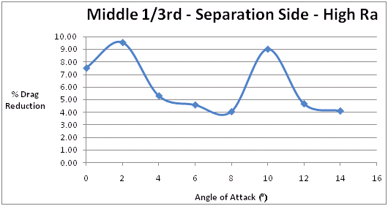
Figure 4.4: Graph of % Drag Reduction against the AOA for the NACA 0024 profile.

It can be seen that the % drag reduction (relative to the baseline values) fluctuated as the AOA was increased. At 0º it can be noted that there was approximately a 7.5% reduction in drag. While there would have been no pressure drag or flow separation occurring at this AOA, the presence of the dimples must have decreased the skin friction drag. In general a roughened surface acts to increase the skin friction drag of an object, but as discussed in Section 2.3.1, riblets can be used to decrease this component of drag. Lee and Jang [22] found that micro-riblets reduced the skin friction drag by restricting span-wise movement of longitudinal vortices. This reduced the cross-flow fluctuations of velocity and therefore reduced the shear stress [22]. While the width of the riblets would have been relatively close in value to the average width of a dimple, this mechanism only worked at a very low Re. For flow velocities greater than 3m/s the riblets caused an increase in skin friction drag and as the flow velocity applicable to Phase 1 was 27m/s, this should have resulted in a large skin friction drag increase. Therefore, at 0° AOA the 7.5% drag reduction did not agree with theory.

Following on from this, another test was conducted where the middle and last 1/3rd sections were dimpled on the separation side to a high Ra, but there was no change in drag at 0º. Rapid changes in the drag and lift forces produced between each 2º increment in the AOA were observed, which could not be explained for any logical reason, which resulted in a large degree of uncertainty with the results. Therefore, the conclusion was attributed to the measurement errors with System 1 and one of the main errors identified was concerned with a cross-coupling effect of the drag and lift forces. This in other words meant that both of these forces were not being isolated properly, which made the measurement of lift and drag difficult, as the cantilever type arrangement of the system created a moment on the balance. However, while a force interaction matrix method could have been used to correct for the cross-coupling effects, similar to that presented in Section 4.3.2 for System 2, this would have required two individual circuits for lift and drag measurement in order to be utilised. Another large error with System 1 was that a drift in the sensitivity of the balance occurred over time. There was a reduction in sensitivity of the drag measurement and an increase in sensitivity of the lift measurement. Figure 4.5 illustrates the % increase in the values taken between the lift calibration conducted after testing, compared to the one conducted before testing commenced. There was a 67% peak value increase at a load of 1N and an average of a 43% increase from this point onwards.

Figure 4.5: Graph of lift sensitivity increase after testing compared to before.
While different sets of calibration data were used, some uncertainty still existed over the results taken. In addition, the system exhibited random offset errors which were non-zero readings that remained on the output when a load was removed from the balance. These problems were attributed to ‘slipping calibration’ and the cause for these errors may have been due to one of the strain gauges having a poor bond with the flexure to which it was attached [35]. This was why great care was especially taken during the application of the larger gauges with respect to System 2.

In relation to the Digital Strain Indicator (DSI) used with System 1, while it was relatively easy to set-up, using it had some limitations. Firstly, the V_{EX} supplied to the gauges was fixed at 2Vdc, which was not high enough to maximise the sensitivity of the strain gauge circuit. This was in addition to the other drawback with the DSI which was that the signal amplification (gain) produced was fixed at 40. This was not as high as would have been desired in order to generate a sufficiently large output reading. While the balance was in its lift configuration set-up in Figure 4.6, it was also found that due to the cantilever effect the drag measurement was in fact more sensitive in this set-up. As a result of the large interaction of the drag and lift forces it was necessary to devise a method for isolating these forces from the readings taken. Therefore, the displacement of the strut during testing was recorded with a ruler, and from a calibration process the corresponding lift force was subtracted from the overall output value read from the balance instrumentation. The resulting reading was noted as the drag force, however this method was inefficient and had its uncertainties due to the measurement error involved with the strut and ruler technique.

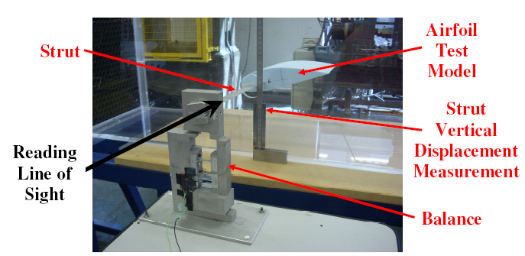
Figure 4.6: The technique used to account for the interaction effects.

It must be noted also that for the tests conducted with System 1, the lift values obtained were negative, as the test models were tested at negative AOA such that they created downforce. The reason behind this was due to the balance being less sensitive in the measurement of negative lift as opposed to positive lift. As the measurement of drag was deemed to be the most important aspect, the lower sensitivity of lift measurement in this set-up reduced the interaction effects of lift on drag measurement. Therefore, during the calibration process weights were suspended from the strut which simulated downforce. In Figure 3.19 however, the calibration of positive lift was being conducted but this was prior to discovering the lower lift sensitivity.

4.5 Improved Performance of System 2

In relation to choosing a suitable gauge for System 2, the following equation demonstrates how the resistance value of the gauge was selected [37]:

Power Dissipated = P_{G} = $\frac{{V_{G}}^{2}}{R_{G}}$ Equation 4.7

Where R_{G} is the resistance value of the gauge and V_{G} is the voltage across a gauge (equal to half the V_{EX}) [37]. Therefore, in Equation 4.7 it can be seen that by increasing the resistance of a gauge, the power dissipated through heat decreases. As a result, gauges with a high resistance value of 1000Ω were selected for System 2. This was significantly higher than the 120Ω gauges used with System 1. Therefore, in relation to Equation 4.7 the P_{G} of one of the gauges (System 2) was equal to 0.025W. In this calculation the value of V_{G} was taken as 5Vdc as the voltage across one gauge was equal to half the V_{EX} [37]. Following on from this, the power density was defined by the following equation [37]:

P_{D} = $\frac{P_{G}}{A}$ Equation 4.8

As a result, the P_{D} related the relationship between the P_{G} and the area (A) to which it was applied [37]. With the grid area of the gauge type used with System 2 being 9.36 × 10⁻⁵m², 5.85 times larger than the grid area of the System 1 gauge type, the P_{D} was 267.09W/m². As two gauges were positioned on opposite sides of the thin flexures in the same relative locations, this aspect was also taken into account. Therefore, even in the case where the P_{G} value was doubled, but still acted over the same area, this would have led to a P_{D} of 534.19W/m². However, as a guideline for thin steel sections the maximum allowable P_{D} would be 1500-3000W/m² [47]. As a result, it can be seen from the calculations that even the value of 534.19W/m² would still be well within this guideline. This therefore validated the ability of the gauges to withstand a higher V_{EX} with a low level of gauge heating being produced, resulting in much higher measurement sensitivity and signal stability.

The gain level set on the amplifier circuits was 1000 and while this could have been increased much further, not only were the output signals already sufficiently large but a higher gain could have led to noise problems and reduced signal stability. However, this was much higher than the fixed gain of 40 produced by the DSI used with System 1. Due to the resolution of the DAQ card being approximately 1mV, this value would have corresponded to a minimum load response (sensitivity) associated with the drag and lift measurement [47]. In terms of the drag sensitivity, where 0.1N of load corresponded to 140mV (0.71N/V) output from the calibration process, 1mV corresponded to 0.0007N approximately. However, it must be stated that this value of 0.0007N was extrapolated from the calibration data, as the smallest load applied was 0.1N. However, this would have been a reasonable approximation due to the very high linearity observed from the calibration process.

As the maximum drag force generated during the Phase 2 testing was approximately 2.5N, which produced an output of 3300mV, this resulted in a ratio of 3300:1 of the maximum to minimum loads (1mV corresponded to a 0.0007N minimum load). Another way of analysing this was that the minimum reading was 0.03% approximately of the full scale value. As 0.03% was equal to 3 drag counts, where 1 drag count would have been equal to 0.01% of full scale, the resolution of the set-up of System 2 was of very high order [47]. In terms of the maximum lift force which was approximately 8.5N, the lift sensitivity of 85mV per 0.1N load led to a minimum lift force response of 0.0012N approximately. As the full scale output equalled 7360mV, this resulted in a ratio of 7360:1 of the maximum to minimum loads. Therefore, the minimum reading was 0.014% of full scale or 1.4 lift counts approximately.

4.6 Phase 2 Single Airfoil Testing Results

4.6.1 Baseline Results – NACA 0024 and NACA 0006

Before starting to discuss the results that corresponded to the various dimple modifications made to the test models, it is first necessary to analyse the baseline results to which the modifications are compared to. The baseline results were the drag and lift values measured from a fully smooth airfoil, prepared as discussed in Section 3.1, in the AOA range from 0° to 20°. In this section the baseline results for the NACA 0024 profile will be discussed first and following this the NACA 0006 baseline results will also be analysed. For the rest of this chapter the ‘NACA’ parts of the names of the two airfoil profiles will be omitted and they will be referred to as either ‘0006’ or ‘0024’ airfoils/profiles.

(a) 0024 Profile

It was discussed in Section 3.4.2 that the static pressure varied along the test section, due to the boundary layer along the tunnel walls becoming thicker [35]. This reduced the ‘effective frontal area’ of the test section and the result of this was that the pressure is lower towards the end of the test section. As a result, this would have had the tendency to pull the airfoil in the flow direction and this produced a small additional drag force, known as ‘horizontal buoyancy’ [35]. As discussed in Section 2.1.5, wings of low aspect ratio would have a high induced drag component [7]. As all of the airfoils used in both phases of this research had an aspect ratio close to 1, this would have resulted in a high amount of induced drag being evident. The proximity of the tunnel walls to the sides of the airfoil may also have increased the effect of the induced drag, as local flow separation may have occurred on the sides of the airfoil [35]. This effect may have been more severe for the thicker 0024 profile. As the blockage ratio increased, the wake formation behind the airfoil would have been exaggerated in size. This was due to the accelerated flow around the edges of the wake resulting in lower pressure, which acted to expand the wake and therefore led to an increase in drag [35]. Also, as the wake formation behind the test object was compacted into a smaller space than it would naturally expand to, this increased its turbulence intensity [35].

In addition, the proximity of the test section boundaries to the airfoil would have had an influence on the effective angle of incidence of the flow [46]. This is known as ‘streamline curvature’ and it can affect the true AOA of the airfoil [46]. These resulting errors due to the blockage ratio not only affected the baseline results, but would have applied to all of the testing results. However, while the drag and lift forces and the resulting coefficients (C_{D} and C_{L}) at a given AOA would be different to those without such blockage effects, these errors would be consistent for similar tests. As a result, this allowed the drag and lift values to be compared on an equal basis. Therefore, in Figure 4.7 the baseline drag and lift results for the 0024 profile can be seen.

Figure 4.7: Baseline drag and lift values for the 0024 profile.

Although the 0024 profile was symmetrical such that it should not have produced any lift at 0° AOA, Figure 4.7 shows that it was generating 0.49N of lift. The reason for this can be explained by the flow angularity in the test section as a result of the blockage ratio. Although at 0° AOA the blockage ratio would be at its smallest value (largest is at 20° AOA = 19.37%), this would still equal 11.54% in relation to Equation 3.2. As mentioned above, the relatively close proximity of the test section boundaries to the airfoil would have influenced the effective angle of incidence of the flow. This ‘streamline curvature’ would have in turn affected the true AOA of the airfoil, resulting in it having a better lift to drag ratio [46]. Therefore, it was calculated from the data that the true 0° AOA was located at approximately -1°. This effect of the true AOA being slightly lower than that indicated on the balance is a common occurrence in wind tunnel testing in cases where the blockage ratio is not sufficiently low [35].

While the strain gauge balance only had markings to indicate the positive 0º to 20º AOA range, it was decided that it would be reasonable that this relatively small error could be ignored as all tests will be conducted on an equal basis. In relation to the general trend of the lift for the 0024 baseline, the increase in the lift force was approximately equal between each 1º AOA increment up to 10º. The relative lift increase in the 10º to 20º range between each 1° increment decreased in value slightly, as the AOA was increased towards 20°. However, it can be seen in Figure 4.7 that the overall trend was quite linear. However, a major point that could be noticed with the lift curve is that no stall point was evident. The stall angle for a 0024 profile should occur at approximately 18° [6]. The reason as to why the airfoil does not appear to be reaching a stalling point can be explained by the improved lift to drag ratio, as a result of the streamline curvature and high blockage ratio [46].

The coefficients of drag (C_{D}) and lift (C_{L}) were calculated for the 0024 baseline test. At an AOA of 18°, taken as the maximum typical stalling AOA, these coefficients were calculated with the equations discussed in Section 2.1.3. The values of the density and the velocity of the air flow were taken from Section 4.1.2. In addition, the planform area (chord length by span) of the airfoil was required for the C_{D} and C_{L} calculations (Appendix B). Therefore, from the drag and lift force values at 18° AOA in Figure 4.7, the C_{D} and C_{L} values were 0.161 and 0.573 respectively. As a result, the C_{D} value was approximately 10 times higher than the theoretical value, with the C_{L} value being approximately half the theoretical value [6]. However, these theoretical values were applicable to an infinite wing (no wing tips) for which the effect of wing tip vortices and the resulting induced drag would not have been accounted for. As the level of induced drag would have been high for the airfoils tested in this research, as they had an aspect ratio of approximately 1, this accounts for some of the difference. In addition, the relatively high blockage ratio adversely affected the drag and lift characteristics as discussed above. Consequently, at 18° AOA the lift to drag ratio was equal to 3.55 and this value is in stark contrast to a typical value in the range of 12 to 20, which is the case for wings on commercial airplanes [1].

(b) 0006 Profile

The baseline results of lift and drag for this profile can be seen in Figure 4.8. It can be observed that the testing was only conducted up to 15° AOA, as opposed to 20° for the 0024 airfoil, as the airfoil became quite unstable at 15° with large fluctuations in the drag force particularly. As shown in the x-axis of Figure 4.8 increments of 3° were used and in the majority of the test results presented in this chapter, it was more efficient to use larger increments than 1°. Although the balance was designed to make AOA changes in 1° increments, using larger increments saved time during the testing. However, it is important to state that doing this did not produce drag and lift force graphs which would have been any different in profile to equivalent graphs with smaller AOA increments. The drag and lift forces did not increase and decrease in value rapidly over small AOA increases. Therefore, any increase or decrease in the drag or lift values compared to the baseline results occurred in a more gradual fashion as the AOA was increased, thereby allowing larger AOA increments to be used.

When the standard deviation values of the drag and lift signals recorded at 12° and 15° AOA were compared, it was observed that the drag variation increased by 2.5 times. As the drag flexures were longer in length than the lift flexures, their lower torsional rigidity led to a higher sensitivity in relation to a largely fluctuating pitching moment. In comparison to the 0024 profile at 15° AOA, the 0006 profile was producing 3.45% more drag and 2.01% more lift. In addition, the standard deviation value of the drag signal at 15° AOA was 4.35 times higher (1.77 times higher for the lift) than the 0024 profile. Although there was no sign of stalling evident for the 0006 airfoil, as with the 0024, thinner profiles will have a lower stalling angle [6]. As a result, the 0006 profile should have stalled at an AOA between 10° and 12° [6]. The high instability of the 0006 airfoil can be explained by a more severe induced drag component occurring. As this profile was 4 times thinner than the 0024, the pressure differential between both sides of the airfoil mixed more easily. Therefore, the flow that was drawn from the lower high pressure side to the upper low pressure side would have had less distance to travel around the thinner sides of the 0006 profile. Therefore, a larger amount of wing tip vortices formed, which not only affected the drag and lift characteristics, but also created aerodynamic instability [3].

As mentioned earlier, the lift and drag levels at 15° AOA were similar to the respective values for the 0024 profile. However, while the two different airfoils had nearly identical spans, the chord length of the 0006 was a good deal less (190mm compared to 207mm). Therefore, this led to the 0006 airfoil having a planform area 7.77% less which should result in lower values of drag and lift at a given AOA. This is in addition to the fact that the thinner 0006 profile should produce less drag at a given AOA [6]. Therefore, the fact that the 0006 airfoil was producing similar drag values at 15° AOA to the 0024 airfoil, can be explained by the greater level of induced drag associated with the thinner profile. While the blockage caused by the 0006 airfoil was less due to its lower thickness and overall size, at 15° AOA this was still equal to a relatively high value of 11.66%. For example, when the blockage ratios of both profiles were compared at 20° AOA, despite the reduced thickness and smaller overall size of the 0006 profile, this still generated 78.32% of the blockage that the 0024 profile created. Thus, the blockage errors discussed before in relation to the 0024 profile also applied to the 0006 profile, perhaps to a slightly lower extent. Even though at 15° AOA the 0006 profile would have been experiencing high levels of induced drag and flow separation, the high blockage ratio increased its stalling angle [46].

Figure 4.8: Baseline results of lift and drag for the 0006 profile.

As discussed in relation to the baseline 0024 values of C_{D} and C_{L}, similarly these values were calculated for the 0006 profile. The theoretical stalling angle at 12° yielded values of C_{D} and C_{L} of 0.115 and 0.486 respectively. This resulted in a C_{D} value being approximately 11.5 times higher and the C_{L} value approximately 60% of the respective theoretical values [6]. Also, at 12° AOA the lift to drag ratio was 4.21, which was slightly higher than that of the 0024 airfoil at its stalling AOA of 18°.

4.6.2 Modification Test Results - NACA 0024

In Section 3.2.1 it was discussed that the two main parameters regarding the application of dimples to the airfoils was their location and their degree of surface roughness. The locations to which the dimples were applied were divided into 1/3rd sections, on the low pressure flow separation side, as highlighted in relation to Figure 3.5. In general, if the high pressure side of the airfoil was dimpled it would have a modification applied to its full surface. This was primarily conducted to observe the effect on skin friction drag and on any possible interaction of the flow leaving both surfaces at the trailing edge. In addition, the two different degrees of the dimple effect tested consisted of a low and a high surface roughness (low/high Ra). It was also discussed in Section 3.2.1 that the variables involved with the use of the sand blasting rig to create a dimple pattern could be kept constant, therefore this led to very little difference between the relative low or high Ra modifications. In order to produce a less fragmented discussion and analysis of the results, due to the number of tests conducted in the research, some results are grouped together into the same graph. This enabled an easier comparison of different tests rather than discussing each one individually.

Therefore, the first two modifications that are discussed are the application of a high Ra dimple effect to the first 1/3rd section and to the first and second 1/3rd sections, on the flow separation side of the airfoil. All other parts of the airfoil were left fully smooth in both cases. In Figure 4.9 the results of these dimple modifications in relation to drag can be seen. These are compared to the baseline drag values for this particular airfoil, which are the same as those in Figure 4.7.

Figure 4.9: First two tests conducted with the 0024 airfoil.

Therefore, the first major characteristic that can be observed for both of these modifications is that the testing was only conducted up to 8° AOA. The reason for this was, due to the application of dimples to the frontal section on the flow separation side, this resulted in very high aerodynamic instability. As a result, the largely fluctuating lift and drag forces caused the flexures to vibrate at a level that was more than desirable. Even though it can be seen that for the two modifications the drag forces at 8° AOA were still relatively low, upon analysing the standard deviation values of the recorded signals on the DAQ software, the resulting large values indicated highly fluctuating drag and lift forces. For the first 1/3rd modification, the values of the standard deviation of the lift and drag signals at 8° AOA were similar to the respective values for those at 20° for the baseline results. However, the fully smooth airfoil was still very stable at 20° AOA, with no rapid fluctuation in the drag or lift forces. Therefore, if the two sets of signals had quite similar values of standard deviation, the frequency of the fluctuations in the output signals should be different. This concept is illustrated in Figure 4.10, where the drag voltage output signals recorded for the baseline at 20° AOA and the first 1/3rd modification drag signal at 8° are compared.

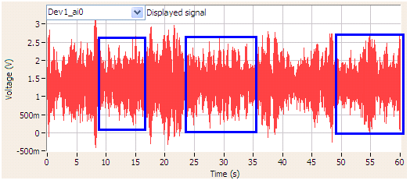
(a)
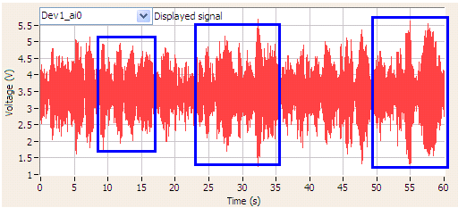
(b)
Figure 4.10: (a) First 1/3rd modification drag signal at 8°, (b) baseline drag signal at 20°.
It can be observed in Figure 4.10(a) and (b) that the blue boxes highlight similar parts in time for each signal. However, in these boxes in Figure 4.10(b), it can be seen that the output values are more concentrated and vary less over time, leading to thicker and wider groupings of the signal peaks. On the other hand in the corresponding boxes in Figure 4.10(a), the spikes in the voltage output vary more rapidly over time and this led to a thinner and sharper profile of the signal peaks. In fact, the standard deviation value of the drag signal for the baseline was 0.46N while the corresponding value for the first 1/3rd modification was lower at 0.36N. Therefore, this shows that while the outputs recorded from different tests may have had similar values of standard deviation, one signal could vary much more rapidly over time and have higher fluctuation frequencies as a result. This explains the reason as to why the first 1/3rd modification at 8° AOA resulted in a relatively low value of standard deviation, but created large fluctuations in the drag and lift forces. Therefore, the testing was stopped at this point to prevent any damage occurring to the flexures.

With reference to the first and second 1/3rd modification, the lift and drag outputs had a standard deviation of approximately three times greater magnitude at 8° AOA compared to the first 1/3rd modification. However, from a visual point of view when the testing was being conducted, it was difficult to observe a noticeable difference in the severity of the fluctuations at 8° AOA between both tests. Therefore, after analysing the drag and lift voltage output signals, this may be explained by the fact that the forces were not fluctuating as rapidly compared the first 1/3rd case, but fluctuated by a greater overall amount. As a result, the frequency of the fluctuations was lower but the range over which they fluctuated (amplitude or peak-to-peak values) was higher and this led to higher standard deviation values.

In relation to the actual drag values obtained for the two modifications, the first 1/3rd high Ra dimple effect caused a drag increase of 8.86% at 0° AOA. This was caused by the dimples tripping the boundary layer into turbulence at the front of the airfoil which in turn led to a higher value of skin friction drag. As the AOA was increased the drag becomes slightly higher relative to the baseline, where the turbulent boundary layer and increased Reynolds shear stress led to an increased drag force. This agrees with theory as when the transition point shifts forward it leads to an increase in drag [1]. However, an analysis of any possible reduction in pressure drag could not be conducted due to the testing being stopped at 8° AOA (before its level would have become significant). However, the results for the other modification were quite different and at first glance there did not appear to be an easy explanation for these results. It can be observed in Figure 4.9 that at 2° AOA there was a large drop in drag to a near zero value of 0.08N. Following this, the drag remained lower than the baseline up to 8° AOA. Therefore, if it is a case where extending the dimples to the 2/3rds point along the separation side of the airfoil could decrease the skin friction drag, it would be expected that dimpling the full separation side would also result in a lower drag force. However, as will be seen later, the drag forces generated by this modification resulted in a higher value of drag at each AOA compared to the baseline. Therefore, the dimple modification to the first and second 1/3rd sections must have had a unique effect on skin friction drag.

The lift results for the two modifications, compared to the baseline values of lift, can be seen in Figure 4.11. Overall, the two modifications exhibited similar values of lift up to 6° AOA where the lift forces dropped below that of the baseline, especially in relation to the first 1/3rd modification. It can also be observed that the first and second 1/3rd modification produced 28.7% more lift compared to the baseline at 2° AOA. This was also the point where the drag generation was almost zero, in relation to Figure 4.9.

Figure 4.11: Lift results compared to the baseline for the first two modifications tested.

However, when the unusual drag effects in relation to the first and second 1/3rd modification in conjunction to the high instability generated by the modifications at a relatively low AOA were assessed, it can be stated that these two modifications produced quite a negative overall effect on the aerodynamic performance of the airfoil. Following this, the remaining modifications conducted to this airfoil are highlighted in two separate graphs, again one for drag and one for lift. The effect of these modifications firstly on drag, in relation to the baseline results, can be seen in Figure 4.12. These tests consisted of a high Ra application of the dimples to the full flow separation side, to the high pressure side only (airfoil inverted from last test) and to both sides of the airfoil.

Figure 4.12: Drag results compared to the baseline for the remaining modifications to this airfoil.

These modifications increased the drag forces at each AOA compared to the baseline. Although the application of the dimples to the high pressure side produced very similar levels of drag to the baseline at the higher AOA, in general these modifications had an overall negative effect on the drag force. As with the previous two modifications discussed in relation to Figures 4.9 and 4.11, the application of the dimples to the full separation side (Full Sep Side) or to both sides (Full Both) caused large instability effects. However, these two modifications in relation to Figure 4.12 generated larger fluctuations in their drag signals in comparison to the relative fluctuations in their lift signals. Therefore, when the last 1/3rd section of the airfoil was dimpled (full separation side modification) this resulted in slightly less fluctuations of the forces, and allowed the testing to continue to 10° AOA as opposed to 8° (Figures 4.9 and 4.11). With regards to the test where both sides of the airfoil were dimpled, this was slightly more stable again as the testing continued to an AOA of 12°.
The addition of the dimples to the bottom high pressure side of the airfoil, regarding ‘Full High P’ in Figure 4.12, did not affect its stability and the testing was able to be conducted up to 20°. However, when the dimples were added to the frontal part of the flow separation side, large instabilities were observed greatly fluctuating the lift and drag forces. While the first and second 1/3rd modification discussed in relation to Figure 4.9 produced a drag reduction in the low AOA range, it can be seen in Figure 4.12 that by adding dimples to the rest of the parts of the upper and lower surfaces of the airfoil caused the drag to increase compared to the baseline. While it can be logically explained that a drag increase was expected by adding dimples to the high pressure side, as it increased the skin friction drag, it is unusual that the dimpling of both sides caused a reduction in drag compared to the full separation side modification. In Figure 4.12 it can be observed that when the high pressure side was dimpled, adding dimples to the upper surface had no effect on the levels of drag produced.

The lift curves from the tests where dimples were applied to the high pressure side and to both sides of the airfoil are shown in Figure 4.13. Therefore, in relation to dimpling both sides of the airfoil, the lift dropped off significantly from the baseline and are attributed like above to the large fluctuations in the forces. From the results it can be concluded that dimpling part of the flow separation side, irrespective of the high pressure side being dimpled or not, had a negative effect on the lift generation. Irrespective of the modifications where parts of the flow separation side were dimpled, this acted to decrease the lift curve slope and created large instabilities due to the rapidly changing forces. However, dimpling both sides of the airfoil fully had the greatest negative effect on the lift generation. For the test where the full separation side was dimpled only, this dropped away from the baseline more gradually but had the same approximate values as ‘Full Both’ at 8° and 10° AOA.

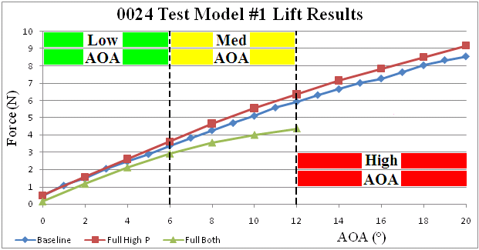
Figure 4.13: Comparison of lift results for high Ra modifications to the high pressure side and to both sides of the airfoil.

While the effects of the dimple modifications discussed so far have had largely an overall negative effect on the aerodynamic performance of the airfoil, dimpling the full high pressure side actually increased the lift generation compared to the baseline. Therefore, in relation to Figure 4.13 from 5-6° AOA onwards (Med AOA Range) there was a slight increase in the lift curve. At 20° there was an increase of 7.04% in the lift force compared to the baseline. However, in reference to Figure 4.12, while the drag increased against the baseline at low AOA, from 12° onwards (High AOA Range) it was quite similar in value to the baseline. Therefore, the % change in lift and drag forces generated by the high pressure side modification compared to the baseline, can be seen in Table 4.4.

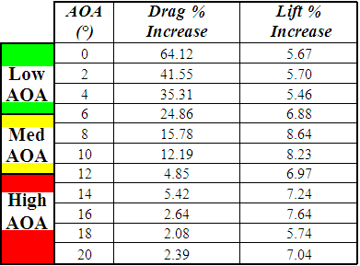
Table 4.4: Percentage change in the drag and lift forces at each AOA compared to the baseline.

While in Figure 4.13 it appears that the lift increase became larger compared to the baseline as the AOA was increased, the actual value of % lift increase (relative increase with respect to the increasing baseline lift force) remained somewhat constant. While in Table 4.4 it can be observed that there was a large increase in drag in the low AOA range, from 12° onwards there would have been an overall increase in aerodynamic efficiency. The reason as to why the % drag increase values in Table 4.4 became smaller as the AOA was increased, was due to the fact that the increased skin friction drag became a much smaller component of the overall drag force. As there would have been no pressure drag, a very small lift force and therefore virtually no induced drag acting at 0°, it would be reasonable to state that this modification increased the overall skin friction drag of the airfoil by 64.12% at 0°. Therefore, as a result of adding a high Ra dimple effect to the high pressure side this led to an average lift increase across the full AOA range of 6.84% (average of ‘Lift % Increase’ values in Table 4.4).

As the turbulent boundary layer had a higher kinetic energy than the laminar boundary layer on the top surface of the airfoil, this acted to deflect the flow downwards at the trailing edge of the airfoil. This is therefore similar to the principle whereby the rotation of trailing wing tip vortices (induced drag) deflects the flow field behind a wing downwards (downwash), thereby causing a slight local increase in the angle of incidence of the flow around the wing. In other words, the resultant velocity direction at the aerodynamic centre of the airfoil was inclined downwards relative to the direction of the undisturbed free-stream flow [1]. As a result, the effective AOA at the aerodynamic centre was inclined by the downwash angle [1].

As the % increase in the lift force was quite similar across the full AOA range, the tilting effect may have become slightly larger as the AOA increased. For example, at 2° AOA there was a lift increase of 5.7% and at 18° the lift increase was 5.74%. At 18° the lift force generated in the baseline test was 8.04N which was much higher than the 1.5N generated at 2°. This would equate to an effective change in the AOA of 0.11° at 2° AOA (5.7% of 2°) and 1.03° at 18° AOA (5.74% of 18°). These calculations were approximated but the theory of conducting these calculations would be correct due to the fairly high linearity of the baseline lift curve. The reason as to why the effective tilting of the flow directly behind the wing became greater as the AOA was increased is because, as the flow separation increased from the top surface of the airfoil, this increasing low pressure region was more easily drawn downwards. Therefore, the turbulent boundary layer created by the dimples on the high pressure side led to a flow of higher kinetic energy leaving the trailing edge, which had a stronger tilting effect as both the AOA and the flow separation increased.

Therefore, as adding dimples to the frontal section of the airfoil on the flow separation side was found to cause large aerodynamic instabilities, the next series of tests conducted analysed the effect of leaving the frontal section smooth while dimpling other parts of the airfoil. As a result it was decided to leave the first 1/3rd section smooth and to apply the high Ra dimple effect to the middle and last 1/3rd sections. This required the use of another test model and the baseline values of this airfoil had to be acquired first. Therefore, in Figure 4.14 the drag results of the baseline compared to two other modification tests can be seen. These two tests were therefore: the middle and last 1/3rd sections dimpled with the same high Ra effect as in previous tests and following this the full high pressure side was also dimpled with the same high Ra effect.

Figure 4.14: Drag results of two further modifications to the 0024 profile compared to the baseline values.

Therefore, in relation to not dimpling the frontal (first 1/3rd) section on the flow separation side, this eliminated the instability problems associated with the previously discussed tests. Upon analysing the standard deviation values of the signals recorded at each AOA from each test, these were all in close agreement. Therefore, no significant difference was noticed in terms of fluctuating forces during the testing compared to the tests where the first 1/3rd was dimpled. As discussed before, dimpling the bottom high pressure side of the airfoil had virtually no effect on the aerodynamic stability of the airfoil. In relation to the middle and last 1/3rd modification there was a slight increase in drag from 5° to 15° AOA, peaking at 10°. At 20° AOA it was observed that there were minor drops in drag for the two modifications, with the larger being 2.47% for the test where the high pressure side was dimpled. A smaller 1.35% drop in the drag force at 20° was the case for the other modification (Mid + Last 1/3rd). It was difficult to state whether the dimples reduced the flow separation marginally as a result of these small decreases.

In addition, as both sides of the airfoil were dimpled in the case where the high pressure side was dimpled, the effect whereby the turbulent boundary layer on the bottom surface created a tilting of the flow should have been cancelled out by the turbulent flow leaving the top surface. For the test where the high pressure side was dimpled, it can be seen that at 0° AOA the drag for this modification was higher than the other two tests. This was due to the presence of the dimples on the high pressure side adding to the skin friction drag. However, as the AOA increased the drag generated became marginally smaller than that of the middle and last 1/3rd test, possibly due to the interaction between the turbulent and laminar boundary layer flow leaving both surfaces. In the case where the high pressure side was not dimpled, this created a small additional drag force. Therefore, while there may have been a reduction in flow separation created by the dimples, the overall drop in the drag force was possibly limited by the increase in skin friction drag.

In relation to the effects of these modifications on lift generation compared to the baseline, these results can be seen in Figure 4.15. There was a lift increase for the middle and last 1/3rd modification, due to the turbulent boundary layer on the upper surface decreasing the pressure above the airfoil, which in turn led to a higher pressure differential between both sides. The kinetic energy of the flow above the airfoil was converted into turbulent fluctuations, as a result of the turbulent boundary layer created by the dimples, which in turn lowered the pressure profile above the airfoil. However, when the high pressure side of the airfoil was then dimpled this in turn cancelled out the increased lift effect, as can be seen in Figure 4.15.

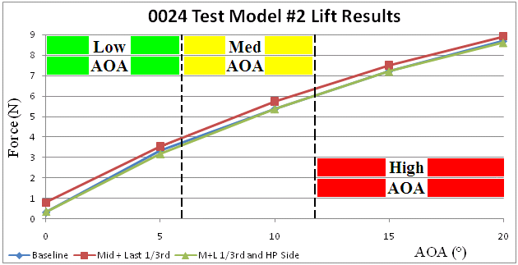
Figure 4.15: Comparison of lift results to the baseline for the two modifications to the 0024 profile.
Therefore, in relation to the middle and last 1/3rd test, as the AOA increased, the relative % lift increase compared to the baseline dropped off slightly. In Table 4.5 the values of the lift forces compared to the baseline can be seen. The large 144.18% lift increase at 0° AOA occurred due to a decrease in the pressure above the airfoil, which produced a sensitive effect on the lift generation. This was due to the fact that at 0° there was a small amount (0.33N) of lift force being generated, as a result of the flow angularity in the test section due to the blockage effect. However, as the AOA increased the % lift increase relative to the baseline became smaller in value (2.64% at 20°).

However, in the test where the high pressure side was only dimpled this also led to a lift increase, with an average value of 6.84% across the full AOA range (Table 4.4). The mechanism by which this created a lift increase was due to the downward tilting of the local flow field around the airfoil, as a result of the turbulent flow leaving the bottom of the airfoil. On the other hand it would be reasonable to assume that this effect was occurring in relation to the middle and last 1/3rd test, although to the opposite effect. It could be argued that the turbulence intensity of the boundary layer may not be as strong in comparison, as the dimple modification started at 33% along the airfoil chord as opposed to starting at the leading edge. However, in the case where the dimples were on the bottom high pressure side, the effect whereby the turbulent boundary layer acted to lower the pressure was suppressed by the higher pressure region. Therefore, the dimples were found to increase the lift when located on both sides of the airfoil by these two different mechanisms.
AOA (°) | Baseline (N) | Mid+Last 1/3rd (N) | % Lift Increase
0 | 0.33 | 0.81 | 144.18
5 | 3.34 | 3.55 | 6.44
10 | 5.38 | 5.75 | 6.79
15 | 7.23 | 7.52 | 4.01
20 | 8.70 | 8.93 | 2.64

Table 4.5: The % lift increase achieved by the middle and last 1/3rd modification.

Also, it can be concluded that the presence of dimples in the first 1/3rd section on the low pressure side of the airfoil caused large aerodynamic instabilities and fluctuations of the drag and lift forces. When the dimples were located ahead of or at the aerodynamic centre, this caused a large instability in the pitching moment. This agrees with theory as the maximum lift co-efficient is sensitive to leading edge roughness [1,6]. In addition, increasing the surface roughness at a point more than approximately 0.2c from the leading edge has little effect on the lift curve slope [1,6]. This can be seen in Figure 4.15 where the dimpling of the middle and last 1/3rd section did not have a notable negative effect on the lift curve. As the aerodynamic centre was located at the quarter chord (0.25c) point, also the same point at which the strut was inserted, by not adding dimples in the first 1/3rd (0 to 0.33c) section this prevented such instabilities.

The rapid formation of a turbulent boundary layer immediately following the stagnation point, in relation to the laminar flow regime based on the chord length of the airfoils, caused a large instability at the front of the airfoil. This effect may also have been exaggerated by the fact that the flexures, due to their relatively weak flexural and torsional nature, were mechanically very sensitive to force fluctuations. As the strain gauge and overall instrumentation set-up was also very sensitive, this explains the large fluctuations that were observed on the output signals. However, on the other hand when a laminar boundary layer was allowed to form at the leading edge, a transition into turbulence further along the airfoil did not appear to cause such instabilities.

4.6.3 Modification Test Results - NACA 0024 with End-Plates

The next set of results that will be discussed featured the use of end-plates (winglets) in order to reduce the wing tip vortices and induced drag component. This therefore allowed an analysis of the effect of the dimples on lift and drag in the scenario where this effect was greatly reduced or perhaps eliminated. It is worth pointing out that the testing with the use of end-plates was only conducted with the 0024 profile. This was so as attaching the end-plates to very thin 0006 airfoils would have been quite difficult. As it was necessary to easily attach and remove the end-plates in order to add new modifications to an airfoil, the insertion of screws into the sides of the 0006 profile would not have been feasible.

At first glance of the end-plates used in Figure 3.8 it may appear that these were relatively small in height, especially near the front and rear of the airfoil due to their semi-circular shape, however this was necessary for two reasons. Firstly, there was the issue of tunnel size restrictions and secondly the effect of the additional weight was also considered. This was not from a point of view where the flexures had to support more weight, since they were able to withstand much higher upward lift forces, but rather from the fact that the weight would have created a moment about the 0.25c (strut) point. Therefore, in relation to Figure 3.8 a clockwise moment was created on the flexures located on the side of the tunnel from which the photograph was taken. This was simply because the majority of the weight was acting to the right of the 0.25c point. This was an important consideration in relation to the relatively low torsional rigidity of the flexures, especially in relation to the longer drag flexures. While the end-plates could have been re-shaped to correct for this, this would have required an extension to their front or through the use of small weights added to a particular point. This would not only have been a meticulous process but in the case where the end-plates could have been extended forwards, this would have interfered with the flow reaching the leading edge of the airfoil. In Figure 4.16 the lift and drag results for an unmodified 0024 airfoil with these end-plates are compared to the baseline results without the end-plates.

Figure 4.16: Comparison of 0024 baseline results with and without the use of end-plates (EP).

At 0° AOA there was a large increase in the lift force in the test with the end-plates attached. Therefore, the end-plates created a shift in the true AOA of the airfoil as a result of the moment that acted on the flexures. As a result, the additional lift force generated at 0° AOA with the end-plates (1.81N) was extrapolated to be equivalent to the lift force generated at 3.7° approximately, for the baseline test without end-plates. Even though the tests with the end-plates were compared on a like with like basis, in order to compare these two baseline tests in Figure 4.16, it would have been necessary to compensate for this effect. Therefore, even when this initial offset is subtracted from each AOA value, the lift curve slope increased with the use of the end-plates. There was a peak increase in lift of 2.57N at 14° AOA and the increase relative to the baseline became smaller after this. Therefore, at 20° the end-plates created an additional lift force of 1.94N by significantly reducing, or possibly eliminating, wing tip vortices and the induced drag component. Another important point was that the lift curve appeared to be levelling off as it approached 20°. However, it is difficult to say how much further the AOA would need to have been increased before a drop in the lift curve (indicative of a stalling point) would have become apparent.

In relation to the change in the drag force again there was a small shift at 0° AOA. The additional drag force (0.35N) was extrapolated from the data to be equal to that produced at 6.6° approximately, for the case without end-plates. This AOA shift was higher than that of the change in lift, although bearing in mind that the lift force increased at a much higher rate thereby explaining the smaller relative AOA shift. Therefore, the increase in the drag force was due to two effects. Firstly, the small additional drag force produced by the end-plates and the screws themselves was a factor. Also, due to the effective AOA increase of 3.7° as a result of the additional small weight of the end-plates that acted on the flexures, this led to an increase in drag. While it may have been expected that there would have been a drag increase at the lower AOA, at the higher AOA as wing tip vortices should be significantly reduced there should not have been as large of a increase in drag as observed in Figure 4.16. Therefore, while the end-plates were effective in increasing the lift curve slope, the reduction of wing tip vortices in terms of reducing the induced drag must have been overshadowed by an increase in drag from another source. This effect can be explained by the proximity of the end-plates to the test section walls. As a result there must have been some local flow separation occurring along the sides of the end-plates [35]. This therefore accounts for the additional maximum 1N of drag generated at 18° to 20° AOA.

In terms of the stability of the airfoil with end-plates attached, this resulted in drag and lift standard deviation values much lower than those for a 0024 without end-plates. Therefore at 20° these drag and lift values for the end-plate case were 0.16N and 0.28N respectively. However, from the previous testing these respective values were 0.46N and 0.53N. This increase in the stability therefore confirms the effectiveness of the end-plates in greatly reducing the wing tip vortices. While it would have been possible to compensate for the effective initial shifts in lift and drag at 0° by the subtraction of this difference from all values across the AOA range, it was decided to leave the results as they were. This was so as when the tests were compared with different dimple modifications with the use of the end-plates, this would have been conducted on a similar basis as these aforementioned effects would have applied to all tests. This led to a comparable methodology to be adopted, allowing a like with like analysis of the results. There were three different modifications tested with the use of end-plates, excluding the baseline (also with end-plates), and the drag results can be seen in Figure 4.17. The modifications that were applied to the separation side only were: the middle 1/3rd dimpled with a high Ra, the middle and last 1/3rd with a high Ra and this modification again with the addition of a low Ra dimple effect to the first 1/3rd section.

Figure 4.17: The drag results in relation to the tests conducted with the end-plates.

Therefore, the order of the legend at the bottom of Figure 4.17 indicates the order in which these tests were conducted. In relation to dimpling the first 1/3rd as the testing was halted at 10° AOA due to the large aerodynamic instability and fluctuation of the forces, this confirmed the earlier finding regarding the application of a high Ra dimple effect to the first 1/3rd (without end-plates). Therefore, as this was a low Ra modification in relation to Figure 4.17, this showed that any degree of dimple effect applied to the frontal section would have adversely affected the performance of the airfoil. Consequently, whether end-plates were used or not it can be concluded that no dimple effect should be applied to the frontal section of the airfoil on the low pressure side.

However, in relation to the other two modifications tested it can be observed that even though there was a drag increase in the lower AOA range, there was a reduction in drag at the higher AOA. This was particularly true for the middle and last 1/3rd modification, where the drag produced dropped below that of the baseline from 10° AOA onwards. Therefore, while these respective two modifications increased the drag in the low AOA range due to the increase in skin friction drag, as the AOA increased the drag reduction appeared to be caused by the dimples delaying flow separation. The fact that this effect was stronger for the middle and last 1/3rd modification must have been the case as the extension of the dimples to the trailing edge provided the additional required excitation of turbulence in the boundary layer to overcome the adverse pressure gradient. This therefore acted to increase the kinetic energy of the otherwise slowing particles and led to a smaller degree of flow separation occurring. The reason as to why the drag reduction for the middle 1/3rd modification only occurred at 18° AOA, was because at this AOA the adverse pressure gradient would have moved the point of flow separation up to the mid-chord point. Therefore, when the point of flow separation was closer to the trailing edge, the turbulent excitation provided by the dimples was not strong enough to overcome the effect of the adverse pressure gradient and delay the flow separation. However, with regards to the middle and last 1/3rd modification, the presence of the dimples in the last 1/3rd section explains the decrease in drag at the lower AOA.

In the case where this middle and last 1/3rd modification was applied to an airfoil without end-plates, there was a slight increase in drag in the medium AOA range and only a very small drop in drag at 20° AOA. Therefore, as the end-plates significantly reduced the wing tip vortices and increased the lift curve slope, this larger drop occurred as no wing tip vortices interacted with the separated flow and wake region behind the airfoil. As a result, the turbulence intensity of the wake was higher with the interaction of the wing tip vortices. This was especially true when the size of the test section was considered, as the wake due to flow separation and the trailing vortices were compressed into a relatively small space. In other words, this dimple effect did not provide the required excitation and increase in boundary layer kinetic energy to overcome the severity of the adverse pressure gradient, in the case of the decreased pressure field behind the airfoil in the test without end-plates. Following this, the next set of results that were analysed were the effect of these modifications on the lift force and the corresponding graphs can be seen in Figure 4.18.

Figure 4.18: The lift results in relation to the tests conducted with the end-plates.

Similar to the test where the full flow separation side was dimpled with a high Ra, when the first 1/3rd had a low Ra dimple effect this had a detrimental effect on the lift in addition to creating high aerodynamic instability. This finding is in line with theory as the lift coefficient is sensitive to leading edge roughness [6]. However, in relation to the other two modifications, from the middle of the AOA range onwards there was a gradual decrease in the lift force compared to the baseline. Therefore, while the dimples were seen to decrease the drag in relation to Figure 4.17, there was also a corresponding decrease in the lift force. When comparing the middle and last 1/3rd modification to the baseline at 20° AOA, there was a reduction in drag of 11.15% and also a 8.46% drop in lift. These were the two largest drops in both drag and lift as there was a gradual decrease in both forces from 10° and 8° AOA respectively, compared to the baseline. Therefore, the percentile decrease at 20° AOA corresponded to a drop of 1.04N in the lift force and a drop of 0.39N in the drag force. As a result, there was an overall corresponding increase in the aerodynamic efficiency of the airfoil. The lift to drag ratio of the baseline at 20° AOA was equal to 3.52, while it was equal to 3.63 (3.13% increase) for the middle and last 1/3rd modification.

4.6.4 Baseline & Modification Test Results – NACA 0006

As highlighted before, it was decided that it was best to carry out various modification tests to the 0024 test models first and then test any modifications that showed aerodynamic benefits on the 0006 profile. Therefore, the first step was to conduct the baseline test for this profile and these results were previously discussed in relation to Figure 4.8 and in this section they are analysed in further detail. The first noticeable difference between this baseline and the baseline of the 0024 profile was that the testing stopped at an AOA of 15°. The stalling AOA for this profile based on a Re of 3 × 10⁶ was approximately 12° [6]. As discussed before in relation to the baseline test for the 0024 profile, not only was this stalling angle based on a much higher Re number than that applicable to this testing, but this stalling angle was also based on infinite wing data. Therefore, the effects of wing tip vortices and induced drag would not be present in relation to this guideline. As a result it would be expected that the stalling angle of this airfoil, due to its aspect ratio of approximately 1 and large accompanying induced drag component, should be lower. Also, as discussed before regarding the 0024 profile the fact that this data is based on a Re of 3 × 10⁶ should mean that a higher lift curve slope should be applicable, compared to the current test conditions [1]. Thus, this would also mean that a lower lift curve slope should be the case in relation to this baseline test, leading to a lower stalling AOA. In other words, the effect of the higher Re and the absence of wing tip vortices in this theoretical guideline of the stalling AOA, should equate to an actual stalling AOA lower than 12°.

In Figure 4.8 it can be seen that the testing was conducted up to an AOA of 15°. While this should have been well past the stalling angle, no sign of such a peak and drop in the lift curve was evident. However, from 12° AOA onwards the level of the fluctuation of the forces became quite high with large values of standard deviation of the signals recorded as a result. The standard deviation of the drag output was significantly higher, 2.43 times higher than that of the lift at 12° and 3.83 times higher at 15° AOA. During the testing itself it was observed that there was more fluctuation in the drag plane as opposed to the lift plane, which explains the resulting variation in the output signals recorded. Therefore, this would have been signifying large levels of flow separation and the degree of the fluctuations in the drag output would have also indicated that the stalling angle had been exceeded as a result. However, there was no drop in the lift curve and the lift force increased in value at the higher AOA. As discussed in Section 3.4.2, in relation to the errors produced by a high blockage ratio in terms of drag and lift measurement, this effect can be explained. While there was a high level of flow separation and vortex shedding as indicated by observation during testing and from the standard deviation values, the high blockage ratio also acted to increase the lift curve slope [46]. This occurred due to a term known as streamline curvature as explained in Section 3.4.2. However, as discussed before in relation to the tests with the 0024 profile, the testing was stopped at 15° AOA in this case to prevent any damage occurring to the flexures and/or strain gauges.

In relation to the 0006 baseline levels of lift and drag generated, when compared to the baseline results of the 0024, at 15° AOA the drag was 0.06N (3.5%) higher. However, due to the increased thickness ratio of the 0024 profile its drag level should have been higher than the 0006 profile at 15° [6]. Also, as the 0006 airfoil had a chord length 17mm less than the 0024, this relatively low difference in drag would have been larger if it had the same chord length as the 0024 airfoil. In addition, the lower blockage ratio of the 0006 airfoil should also have signified less of a resulting increase in the drag force as a result. Therefore, the fact that the drag produced by the 0006 profile was not lower appeared unusual at first, but can be explained to be the consequence of an increased induced drag component. As the 0006 profile was thinner it would have been easier for wing tip vortices to form, as the flow would have had less distance to travel around the sides of the airfoil. This would have resulted in an increased intensity of the wing tip vortices and therefore of the induced drag component.

Regarding the lift force comparison at 15° AOA, the lift force produced by the 0006 profile was 0.14N (2%) higher. With respect to these two NACA profiles, as the thickness ratio was increased this should result in a decrease in the lift curve slope [6]. However, when the 7.77% smaller planform area of the 0006 airfoil was also considered, this should result in a decreased lift force compared to the case if it had the same dimensions of the 0024 profile. Therefore, the lift characteristics of the 0006 profile were more influential and this explained the overall small lift increase.

Therefore, the modification that was tested with the 0006 profile was a high Ra dimple effect on both sides, and the drag and lift results for this can be seen in Figure 4.19. This test revealed the same instability problems that occurred with the 0024 profile when the frontal section on the separation side was dimpled. At 12° AOA the standard deviation values for the drag and lift outputs were higher, especially for the drag signal, when compared to the same corresponding test with the 0024 profile. Thus the drag force fluctuated over a greater range compared to the 0024 test, although the frequency of the fluctuations was lower. It was found that a very large increase in the standard deviation values resulted, in particular with the drag value, when the AOA was increased by a small amount to 12°. However, unlike the 0024 profile, when this test was compared to the 0006 baseline at 12° AOA, the lift and drag forces were quite close in value. Therefore, there was not a significant increase or decrease in the lift or drag force.

Figure 4.19: 0006 airfoil dimpled with a high Ra modification to both sides fully.

When these results are compared to the baseline in Figure 4.8, there was an average drag increase of 0.11N across the AOA range. The drag force increase was very similar for each AOA and this would therefore indicate that the % drag increase compared to the baseline became smaller as the AOA was increased. Therefore, at 12° AOA there was a resulting 0.05N or 3.22% drag increase. While the lift increased and decreased slightly compared to the baseline depending on the AOA, overall there was no significant change in the lift curve slope. Therefore, the effect of the dimples at the leading edge did not appear to affect the lift curve to the same extent as the 0024 profile. However, as previously mentioned the aerodynamic stability was affected with larger drag and lift signal values of standard deviation, in comparison to the same test with the 0024 profile.

4.7 Phase 2 Split Flap Airfoil Testing Results

The next part of the experimental testing was concerned with arranging two airfoils in a split flap arrangement, as previously discussed in Section 3.3.2. This testing, which expanded the scope of the research, allowed an investigation of the effect of the dimples on drag and lift applied to a flap. As the majority of wing sections on aircrafts contain flaps, if a modification to an airfoil was successful it would have been necessary to investigate any effect it would have had on a smooth flap at its trailing edge. In addition, upon adding a particular modification to the flap itself, it may have been found that the presence of a smooth main airfoil element affected the drag and/or lift improvement characteristics. There was also the aspect that a dimple modification to the main airfoil would have a beneficial effect on the drag produced by the flap, through the turbulent flow delaying the point of flow separation on the flap. The main airfoil element used in all of these tests was the 0024 profile and both the 0006 and 0024 profiles were tested as the flaps.

4.7.1 Baseline Results – NACA 0024 Flap

Therefore, as with the previous testing it was first necessary to obtain the baseline drag and lift results. In Figure 4.20 a comparison of the lift and drag results against those from a separate baseline test, without the main airfoil and support frame set-up (0024 flap airfoil only), can be observed. Thus, this highlighted the difference in the baseline tests due to the presence of the main airfoil and the increased blockage ratio of the overall set-up.

Figure 4.20: Comparison of the baseline results for the single (S) and split flap 0024 tests.

In Figure 4.20 the (S) terms in relation to the trend lines signify the single airfoil (flap only) set-up. For the comparison of the drag baselines, it can be observed that there was not a significant amount of difference. The drag produced by the 0024 profile in the single airfoil set-up became slightly higher than the split flap case, as the AOA was increased. The reason for this may have been due to the slightly disrupted flow leaving the main airfoil acting to delay the point of flow separation on the flap. However, since the main airfoil was at 0° AOA it was more likely that this was caused by the turbulence being created by the support frame holding the main airfoil in place. Therefore, at 20° AOA there was a resulting 14.07% reduction in the drag force. In relation to the lift forces generated, it can be seen that there was a larger difference in these values compared to the drag baselines. The lift force at 0° in the split flap test was at a negative value of -0.79N and therefore the flap was producing negative lift or downforce. Following this the levels of lift produced remained lower than the single airfoil case until approximately 20°. This must have been the case due to the main airfoil deflecting the flow angularity over the flap such that it decreased its effective AOA and less lift was produced in the AOA range as a result.

For example, the lift produced at 5° AOA in the split flap set-up would have been approximately equal to the lift force produced at 2° for the single airfoil set-up. However, this shift in the effective AOA was decreased as the AOA was increased and both were approximately equal at 20°. The reason for this can be explained by the fact that this set-up led to a higher blockage ratio. Therefore, compared to the single airfoil set-up at 20° AOA the blockage ratio would have been increased to 34.97% from 19.37%. As discussed earlier in this chapter and in relation to the theory covered in Section 3.4.2, this would have resulted in a better lift to drag ratio with a higher lift curve slope resulting. Thus this explains how the lift produced by the split flap set-up started off lower than that of the single airfoil, but gradually increased to a point where at 20° both were approximately equal. However, while the drag force should also have increased in relation to the increased blockage ratio, as mentioned above this must have been alleviated by the increased turbulence of the flow flowing over the flap from the main airfoil. Despite the increased blockage ratio of the split flap set-up, all modifications tested were compared relative to the split flap drag and lift baselines (Figure 4.20), which enabled a like with like comparison of the results.

4.7.2 NACA 0024 Split Flap Test Results

The first two modifications were where the flap had dimples applied to its middle and last 1/3rd sections, on the flow separation side, to both a low and high Ra degree. Therefore, all other sections on the flap and the entire main airfoil were left smooth. Out of the various tests conducted with the split flap set-up, the high Ra modification mentioned above provided the largest reduction in drag. Firstly the drag values obtained from these tests, in comparison to the split flap baseline values, are presented in Figure 4.21.

Figure 4.21: Comparison of drag results from first two modifications to the baseline values.

The flap dimpled with a low Ra effect, showed virtually no change in the drag levels produced at each AOA compared to the baseline. The blue trend line representing the baseline values was hidden behind the trend line of this modification for the majority of the AOA range. However, with the high Ra modification it was observed that the resulting increase in the surface roughness level led to a change in the drag levels. Therefore, at 0° AOA there was an increase in the drag force of 21.6% which can be attributed to the increased skin friction drag. However, at 5° AOA both drag levels were almost equal and the drag produced by the modified flap dropped below the baseline from this point onwards. This led to a drag reduction at 20° AOA of 8.23% (0.18N).

In relation to the stability of the flap due to this modification, as with the tests conducted in the single airfoil set-up where the frontal section was not modified, there was no significant difference between the standard deviation values of this modification and the baseline. For example, the standard deviation of the baseline at 20° was 0.1N and the respective value for the ‘High Ra’ modification was 0.17N. It is also worth pointing out these values at 20° represented the largest difference between the two respective standard deviation values across the AOA range. As the reduction in the drag force was 0.18N, the respective standard deviation values (which were $±$ values about the mean of the recorded fluctuating signals) illustrate that the 8.23% drag reduction value determined was accurate. Therefore, while this was a promising result in terms of drag reduction, the effects of this modification on the lift values must also be assessed. The lift results for these two modifications compared again to the baseline values can be seen in Figure 4.22.

Figure 4.22: Comparison of lift results from first two modifications to the baseline values.

In relation to the low Ra modification, as with the drag values in Figure 4.21 there was virtually no change from the baseline except for a very small drop at 20° AOA. For the high Ra dimple effect it can be seen that there was quite a small drop in the lift values, with the largest drop of 6.53% occurring at 10°. The drop in lift at 20° was only 1.94%, which when compared to the respective drag reduction of 8.23% at this AOA, which led to an increase in the aerodynamic efficiency of 6.87%. At 15° there was also a 5.73% increase in the aerodynamic efficiency and due to the largest drop in lift occurring at 10°, there was a small drop of 0.59% in the lift to drag ratio at this AOA. Therefore, it can be concluded for the high Ra modification that the best compromise in terms of a reduction in both drag and lift occurred at 20° AOA. This was so as at this AOA the level of flow separation would have been at its greatest, which led to the largest reduction in the drag force by the dimples as a result.

In terms of this middle and last 1/3rd high Ra modification discussed earlier in relation to the single airfoil testing with end-plates, the trend was similar for the drag results for both test set-ups. This was so as there was a drag increase in the low AOA range for both tests and from approximately 8° to 10° onwards the same modification provided an increasing drag reduction (relative to the respective baselines). For the single airfoil test there was a slightly larger drag reduction of 11.15% at 20°. However, there was also a larger effect on lift generation in the single airfoil test, with a reduction in lift from approximately 7° AOA onwards leading to a 8.46% reduction at 20°. Therefore, with a much lower lift loss the split flap set-up resulted in this modification providing a larger 6.87% increase in the lift to drag ratio at 20°, compared to the 3.13% increase for the single airfoil set-up. However, due to the presence of the main airfoil upstream of the flap and issues surrounding the increased blockage ratio, it would be expected that the lift and drag changes due to the same modification should have been different. Therefore, in both the single and split flap airfoil testing, this high Ra modification to the middle and last 1/3rd sections on the separation side resulted in the largest drag reduction without adversely affecting the aerodynamic stability.

Following this, the next two modifications were where the flap had the same high Ra modification as before, but the main airfoil was dimpled fully on both sides with a low and a high Ra dimple effect. Therefore, the drag results of these modifications compared to the baseline can be seen in Figure 4.23.

Figure 4.23: Comparison of drag results from modifications to the main airfoil.

This methodology was set up to determine if there was any benefit in dimpling the main airfoil in terms of the high Ra modification on the flap, which resulted in delayed flow separation and improved aerodynamic efficiency. In Figure 4.23 for the two modifications there was a slight increase in the drag at the lower AOA, but a decrease in drag at the higher AOA. However, it was when the main airfoil was dimpled with a low Ra, that it led to an overall larger decrease in drag compared to the baseline from approximately 10° onwards. While at 20° AOA the drop in the drag force experienced by the flap were approximately equal for the two modifications (≈4.5%), there was no significant reduction in drag for the high Ra modification except near the end of the high AOA range.

The reason as to why there was a drag increase for both modifications in the low AOA range, at 5° in particular, was due to the added skin friction drag experienced by the flap as a result of the increased flow turbulence leaving the main airfoil. It was not until the AOA was increased further and where the flap started to generate higher levels of flow separation that the additional kinetic energy of the turbulent flow aided in delaying the point of flow separation. However, in Figure 4.23 it can be seen that it was the low Ra modification to the main airfoil that provided the best benefit in terms of drag reduction. The low Ra dimple effect provided the adequate level of flow turbulence to delay the point of flow separation on the flap, while the high Ra modification acted to increase the skin friction drag of the flap. It is only until near 20° AOA where the high Ra modification created a larger decrease in pressure drag, relative to the increase it caused in the skin friction drag. Therefore, the low Ra dimple effect provided the best compromise between both of these aspects.

In relation to the effects of these two modifications on the lift characteristics, Figure 4.24 compares these results to the baseline lift values. Thus, by dimpling the main airfoil with either a low or a high Ra degree of dimples this adversely affected the lift generation characteristics of the flap. Similarly, the high Ra modification led to a larger drop in lift across the AOA range, with a 12.39% reduction at 20°. As a result of increased flow turbulence passing over the flap by increasing the surface roughness of the main airfoil, a lower lift curve slope for the flap as can be seen in Figure 4.24 was the case.

Figure 4.24: Comparison of lift results from modifications to the main airfoil.

In terms of the modifications to the main airfoil that were tested and considering the larger adverse effect they had on the lift characteristics of the flap, it is concluded that dimpling the main airfoil had an overall negative effect on the aerodynamic performance of the flap. The final test that was conducted with this set-up was where both the main airfoil and the flap had a high Ra dimple effect applied to both sides fully. In Figure 4.25 the drag results compared to the baseline can be seen.

However, this modification had the worst overall effect on the drag and lift generated by the flap, where at 20° AOA there was a 3.4% drag increase and a 11.32% lift decrease. The drag increase due to this modification was actually at its lowest value of 3.4% at 20°, as it gradually became closer in value to the baseline from an initial increase of 67.84% at 0° AOA.

Figure 4.25: Comparison of drag results to the baseline values for modification to both airfoils.

In relation to the lift decrease, as can be seen in Figure 4.26 this was at its maximum at 15° AOA (14.56%) and was slightly less at 20° (11.32%). However, it can be observed that it gradually decreased with respect to the baseline from 0° AOA onwards. In comparison to the single airfoil testing, this same modification would have generated large aerodynamic instabilities and fluctuation of the forces. Due to the turbulent flow emanating from the main airfoil this instability effect was not present and the testing could be conducted up to 20° AOA.

At 20° the lift standard deviation value compared to that of the baseline was nearly identical and while the value increased by approximately 2.5 times for the drag, no significant instability effects were observed during testing. The explanation for this effect was due to the turbulent flow that was reaching the leading edge of the flap. As with the single airfoil testing which had a laminar flow regime with low free-stream turbulence reaching the leading edge, a dimple modification to the first 1/3rd section would have created a rapid formation of a turbulent boundary layer. This was explained as the cause for the instability effect, which was exaggerated due to the low flexural and torsional strength of the flexures. However, as the flow leaving the dimpled main airfoil was turbulent in relation to the above modification, there would not be such a rapid formation of a turbulent boundary layer at the leading edge of the flap.

Figure 4.26: Comparison of lift results to the baseline values for modification to both airfoils.

Compared to Figure 4.24, where the flap had a middle and last 1/3rd high Ra modification with the main airfoil modified the same as in this test, the general trend of the lift dropping away from the baseline was similar. The 11.32% drop in the lift force at 20° AOA in this case was quite similar to the 12.39% drop for the test with the middle and last 1/3rd modification to the flap. Regarding the drag force, while it was a good deal higher than the baseline at the lower AOA, it closed in on the baseline values as the AOA was increased up to 20°. Therefore, the additional dimples on the flap caused an increase in the skin friction drag, which despite their ability to delay flow separation in the middle and last 1/3rd location, this increased the overall drag generated by the flap.

4.7.3 Baseline Results – NACA 0006 Flap

Following the use of a 0024 profile as the flap a 0006 profile was also tested. The baseline drag and lift results, which are compared to the baseline test with only the flap in place, can be seen in Figure 4.27.

Figure 4.27: Comparison of the 0006 baseline tests with the split flap set-up and the single flap airfoil (S) set-up.

For the comparison of the drag baselines, it can be observed that there was very little difference in these results. At 0° AOA the drag produced in the split flap set-up was 56.09% lower than in the single airfoil set-up and at 15° it was 5.03% lower. In relation to same baseline comparison for the 0024 flap in Figure 4.20, the single airfoil set-up produced more drag which increased as AOA became higher. However, in relation to Figure 4.27 the difference in the drag forces produced between both set-ups was much smaller and it peaked at 0° AOA. The reason for the 5% less drag produced by the split flap at 15° would have been due to the distorted flow leaving the main airfoil and the support frame in particular. This therefore acted to delay the point of flow separation on the flap slightly. Also, regarding Figure 4.20 the smallest difference in drag was at 0° and as can be seen in Figure 4.27 there was a large difference. This must have been due to the tilting of the flow leaving the main airfoil/support frame, which affected the 0006 flap more so at 0° and it must have brought its effective AOA closer to a true 0°, with respect to the free-stream flow.

In relation to the lift forces generated it can be seen that there was a larger difference in these values, as was the case in Figure 4.20, compared to the drag baselines. The lift force at 0° AOA in the split flap test was however a positive value of 1.31N compared to the negative lift case with the 0024 flap. The split flap set-up was producing slightly more lift at 0°, but following approximately 2°, the levels of lift produced remained lower than the single airfoil case. This must have been the case due to the main airfoil deflecting the flow over the flap, such that it decreased its effective AOA and less lift was produced in the AOA range as a result. Again, this was a similar result to the 0024 flap in Figure 4.20, however the 10.41% drop at 15° was larger than the respective drop of 6.46% for the 0024 flap. In addition, in Figure 4.20 the lift produced by the split flap set-up closed in on the single airfoil values as the AOA was increased, with them being approximately equal at 20°.

An important point to note from Figure 4.27 is that, even though the 0006 profile had a low stalling angle, in the split flap set-up it was much more stable and was tested up to 20°. While the values of the standard deviation were higher at 20° when compared to the 0024 split flap case, these values would have been comparable to those found at 9° in the single 0006 baseline test. Therefore, no significant fluctuation in the forces occurred at 20° AOA and this allowed for a larger testing range to be analysed as a result.

4.7.4 NACA 0006 Split Flap Test Results

The modification that was tested with this set-up was where both the main and flap airfoils were dimpled with a high Ra fully on both sides (Figure 4.28). When the drag and lift results were compared to the baseline values in Figure 4.27 there was an increase in drag of 80.67% at 0° AOA. Therefore, not only did the dimples on the flap increase the skin friction drag, but the turbulent flow generated by the dimples on the main airfoil acted to additionally increase the skin friction drag. However, as the AOA was increased the difference in the drag forces became much smaller, with only a slight increase of 2.38% at 20°. As a result no significant reduction of flow separation occurred and despite that the increased skin friction drag would have became a smaller component of the overall drag force as the AOA was increased, there was still a small drag increase at 20°.

Figure 4.28: Drag and lift results for the high Ra modification applied fully to both airfoils.

Regarding the lift force differences with respect to the baseline values, the modification to the main airfoil and flap resulted in a lift increase of 15.77% at 0°. However, as the AOA was increased to approximately 8° there was a cross-over of the two respective lift curves and from this point onwards the dimple modification resulted in a small lift decrease. At 15° the lift reduction was 3.57% and at 20° it was 2.61%. However, this same modification in the case of the 0024 split flap had a worse effect on the lift at 20° AOA, with an 11.32% decrease compared to its baseline. While the lift curves as a result of the same modification to the 0006 and 0024 split flap set-ups were quite different, the drag curves exhibit similar trends. In comparison to the same relative modification in the 0006 single airfoil testing, due to the presence of the dimpled main airfoil there was a drastic improvement in the standard deviation values. This was so as the single 0006 airfoil had a drag standard deviation value of 2.14N and a lift value of 0.87N at 12° AOA, but the split flap had respective values of 0.3N and 0.37N. The increased turbulence of the flow over the flap from the main airfoil resulted in a more steady formation of a turbulent boundary layer at the leading edge of the flap, thereby it virtually eliminated this instability effect.

Therefore, from the wide range of testing conducted during Phase 2 of the research with the use of the balance and DAQ set-up (System 2), a summary will now be presented with the main findings in relation to the effect of the dimple modifications on lift and drag. Firstly, it can be stated that dimpling the frontal section of the low pressure side of the airfoils led to large aerodynamic instabilities. As a result, the testing could only be conducted up to a typical AOA of 10° in order to prevent damage being caused to the flexures. Therefore, dimples located before the aerodynamic centre of the airfoil led to this instability effect, as a result of the formation of a turbulent boundary layer at the front of the airfoil. However, adding dimples from the 0.33c point onwards, thereby allowing the formation of a laminar boundary layer at the front of the airfoil which was later tripped into turbulence, did not result in such force fluctuations.

Dimpling the full high pressure side of the NACA 0024 profile (single set-up) with a high Ra dimple effect resulted in a 6.84% average lift increase, across the AOA range. There was a small increase in drag in the low AOA range, but the values were similar to the baseline from 12° onwards (high AOA range). This increase in lift was caused by the turbulent flow, leaving the high pressure side, tilting the flow behind the airfoil downwards. This effect is similar to the downwash effect that is associated with wing tip vortices. This resulted in an effective local AOA increase at the aerodynamic centre. For the NACA 0024 profile, an increase in the lift force was also observed as a result of a high Ra modification to the middle and last 1/3rd sections, on the flow separation side. There was a large lift increase of 144.18% at 0° with a much smaller increase after this, between approximately 6.5% to 2.5% (decreasing towards 20°). This effect was caused by the dimples decreasing the pressure gradient above the airfoil. However, in relation to the modification to the high pressure side, which also resulted in a lift increase, this effect would have been suppressed by the higher pressure gradient on this side of the airfoil. Therefore, the increases in the lift force were explained to be caused by these two different mechanisms.

In terms of the best result achieved with the use of the end-plates applied to the 0024 profile, this was where the middle and last 1/3rd sections on the low pressure side were dimpled with a high Ra. Although there was a small drag increase in the low AOA range, from 10° onwards the drag force generated compared to the baseline decreased. However, the lift force also decreased from approximately 8° onwards and at 20° there was a drag decrease of 11.15% with a lift decrease of 8.46%. This therefore led to a marginal increase in the aerodynamic efficiency of 3.13%.

In terms of the best modification regarding the split flap set-up, this again was where the 0024 flap had its middle and last 1/3rd sections dimpled with a high Ra. Therefore, with this modification and with the main airfoil left fully smooth, this resulted in a drag decrease from approximately 8° AOA onwards. While there was an initial increase in drag in the low AOA range, explained to be due to the dimples increasing the skin friction drag, this modification led to a maximum drag decrease of 8.23% at 20°. In relation to the effects on the lift force, there was an overall very small drop across the AOA range, with the largest drop of 6.53% occurring at 10°. Therefore, when the respective 1.94% drop in lift at 20° was compared to the decrease in drag at this AOA, this led to an increase in the aerodynamic efficiency of 6.87%.

4.8 Phase 2 Smoke Flow Visualisation Photography

Following the experimental testing with the use of the strain gauge balance and DAQ set-up, the next step was to carry out the smoke flow visualisation photography. It was hoped that this process would have allowed a visual interpretation of the some of the drag and lift results gathered from the previous testing. However, it must be pointed out that this part of the research was carried out in a much shorter period of time due to the extent of work involved with the design, optimisation, calibration and testing with the balance set-up. It was therefore considered as an addition to the previously discussed experimental results, which comprised the vast majority of the experimental testing.

There were two separate parts to the smoke flow visualisation photography: testing an airfoil set-up with no modifications (baseline) and the testing of a particular dimple modification for comparison. It was decided to conduct these tests at 0° and 20° AOA, in order to have photographs from both ends of the AOA range. In addition, time restrictions did not allow for more photographs to be taken from different AOA. It was decided that for this testing a single 0024 airfoil set-up would be used. The dimple modification tested was the middle and last 1/3rd high Ra dimple effect, to the flow separation side. Therefore, the drag and lift results gathered for this modification from the testing with System 2, with respect to Figures 4.14 and 4.15, were compared to the observations from the photography. As discussed in Section 3.11, this smoke flow visualisation process was conducted with the wind tunnel fan set to its lowest speed setting. This created a flow velocity through the test section of approximately 8.15m/s. Conducting the smoke flow visualisation tests at this low speed achieved the best results in terms of the quality of the photography. This was so as at higher flow speeds the smoke stream experienced degradation and the smoke stream became less visible as a result.

This property is known as mechanical degradation in flow (MDF) as discussed in Section 3.11. Two different shutter speeds were used for the photography. The quickest setting of 1/4000th of a second was used to capture an ‘instantaneous’ image. In addition, a shutter speed of 1/200th of a second was used to produce photographs that resulted in a more solid and ‘fluid-like’ streamline of the smoke flow. This allowed for a comparison between different images, which resulted in different flow characteristics being observed. In terms of analysing the distance that a smoke particle travelled for the 1/4000th and 1/200th shutter speeds, in relation to the 8.15m/s flow velocity, this would have been approximately 2mm and 41mm respectively. Therefore, a photograph that was taken at the 1/4000th shutter speed of the unmodified 0024 airfoil at 0° can be seen in Figure 4.29(a), with the 1/200th shutter speed photograph in Figure 4.29(b).
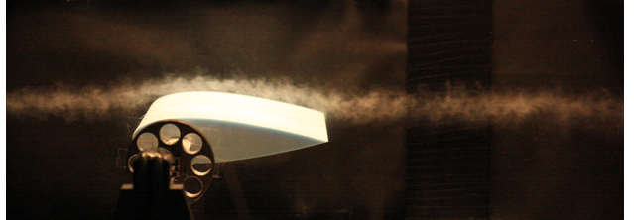
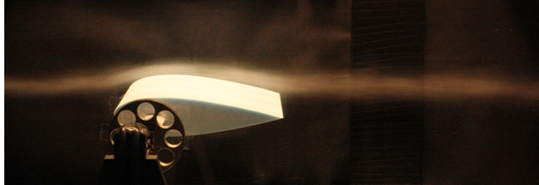
(a)
(b)
Figure 4.29: (a) The unmodified 0024 airfoil at 0° with the 1/4000th shutter speed, (b) with a 1/200th shutter speed.

Therefore, upon analysing Figure 4.29(a) it was apparent that the smoke streamline was somewhat unsteady in nature. The Re of the flow at this slowest tunnel speed was 112,845 and well within the Re criterion of 500,000 for a laminar flow regime [9]. In addition, the free-stream turbulence intensity levels were reduced as much as possible as discussed in Section 3.4.1. Therefore, at this lowest speed it is considered that the velocity was slightly too fast, which led to a certain degree of flow degradation. This was also true in relation to the photographs taken at 20° AOA, as will be seen below, where it was difficult to observe individual vortex structures.

Thus, for the analysis of the drag and lift characteristics of the airfoil, in relation to the relevant photographs, it was possible to assess certain other aspects of the smoke stream. These were: its thickness and the point at which there was an increase in the distance between the smoke stream and the upper surface of the airfoil. The smoke stream was injected into the test section such that it was approximately 1cm above the airfoil near its leading edge, when the airfoil was at 20°. Therefore, the point at which along the airfoil this gap suddenly increased was indicative of the free shear layers and the flow separation point. However, in relation to Figure 4.29, the smoke stream followed a straight path through the test section. Therefore, no effects of downwash as a result of lift generation and the wing tip vortices were the case at 0° AOA. In Figure 4.30 the photographs taken for the modified airfoil at 0° can be seen.

From the results obtained with the balance an increase of 144.18% in lift was the case at 0° for this modification. This was as a result of the increase in the low pressure region above the airfoil, due to the creation of turbulence by the dimples in the middle and last 1/3rd sections. Therefore, when comparing the two photographs in Figure 4.30 to those in Figure 4.29, it can be seen that the smoke stream was thicker due to this reduction in pressure. This effect was more obvious with the two respective 1/4000th shutter speed photographs, corresponding to (a) in both Figures 4.29 and 4.30.
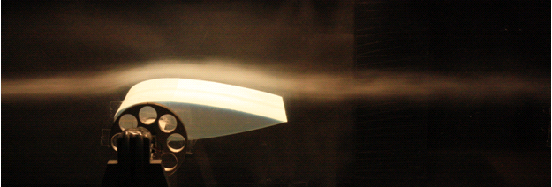
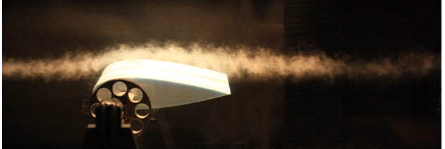
(a)
(b)
Figure 4.30: (a) The modified 0024 airfoil at 0° with the 1/4000th shutter speed, (b) with a 1/200th shutter speed.

It is worth pointing out that the smoke stream varied slightly over the range of photographs taken, in terms of its concentration due to the slightly fluctuating vaporisation process of the oil. In addition, as the lift and drag forces would have fluctuated slightly over time this would also have created a slight variation in the photography. However, a general trend was noticed whereby the smoke stream was slightly thicker for the dimpled airfoil, which appears to be consistent with the explanation given of the reduction in pressure. In Figure 4.31 the photographs taken for the dimpled airfoil at 20° AOA can be seen.

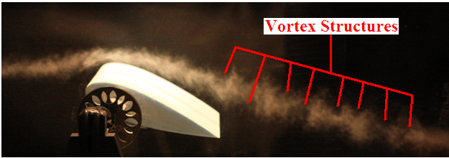
(a)
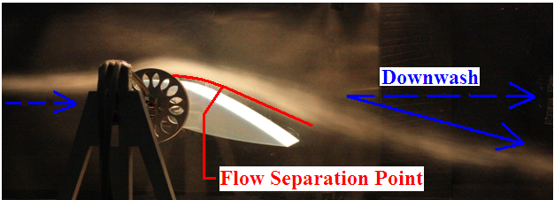
(b)
Figure 4.31: (a) The modified 0024 airfoil at 20° with the 1/4000th shutter speed, (b) with a 1/200th shutter speed.

In Figure 4.31(a) it was observed that vortex shedding characteristics were highlighted by the smoke stream. As the individual vortices could not be clearly identified due to the flow velocity as previously discussed, empty regions where no smoke was evident were representative of the large vortex structures. This was so due to their high turbulence which caused a large degradation of the smoke flow. This effect was more noticeable as the smoke flow moved further downstream, due to the propagation of the vortices. Therefore, in comparison to the smoke stream prior to the flow separation point, the concentration of the stream became lower due to the degradation effects of the highly turbulent wake region. The downwash (labelled in Figure 4.31(b)) occurred due to the induced velocity in a downward direction as a result of the wing tip vortices [7]. This induced drag component, as discussed in Section 2.1.5 and in relation to the results presented thus far in this chapter, increased the effective AOA at the aerodynamic centre of the airfoil [7].
In addition, in Figure 4.31(b) the photograph was taken at a slightly lower height in order to allow the increasing distance of the smoke stream from the airfoil to be observed more clearly. On the other hand, the slightly higher angle that the camera was set to on the tripod was to allow a better observation of the smoke stream at the leading edge of the airfoil. This was therefore due to the design of the balance which blocked the airfoil view to some extent. However, for this 0024 profile the maximum lift coefficient should be reached when the flow starts to separate at approximately the mid-chord point [7]. Therefore, in Figure 4.31(b) it can be seen that the point at which the flow separated, where the gap between the smoke stream and the airfoil suddenly increased, was located at approximately the mid-chord point. However, it was known that the high blockage ratio affected the lift and drag forces and in particular the lift curve slope, with no stalling point evident from the results obtained with the balance. While the stalling AOA of the 0024 profile should have been approximately 18° [6], it could have been possible that if the AOA was increased beyond 20° a stalling point would have been observed in the graphs presented in this chapter.

Due to the small changes in lift and drag, apart from the large lift increase at 0°, it was difficult to relate characteristics from the photography to the results obtained for this modification. For the most part, there was not a large amount of variation in the forces throughout the testing with System 2, as a result of a dimple modification being compared to the baseline results. While it would have been interesting to photograph other dimple modifications, such as those from the split flap or the end-plate testing, time restrictions did not allow for this. Also, as stated before, the work carried out in relation to Phase 2 testing and the amount of time involved with all the elements surrounding the balance/DAQ system (System 2) design and implementation, therefore comprised the majority of the overall research.

Chapter 5 – Conclusions & Recommendations

5.1 Conclusions

The conclusions drawn from this research were as follows:

- A literature review was conducted on topics such as aerodynamics, fluid mechanics and flow separation in particular. Chapter 2 also contained a detailed review of recent research conducted into new drag reduction techniques. Other sections discussed strain gauge theory and introduced the concept of internal/external strain gauge balances. This background research set the current work into context in terms of originality. However, it must be stated that overall there was a lack of research concerning surface modifications specifically for reducing pressure drag and delaying flow separation on airfoils. The completion of this literature review therefore achieved Aim 1 as set out in Chapter 1.

Aim 2 defined in Chapter 1 was achieved as follows:

- Following on from Phase 1 of the research, a new strain gauge balance (System 2) was designed and manufactured, for Phase 2 of the research, in order to meet the specific testing requirements. This design corrected the measurement errors and low sensitivity associated with System 1.

- In conjunction with this, a data acquisition system was constructed to capture the fluctuating drag and lift forces. The overall set-up was highly sensitive and had the ability to measure the forces with a high degree of accuracy and stability over time. The wind tunnel was also modified in order to reduce the free-stream turbulence through the test section. This resulted in a decrease of the maximum flow velocity through the test section from 27.25m/s to 23.2m/s.

- A thorough calibration process was conducted for Systems 1 and 2. In particular with System 2, the calibration highlighted its very high sensitivity and stability. It also verified the effectiveness of its design with very small levels of force interaction occurring between the two sets of flexures. In addition, a force interaction matrix method was used to account for the small interaction on the drag output due to the lift force (System 2).

Aim 3 defined in Chapter 1 was achieved as follows:

- Three different 4-digit NACA profiles were chosen as the test models. These were: a thin symmetric (0006) profile, a thick symmetric (0024) profile and a thick cambered (4424) profile.

- The airfoil test models were dimpled through a sand blasting process. From this, it was possible to obtain different levels (degrees) of surface roughness. Two main degrees were used and they were classified as a low and a high Ra (average surface roughness value) dimple effect. The other aspect of modifying the airfoils was the location of the dimples. These were applied to various sections on the flow separation (low pressure) side of the airfoil and to the high pressure side also.

- The airfoils were tested through an AOA range from 0° to 20°. It was initially expected that this would allow an analysis of the effect of the dimples past the stalling AOA of the airfoils. However, as a consequence of the high blockage ratio involved with the testing, this resulted in the characteristics of the drag and lift forces being affected. As a result of an aspect known as ‘streamline curvature’, this led to no stalling point being evident on the lift curve slopes upon analysing the test results.

- The airfoils were tested in different set-ups, these were: the NACA 0006 and 0024 profiles were tested individually known as ‘Single Airfoil Testing’, the NACA 0024 profile was tested with the use of end-plates in order to observe the effects of the dimples as a result of greatly reducing the induced drag component, and these two profiles were also tested in a split flap configuration, known as ‘Split Flap Airfoil Testing’. All of this testing constituted the Phase 2 testing, with the NACA 4424 profile tested in Phase 1. However, due to the measurement errors associated with System 1, the results obtained in Phase 1 had uncertainties in their accuracy.

- In relation to the induced drag component, this was particularly high for the test models used as they had an aspect ratio of only approximately 1. Therefore, a large degree of wing tip vortices would have been present which adversely affected the lift to drag ratio of the airfoils.

- Based on the single airfoil testing, this had a maximum Re of 321,227 which signified a laminar flow regime. With regards to the split flap airfoil testing, the maximum Re based on the effective chord length of the main airfoil and the flap was 588,141. Therefore, this number signified that the flow was just inside a transition region from laminar to turbulent flow.

Aim 4 defined in Chapter 1 was achieved as follows:

- From the testing it was discovered that dimpling the frontal section of the low pressure side of the airfoils led to large aerodynamic instabilities. The drag and lift force signals recorded by the DAQ system exhibited large fluctuations over time, with correspondingly higher values of signal standard deviation. As a result, testing could only be conducted up to 10° AOA approximately, in order to prevent damage being caused to the flexures. Therefore, dimples located before the aerodynamic centre of the airfoil led to this instability effect, as a result of the formation of a turbulent boundary layer at the front of the airfoil. However, adding dimples from the 0.33c point onwards, thereby allowing the formation of a laminar boundary layer at the front of the airfoil, did not result in such force fluctuations.

- In relation to comparing the standard deviation values produced as a result of the different modifications, it was observed that not only did the range of the fluctuations change, but also the frequency of the force variation changed. Therefore, two signals from two separate tests may have had similar values of standard deviation, but one signal would have signified a more rapid fluctuation of the drag/lift forces.

- Dimpling the full high pressure side of the NACA 0024 profile, with a high Ra dimple effect, resulted in a 6.84% average lift increase across the AOA range. There was a small increase in drag at the lower AOA, but the values were similar to the baseline from 12° onwards. This increase in lift was caused by the turbulent flow, leaving the high pressure side, tilting the flow behind the airfoil downwards. This was similar to the downwash effect associated with wing tip vortices. This resulted in an effective local AOA increase at the aerodynamic centre.

- For the NACA 0024 profile, an increase in the lift force was also observed as a result of a high Ra modification to the middle and last 1/3rd sections, on the flow separation side. There was a large increase of 144.18% at 0° with a much smaller increase after this, between approximately 2.5% to 6.5% (decreasing towards 20°). This effect was caused by the dimples decreasing the pressure gradient above the airfoil. However, in relation to the modification to the high pressure side which also resulted in a lift increase, this effect would have been suppressed by the higher pressure gradient on this side of the airfoil.

- In terms of testing the NACA 0024 profile with end-plates in order to reduce the induced drag component, this resulted however in an effective AOA shift due to the additional weight creating a moment on the sensitive flexures. As a result, the additional lift force generated at 0° was 1.81N and this was extrapolated to be equivalent to the lift force generated at 3.7° approximately, for the baseline test without end-plates. The additional drag force of 0.35N at 0° was found to be equivalent to that produced at 6.6° approximately, also for the case without end-plates. However, even when this initial offset was subtracted from each AOA value, the lift curve slope increased with the use of the end-plates. There was a peak increase in lift of 2.57N at 14° AOA and the increase relative to the baseline became smaller after this. However, the extent of the relative drag increase as the AOA was increased, compared to the baseline test without end-plates, was due to the proximity of the end-plates to the test section walls. As a result, there must have been some local flow separation occurring along the sides of the end-plates. In terms of the stability of the airfoil with the end-plates attached, this resulted in drag and lift standard deviation values much less than those for the 0024 profile without end-plates.

- In terms of the best result achieved with the use of the end-plates applied to the 0024 profile, this was where the middle and last 1/3rd sections on the low pressure side were dimpled with a high Ra. Although there was a small drag increase in the low AOA range, from 10° onwards the drag force generated compared to the baseline decreased. However, the lift force also decreased from approximately 8° onwards and at 20° there was a drag decrease of 11.15% and a lift decrease of 8.46%. This therefore led to a marginal increase in the aerodynamic efficiency of 3.13%.

- With regards to the testing with the split flap set-up, when compared to the single airfoil (flap only) baseline it was observed that both the drag and lift forces were lower across the AOA range. There was a larger difference in the lift force initially and as the AOA approached 20°, it became closer in value to the single airfoil set-up. Therefore, at 20° these values were approximately equal, however there was also a 14.07% decrease in the drag force at this point. These differences in the drag and lift curve slopes were due to the increased blockage ratio of the set-up, with a maximum value of 34.97% compared to the maximum value of 19.37% for the single airfoil set-up. In addition, the main airfoil and support frame set-up acted to increase the flow turbulence and created a flow angularity over the flap, thereby explaining the decrease in the drag and lift forces, respectively.

- In terms of the best modification regarding the split flap set-up, this again was where the 0024 flap had its middle and last 1/3rd sections dimpled with a high Ra. Therefore, with this modification and with the main airfoil left fully smooth, this resulted in a drag decrease from approximately 8° AOA onwards. While there was an initial increase in drag in the low AOA range, explained to be due to the dimples increasing the skin friction drag, this modification led to a maximum drag decrease of 8.23% at 20°. In relation to the effects on the lift force, there was an overall very small drop across the AOA range, with the largest drop of 6.53% occurring at 10°. Therefore, when the respective 1.94% drop in lift at 20° was compared to the decrease in drag at this AOA, this led to an increase in the aerodynamic efficiency of 6.87%.

- By increasing the surface roughness of the main airfoil this led to a decrease in the lift produced by the NACA 0024 flap. The high Ra dimple effect applied fully to both sides of the main airfoil led to a lift decrease of 12.39% of 20°. Therefore, the increase in the flow turbulence over the flap acted to reduce the lift curve slope.

- Even though dimpling the frontal section of the flow separation side in the single airfoil testing led to large instability problems, when the main airfoil was dimpled this alleviated this effect occurring with the flap. Therefore, the increased flow turbulence, as a result of the dimples on the main airfoil, allowed a more steady formation of a turbulent boundary layer at the leading edge of the flap. This thereby virtually eliminated the aerodynamic instability and this applied for the testing with both the NACA 0024 and 0006 flaps.

- As the final part of Phase 2 of the research the smoke flow visualisation photography was carried out. However, as the design, optimisation, calibration and testing with System 2 comprised the majority of the overall research, the smoke flow analysis was conducted over a short period of time. Despite this the photography revealed some interesting flow characteristics which were used to verify some explanations given in relation to the test results obtained with System 2. It was concluded that while this process was conducted with the wind tunnel set to its lowest flow velocity (8.15m/s), this flow velocity was still slightly too fast. This was so as it appeared to cause a certain degree of flow degradation in the smoke stream and it was difficult to observe individual vortex structures.

5.2 Recommendations

The following recommendations have arisen from the research:

- In relation to the Reynolds numbers involved with the testing, the dimples may produce a greater amount of drag reduction by delaying flow separation as a result of a higher Re flow scenario. As laminar separation was applied to the experimentation, the dimples may not have provided enough excitation to the boundary layers to overcome the severity of the flow separation associated with laminar flow regimes. Therefore, perhaps the maximum velocity of the tunnel could be increased by the installation of a more powerful fan, or test models based on longer chord lengths could be used. However, an increase of the model size would be restricted due to blockage ratio issues.

- As opposed to airfoils, alternative test models could be tested with this dimple effect. Since there were concerns regarding the blockage ratio in this research, smaller objects which would produce large amounts of pressure drag, thus forward/rearwards facing steps with faces normal to the free-stream flow, could be tested.

- With regards to the smoke flow visualisation photography, the slowest tunnel velocity that could be selected on the fan speed controller was 8.15m/s. For more effective future testing with smoke flow, it would be preferable to use a different controller to achieve a lower velocity which would reduce the mechanical degradation of the smoke particles.

5.3 Conference Attendance and Presentations

- A poster entitled “Reduction of Flow Separation by Excitation of Boundary Layer Kinetic Energy around an Airfoil” was presented at the 11th Annual Sir Bernard Crossland Symposium, which was held at the University of Limerick on March 12th and 13th 2008. It was organised jointly by Engineers Ireland and the Council of Professors of Mechanical Engineering. Presentations were made by many research students from various universities all over Ireland.

- In October 2006 attendance at the 6th MIRA International Aerodynamics Conference which was held in the Heritage Motor Centre in Warwickshire, England. It ran over two days and was attended by over 100 delegates from all over the world. Papers were presented on various aspects of aerodynamic design relating to saloon cars, trains and motorsport. It also featured presentations on the use of CFD in the development of aerodynamic designs and the design and testing set-up of wind tunnels. While no paper was presented, as this was near the start of the research, attending this conference proved to be very informative and allowed a great insight into the current trend in aerodynamic design.

References

[1] Bertin, J.J. and Smith, M.L., (1979), “Aerodynamics for Engineers”, Prentice-Hall Inc., New Jersey, ISBN 0-13-018234-6.

[2] Wind Tunnels of NASA - Chapter 1: Whirling Arms and the First Wind Tunnels, [online], http://www.hq.nasa.gov/office/pao/History/SP-440/ch1-3.htm (Accessed 12th July 2010)

[3] Anderson, J.D. Jr., (1991), “Fundamentals of Aerodynamics”, 2nd Edition, McGraw-Hill, London, ISBN 0071007679.

[4] Aerospaceweb.org - Angle of Attack and Pitch, [online],
http://www.aerospaceweb.org/question/aerodynamics/q0165.shtml (Accessed 12th July 2010)

[5] Barnard, R.H. and Philpott, D.R., (1995), “Aircraft Flight”, 2nd Edition, Longman Singapore Publishers Ltd., Singapore, ISBN 0582236568.

[6] Abbott, I.H., Von Doenhoff, A.E., (1959), “Theory of Wing Sections”, Dover Publications, New York, ISBN 486-60586-8.

[7] Thwaites, B., (1987), “Incompressible Aerodynamics”, Dover Publications, New York, ISBN 0-486-65465-6.

[8] Jacobs, E.N., Ward, K.E. and Pinkerton, R.M., (1933), “The Characteristics Of 78 Related Airfoil Sections From Tests In The Variable-Density Wind Tunnel”, NACA Report No. 460, National Advisory Committee for Aeronautics, Virginia, USA, pp. 299-300.

[9] Douglas, J.F., Gasiorek, J.M. and Swaffield, J.A., (1998), “Fluid Mechanics”, 3rd Edition, Longman Singapore Publishers Ltd., Singapore, ISBN 0-582-23408-5.

[10] Currie, I.G., (2003), “Fundamental Mechanics of Fluids”, 3rd Edition, Marcel Dekker Inc., New York, ISBN 0824708865.
[11] Landau, L.D. and Lifschitz, E.M., (1982), “Fluid Mechanics”, 2nd Edition, Pergamon Press, Oxford, ISBN 0080339328.

[12] Miley, S.J., et al., (1995), “Slat transition characteristics on the NASA B737-100 aircraft using infrared imaging and hot film anemometry”, In: Crowder, J.P., editor, “Flow Visualisation VII”, Begell House, New York, ISBN 1567000363, pp. 950-956.

[13] Abbott, I.H., et al., (1945), “Summary of Airfoil Data”, NACA Report No. 824, National Advisory Committee for Aeronautics, Virginia, USA.

[14] Schlichting, H. and Gersten, K., (2000), “Boundary Layer Theory”, 8th Edition, Springer-Verlag, New York, ISBN 3-540-66270-7.

[15] Betz, A., (1925), “A Method for the Direct Determination of Wing-Section Drag”, NACA Report No. 337, National Advisory Committee for Aeronautics, Virginia, USA.

[16] Dalhousie University - Golf Ball Dimples and Flow Separation, [online],
http://www.me.dal.ca/site2/courses/mech3300/4_Drag.pdf (Accessed 5th October 2007)

[17] Whitmore, S.A., Sprague, S., Naughton, J.W., (2001), “Wind-Tunnel Investigations of Blunt-Body Drag Reduction using Forebody Surface Roughness”, NASA/TM-2001-210390, NASA Dryden Flight Research Centre, California, USA.

[18] Igarashi, T., Terachi, N., (2002), “Drag reduction of flat plate normal to airstream by flow control using a rod”, Journal of Wind Engineering and Industrial Aerodynamics Vol. 90, pp. 359-376.

[19] Nakamura, H. and Igarashi, T., (2008), “Omni-directional reductions in drag and fluctuating forces for a circular cylinder by attaching rings”, Journal of Wind Engineering and Industrial Aerodynamics Vol. 96, pp. 887-899.

[20] Lienhart, H., Breuer, M. and Köksoy, C., (2008), “Drag reduction by dimples? – A complementary experimental/numerical investigation”, International Journal of Heat and Fluid Flow Vol. 29, pp. 783-791.
[21] Brostow, W., (2008), “Drag reduction in flow: review of applications, mechanism and prediction”, Journal of Industrial and Engineering Chemistry Vol. 14, pp. 409-416.

[22] Lee, S.J. and Jang, Y.G., (2005), “Control of flow around a NACA 0012 airfoil with a micro-riblet film”, Journal of Fluids and Structures Vol. 20, pp. 659-672.

[23] Bechert, D.W., et al., (2000), “Fluid mechanics of biological surfaces and their technological application”, Naturwissenschaften Journal Vol. 87, pp. 157-171.

[24] Viswanath, P.R., (2002), “Aircraft viscous drag reduction using riblets”, Progress in Aerospace Sciences Vol. 38, pp. 571-600.

[25] Grosche, F.R. and Meier, G.E.A., (2001), “Research at DLR Gottingen on bluff body aerodynamics, drag reduction by wake ventilation and active flow control”, Journal of Wind Engineering and Industrial Aerodynamics Vol. 89, pp. 1201-1218.

[26] Tian, L., et al., (2007), “The Mechanism of Drag Reduction around Bodies of Revolution using Bionic Non-Smooth Surfaces”, Journal of Bionic Engineering Vol. 4, pp. 109-116.

[27] Eguchi, Y., et al., (2002), “Drag reduction mechanism and aerodynamic characteristics of a newly developed overhead electric wire”, Journal of Wind Engineering and Industrial Aerodynamics Vol. 90, pp. 293-304.

[28] Jolibois, J., Forte, M. and Moreau, E., (2008), “Application of an AC barrier discharge actuator to control airflow separation above a NACA 0015 airfoil: optimization of the actuation location along the chord”, Journal of Electrostatics Vol. 66, pp. 496-503.

[29] Sosa, R. and Artana, G., (2006), “Steady control of laminar separation over airfoils with plasma sheet actuators”, Journal of Electrostatics Vol. 64, pp. 604-610.

[30] Osborn, R.F., et al., (2001), “Active flow control using high frequency compliant structures”, American Institute of Aeronautics and Astronautics (AIAA) Vol. 2001-4144.

[31] Shan, H., et al., (2008), “Numerical study of passive and active flow separation control over a NACA 0012 airfoil”, Journal of Computers and Fluids Vol. 37, pp. 975-992.

[32] Beaudoin, J.F., et al., (2006), “Bluff-body drag reduction by extremum-seeking control”, Journal of Fluids and Structures Vol. 22, pp. 973-978.

[33] You, D. and Moin, P., (2008), “Active control of flow separation over an airfoil using synthetic jets”, Journal of Fluids and Structures Vol. 24, pp. 1349-1357.

[34] Van Dam, C.P., (1999), “Recent experience with different methods of drag prediction”, Progress in Aerospace Sciences Vol. 35, pp. 751-798.

[35] Rae, W.H. Jr. and Pope, A., (1984), “Low-Speed Wind Tunnel Testing”, 2nd Edition, John Wiley & Sons Inc., New York, ISBN 0-471-87402-7.

[36] University of Cambridge - Hot Wire Anemometers, [online],
http://www-g.eng.cam.ac.uk/whittle/current-research/hph/hot-wire/hot-wire.html
(Accessed 12th July 2010)

[37] Window, A.L., (1992), “Strain Gauge Technology”, 2nd Edition, Elsevier Applied Science, London, ISBN 1851668640.

[38] Kuphaldt, T.R., (2006), “Lessons in Electric Circuits”, Electrical Instrumentation Signals Vol. 1, [online], http://www.ibiblio.org/obp/electricCircuits/DC/DC_9.html (Accessed 12th July 2010)

[39] Evaluation Engineering - Making Basic Strain Measurements, [online],
http://www.evaluationengineering.com/index.php/solutions/instrumentation/making-basic-strain-measurements-a-tutorial.html (Accessed 12th July 2010)

[40] Beckwith, T.G., Marangoni, R.D. and Lienhard, J.H., (2006), “Mechanical Measurements”, 6th Edition, Prentice-Hall Inc., New Jersey, ISBN 0201847655.

[41] Tait, S.W. and Niven, A.J., (1997), “The Design and Manufacture of an Internal Strain Gauge Balance for Use with the VVR Balance”, Internal Report, University of Limerick, Ireland.

[42] Triumph Aerospace Systems - Force Measurement Systems Gallery, [online],
http://www.alliedaerospace.com/WT%20FMS%20Gallery.htm (Accessed 12th July 2010)

[43] Applied Research Inc. - Wind Tunnel Hardware Development, [online],
http://www.bihrle.com/site/services_wtd.html# (Accessed 12th July 2010)

[44] Aerolab - Pyramidal Balances, [online], http://www.aerolab.com/ (Accessed 12th July 2010)

[45] Mainsah, E., Greenwood, J.A. and Chetwynd, D.G., (2001), “Metrology and Properties of Engineering Surfaces”, Kluwer Academic Publishers, Boston, ISBN 0412806401.

[46] Mehta, R.D. and Bradshaw, P., (1979), “Design rules for small low speed wind tunnels”, Journal of the Royal Aeronautical Society Vol. 73, pp. 442-449.

[47] Dally, J.W. and Riley, W.F., (1991), “Experimental Stress Analysis”, 3rd Edition, McGraw-Hill, New York, ISBN 0070152187.

[48] Vishay Measurements Group, (1992), “Student Manual for Strain Gage Technology - Strain Gage Selection, Criteria, Procedures and Recommendations”, North Carolina, USA.

[49] RS Components, (1997), “Strain Gauges and Load Cells - Data Sheet 232-5957”, Northants, UK.

[50] Yen, D. and Bräuchle, F., (2000), “Calibration and Uncertainty Analysis for the UC Davis Wind Tunnel Facility”, Wind Tunnel Calibration Document, University of California, USA.

[51] Volluz, R.J., (1961), “Handbook of Supersonic Aerodynamics, Section 20, Wind Tunnel Instrumentation and Operation”, U.S. Naval Ordnance Laboratory Report 1488, Maryland, USA.

[52] O’Reilly, E., (2006), “Analysis of Boundary Layers through Computational Fluid Dynamics and Experimental Analysis”, Masters Thesis, Dublin City University, Ireland.

Appendices

Appendix A – Recent Numerical Developments of Drag Calculation

Following on from Section 2.4, the process by which Equation 2.13 was developed by van Dam [34] is discussed. There are two different perspectives when examining the drag force on an object. One angle is from that of the body and another is from that of the fluid flow. According to Newton’s third law, the force on an object due to the fluid flow over it is opposite to the force imposed by the object on the fluid flow. Therefore, alternate drag equations to Equation 2.1 described in Section 2.1.3, which is the classical drag force equation dating back many years, have been developed which are more modernised and specialised. These equations will be discussed from the object perspective firstly and then from the fluid-flow perspective.

A.1 Object Perspective

As air flows over an aircraft wing for example, normal and tangential forces which constitute drag and lift forces can be expressed in the following total form [34]:

F_{b} = ∫∫ ( - pn + τ : n) dS_{Body} Equation A1

Where: S_{Body} is the integration surface of the body, p is the pressure, n = n_{x}$\hat{i}$ ₊ n_{y}$\hat{j}$ ₊ n_{z}$\hat{k}$ which is the outward pointing unit vector normal to S_{Body} and τ is the viscous stress tensor = $\left[\begin{matrix}τ_{xx} & τ_{xy} & τ_{xz} \\ τ_{yx} & τ_{yy} & τ_{yz} \\ τ_{zx} & τ_{zy} & τ_{zz}\end{matrix}\right]$

The viscous stress tensor includes all of the laminar and turbulent stresses acting on the air molecules. The total force F_{b} has the following force components (assuming a right-handed coordinate system with orthogonal axes as that in Figure A1): drag which is aligned with the free-stream velocity (U∞), the side force to the right and lift pointing straight up [34]. Therefore, this total force can be expressed as follows [34]:

F_{b} = D$\hat{i}$ + Y$\hat{j}$ + L$\hat{k}$ Equation A2

Therefore, this leads to the expression in relation to the three aforementioned forces acting through the aerodynamic centre on the object. The aerodynamic drag can now be expressed by altering Equation A1 with respect to the τ matrix [34]:

D = ∫∫ (- pn_{x} + τ_{xx}n_{x} + τ_{xy}n_{y +} τ_{xz}n_{z}) dS_{Body} Equation A3

Determining the drag using Equation A3 for a complex shape such as an airfoil would need to be conducted with powerful numerical software. In addition, the pressure term (p) in Equation A3 may include components of a variety of phenomena such as induced drag, and wave drag when analysing supersonic flows [34]. It is when these contributions are separated into their individual components that a greater understanding of the nature and origins of drag can be gained, as opposed to representing the drag force/coefficient by a numerical value.

A.2 Fluid-Flow Perspective

Upon analysing the effect of an object moving through the air, such as an airfoil, it effects the movement and forces exerted on the fluid. As before and in relation to Newton’s third law of motion, the air will generate forces on the airfoil and vice versa. Therefore, certain equations have been developed that describe the linear-momentum relation for a volume of air (V), enclosing an airfoil in steady uniform flow [34]:

Σ F = ∫∫ ρV(V · n) dS_{Body} Equation A4

Where: Σ F is the vector sum of all forces acting on the air inside the control volume (V), ρ is the density of the air flow, V = u$\hat{i}$ + v$\hat{j}$ + w$\hat{k}$ which is the mean air flow velocity inside the control volume and (S) is the closed control surface [34]. In Figure A1 the closed control surface (S) is illustrated, where (S) = S_{Exit} + S_{Side} + S_{Inlet} and note that the inlet and exit sides of the control surface are normal and the side planes are parallel to the free-stream flow.
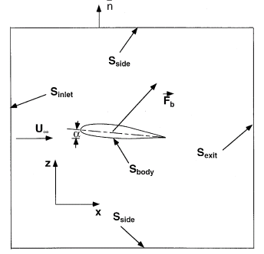

Figure A1: A 2-D airfoil in uniform flow inside the control surface [34].

Following on from Equation A4, its left-hand side can be written as the sum of the total forces generated by the airfoil on the air itself from before (- F_{b}), the pressure force on the fluid at S and also the viscous force on the air at S [34]:

Σ F = - F_{b} + ∫∫ - pn dS + ∫∫ τ : n dS_{Body} Equation A5

By combining Equations A4 and A5, the following so called far-field expression for the drag can be obtained [34]:

D = - ∫∫ [pn_{x} + ρu(V · n) + (τ_{xx}n_{x} + τ_{xy}n_{y} + τ_{xz}n_{z})] dS_{Body} Equation A6

However, in reality an airfoil would be travelling in an unbounded flow. Therefore, it is necessary to consider the effect of moving the inlet, exit and sides of the control surface in Figure A1 far enough away from the airfoil to represent a true unbounded flow. Thus to safely make the assumption that the flow is undisturbed at those locations, this leads to the following final expression for the drag force [34]:
D = - ∫∫ [(p – p∞) + (ρu² - ρ∞$U_{∞}^{2}$)] dS_{Exit} + ∫∫τ_{xx} dS_{Exit} Equation A7

Therefore, U∞∫∫(ρu - ρ∞U∞) dS_{Exit} is equal to $\dot{m}$U∞, where $\dot{m}$ is the net mass of the air generated within the control surface defined in Figure A1 [34]. If the analysis is restricted to the air flow where $\dot{m}$ is zero and making the assumption of inviscid flow, this leads to the drag integral [34]:

D = - ∫∫ [(p – p∞) + ρu(u - U∞)] dS_{Exit} Equation A8

However, the problem with Equation A8 is that the integration must be calculated over a very large area in order to capture all of the pressure and momentum flux, which are contributing to the overall drag force [34]. It is possible to develop Equation A8 into a more user-friendly equation where it only requires an evaluation over a limited area [34]. While a description of its derivation is outside the scope of this section, the result of this is Equation 2.13 as presented in Section 2.4.

Appendix B – Airfoil Dimensions

The details of all the test models used in this research (Phase 1 and 2 testing) are listed in Table B1. It can also be seen that the airfoils had an aspect ratio (span divided by chord) of approximately 1.

Test Model  Number | NACA Profile | Chord (mm) | Span (mm) | Aspect Ratio
*Phase 1 Testing*
1 | 0006 | 210 | 208 | 0.99
2 | 0006 | 210 | 208 | 0.99
3 | 0024 | 205 | 209 | 1.02
4 | 0024 | 207 | 209 | 1.01
5 | 4424 | 205 | 208 | 1.01
6 | 4424 | 205 | 209 | 1.02
*Phase 2 Testing*
1 | 0024 | 207 | 209 | 1.01
2 | 0024 | 206 | 210 | 1.02
M1 | 0024 | 207 | 201 | 0.97
F1 | 0024 | 207 | 210 | 1.01
M2 | 0024 | 206 | 201 | 0.98
F2 | 0006 | 207 | 210 | 1.01
Table B1: The dimensions and resulting aspect ratio for each of the test models used.

Appendix C – Strain Gauge Specifications

The properties of the strain gauges that were used with Systems 1 and 2 are listed in Tables C1 and C2 respectively.

Strain Gauge Specifications
Maximum Measurable Strain | 3 - 4%
Gauge Resistance | 120Ω
Gauge Resistance Tolerance | Within $±$0.5%
Grid Length | 8mm
Gauge Factor | 2.1
Gauge Factor Tolerance | Within $±$1%
Carrier Length | 13mm
Width | 2mm (Grid) 4mm (Carrier)
Grid Material | Constantan (Copper-Nickel Alloy)
Operating Temperature Range | -30ºC to +80ºC (Polyester Carrier)
Thermal Output | Within $±$2µε/ºC
Gauge Factor Change with Temperature | Within $±$0.015%/ºC

Table C1: Specifications of the strain gauges used with System 1.

Strain Gauge Specifications
Maximum Measurable Strain | 3%
Linear Expansion Factor | 16.2 × 10⁻⁶/ºC  (Steel Temperature Compensated)
Gauge Resistance | 1000Ω
Grid Length | 13mm
Gauge Factor | 2
Gauge Factor Tolerance | Within $±$5%
Carrier Length | 22.7mm
Width | 7.2mm (Grid) 10mm (Carrier)
Grid Material | Constantan (Copper-Nickel Alloy)
Operating Temperature Range | -30ºC to +180ºC (Polyimide E Carrier)
Maximum Supply Voltage | 55V_{RMS}
Table C2: Specifications of the strain gauges used with System 2.

Appendix D – Material Properties

The properties of the stainless steel material used for the flexures in System 2, and the aluminium grade used for all the other balance components (in Systems 1 and 2) are listed in Tables D1 and D2 respectively.

Stainless Steel 304
18/10 Stainless (18% Chromium, 10% Nickel and 0.08% Carbon approx.)
Density | 8,000kg/m³
Hardness (Vickers) | 129
Yield Tensile Strength | 215MPa
Ultimate Tensile Strength | 505MPa
Young’s Modulus | 200GPa
Elongation at Break | 70%
Thermal Conductivity | 16.2W/m$∙$K

.

Table D1: Mechanical and thermal properties of the stainless steel material used for the flexures in System 2.

Aluminium 6082-T6
(Approx. 0.6% Magnesium and 1% Silicon)
Density | 2,700kg/m³
Hardness (Vickers) | 95
Yield Tensile Strength | 255MPa
Ultimate Tensile Strength | 300MPa
Young’s Modulus | 70GPa
Elongation at Break | 10%
Thermal Conductivity | 170W/m$∙$K
Table D2: Mechanical and thermal properties of the aluminium material used for the various balance components (Systems 1 and 2).

Appendix E – System 2 Flexure Design

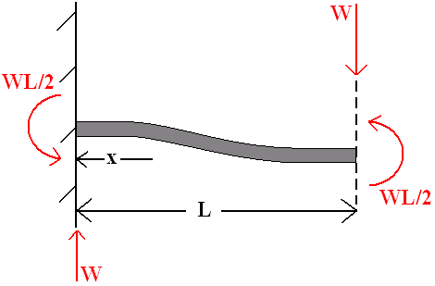
Figure E1: Diagram illustrating the loading scenario on the flexures.

Where W is the load, L is the length of the flexure and x is the distance of a point on the flexure from the fixed support end. Therefore, the flexure loading was defined as a thin beam that was free and guided at one end and fixed at the other end [47]. The equation to calculate the stress at any point along the flexure is as follows [47]:

Stress at any point = σ = $\frac{W}{Z}$ ($\frac{1}{2}$L – x ) Equation A9

Where Z is the section modulus of the flexure cross-section and this is equal to the moment of inertia (I) divided by the distance from the neutral axis of the flexure to its top or bottom surface, or in effect half its thickness, (c). The section modulus can therefore be defined by [47]:

Section Modulus = Z = $\frac{I}{c}$ = (${bh}^{3}$/12) / (h/2) Equation A10

Where b is the width of the flexure and h is its thickness. From Equation A9 it can be seen that the maximum stress occurred at the fixed support, where the value of x was zero. The level of stress gradually decreased along the length of the flexure in a linear fashion. Therefore, the stress at the fixed support can be simplified to [47]:

σ = $\frac{WL}{2Z}$ Equation A11

Equations A9 and A11 are in contrast to the equation for a cantilevered beam, which does not have its length value (L) divided by 2. Initially it was known that the flexures should be as thin as structurally possible, in order to maximize the strain sensitivity. Therefore, the flexures were cut from a sheet of 0.5mm thick Stainless Steel 304. However, regarding the thickness value, upon measurement it was found that the average thickness value of the sheet was 0.6mm. In terms of accuracy for the calculation of the maximum stress levels and relevant force loading, this value was used as opposed to 0.5mm. The width of the flexures were chosen initially to be 20mm, which was the same width as the connection blocks (Figure 3.32). As a result, the only variable to be selected was the length of the flexures and this simplified the design process. Due to the modifications to the wind tunnel to reduce the test section flow turbulence (for Phase 2), this reduced the flow velocity through the test section.

Therefore, an approximate guideline of 10N maximum lift force and 4N maximum drag force, was extrapolated from the Phase 1 test results in conjunction with the knowledge of the reduced tunnel velocity values. These two values determined were also slightly conservative and it was expected that the maximum drag and lift values would be slightly less. By re-arranging Equation A11 for W, which would represent the maximum load required in order to cause failure to the flexures (σ was 215MPa from Appendix D), the active strain lengths of the drag and lift flexures were determined to be 55mm and 35mm respectively. The corresponding force (aerodynamic loading) that needed to be applied to the strut in order to cause failure to the drag and lift flexures (structural capacity) was 9.38N and 14.74N respectively.

As discussed in Section 3.7.2, the flexures were also very insensitive to their respective secondary forces. For example, the drag flexures (with their primary force due to drag) were insensitive to the lift force (secondary force) and vice versa for the lift flexures. The flexure thickness had a square relationship with strain as shown in the following equation [47]:

Strain at any point = ε = $\frac{6W(0.5L-x)}{bh^{2}E}$ Equation A12

Where W is the load, L is the flexure length, x is the distance of a point on the flexure from the fixed support end, b is the flexure width, h is its thickness and E is the Young’s Modulus of the material. The square relationship between the thickness and the strain in Equation A12 resulted in the secondary force sensitivity being approximately 1,111 times lower ((20mm$÷$0.6mm)²) than that of the primary force sensitivity. As a result, the secondary force insensitivity factor was deemed to be more than adequate, while at the same time a flexure width of 20mm was not detrimental in relation to achieving a high strain sensitivity (primary force).

Appendix F – Strain Gauge Amplifier Circuitry

Table F1 details the specifications of the strain gauge amplifier circuits used. These values listed are for those applicable at 25°C ambient temperature and at a supply voltage of $±$12V [49].

Amplifier Circuit Specifications
Supply Voltage Range | $±$2V to $±$20V
Input Offset Voltage | 200μV max.
Input Offset Voltage/Temperature | 0.5μV/°C max.
Input Offset Voltage/Supply | 3μV/V max.
Input Offset Voltage/Time | 0.3μV/month max.
Input Impedance | >5MΩ min.
Input Noise Voltage | 0.9μVp.p max.
Bandwidth (Unity Gain) | 450kHz
Output Current | 5mA
Closed Loop Gain (Adjustable) | 3 to 60,000
Open Loop Gain | >120dB
Common Mode Rejection Ratio (CMRR) | >120dB
Bridge Supply Voltage/Temperature | 20μV/°C
Maximum Bridge Supply Current | 12mA
Power Dissipation | 0.5W
Warm-up Time | 5 mins
Operating Temperature Range | -25°C to +85°C

Table F1: Specifications of the two strain gauge amplifiers used (System 2) [49].

In Figure F1 a circuit diagram for the amplifier circuit can be seen. In reference to the letter symbols: A is the positive bridge supply (+V_{S}), B is compensation, C is the VR₁ potentiometer for setting the bridge supply voltage, D is the positive input, E is the output, F is the negative input, G is the negative bridge supply (-V_{S}) and H represents the VR₂ potentiometer for setting the output voltage to zero [49]. The 24 pin DIL (Dual In Line) amplifier chip is located in the centre of the circuit, with Figure F2 illustrating the inputs and outputs of the chip. It can be observed that in the current circuit configuration only 11 of the pins have active connections (others labelled N/C are not connected).

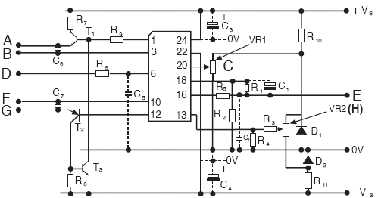
Figure F1: Circuit diagram of the strain gauge amplifier [49].

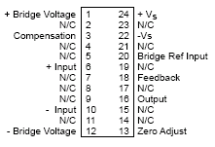

Figure F2: The inputs and outputs with respect to the pins of the amplifier chip [49].

The level of gain produced by the circuit (adjustable from 3 to 60,000) can be changed to a given value in relation to the following equation [49]:

Gain = 1 + $\frac{R_{1}}{R_{2}}$ Equation A13

The gain level set on the circuits was 1000 (default value), where R₁ was equal to 100kΩ and R₂ was equal to 100Ω. In relation to the zero adjustment range of the output bridge voltage, this range was increased or decreased by increasing/decreasing the values of R₃ and R₄ [49]:

Zero Adjustment Range (ZAR) = $±$ 6.2V × $\frac{R_{4}}{R_{3}+ R_{4}}$ Equation A14

When the strain gauge amplifiers were first set-up and tested, it was found that the VR₂ potentiometer was not able to adjust the output voltage to 0V. The R₃ resistor in the circuit (originally 100kΩ) was reduced to a value of 10kΩ, which resulted in the ZAR being equal to $±$0.042V, thereby increasing the adjustment range ten-fold and allowing full control of the zero output voltage point.

In the amplifier circuits there was an option of installing three capacitors (C₅, C₆ and C₇) which reduced the noise level produced by the circuit and also slowed the output response. The addition of two other capacitors (C₁ and C₂) reduced the noise level further by reducing the operational bandwidth. The installation of these 5 capacitors therefore aided in increasing the signal to noise ratio of the output signals. Each amplifier circuit, apart from the amplifier chips and the wiring connector blocks, contained: 11 resistors, 7 capacitors, 3 transistors, 2 diodes and 2 potentiometers.

Appendix G – Data Acquisition Card Specifications

DAQ Card Specifications
Manufacturer | National Instruments
Model | USB-6009
Analogue Input
Resolution | 14-Bit
Maximum Sample Rate | 48kS/s
Number of Channels | 4
Maximum Voltage Range | -10V to +10V
Accuracy | 138mV
Analogue Output
Resolution | 12-Bit
Number of Channels | 2
Maximum Voltage Range | 0V to 5V
Accuracy | 7mV
Digital Input/Output

Number of Channels | 12 Bi-directional

Table G1: Specifications of the National Instruments DAQ card.

Appendix H – Data Acquisition Software Set-Up

In this appendix the steps involved in setting up a new DAQ process are explained. The software used was LabVIEW SignalExpress 2009. Once the DAQ card was connected to the laptop via the USB cable, the following steps were taken:

- Add Step → Acquire Signals → DAQmx Acquire → Analogue Input → Voltage.

- Select the ‘ai0’ and ‘ai1’ channels which correspond to the two separate amplifier circuits. In relation to the wiring of the set-up, ‘ai0’ corresponded to the drag output and ‘ai1’ was the lift output.

- Once the Configuration tab automatically opens set the ‘Acquisition Mode’ to ‘Continuous Samples’. This step and steps 4, 5 and 6 are highlighted in Figure H1.

- Set the ‘Terminal Configuration’ to ‘Differential’.

- Also, at this point the ‘Signal Input Range’ can be set depending on the signals being sampled. However, this was left at the default setting of -10V to +10V.

- Select the ‘Sample Rate’ in Hz and the ‘Number of Samples to Read’. The total number of samples to be read divided by the sample rate will be equal to the total time in seconds for which the DAQ process will run.

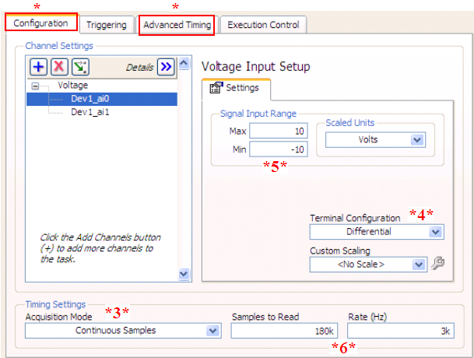
Figure H1: Illustration of the different settings that were adjusted before commencing a DAQ process.

- Switch to the ‘Advanced Timing’ tab and under ‘Additional Timing Settings’ set the ‘Timeout’ (in seconds) equal to the total sampling time, based on the last step. No other settings under this tab need to be changed.

- Click the ‘Run’ button to the right of the ‘Add Step’ button. Set the ‘Configure Run’ in seconds equal to the previously chosen sampling time.

- Switch to the ‘Data View’ tab and add a second ‘Time Graph’. Following this, drag the voltage channels (ai0 and ai1) separately to either of these graphs.

- In order to improve the performance of the software during the sampling/recording process, ensure that in the ‘Operate’ tab, ‘Update Signal Views While Running’, is set to ‘Update None’. Also, under Tools → Options → Logging Tab → ‘Prepare log data for viewing’ was set to ‘After logging completes’.

- At this point the project was saved under a name relevant to the given test.

- Therefore, once the strain gauges and amplifier circuits are given an initial heat-up time, to conduct a DAQ process: click ‘Record’ and tick ‘Voltage’. This in turn automatically selects the two channels (ai0 and ai1). Finally, enter a name/description and click ‘Ok’ to start the recording process.

- In order to conduct a DAQ process for another test, simply click the ‘Record’ button as before and enter a different name in order to distinguish the tests at a later stage. Once the overall testing was completed and after saving the project, it was possible to enter the ‘Playback’ part of the software to analyse the signals recorded. This process was explained in Section 3.10.2.

Appendix I – Force Interaction Graphs

In reference to Section 4.3.2, there were two interaction graphs obtained from the drag and lift force calibrations, L_{R}(D_{L}) and D_{R}(L_{L}) respectively. Therefore, the values of the slopes in Figures I1 and I2, corresponding to K₁₂ and K₂₁ respectively in Section 4.3.2, were used as part of the interaction matrix method. This in turn led to the creation of Equation 4.6 which correctly accounted for the error due to the interaction of the lift force when measuring the drag force. Note that the true output values with respect to Figure I2 are negative, as during the lift force calibration the output read on the drag channel decreased with an increase in the lift force. Therefore, in Section 4.3.2 the value of K₂₁ was found to be -24.333.

Figure I1: The L_{R}(D_{L}) graph resulting from the interaction of the drag force on the lift output.

Figure I2: The D_{R}(L_{L}) graph resulting from the interaction of the lift force on the drag output.

