Chapter 4: Synthesis of Dinuclear Triazole Containing Complexes via Suzuki Cross-Coupling.

Abstract:
Chapter 4 investigates the Suzuki cross-coupling reaction as an alternative to the synthetic strategy described in the chapter 3. The Suzuki coupling reaction is well-recognized in organic syntheses as a useful method for the formation of heteronuclear species and is used here for the purpose of synthesizing an asymmetrical heteronuclear metal complex.

The chapter includes a comprehensive overview of the Suzuki coupling catalytic cycle and a literature review of how this diverse reaction has been used within inorganic syntheses to date. We describe the synthetic approach taken for the preparation of a ruthenium dinuclear complex with an asymmetric bridging ligand using this cross-coupling method. A discussion as to possible reasons the reaction proved unsuccessful is provided.

4.1 Introduction
In our investigation into alternative synthetic strategies for the formation of multi-nuclear asymmetric transition metal complexes we move on to discuss cross-coupling reactions. This technique has been used extensively within organic synthesis for the formation of a variety of homocoupled and heterocoupled compounds. These catalyzed carbon-carbon reactions are very powerful and a well recognized tool in synthetic chemistry. The reactions are used in the formation of many organic compounds including aryl-aryl compounds, and tertiary phosphines. However the applications of this synthetic technique are so numerous they will not be discussed here but may be reviewed in the references listed., , ,

Several variations of the carbon-carbon coupling reactions have been described, where the organometallic reagent (nucleophile) may be based on magnesium, zinc, cooper, silicon or boron. Some of the most widely documented reactions include Suzuki-Miyaura (boron mediated), Kumada (magnesium mediated), Stille (tin mediated), Negishi (zinc mediated), Sonogashira (copper mediated) and Heck (palladium mediated) coupling reactions. Each reaction type has both advantages – mild reaction conditions and good selectivity- and disadvantages – toxicity/waste and air sensitivity -associated with them and are utilized depending on the reaction requirements. To date the most popular have proven to be Stille, Suzuki and Negishi coupling due to their stable intermediates. (Figure 4.1)

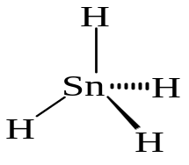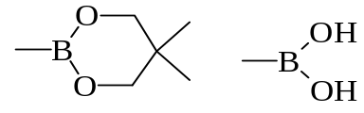

Figure 4.1: Stannane (Stille) and boronic acid (Suzuki) reagents used cross-coupling reactions.

However it was decided to use Suzuki coupling for the synthesis of the asymmetrically bridged ruthenium dinuclear complex due to its mediation of heterogeneous coupling and its proven selectivity and mild reaction conditions. This reaction also provides good yields with boronic acids being stable to heat, oxygen and water. The heterogeneous nature of this reaction is the primary reasoning behind our interest, as we wish to synthesis an asymmetrically bridged heteronuclear metal complex. Formation of only a single product from the reaction would eliminate the need for complicated separation techniques to obtain the desired product, as is the case with reactions carried out via the classic approach discussed previously in chapter 3. Furthermore, relatively straightforward procedures are available to appropriately functionalize precursor complexes with both the bromides and boronic acids, which are essential for this cross-coupling reaction to occur.

Suzuki coupling has become increasingly popular since its discoveryError: Reference source not found in the 1970’s and is well recognized as a successful approach for the formation of heteronuclear species. A general Pd catalyzed Suzuki reaction is shown in figure 4.2, where Ar / Ar’ = aryl group and X = halide. Steps 1-4 in the catalytic cycle will also be examined individually in figures 4.3 – 4.5.

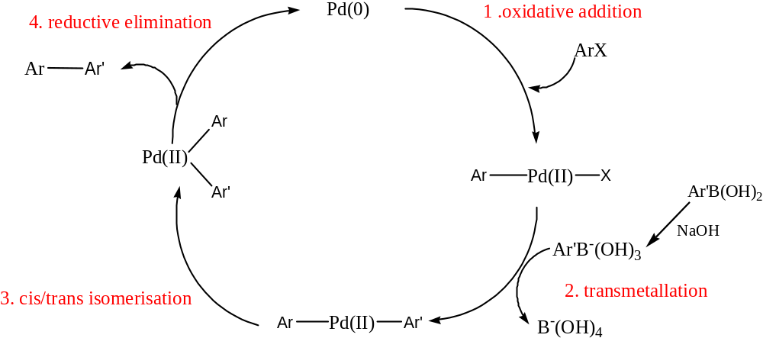

Figure 4.2: General catalytic cycle for organoboranes and organic halides (Suzuki cross-coupling).
The general catalytic cycle for the Suzuki cross-coupling reactions of organoboranes with oganohalides involves oxidative addition, transmetallation and reductive elimination., Although each step involves further intricate processes including ligand exchanges, there is no doubt about the presence of the intermediates which have been characterized by isolation and spectroscopic analysis.,

Oxidative addition is the initial step of the catalytic cycle as shown in figure 4.2. This process occurs between an aryl halide and the palladium(0) complex to afford a stable trans-palladium(II) complex. This process results in bond formation between a coordinately unsaturated species (Pd catalyst) and the appropriately functionalized aryl halide, to produce a coordinately saturated species, such as the organopalladium halide as shown in figure 4.3.

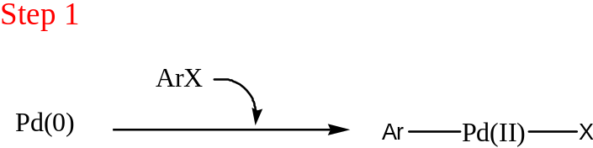

Figure 4.3: Oxidative addition of the metal catalyst into the single bond of the substrate

This is often the rate determining step within the catalytic cycle, with the relative reactivity of the functional groups decreasing in the order of I > OTf > Br >> Cl. Also aryl halides with electron withdrawing groups in close proximity are, in general, more activated towards coupling then those with electron donating groups present.

The second step we observe is transmetallation were the nucleophile, in this case boronic acid, is transferred from the organometallic reagent to the organopalladium(II) halide complex to provide the diorganopalladium complex as shown in figure 4.4. In Suzuki cross-coupling this step is previewed by the displacement of the halide ion from the organopalladium halide complex from the oxidative addition step to a base. This is the key difference between the Suzuki cross-coupling and other general cross-coupling reactions.

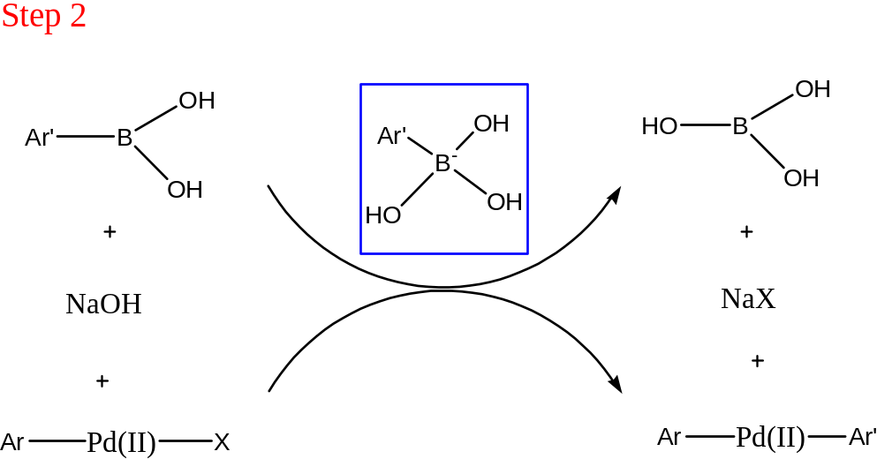

Figure 4.4: Transmetallation of an active complex with an organometallic substrate.

This step can prove problematic due to organoboron compounds being unlikely to participate in the catalytic cycle since they are inert to organopalladium(II) halides.Error: Reference source not found However it has been reported that the addition of sodium hydroxide or other bases exerts a remarkable effect on the transmetallation rate of organoboron reagents with metallic halides. Thus the transmetallation step with transition metal complexes can proceed well, but the choice of a suitable base and ligands on transition metal complexes are essential. The suitable base chosen enhances the reactivity of the organoboron complex, which has a low nucleophilicity due to the organic group attached to the boron atom. This is achieved by quaternization of the boron atom with a negatively charged base giving the corresponding “ate” complex as shown above in figure 4.4., This reaction is particularly important because it allows the coupling of two different components. It is conceivable that the coordination of the palladium(II) species to the carbon-carbon multiple bonds constitute the initial step for the interaction of both species and probably this π-interaction serves to accelerate the ligand exchange.

The final step observed in the catalytic cycle is reductive elimination were the metal atom is removed and a new single bond is formed. This is the reverse of the initial step, oxidative addition, with the palladium catalyst being recycled from a higher oxidation state to a lower oxidation state, and beginning the coupling process again, with the desired cross-coupled product also being formed. The reaction takes place directly from the cis-intermediate to the trans-intermediate after its isomerization to the corresponding cis-complex, figure 4.5.

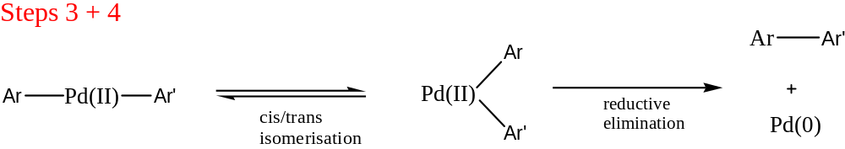

Figure 4.5: Schematic representation of the isomerization of the Pd intermediate from its trans to its cis form (step 3) and the final process of reductive elimination (step 4).

The removal of the ligands from the coordination sphere of the metal is an active process and is driven by the formation of a more stable product, rather than the organopalladium complex which has higher energy.

Within the 4 steps of this catalytic cycle other variables must also be considered, such as 1) catalyst, 2) base, 3) solvent, 4) temperature and 5) reaction time. Each of these five factors can be varied to generate the optimum reaction conditions for coupling for Suzuki coupling.

In terms of the catalyst palladium(0) is the most commonly used catalyst in Suzuki coupling. Palladium chemistry is dominated by two oxidation states both of which may be used within catalytic cycles. The lower oxidation state (0) is nominally electron rich and will undergo oxidative addition with suitable substrates such as halides resulting in a palladium(II) complex. In reactions requiring palladium(0), formation of the active may be achieved more conveniently by reduction of the palladium(II) complex in situ. This may be achieved with amines, phosphines or alkenes without the need to synthesize and isolate the palladium(0) complex.

Palladium complexes that contain fewer then four phosphine ligands or bulky phosphines such as tris(2,4,6-tri-methoxyphenyl)phosphine are, in general, highly reactive for the oxidative addition because of the ready formation of coordinately unsaturated palladium species. The most commonly used catalysts generally include tertiary phosphines which although are useful in controlling reactivity and selectivity in homogeneous catalysis they usually require air-free handling to prevent oxidation. More importantly they are subject to P-C bond degradation at elevated temperatures. Therefore care must be taken as in certain catalytic processes as this may result in deactivation of the catalyst and as a consequence, higher phosphine concentrations are required. The most commonly used catalyst in Suzuki coupling reactions is Pd(PPh)₃, with PdCl₂(PPh)₃ and Pd(OAc)₂ also being efficient due to their stability to air and their ability to be readily reduced to the active Pd(0) complex.

A variety of solvents and bases have been used for Suzuki coupling reactions. Toluene and THF Error: Reference source not found, Error: Reference source not found have proved very popular for the coupling of organic species with acetonitrile and DMF being used for the coupling of inorganic species. With respect to the base effect the most widespread include NaOH, NaCO₃ and KCO₃.

Although not very widespread Suzuki cross-coupling has been used within inorganic synthesis. While it was developed for the construction of natural products containing biaryls units this coupling reaction has turned out to be efficient for the synthesis of many organometallic compounds. It may function in many different ways to generate a variety of desired products, i.e. it may be used to directly produce a number of dinuclear metal complexes or on the periphery of a complex itself to attach spacer groups or anchoring groups. One of the first reports by Sauvage et al detailed the synthesis of a multi-component ruthenium system via Suzuki cross-coupling. This group synthesized two homodinuclear ruthenium(II) complexes using functionalized mononuclear complexes as building blocks with a difunctionalized aromatic spacer, as shown in figure 4.6. By utilizing a diboronic starting material and an appropriately bromo functionalized ruthenium complex the coupling could proceed in the presence of Pd(0) catalyst, sodium carbonate base and DME as a solvent.

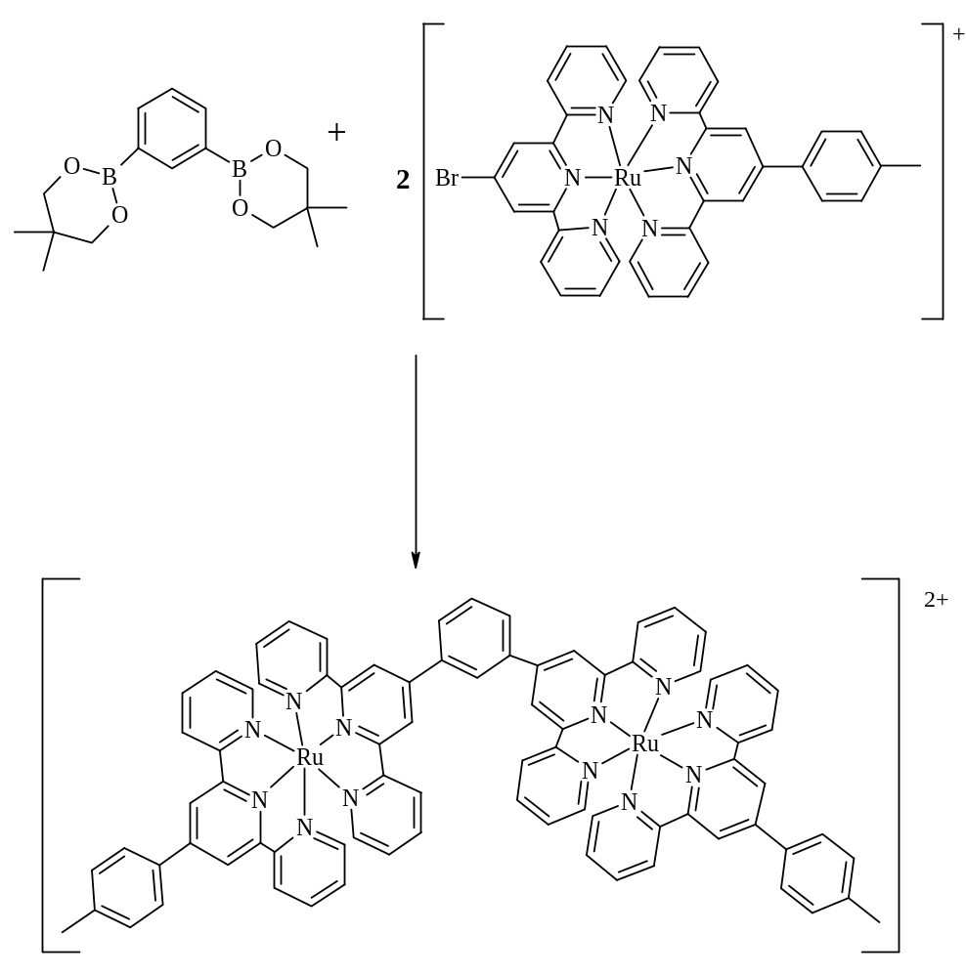

Figure 4.6: Reaction scheme for the formation of a diruthenium complex via Suzuki cross-coupling.Error: Reference source not found

This new methodology demonstrated how kinetically inert metal ( Ru(II), Os(II), Rh(II) or Pt(II)) complexes could now be used as building blocks for constructing multi-component molecular systems by using some classical organic reactions.

Suzuki cross-coupling has also been utilized to increase the number of aromatic substituents at the periphery of a dinuclear ruthenium complex to investigate the effect this has on the core coordination sphere of the metal centers and the electrophore characteristic of the complex, as shown in figure 4.7. This type of system was investigated based on developing materials with possible applications as molecular wire. There have also been other recent publications elaborating on the use of ruthenium(II) complexes in an oxidative or reductive coupling reaction affording homodinuclear species. ,

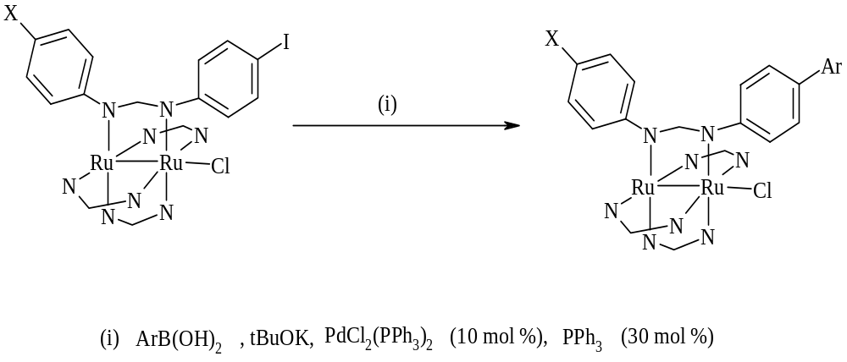

Figure 4.7: Synthetic route for the peripheral modification of the homo-dinuclear ruthenium (II) complex via Suzuki coupling.Error: Reference source not found

The most recent development in the use of Suzuki coupling in the formation of ruthenium metal complexes was carried out by Rau et al in their formation of derivatives of the ligand dipyrido[3,2-a:2’,3’-c]phenazine (dppz) and the investigation into the photophysical properties of the ruthenium complexes of such ligands (figure 4.8). Ruthenium complexes of (dppz) are extensively investigated due to the multiple applications arising from such a strongly luminescent complex, varying from luminescent DNA sensors to reversible electron carriers.

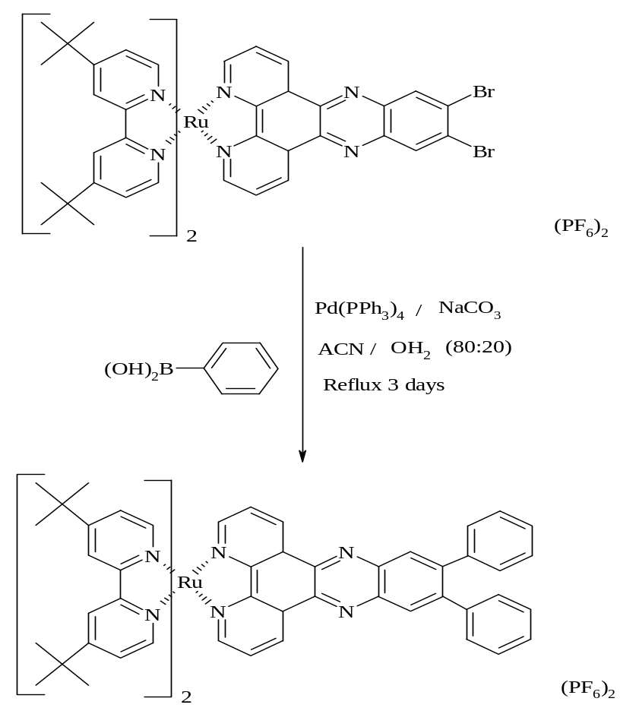

Figure 4.8: Ruthenium complex based Suzuki reaction.Error: Reference source not found

This reaction was used to introduce substituents onto the periphery of the (dppz) ligand in the design of new (dppz) type structures. The successful use of the Suzuki protocol to transform the ruthenium metal complex (approx: 70% yield) illustrates the potential of organometallic coupling reactions to selectively modify precursor complexes. This development opens the route to towards the introduction of substituents representing potential coordination sites, such as different pyridines, which would interfere with complexation if introduced into the free ligand.

The examples discussed above demonstrate the possible applications available for the use of organo-catalyzed reactions, specifically Suzuki cross-coupling, to both modify and syntheses previously complicated metal complexes. This reaction has proven very diverse in its application and has introduced an alternative to the more routine methods of synthesizing metal complexes.

The aim of this chapter is to syntheses a ruthenium dinuclear complex with an asymmetrical bridging ligand via Suzuki coupling reactions. As shown below in figure 4.9 we firstly prepare a mononuclear precursor complex with a complete chelating site. A new binding site is then created in step B via cross-coupling reaction at the metal centre of the precursor complex. In the final step C, a second metal ion can now coordinate to this new chelating site resulting in the formation of a dinuclear complex with no isomers or difficult to remove side products present.

A
Catalyst
C
B

Figure 4.9: The strategy for the synthesis of hetero- / homo-dinuclear complexes via cross-coupling technique.

As it is a Suzuki coupling reaction that will be utilized the precursor complex will have a bromine substituent present to allow for coupling to occur with a ligand functionalized with an appropriate boronic acid. The structures of the precursor complex and ligand are shown below in figure 4.10, with the expected reaction product shown in figure 4.11.

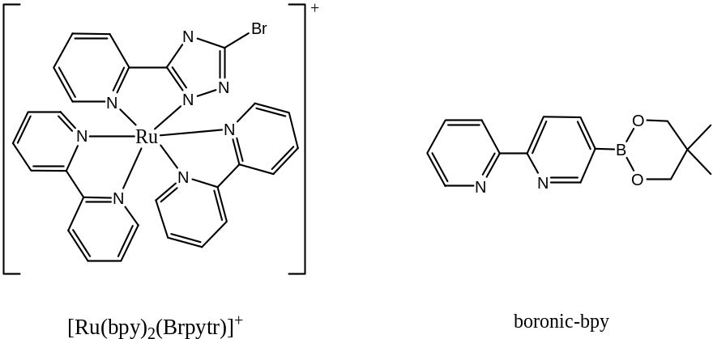

Figure 4.10: Precursor complex and ligand for synthesis of ruthenium dinuclear complex via Suzuki cross-coupling, were bpy= 2,2’-bipyridine,
HBrpytr = 2-(5-(bromo-4H-[1,2,4]-triazol-3-yl)-pyridine and boronic-bpy = 5-(neopentyl glycolatoboron)-[2,2’]-bipyridyl

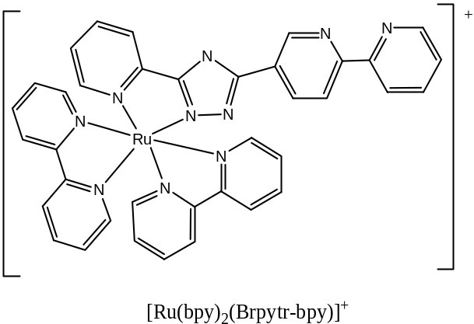

Figure 4.11: Product of the Suzuki cross-coupling

4.2 Experimental

4.2.1 Synthesis of Ligands

Hpytr (2-(4H-[1,2,4]-triazol-3-yl)-pyridine).
To 15 cm³ (0.26 mol) hydrazine hydrate 20 g (0.19 mol) 2-cyanopyridine was added. The mixture was stirred at room temperature for 2 hours and then left at 4⁰C for 1 hr. The intermediate, 2-pyridylamidrazone, was filtered and washed with diethyl ether.
2-pyridylamidrazone was dissolved in concentrated formic acid and heated until only a small amount of solvent was left. The crude product was recrystallized from an ethanol / water mixture (pH 7).
Yield: 60.6%, 20.3 g
¹H NMR (CDCl₃, 298K) δ 8.78 (1H, H6a, d, J = 5 Hz), 8.25 (1H, H3a, d, J = 8 Hz), 8.15 (1H, H5’a, s), 7.85 (1H, H4a, t, J = 6.4 Hz, J = 6.4 Hz), 7.38 (1H, H5a, t, J= 6.4 Hz, J = 6.4 Hz).

Brpytr ( 2-(5-(bromo-4H-[1,2,4]-triazol-3-yl)-pyridine).⁴¹
To a suspension of 2.45 g (16.8 mmol) of Hpytr in 125 cm³ of water a 10M aqueous solution of sodium hydroxide was added to dissolve the solid. To this solution 1.3 cm³ (25 mmol) bromine was added dropwise making sure that the solution always remained basic (pH 12). After stirring for 2 hours at room temperature the mixture was acidified with 5M hydrochloric acid to pH 4. The crude product was filtered and recrystallized in ethanol.
Yield: 80.9%, 3.06 g.
¹H NMR (CDCl₃, 298K) δ 8.79 ( 1H, H6a, d, J = 8 Hz), 8.24 (1H, H3a, d, J = 4.4 Hz), 7.95 (1H, H4a, dd, J = 7.6 Hz, J= 8 Hz), 7.49 (1H, , H5a, d, J = 4.8 Hz, J = 6.8 Hz).

5-Brbpy ( 5-bromo-[2,2’]-bipyridyl).⁴⁴
A flame dried schlenk tube was charged with 0.299 g (0.258 mmol) Pd(PPh₃)₄ and 2 g (8.44 mmol) 2,5-dibromopyridine under argon. 38.7 cm³ (16.8 mmol) of 2-pyridylzinc bromide (0.5M in THF) was added and the mixture was stirred at room temperature overnight, during which time a white precipitate formed. The reaction mixture was poured into an aqueous EDTA / Na₂CO₃ solution. After the precipitate was dissolved, the mixture was extracted with dichloromethane (3 x 50 cm³), and then dried with over MgSO₄. The solvent was evaporated and the residue was chromatographed on an alumina column (neutral) with 3:1 hexane:ethyl acetate as eluent. The first band was identified as the crude product, which as purified by recrystalization with ethyl acetate.
Yield: 79.79%, 1.58 g
¹H NMR (CDCl₃, 298K) δ 8.73 (1H, H6’, d, J = 2 Hz), 8.67 (1H, H6“, dd, J = 5.2 Hz), 8.38 (1H, H3“, d, J = 7.6 Hz), 8.33 (1H, H4’, d, J = 7.6 Hz), 7.94 (1H, H3’, dd, J = 7.6 Hz), 7.83 (1H, H4“, td, J = 7.6 Hz, J = 7.6 Hz), 7.35 (1H, H5“, td, J = 7.6 Hz, J = 5.2 Hz).
Elem Anal. C₁₀H₇N₂Br: Calc: C 51.06%, H 2.97%, N 11.91%
Found: C 51.33%, H 3.09%, N 11.49%

5-B(OR)₂bpy (5-(neopentyl glycolatoboron)-[2,2’]-bipyridyl).
A flame dried Schlenk tube was charged 24.5 mg (0.03 mmol) Pd(dppf)Cl₂ (dppf = diphenylphosphino ferrocene), 294 mg (3.02 mmol) of potassium acetate and 237.3mg (1.05 mmol) of bis(neopentyl glycolato)diboron under argon. 10 cm³ of dry DMSO and 235 mg (1.01 mmol) of 5-Brbpy was added. The reaction mixture was stirred at 80⁰C for 6.5 hours under argon and then diluted with 100 cm³ of toluene. The organic solution was washed with water (4 x 100 cm³) and dried MgSO₄. The solvent was removed by rotary evaporation. The crude product filtered and washed with cold methanol to obtain pure product.
Yield: 31.8%, 85 mg,
¹H NMR (CDCl₃, 298K) δ 8.98 (1H, H6’, s), 8.68 (1H, H6“, dd, J = 5.6 Hz), 8.41 (1H, H3“, d, J = 8 Hz), 8.34 (1H, H4’, d, J = 8 Hz), 8.17 (1H, H3’, dd, J = 8 Hz), 7.79 (1H, H4“, t, J = 7.6 Hz, J = 8 Hz), 7.28 (1H, H5“, t, J = 5.6 Hz, J = 7.6 Hz), 3.8 ( 4H, neo CH₂, s), 1.04 (6H, neo CH₃, s).
Elem. Anal. C₁₅H₁₇N₂BO₂: Calc: C 67.21 %, H 6.34 %, N 10.45 %
Found: C 67.18 %, H 6.42 %, N 10.23 %

4.2.1.1 Attempted Ligand Syntheses:

5-B(OH)₂bpy (5-boronic acid-[2,2’]-bipyridyl)
Method 1:
A solution of 5-Bromo-[2,2’]-bipyridyl (400 mg, 1.7 mmol) in 3.5 cm³ dry THF under argon was cooled to -78⁰C. To this solution N-butyllithium (2.71 mmol, 1 cm³) was added dropwise followed by triisopropyl borate (8.85 mmol, 2 cm³). The reaction mixture was stirred at -78⁰C for 2 hours and then stirred at -20⁰C for 2 hours. Water (5 cm³) was added and the mixture was concentrated to one third under reduced pressure. Extraction was performed with diethyl ether and the organic layer was washed with water and dried over magnessium sulphate and concentrated under reduced pressure. Recrystallisation was carried out in a diethyl ether/ pentane solution.
The desired product was nt obtained.
See table 4.1

Mehtod 2:
A solution of N-butyllithium ( 0.5 cm³, 1.14 mmol) in 0.5 cm³ dry THF was cooled to -78⁰C. To this solution 5-Bromo-[2,2’]-bipyridyl ( 1.03 mmol, 243 mg) in 0.5 cm³ dry THF was added dropwise and allowed to age for 15 min. Triisopropyl borate (1.9 cm³, 1.24 mmol) was added over 2 min and the reaction mixture was left to stir for 2 hours at -78⁰C. The reaction was quenched with slowly with 2.7 N HCl (1.1 cm³) with a white precipiate crashing out.The precipitate was filtered and recrystallized in an ethyl acetate solution. The desired product was not obtained.
See table 4.1

5-B(OR)₂pytr ( 2-(5-(neopentyl glycolatoboron) -4H-[1,2,4]-triazol-3-yl)-pyridine)
Method 1:

A flame dried Schlenk tube was charged 32.5 mg (0.04 mmol) Pd(dppf)Cl₂, 391 mg (3.99 mmol) of potassium acetate and 315.6 mg (1.39 mmol) of bis(neopentyl glycolato)diboron under argon. 10 cm³ of dry DMSO and 300 mg (1.30 mmol) of 2-(5-(Bromo-4H-[1,2,4]-triazole-3-yl)-pyridine was added. The reaction mixture was stirred at 80⁰C for 6.5 hours under argon and then diluted with 100 cm³ of toluene. The organic solution was washed with water (4 x 100 cm³) and dried over MgSO₄. The solvent was removed by rotary evaporation. The crude product filtered and washed with cold methanol.
The desired product was not obtained.
See table 4.1

5-B(OH)₂pytr 2-(5- (boronic acid)-4H-[1,2,4]-triazol-3-yl)-pyridine)
A solution of N-butyllithium ( 1.6 cm³, 1.71 mmol) in 1.5 cm³ dry THF was cooled to -78⁰C. To this solution 2-(5-(Bromo-4H-[1,2,4]-triazole-3-yl)-pyridine (1.56 mmol, 350 mg) in 2.6 cm³ dry THF was added dropwise and allowed to age for 15 min. Triisopropyl borate (1.9cm³, 1.87mmol) was added over 2 min and the reaction mixture was left to stir for 2 hours at -78⁰C. The reaction was quenched with slowly with 2.7N HCl (1.1 cm³) with a white precipiate crashing out. The precipitate was filtered and recrystallized in an ethyl acetate solution.
The desired product was not obtained.
See table 4.1

4.2.2 Synthesis of Mononuclear Complexes

[Ru(bpy)₂(Brpytr)](PF₆)
To 100 mg (0.44 mmol) of 2-(5-(bromo-4H-[1,2,4]-triazol-3-yl)-pyridine (Brpytr) dissovled in 50 cm³ of 1:1 water / ethanol mixture 176 mg (0.33 mmol) cis-Ru(bpy)₂Cl₂ was added. The mixtre was heated at reflux overnight turning the reaction mixture to a warm red colour. Ethanol was removed by rotary evaporation and a drop of ammonium solution was added. The product was isolated by the addition of aqueous NH₄PF₆. It was then filtered and washed with diethyl ether. The complex was purified by column chromatography on neutral alumina with acetonitrile as eluent. The product was obtained upon evaporation of the solvent.
Yield: 132 mg, 51%
¹H NMR (CD₃CN, 298K) δ 8.49 – 8.38 (4H, bpy, m), 8.03 (1H, H6a, d, J = 6.8 Hz), 7.81 – 7.68 (9H, bpy(x8) & H3a, m), 7.49 (1H, H4a, t, J = 7.4 Hz, J = 7.2 Hz), 7.37 – 7.15 (4H, bpy(x4), m), 7.09 (1H, H5a, t, J = 6.4 Hz, J = 7.4 Hz)
Elem Anal. C₂₇H₂₀N₈BrRuPF₆: Calc: C 41.43%, H 2.55%, N 14.32%
Found: C 41.34%, H 2.67%, N 14.26%

[Ru(bpy)₂(5-Brbpy)](PF₆)₂
To 127 mg (0.54 mmol) 5-bromo-[2,2’]-bipyridyl (Brbpy) dissolved in 50cm³ of 1:1 water / ethanol mixture 185 mg (0.36 mmol) of cis-Ru(bpy)₂Cl₂ was added. The mixture was heated at reflux overnight turning the reaction mixture a warm red colour. Ethanol was removed by rotary evaporation and the product was isolated by the addition of aqueous NH₄PF₆. The crude product was then filtered and washed with diethyl ether. The complex was purified by recrystallization in methanol / water (1:1) followed by column chromatography on neutral alumina with acetonitrile as eluent. The product was obtained upon evaporation of the solvent.
Yield: 269 mg, 76%
¹H NMR (CD₃CN, 298K) δ 8.5 (5H, bpy, m), 8.38 ( 1H, H6’, s), 8.24 (1H, H6“, dd, J = 6.8 Hz), 8.05 (5H, bpy, m), 7.8 (2H, H3“ + H4’, d, J = 8.2 Hz), 7.74 (1H, H3’, d, J = 4.8 Hz), 7.7 (1H, H4’’, t, J = 7 Hz, J = 8.8 Hz), 7.65 (1H, H5’’, t, J = 6.8 Hz, J = 7 Hz), 7.4 (6H, bpy, m).
Elem Anal. BrC₃₀H₂₃N₆RuP₂F₁₂: Calc: C 38.38%, H 2.45%, N 8.95%
Found: C 38.49%, H 2.44%, N 8.71%

[Ru(^{t}butyl-bpy)₂(5-Brpytr)](PF₆)
To 360 mg (1.6 mmol) 2-(5-(bromo-4H-[1,2,4]-triazol-3-yl)-pyridine (Brpytr) dissolved in 50 cm³ of 1:1 water / ethanol mixture 1 g (1.3 mmol) of [Ru(^{t}butyl-bpy)₂Cl₂] was added. The mixture was heated at reflux overnight turning the reaction mixture a warm red colour. Ethanol was removed by rotary evaporation and the product was isolated by the addition of aqueous NH₄PF₆. The crude product was then filtered and washed with diethyl ether. The complex was purified followed by column chromatography on neutral alumina with acetonitrile as eluent. The product was obtained upon evaporation of the solvent.
Yield: 459 mg, 36.3 %
¹H NMR (CD₃CN, 298K) δ 8.80 (2H, H6-bpy, dd, J = 5.2 Hz), 8.71 (2H, H5-bpy, dd, J = 13.6 Hz), 8.08 (1H, H3a, d, J = 7.6 Hz), 7.98 (1H, H4a, t, J = 7.6 Hz, J = 6.8 Hz), 7.89 ( 2H, H6-bpy, t, J = 5.2 Hz, J = 5.6 Hz), 7.73 (2H, H3-bpy, dd, J = 6 Hz, J = 6 Hz), 7.65 (2H, H3-bpy, d, J = 6 Hz), 7.53 (2H, H5-bpy, t, J = 4 Hz, J = 5.6 Hz), 7.40 (1H, H6a, dd, J = 4Hz), 7.24 (1H, H5a, t, J = 5.6 Hz, J = 6 Hz), 1.42 (36H, ^{t}butyl, s)
Elem. Anal. BrC₄₃H₅₂N₈RuPF₆: Calc: C 51.29%, H 5.17%, N 11.13%
Found: C 50.73%, H 5.19%, N 11.11%

4.2.3 Suzuki Cross-Coupling Reactions

[Ru(bpy)₂(bpy-pytr)]²⁺
Method 1:
A flame-dried Schlenk tube was charged with 100 mg (1 eq., 0.13 mmol) of [Ru (bpy)₂(Brpytr)]PF₆ and put under nitrogen. 7 cm³ of dry DMSO was added. 9 mg (0.06 eq., 0.0075 mmol) of Pd(PPh₃)₄ ((PPh₃)₄ = tetrakis triphenylphophine) dissolved in 1 cm³ of dry DMSO under nitrogen atmosphere was added through a syringe. The mixture was stirred for 10 min while degassing with nitrogen. Then 67 mg (2 eq., 0.25 mmol) of 5-(neopentyl glycolatoboron)-[2, 2’] bipyridyl dissolved in 3 cm³ of dry DMSO under nitrogen atmosphere was added through a syringe. To this was added 40 mg (3 eq., 0.38 mmol) of potassium acetate as a saturated aqueous solution. The mixture was stirred for 10 min while degassing with nitrogen and then heated to 85 ⁰C for 20 hours.

After the reaction mixture was left to cool down it was added drop-wise to a saturated aqueous ammonium hexafluorophosphate solution. The solid was filtered, washed with water and diethyl ether and purified by column chromatography on alumina (neutral) with acetonitrile first and then methanol.
The acetonitrile fraction was recognised as the starting complex.

Method 2:
A flame-dried Schlenk tube was charged with 100 mg (1 eq., 0.13 mmol) of [Ru (tbutyl-bpy)₂(Brpytr)]PF₆ and put under nitrogen. 7 cm³ of dry toluene was added. 9 mg (0.06 eq., 0.0075 mmol) of Pd(PPh₃)₄ dissolved in 1 cm³ of dry toluene under nitrogen atmosphere was added through a syringe. The mixture was stirred for 10 min while degassing with nitrogen. Then 67 mg (2 eq., 0.25 mmol) of 5-(neopentyl glycolatoboron)-[2, 2’] bipyridyl dissolved in 3 cm³ of dry toluene under nitrogen atmosphere was added through a syringe. To this was added 40 mg (3 eq., 0.38 mmol) of potassium acetate as a saturated aqueous solution. The mixture was stirred for 10 min while degassing with nitrogen and then heated to 85 ⁰C for 20 hours.

After the reaction mixture was left to cool down it was filtered to remove any undissolved starting material. Then 5 cm³ of 5% NaHCO₃ was added and stirred for 30 minutes. This mixture was the extracted 20 cm³ of ethyl acetate. After extraction the aqueous layer was then acidified with 5M HCl until it reached pH 1 and extracted again with ethyl acetate. All the organic layers where then combined and dried over MgSO₄. The ethyl acetate was then removed and 5 cm³ of H₂O was added. A saturated aqueous ammonium hexafluorophosphate solution was then added to precipitate out the product which was then purified by column chromatography on neutral alumina with acetonitrile as eleunt.
The acetonitrile fraction was recognised as the starting complex.

This reaction was prepared a number of times. A table of reactions is present in section 4.2 and 4.3

[pytr-bpy] 5-[2,2’-bipyridyl]-2-(2’-pyridyl)- 1,2,4-triazole
To a clean dry round bottom flask 82.3 mg 5-bromo-2-(2’-pyridyl)-1,2,4-triazole (0.25 mmol), 141 mg (5-(neopentyl glycoltoboron)-[2,2’]-bipyridyl) (0.5 mmol), 52 mg K₂CO₃ (0.375 mmol), 41 mg Pd(dppf)Cl₂ (0.05 mmol) and 2.5 cm³ toluene was charged. The reaction tube was sealed and the mixture was stirred at 85⁰C for 16 hours. After cooling to room temperature the reaction mixture was diluted with NaHCO₃ (5%, 5-10 cm³) and ethyl acetate (20 cm³)as added after 30 minutes of stirring with NaHCO₃. The aqueous layer was acidified to pH=1 using 3M HCl and extracted 5 times with EtOAC (5 x 50 cm³). The combined organic layers were dried over MgSO₄ and the solvent was removed in vacu. The crude product was then purified via column chormatography on silica gel with hexane:EtOAC (3:2, + 5% methanol) as eleunt. Concentration of the solution afford a dark red solid.
The desired product was not obtained.
See Table 4.4

4.3 Results and Discussion

4.3.1 Precursor Synthesis
The precursor ligands for the Suzuki cross-coupling where chosen according to their role within the coupling reaction and the ease with which they may be functionalized. The two ligands chosen where 2,2’-bipyridine (bpy) and 5-[pyridine]-1,2,4-triazole (Hpytr). The precursor complex and ligands for the Suzuki coupling will be prepared from these starting materials.

The first part of the potential bridging ligand is to include the class B type ligands, such as Hpytr. The synthesis and characterization of the class B ligand Hpytr and its derivative HBrpytr have both been reported previously.Error: Reference source not found Due to the ease with which this ligand may be functionalized with a bromine substituent it was chosen as the first coupling partner (electrophile) to partake in step 1 of the catalytic cycle, oxidative addition. The synthetic pathway for the formation of these ligands is shown below in figure 4.12.

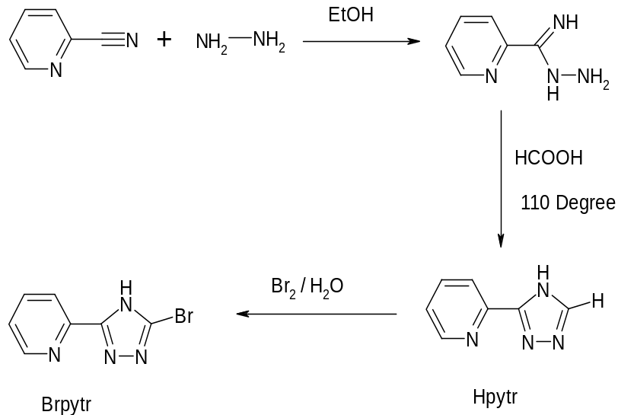

Figure 4.12: Synthetic route for the formation of 2-(5-(Bromo-4H-[1,2,4]-triazol-3-yl)-pyridine HBrpytr.

The second part of the potential bridging ligand is the class A ligand, 2, 2’-bipyridine (weak σ-donor / strong π-acceptor). As the 5-position of the bpy is preferred for electrophilic attack it was chosen to be the nucleophilic partner for the C-C bond formation, with Br as the selected functional group.

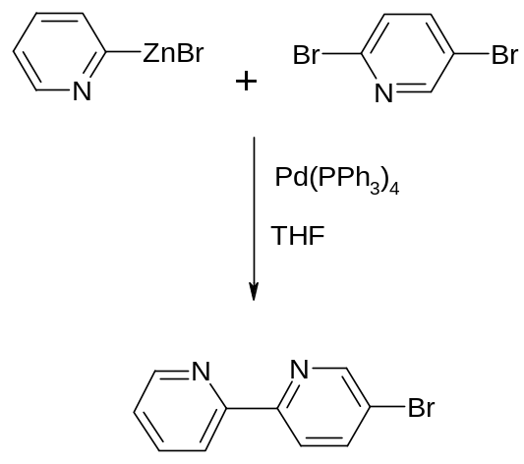

Figure 4.13: Negishi cross-coupling of 5-Brbpy.

Due to the asymmetrical nature of this ligand synthetic difficulties must be considered in its preparation. The procedure for the synthesis of 5-Brbpy, as described by Ziessel and Romero forms 5,5’-diBrbpy as a by-product of the reaction leading to low yields of 5-Brbpy. Therefore it was decided to synthesis 5-Brbpy via a Negishi cross-coupling reaction as shown above in figure 4.13. This reaction was based on a previously reported synthesis by Hanan and co- workers.Error: Reference source not found This synthetic procedure has several advantages over that reported by Ziessel et al. It demonstrates a “one-pot” reaction with the formation of no by-products and the achievement of higher overall yields (70 %). Also the reaction conditions are mild with no special precautions required.

As can be observed from the ¹H-NMR spectrum in figure 4.14 this ligand was obtained in spectroscopic purity. The mass spectrometry and CHN analysis also confirms the formation of this ligand with the results in keeping with those reported previously.Error: Reference source not found
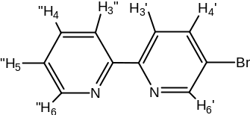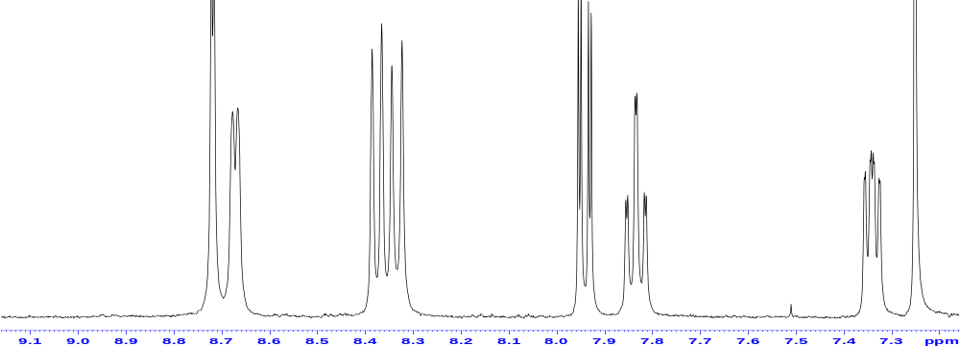

Figure 4.14: ¹H-NMR spectrum of the ligand 5-Brbpy in CDCl₃.

However, as it was decided to pursue the Suzuki cross-coupling method, 5-Brbpy needed its functionality changed to include the presence of boronic acid, as shown in figure 4.15.This synthetic approach is new for the formation of 5-(neopentyl glycolatoboron)bpy (boronic-bpy) and is based on procedures reported previously for similar products.Error: Reference source not found

Figure 4.15: Synthetic route for the formation of boronic- bpy.

The reaction shown in figure 4.15 is a Suzuki coupling of the 5-Brbpy product mentioned above with a diboronic acid, bis(neopentylglycolato)diboron. In this reaction potassium acetate was the optimum base used along with the Pd(II) catalyst, Pd(dppf)Cl₂. Although the yield was low (40 %) the product was obtained in a high level of spectroscopic purity. This can be observed from the ¹H-NMR spectrum in figure
4.16.
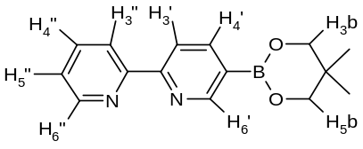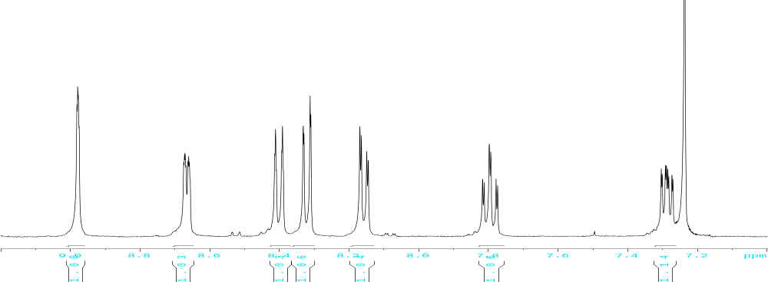
Figure 4.16: ¹H-NMR for the ligand boronic-bpy in CDCl₃

The final precursor compounds to be synthesized in this section are heteroleptic in nature and take the form of [Ru(bpy)₂(Brpytr)]⁺ and [Ru(^{t}butyl-bpy)₂(Brpytr)]⁺ as shown in figure 4.10. As per chapter 3 the preparation of the starting material [Ru(bpy)₂Cl₂].H₂O for the synthesis of the ruthenium bipyridyl complex was carried out with slight differences to literature methods and was used without further purification. The synthesis of the precursor complexes was carried out as reported previously, with the addition of [Ru(bpy)₂Cl₂].H₂O / [Ru(^{t}butyl-bpy)₂Cl₂] to HBrpytr (stoichiometric ratio) and heating to reflux. Here it is necessary to dissolve the ligand completely before addition of [Ru(bpy)₂Cl₂].H₂O / [Ru(^{t}butyl-bpy)₂Cl₂] to limit the formation of any dinuclear complex. The precursor complexes are obtained in high yields and purity.

These complexes required purification via column chromatography due to the possibility of the metal ion coordinating via the N2 or the N4 atom of the triazole. Due to the chemical difference in σ – donor properties of the two nitrogen’s present in the 5-membered triazole ring coordination to either nitrogen will result in different properties being observed. However, the presence of the bromine atom causes steric hindrance within the complex resulting in formation of the N2 isomer (95%) preferentially over the N4 isomer (5%). The ¹H-NMR spectra of the pure N2 isomer of the metal complexes are shown in figure 4.17 and illustrate the high level of purity achieved with these precursor complexes.

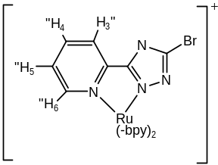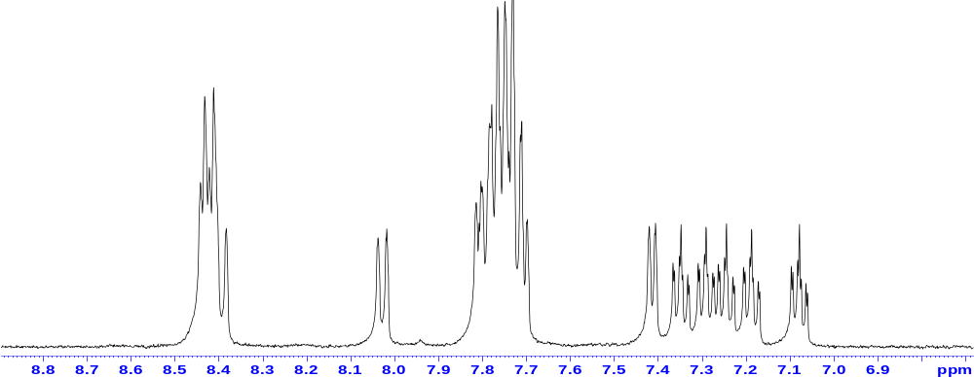

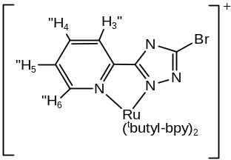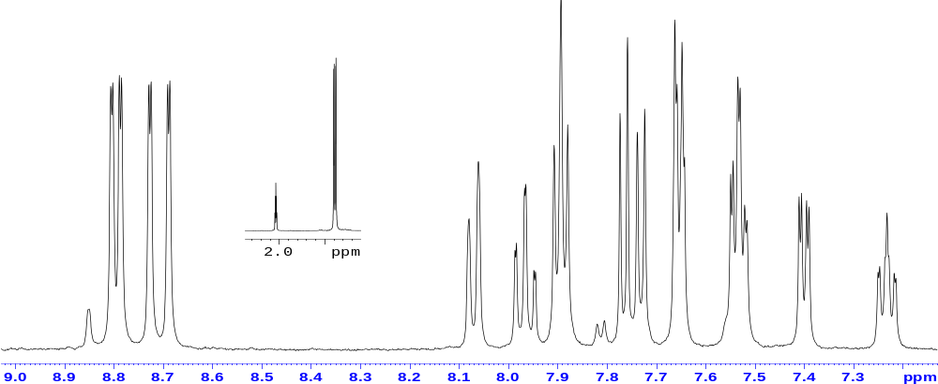

Figure 4.17: ¹H-NMR of [Ru(bpy)₂(Brpytr)]⁺ and [Ru(^{t}butyl-bpy)₂(Brpytr)]⁺ in d-ACN.

4.3.1.1 Attempted Synthesis of Modified Precursors
Efforts where also made to synthesis a second series of appropriately functionalized precursor compounds capable of partaking in the Suzuki coupling reaction. These compounds were designed so as to exchange the functionalities on the precursor compounds already synthesized from the previous section. This led to the attempted synthesis of (5-boronic acid-[2,2’]-bipyridyl) (5-B(OH)₂(bpy)), 2-(5-(neopentyl glycolatoboron)-4H-[1,2,4]-triazol-3-yl)-pyridine (5-B(OR)₂(pytr)) and 2-(5- (boronic acid)-4H-[1,2,4]-triazol-3-yl)-pyridine (5-B(OH)₂(pytr)) as shown below in figure 4.18.
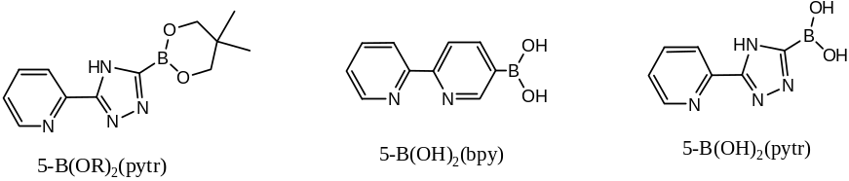

Figure 4.18: Structure of the ligands (5-B(OH)₂(bpy)), (5-B(OR)₂(pytr)) and (5-B(OH)₂(pytr).

The reaction of HBrpytr and bis(neopentylglycolato)diboron to obtain (5-B(OR)₂(pytr)), reaction 1 from table 4.1, was carried out using the previously discussed synthesis for (5-B(OR)₂-bpy) from section 4.3.1.

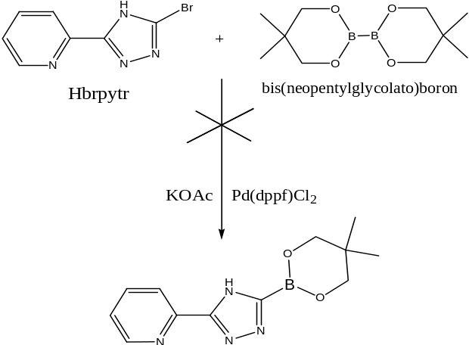

Figure 4.19: Attempted synthesis of (5-B(OR)₂(pytr)
The reaction in figure 4.19 is a Suzuki type coupling between HBrpytr ligand with a diboronic acid. However under the reaction conditions, of Pd(dppf)Cl₂ catalyst and KOAc base, the reaction proved unsuccessful with the detection of only starting material from the NMR and mass spectrometry results. The reaction was tried twice more using a different base and catalyst, see table 4.1, but the desired product was not obtained. As mentioned in the introduction the presence of electron donating substituents have an adverse affect on the cross-coupling. It is therefore thought the very electronegative triazole ring may deactivate the bromine functionality to cross-coupling in this instance.

Subsequently the synthesis of the ligands (5-boronic acid-[2,2’]-bipyridyl) (5-B(OH)₂(bpy)) and 2-(5-(boronic acid)-4H-[1,2,4]-triazol-3-yl)-pyridine (5-B(OH)₂(pytr)), as shown in figure 4.20, were investigated via conventional lithiation methods.Error: Reference source not found
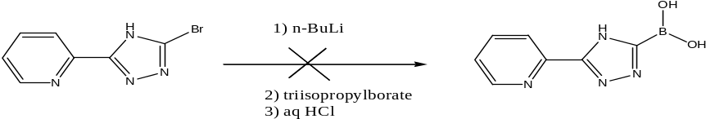

Figure 4.20: Preparation of (5-B(OH)₂(pytr)) via lithiation reaction.

It was thought that the use of traditional lithiation procedures could prove more fruitful in the introduction of a boronic acid substituent rather than the use of a Suzuki coupling reaction. The procedure involves a lithium-halogen exchange between the ligand (5-Brbpy) and triisopropylborate in the presence of dry THF, which as a coordination solvent is used to disassociate the butyllithium intermediate aggregate. However, with the addition of the ligand 5-Brbpy to the reaction flask prior to butyllithium the desired product was not obtained. It was thought the relative acidity of bromopyridines in THF resulted in deprotonation as reported previously in literature. As a result the reverse addition method was tried, whereby butyllithium was added to the reaction flask first and cooled to -78⁰C before the addition of the ligand 5-Brbpy.Error: Reference source not found Nevertheless this method too proved unsuccessful. This reaction was tried with each ligand in both the normal and reverse addition method with the results listed below in table 4.1.
 | Reaction | Starting Material | Target Compound | Catalyst | Base
1 | Suzuki Coupling | 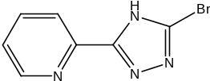 | 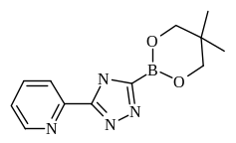 | Pd(dppf)Cl₂ | KOAc
2 | Suzuki Coupling | As above | As above | Pd(dppf)Cl₂ | NaCO₃
3 | Suzuki Coupling | As above | As above | Pd(PPh₃)₄ | KOAc
4 | Lithiation | 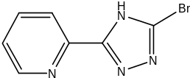 |  | NA | NA
5 | Reverse Addition  Lithiation | As above | As above | NA | NA
6 | Lithiation | 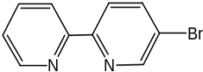 | 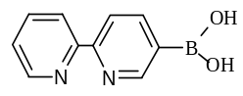 | NA | NA
7 | Reverse Addition  Lithiation | As above | As above | NA | NA
8 | Lithiation | 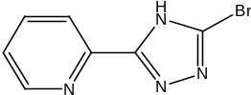 | 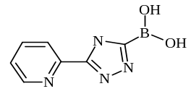 | NA | NA
9 | Reverse Addition  Lithiation | As above | As above | NA | NA

Table 4.1: Attempted syntheses of modified precursors from figure 4.19

As observed from table 4.1 the use of both Suzuki coupling and lithiation methods proved unsuccessful in synthesizing the desired precursor ligands. The optimum conditions for successful cross-coupling of the starting materials were not established with respect to the Suzuki reaction. The use of the normal and reverse addition method of the lithiation procedure also proved unsuccessful. The acidity of the bromopyridines in THF was thought to lead to deprotonation of the 5-Brbpy starting material at the 6 and 4 positions of the pyridine ring, rather than the lithium halogen exchange. Consequently the reverse addition procedure of the lithiation reaction was attempted. This involved the addition of butyllithium to the reaction flask first with cooling to -78⁰C before the addition of 5-Brbpy.Error: Reference source not found This reaction was unsuccessful in the formation of the desired products and is thought to be due to the reaction temperature. As the lithium-halogen exchange is strongly exothermic in nature control of the reaction temperature can be difficult. It is possible that the addition of 5-Brbpy to the reaction mixture at -78⁰C leads to an increase in reaction temperature therefore favoring the deprotonation side-reaction.

4.3.2 Suzuki Coupling Reactions
Having synthesized the appropriate precursor complexes we moved onto the preparation of the asymmetrically bridged ruthenium complex via Suzuki coupling. Numerous attempts were made to couple [Ru(bpy)₂(Brpytr)]⁺ and [Ru(^{t}butyl-bpy)₂(Brpytr)]⁺ with (5-B(OR)₂bpy) under Suzuki reaction conditions, to generate the asymmetrically bridged complex [Ru(bpy)₂(pytr-bpy)]⁺, as shown in figure 4.21. However, despite the variation in reaction conditions the desired product was not obtained.
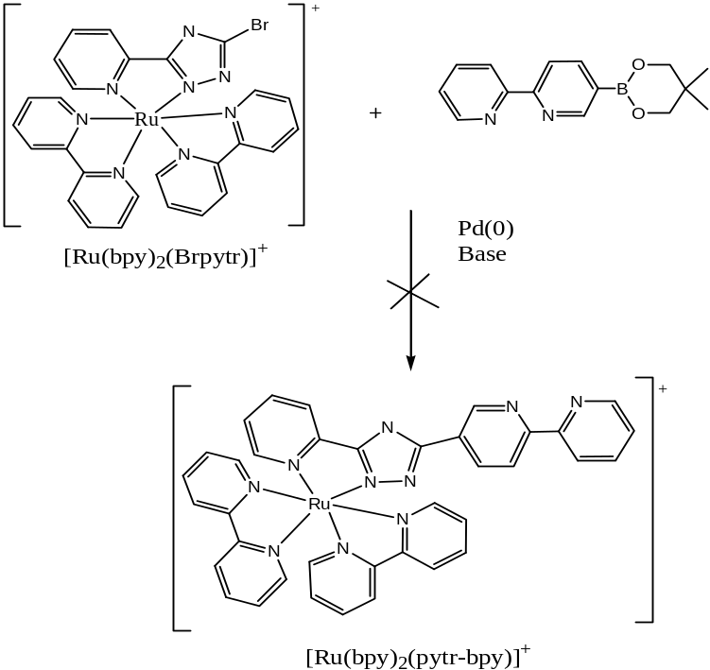

Figure 4.21: Formation of the Suzuki coupled product [Ru(bpy)₂(pytr-bpy)]⁺.
Reaction | Organohalide | Boronic  Acid | Catalyst | Base | Solvent | Temp  ⁰C | Time  (hr)
10 | [Ru(Brpytr)(bpy)₂]⁺ | Boronic-bpy | Pd(dppf)Cl₂ | K₂CO₃ | Toluene | 85 | 14-20
11 | [Ru(Brpytr)(bpy)₂]⁺ | Boronic-bpy | Pd(dppf)Cl₂ | K₂CO₃ | DMF | 100 | 16.5
12 | [Ru(Brpytr)(bpy)₂]⁺ | Boronic-bpy | Pd(dppf)Cl₂ | K₂CO₃ | DMF | 90 | 14-20
13 | [Ru(Brpytr)(bpy)₂]⁺ | Boronic-bpy | Pd(dppf)Cl₂ | KO^{t}Bu | DMSO | 85 | 14-20
14 | [Ru(Brpytr)(bpy)₂]⁺ | Boronic-bpy | Pd(dppf)Cl₂ | KO^{t}Bu | DMF | 100 | 16
15 | [Ru(Brpytr)(bpy)₂]⁺ | Boronic-bpy | Pd(dppf)Cl₂ | NaOH | DMF | 100 | 14-20
16 | [Ru(Brpytr)(bpy)₂]⁺ | Boronic-bpy | Pd(dppf)Cl₂ | KO^{t}Bu | DME | 85 | 14-20
17 | [Ru(Brpytr)(bpy)₂]⁺ | Boronic-bpy | Pd(PPh₃)₄ | K₂CO₃ | DME | 85 | 14-20
18 | [Ru(Brpytr)(bpy)₂]⁺ | Boronic-bpy | Pd(PPh₃)₄ | KO^{t}Bu | DME | 85 | 14-20

Table 4.2: Suzuki reaction attempts using [Ru(Brpytr)(bpy)₂]⁺ and (boronic-bpy) as starting materials.

Reaction | Organohalide | Boronic acid | Catalyst | Base | Solvent | Temp  ⁰C | Time  (hr)
19 | [Ru(Brpytr)(^{t}Butyl-bpy)₂]⁺ | Boronic-bpy | Pd(dppf)Cl₂ | K₂CO₃ | Toluene | 85 | 20
20 | [Ru(Brpytr)(^{t}Butyl-bpy)₂]⁺ | Boronic-bpy | Pd(dppf)Cl₂ | K₂CO₃ | Toluene | 85 | 15
21 | [Ru(Brpytr)(^{t}Butyl-bpy)₂]⁺ | Boronic-bpy | Pd(PPh₃)₄ | K₂CO₃ | THF | 80 | 20
22 | [Ru(Brpytr)(^{t}Butyl-bpy)₂]⁺ | Boronic-bpy | Pd(PPh₃)₄ | K₂CO₃ | THF/  H₂O | 85 | 20
23 | [Ru(Brpytr)(^{t}Butyl-bpy)₂]+ | Boronic-bpy | Pd(PPh₃)₄ | KO^{t}Bu | THF | 65 | 20
24 | [Ru(Brpytr)(^{t}Butyl-bpy)₂^{]+} | Boronic-bpy | Pd(PPh₃)₄ | KO^{t}Bu | DME | 90 | 20
25 | [Ru(Brpytr)(^{t}Butyl-bpy)₂^{]+} | Boronic-bpy | Pd(PPh₃)₄ | KO^{t}Bu | DME | 110 | 20
26 | [Ru(Brpytr)(^{t}Butyl-bpy)₂]⁺ | Boronic-bpy | Pd(PPh₃)₄ | Na₂CO₃ | DME | 92 | 20
27 | [Ru(Brpytr)(^{t}Butyl-bpy)₂]⁺ | Boronic-bpy | Pd(PPh₃)₄ | Na₂CO₃ | DMF | 90 | 20
28 | [Ru(Brpytr)(^{t}Butyl-bpy)₂]⁺ | Boronic-bpy | Pd(PPh₃)₄ | KO^{t}Bu | DMF | 90 | 20

Table 4.3: Suzuki reaction attempts using [Ru(Brpytr)(^{t}butyl-bpy)₂]⁺ and (boronic-bpy) as starting materials.
Despite the numerous reaction attempts shown in tables 4.2 and 4.3 the desired heterodinuclear complex was not obtained. There were many variables associated with this reaction and any one of them may be responsible for the deactivation of the Suzuki reaction. Each of these variables, such as (1) solubility (2) inactivity of boronic acid or other starting materials and (3) steric constraints will now be examined and discussed individually.

From the tables above it is observed that [Ru(5-Brpytr)(^{t}butyl-bpy)₂]⁺ was used instead of the analogous [Ru(5-Brpytr)(bpy)₂]⁺ complex as the electrophile coupling partner in the Suzuki reaction. This was done in an attempt to improve solubility of the metal complex in more organic solvents in the hope that this would increase the probability of the coupling reaction being successful. From literature reviews Error: Reference source not found, it is observed that the majority of Suzuki cross-coupling reactions proceed in solvents such as THF and toluene. The ruthenium complex [Ru(5-Brpytr)(bpy)₂]⁺ is insoluble in such solvents and therefore the complex [Ru(5-Brpytr)(^{t}butyl-bpy)₂]⁺ is employed. This alternative did improve the solubility of the metal complex in various organic solvents but did not lead to the formation of the desired heterodinuclear complex.

A second consideration is the “activity” or lack thereof of the boronic acid compound, (5-B(OR)₂bpy), which is to act as the nucleophile coupling partner in the Suzuki reaction. As detailed in section 4.1 organoboron compounds are generally very inactive to organopalladium halidesError: Reference source not found due to their low nucleophilicity, but in the presence of a suitable base this activity may be greatly enhanced. With this in mind a number of different bases where utilized including the very strong base, K^{t}BuO, in the hope this would activate the boronic acid compound to form the “ate” complex, as shown in figure 4.4. Although not widely used with Suzuki coupling reactions there have been a few reports of fruitful coupling reactions upon use of this base. However, variation of the base proved unproductive and the use of K^{t}BuO is thought to perhaps instead lead to the decomposition of the 5-membered triazole ring due to its very strong base properties.
Alternatively it was thought possible that perhaps the HBrpytr ligand or the [Ru(Brpytr)(bpy)₂]⁺ complex itself were inactive to the initial step of the coupling cycle, oxidative addition. The presence of three strongly electron donating nitrogen groups in the triazole ring could lead to the deactivation of the bromo functionality which is essential for a successful Suzuki cross-coupling reaction to occur. As noted above in section 4.1 the presence of electron donating substituents have an adverse affect on the cross-coupling. If this was to occur, the ruthenium metal complex would be unable to fulfill its function as the electrophile within the catalytic cycle thereby causing a breakdown in the reaction. However, this is only a tentative conclusion as there is no evidence present to suggest this is the case.

A final consideration for the success of the Suzuki coupling is the reactivity of the catalyst. It was proposed that the catalyst [Pd(PPh₃)Cl₂], may not have been unable to “associate” with the mononuclear complex to form the organopalladium halide complex due to steric constraints caused by the presence of the large bipyridine rings.

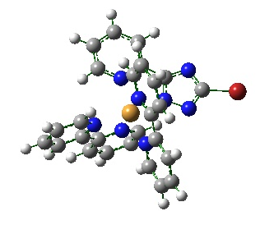

Figure 4.22: Optimized structure of [Ru(bpy)₂(5-Brpytr)]⁺.

If this was to occur it would result in the catalytic cycle being unable to proceed towards oxidation addition and therefore through the catalytic cycle. It is also possible the Pd catalyst may be deactivated at the beginning of the reaction by becoming involved in side reactions, such as ligand exchange, which are favored with respect to the coupling reaction.

As an alternative to the reaction discussed above for the formation a symmetrically bridged ruthenium complex via Suzuki coupling it was determined to investigate the coupling of the uncoordinated ligands. This option was taken in an effort to determine if it the correct reaction conditions may be found when coupling two organic species. The proposed reaction scheme is shown in figure 4.23.

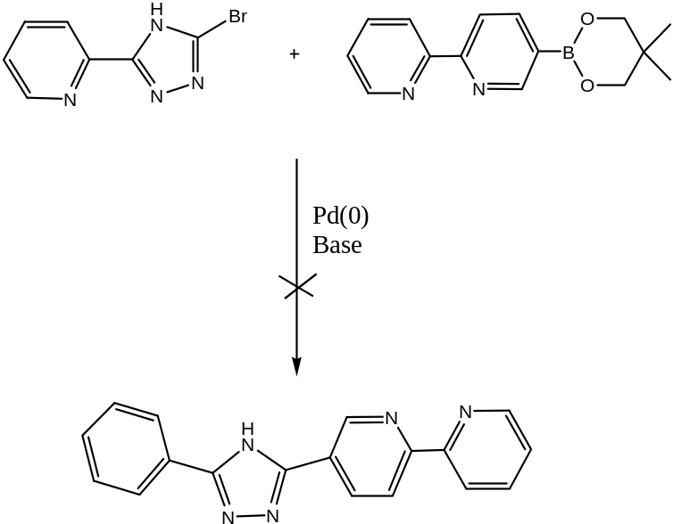

Figure 4.23: Synthetic route for the formation of [5’(2’,2’’-bipyridyl)]-(2’’’-pyridyl)--1,2,4-triazole [(pytr)-bpy].

The conditions needed for this synthesis involved the use of the ligands Hbrpytr and boronic-bpy as the coupling partners in the presence of a catalytic amount of Pd(0) and a suitable base are shown in figure 4.23. This desired product was not obtained with only the starting material recovered from the reaction. The variations in reaction conditions are detailed in table 4.4.

Reaction | Organohalide | Boronic Acid | Catalyst | Base | Solvent | Temp  ⁰C | Time  (hr)
29 | 5-Brpytr | 5-B(OR)₂bpy | Pd(dppf)Cl₂ | K₂CO₃ | Toluene | 85 | 20
30 | 5-Brpytr | 5-B(OR)₂bpy | Pd(dppf)Cl₂ | K₂CO₃ | Toluene:  H₂O | 98 | 64
31 | 5-Brpytr | 5-B(OR)₂bpy | Pd(dppf)Cl₂ | K₂CO₃ | Toluene | 85 | 16
32 | 5-Brpytr | 5-B(OR)₂bpy | Pd(dppf)Cl₂ | K₂CO₃ | DMF | 95 | 20
33 | 5-Brpytr | 5-B(OR)₂bpy | Pd(dppf)Cl₂ | K₂CO₃ | DMF | 95 | 14
34 | 5-Brpytr | 5-B(OR)₂bpy | Pd(dppf)Cl₂ | K₂CO₃ | DMSO | 85 | 14-20
35 | 5-Brpytr | 5-B(OR)₂bpy | Pd(dppf)Cl₂ | NaCO₃ | DMSO | 100 | 14-20
36 | 5-Brpytr | 5-B(OR)₂bpy | Pd(dppf)Cl₂ | NaCO₃ | Toluene | 85 | 14-20
37 | 5-Brpytr | 5-B(OR)₂bpy | Pd(PPh₃)₄ | K₂CO₃ | DMSO | 85 | 14-20
38 | 5-Brpytr | 5-B(OR)₂bpy | Pd(PPh₃)₄ | NaCO₃ | DMSO | 85 | 14-20

Table 4.4: Suzuki coupling attempts using ligands 2-(5-(bromo-4H-[1,2,4]-triazol-3-yl)-pyridine (Brpytr) and 5-(neopentyl glycolatoboron)bpy (5-B(OR)₂bpy).

The reaction variations used in the attempted cross-coupling of the uncoordinated ligands are represented in table 4.4. Once again these reactions did not prove fruitful and the cause of this setback is due to any number of factors which have been discussed previously in this section.

Although the Suzuki cross-coupling reaction is the most straightforward procedure for C-C bond formation the exact reaction conditions have to be determined first to create a successful coupling. Despite numerous attempts this was not achieved for the coupling reported in this chapter. Further investigation into the base effect and the reactivity of the ligands and complexes involved is required before suitable conditions for a successful Suzuki cross-coupling can be established. However, despite being unable to synthesis the desired complex, the precursor complexes synthesized for the coupling reaction were fully characterized.
4.4 Conclusion

This chapter detailed the attempted synthesis of an asymmetrically bridged ruthenium dinuclear complex using the Pd(0) catalyzed Suzuki cross-coupling reaction. Our aim was to propose an alternative synthetic pathway for the formation of multinuclear asymmetric metal complexes. This was investigated in the shape of a Suzuki cross-coupling reaction which is a type of reaction involving a carbon-carbon bond forming between an organoboron nucleophile and an organic halide. This particular reaction was pursued due to its previous success in the formation of heteronuclear species as detailed in section 4.1. However, despite much effort several Suzuki coupling reactions been investigated without success.

In such a diverse reaction there are many variables are associated such as, (1) catalyst (2) coupling partners (nucleophile and electrophile) (3) solvent (4) base effect and (5) reaction time. Due to these variations it remains difficult to obtain the optimum reaction conditions and often many attempts and much trouble shooting is required before these are found. Having tried many alternative reaction conditions and variations, as shown in tables 4.1- 4.4, we were unable to prepare the desired asymmetrically bridged ruthenium dinuclear complex. The changing of electrophile coupling partner to increase solubility in a wider range of organic solvents proved unfruitful, as did the use of a very strong base in an effort to activate the organoboron compound to coupling. There are many possible explanations for these results, which are detailed and discussed in section 4.3.2.

Future investigation would be appropriate in devising the optimum conditions for the coupling of an asymmetrically bridged metal complex, as the Suzuki coupling reaction has previously been successful in achieving complexes with symmetrical bridging metal complexes.³⁴ This technique could prove very efficient in the future synthesis of metal complexes and run in parallel with other coupling reactions mentioned in section 4.1, such as Negishi or Sonogishira, along with synthetic methods currently available. However to achieve this, the obstacle of developing the optimum working conditions must first be overcome.
Chapter 5 moves on to investigate an alternative coupling reaction in the preparation of the desired dinuclear complex(es). There are several other coupling procedures to choose from, as discussed in section 4.1, depending on the desired product. These include Ni(0), Negishi and Stille coupling. The reaction chosen will firstly be examined and then applied to the synthesis of the complexes.

4. 5 Bibliography ? Sainsbury, M., Tet., 1980, 36, 3327
Tsou, T. T: Kochi, J. K., J. Am. Chem. Soc., 1979, 7548
Ager, D. J: East, M. B: Eisenstadt, A: Laneman, S. A., Chem. Comm., 1997, 2359
Banwell, M. G:Goodwin, T. E: Ng, S: Smith, J. A: Wong, D. J., Eur. J. Org. Chem., 2006, 3043
Phan, N. T. S: Van Der Sluys, M: Jones, C. W., Adv. Synth. Catal., 2006, 348, 609
Trzeciak, A. M: Ziolkowski, J. J, Coord., Chem., Rev., 2005, 249, 2308
Bedford, R. B: Cazin, C. S. J: Holder, D, Coord. Chem. Rev., 2004, 248, 2283
(a) Miyaura, N: Suzuki, A. Chem. Commun. 1979, 866 (b) Suzuki, A., J. Organomet. Chem., 1999, 576, 147
(a) Tamao, K: Sumitani, K: Kumada, M, J. Am. Chem. Soc., 1972, 94, 4374 (b) Hayashi, T: Konishi, M: Fukishima, M: Mise, T: Kagotani, M: Tajika, M: Kumada, M, J. Am. Chem. Soc., 1982, 104, 180 (c) Hayashi, T: Konishi M: Kobori Y: Kumada, M, J. Am. Chem. Soc., 1984, 106, 148 (d) Kumada, M, Pure Appl. Chem., 1980, 52, 669 (e) Corriu, J. P: Masse, J. P: Royo G, J. Am. Chem. Soc. Chem. Comm., 1971, 252
(a) Milstein, D: Stille, J. J. Am. Chem. Soc., 1978, 100, 3636 (b) Stille, J. K, Angew, Chem. Int. Ed. Engl. 1986, 25, 508
Negishi, E: King, A: Okukado, N, J. Org. Chem. 1977, 42, 1821
Sonogashira, K, Comput. Org. Synth. Int. Ed. 2000, 3, 551
Heck, R. F: Nolley, J. P, Jr. J. Org. Chem. 1972, 37, 2320
Corbet, J. P: Mignani, G. Chem. Rev. 2006, 106, 2651
Zhuravel, M. A: Nguyen , S. T., Tet. Lett., 2001, 42, 7925
Miyaura, N: Suzuki, A., Chem. Rev., 1995, 95, 2457
Suzuki, A: Diederich, F: Stang, P. J., (Eds.), Metal-Catalysed Cross-Coupling Reactions, Wiley-VCH, Weinheim, 1998, 49
(a) Heck, R. F., Palladium Reagents in Organic Syntheses: Academic, New York, 1985 (b) Hegedus, L. S., Organometallics in Organic Synthesis: Schlosser, M., Ed: Wiley: New York, 1994, 383.
Aliprantis, A. O: Canary, J. W., J. Am. Chem. Soc., 1994, 116, 6985.
(a) Tsuji, T., “Palladium Reagents and Catalysts, Innovation in Organic Synthesis”, 1995, Wiley, Chichester, England. (b) Tsuji, T., Angew. Chem., 1995, 107, 2830
Brown, H, C: Hebert, N. C: Snyder, C, H., J. Am. Chem. Soc., 1961, 83, 1001
(a) Onak, T., Organoborane Chemistry, Academic, New York, 1975 (b) Bubnov, Yu. N., Organoboron Compounds in Organic Synthesis, Harwood Academic Pub, Amsterdam, 1983 (c) Pelter, A: Smith, K: Browne, H. C., Borane Reagents, Academic, New York, 1988
Negishi, E., Aspects of Mechanism and Organometallic Chemistry, Brewster, J. H, Ed: Plenum Press: New York, 1978, 285
Farina, V: Krishnan, X., J. Am. Chem. Soc., 1991, 113, 9585
Gillie, A: Stille, J. K., J. Am. Chem. Soc., 1980, 102, 4933
Ozawa, F: Kurihara, K: Fujimori, M: Hidaka, T: Toyoshima, T: Yamamoto, A., Organometallics, 1989, 8, 180
(a) Parshall, G. W: Ittel, S: Homogeneous Catalysis, John Wiley and Sons, New York, 1992 (b) Pignolet, L. H (Ed.), Homogeneous Catalysis with Metal Phosphine Complexes, Plenum Press, New York, 1983
Waas, J. R: Sidduri, A. R: Knochel, P., Tet. Lett., 1992, 33, 3717
Parshall, G. W: Ittel, S., Homogeneous Catalysis, John Wiley and Sons, New York, 1992
Colman, J. P: Hegedus, L. S: Norton, J. R: Finke, R. G., Principles and Applications of Organotransition Metal Chemistry, University Science Books, Mill Valley, CA, 1987
Hillier, A. C: Grasa, G. A: Viciu, M. S: Lee, H. M: Yang, C: Nolan, S., J. Organometallic Chem., 2002, 653, 69
Suzuki, A., Pure Appl. Chem.,1994, 66, 213
Chodorowski-Kimmes, S: Beley, M: Collin, J. P: Sauvage, J. P., Tet. Lett., 1996, 37, 2963
Xu, G. L: Ren, T., Inorg. Chem., 2006, 45, 10449
(a) Paul, F: Lapinte, C: Coord. Chem. Rev., 1998, 178, 431 (b) Low, P.J, Dalton Trans., 2005, 2821
Denti, G: Serroni, S: Campagna, S: Juris, A: Ciano, M: Balzani, V., Perspectives in Coordination Chemistry, Williams, A. F: Floriani, C: Merbach, A. E., Eds, HCAV and VCH, Basel and Weinheim, 1992.
(a) Beley, M: Collin, J. P: Louis, R: Metz, B: Sauvage, J. P., J. Am. Chem. Soc., 1991, 113, 8521 (b) Constable E. C: Cargill, Thompson, A. M. W: Greulich, S., J. Chem. Soc. Chem. Commun, 1993, 1444
Schafer, B: Gorls, H: Presselt, M: Schmitt, M: Popp, J: Henry, W: Vos, J. G: Rau, S., Dalton Trans., 2006, 2225
Barton, J. K: Danishefsky, A. T: Goldberg, J. M., J. Am. Chem. Soc., 1984, 106, 2172
McGovern, D. A: Selmi, A: O’Brien, J. E: Kelly, J. M: Long, C., Chem. Comm., 2005, 1402
Di Pietro, C: Serroni, S: Campagna, S: Gandolfi, M. T: Ballardini, R: Fanni, S: Browne, W. R: Vos, J. G, Inorg. Chem., 41, 2002, 2871
Cai, D: Larsen, R. D: Reider, P. J., Tet Lett., 2002, 43, 4285.
Romero, F. H: Ziessel, R, Tetrahedron Letters, 1995, 36, 6471
Fang, Y. Q: Hanan, G. S., Synlett, 2003, 6, 852
Sullivan B. P., Salmon D. J., Meyer T. J., Inorg. Chem., 1978, 17, 3334
Fang, Y: Polson, M. I. J: Hanan, G. S., Inorg. Chem., 2003, 42, 5
Cai, D. W: Hughes, D. L: Verhoeven, T. R., Tet. Lett., 1996, 37, 2537
Cai, D. W: Hughes, D. L: Verhoeven, T. R., Tet. Lett., 1996, 37, 2537
Zhuravel, M. A: Nguyen, S. T., Tet. Lett., 2001, 42, 7925
Smith K., Organometallics in Synthesis – A Manual., 2nd Ed., Wiley, New York, 2002
Zhang, H: Chan, K. S., Tet,. Lett., 1996, 37, 1043

