Chapter 7: Conclusions and Future Work

Abstract:

Having completed our investigations into the syntheses available in the development of novel transition metal complexes in the previous chapters, we will now give a summary of our conclusions. Although a detailed conclusion is present at the end of each chapter, here we will summarize our results and propose future work within this area.

7.1 Conclusions and Future Work
The focus of this thesis has been the development of synthetic techniques in the production of novel ruthenium and osmium multi-component supramolecular systems. Due to the increasing complexity and size of the desired compounds the importance of finding alternative routes for their construction is important. This has driven the race to discovering novel synthetic pathways while also using traditional methods from other facets of chemistry such as organic coupling reactions.

It has been shown in chapter 3 that the traditional method for the synthesis of inorganic transition metal complexes is very successful in the case of small mononuclear metal complexes. However as the desired products become more complex, from the di- to the poly- nuclear, it becomes increasing difficult to obtain pure compounds and also to minimize the formation of by-products and undesired isomers. This leads to complicated purification techniques being used and generally a fall in the overall % yield from ligands to precursor compounds to products. Although useful in many cases an alternative synthetic route was investigated to determine if these obstacles could be overcome.

However using this traditional synthetic method two dinuclear complexes with appealing ground state interactions were synthesized. The spectroelectrochemical results obtained show an intervalence transition present for both complexes at approx: 1400 nm and 1900 nm respectively. The type of interaction present in these complexes was not determined. However at a later stage these will be calculated.

The Suzuki coupling reaction in chapter 4 and subsequently the Ni(0) coupling reaction in chapter 5 were investigated as an alternative synthetic method to that discussed in chapter 3. These carbon-carbon bond forming reactions have been used in the organic chemistry form many decades now but are being applied with increasing success in inorganic synthesis in more recent times. Chapter 4 discusses the attempts at using the Suzuki coupling reaction in the formation of an asymmetrically bridging ruthenium dinuclear complex. Unfortunately the desired product was not obtained, see tables 4.1 to 4.4. As noted in this chapter many variables are associated with this coupling method such as catalyst, base and solvent. These parameters are essential for successful cross-coupling to occur, yet if any of these features are deactivated the catalytic cycle will not proceed.

As a substitute for Suzuki coupling a Ni(0) coupling method was investigated in chapter 5. This pathway had been successful previously and proved so once again in the synthesis of 10 dinuclear complexes, nine of which, to the best of our knowledge, are novel complexes. This catalytic cycle was based on the same principals as the Suzuki coupling cycle as shown in figure 5.5. By successfully synthesizing an asymmetrical dinuclear complex containing 1,2,4-triazoles, a system with the possibility of vectored energy- / electron-transfer, controllable by pH and solvent is formed. However as the second half of the bridging ligand is bound at the 5-position on the bpy, which contains the highest π-electron density, the transfer of electronic energy / electrons will most likely be relatively slow in this section of the bridge. This allows for additional control of transfer processes through the speed of the transfer. As noted in the appendix of this thesis, preliminary results on the spectroelectrochemical data on these dinuclear complexes suggests that communication between the two metal centres is present. The data observed indicates that only one of the asymmetrically bridged complexes has interaction present across the bridge, [Ru(bpy)₂(pytr-bpy)Os(bpy)₂]³⁺. As this communication only occurs with one dinuclear complex it suggests the specific position of the ruthenium and osmium metal centre on the bridging ligand is important. However further investigation into the type of interaction present is required.

Having found a synthetic strategy for linking “building blocks” selectively together so that only definite dinuclear complexes can be formed, we can now further apply this method. These dinuclear complexes are defined by the exact position of the metal ion on the asymmetric bridging ligand. By using different metal ions, e.g. Rh and Ir, it is predictable on which site of the bridging ligand which metal binds on in the complex. That means with this procedure it is possible to create one user defined asymmetric complex. Furthermore this method is applicable of the design of multinuclear asymmetric compounds by changing the starting materials from mononuclear complexes into a mononuclear complex and a binuclear complex, two binuclear complexes, trinuclear complexes, and so on. It is shown that the symmetric by-products formed can be separated by common methods.

Future work in this area will involve a further exploration into the optimal conditions for the Suzuki reaction to proceed. However it may prove more fruitful to investigate other coupling procedures such as Negishi, Stille, or Sonagishira where there are fewer variables present from which optimum reaction conditions must be discovered. Further investigation will also be carried out into the types of interaction occurring in the dinuclear complexes synthesized.

Appendix

Spectroelectrochemical Analysis of Heterodinuclear Complexes Synthesized via Ni(o) Coupling

Provisional spectroelectrochemistry results are obtained for the asymmetrically bridged homo- and hetero-dinuclear complexes, shown in figure 1.

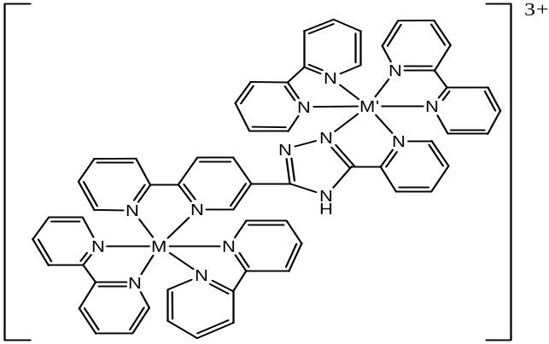

Figure 1: Structure of hetero-dinuclear products [Os(bpy)₂(pytr-bpy)Ru(bpy)₂]³⁺, [Ru(bpy)₂(pytr-bpy)Ru(bpy)₂]³⁺ and [Ru(bpy)₂(pytr-bpy)Os(bpy)₂]³⁺ where M / M’ = Ru/Os

From the electrochemical results obtained in chapter 6, two metal centre oxidations are observed for the dinuclear complex from figure 1. However assignments of these metal centered oxidations are difficult due to the close proximity of the oxidation waves to each other, especially in the complex [Ru(bpy)₂(pytr-bpy)Os(bpy)₂]³⁺. Despite this difficulty the use of near IR spectroelectrochemistry analysis makes this assignment easier. This method involves the analysis of the IR spectrum of the complex while applying a specific voltage to the system.

Figure 2 shows the near IR spectroelectrochemical results obtained for the complex [Ru(bpy)₂(pytr-bpy)Ru(bpy)₂]³⁺. From these spectra we observe that upon initial oxidation to 1.1V the ¹MLCT is significantly reduced, with the appearance of an LMCT at approx: 800 nm. This band not thought to be an IT transition, as it is present for the fully oxidized complex also (green and blue lines).
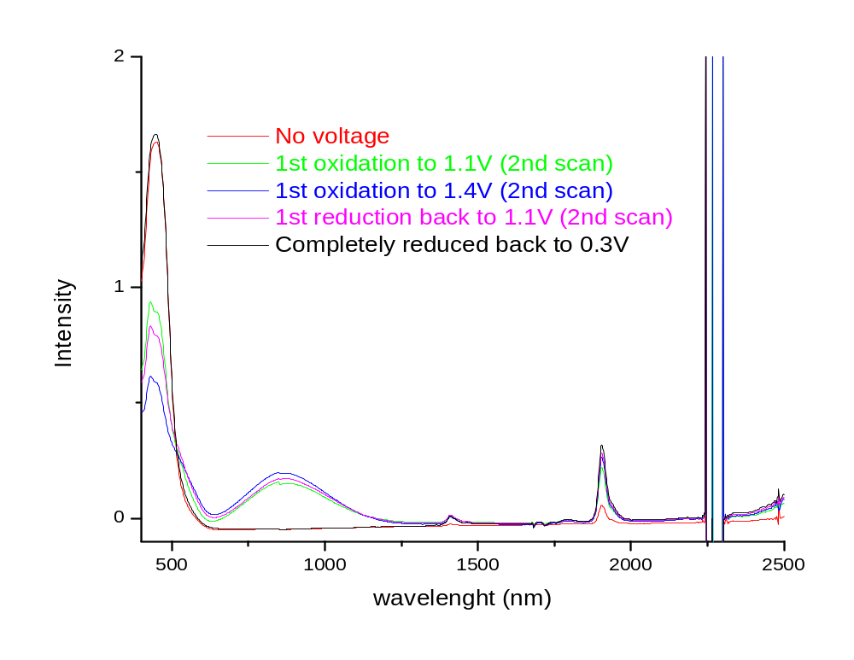
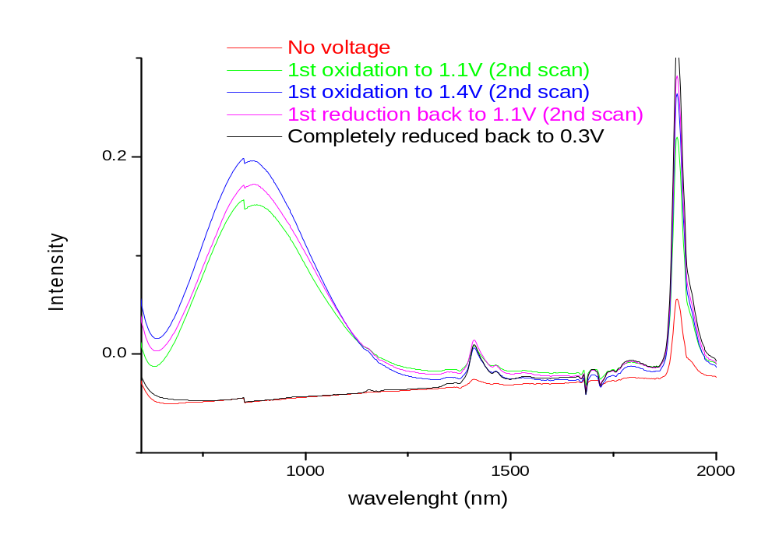
Figure 2: Near IR spectroelectrochemical data for dinuclear complex [Ru(bpy)₂(pytr-bpy)Ru(bpy)₂]³⁺
This LMCT is relatively intense and is probably due to the strong σ-donor abilities of the pyridine-triazole ligand which will donate electron density into the Ru(III) metal centre. As this LMCT band is very intense following the first oxidation it is possible that it is the [Ru(bpy)₂(pytr)] metal centre which is oxidized first, with the [Ru(bpy)₂(bpy)] metal centre being oxidized second. This is in keeping with expected results as metal centers with strong σ-donor ligands present are much easier to oxidize then those bound to strong π-acceptor ligands.

It must be noted from the spectra below we observe no IT transition. If present this band would be expected in the range of 1200 – 2000 nm but no such transition is observed. The only bands are those associated with water creeping into the system at approx: 1400 nm and the presence of the solvent acetonitrile as a very sharp band at approx: 1900 nm.

The next complex to be examined is [Os(bpy)₂(pytr-bpy)Ru(bpy)₂]³⁺ whose spectra are shown in figure 3. This complex, with no voltage applied, shows a ¹MLCT transition at approx: 450 nm and a broad ³MLCT transition at approx: 650 nm. The ¹MLCT indicates the presence of both a ruthenium and osmium metal centre, while the ³MLCT represents an osmium metal centre. From spectrum 3 we observe a decrease in the ¹MLCT and the ³MLCT transition upon oxidation to 0.7V. Further oxidation to 1.45V sees a further decrease in the ¹MLCT, while the ³MLCT is replaced by a LMCT transition which is present in the same region.

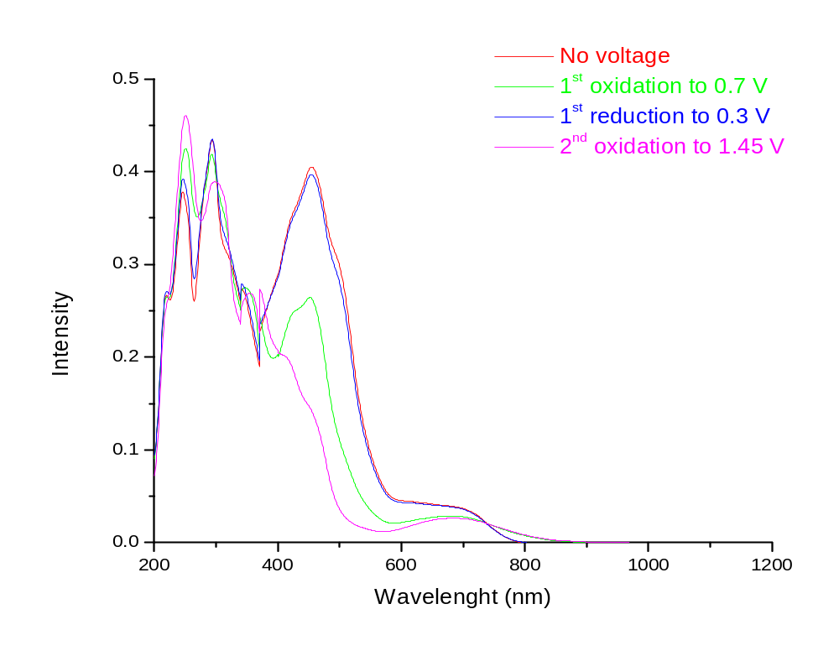
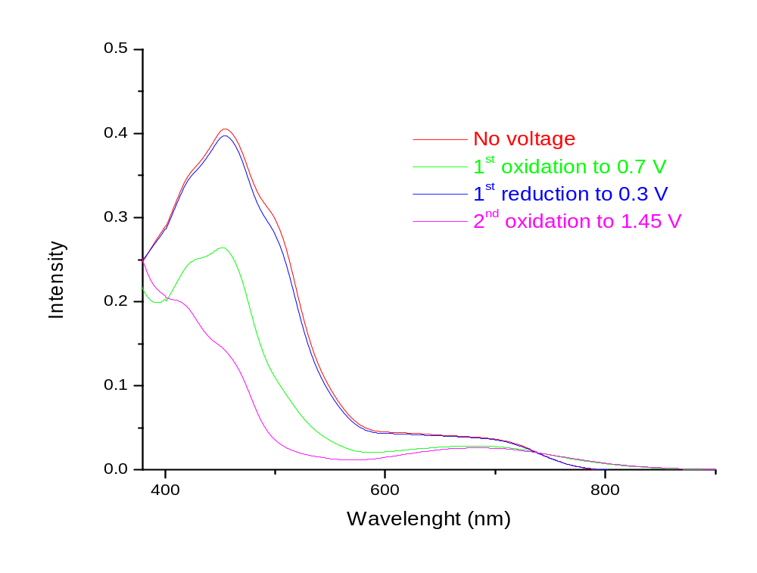
Figure 3: Dinuclear complex [Os(bpy)₂(pytr-bpy)Ru(bpy)₂]³⁺
The initial oxidation at 0.7V resulting in a decrease in the ³MLCT transition suggests the [Os(bpy)₂(pytr)] metal centre is oxidized first. This is as expected due to the strong σ-donor properties of the pyridine-triazole ligand resulting in the osmium metal centre being oxidized at lower potentials. The second oxidation is of the [Ru(bpy)₂(bpy)] metal centre which occurs at a high potential of 1.45V. This high voltage is partially due to the increased charge on the overall complex having already oxidized the osmium metal centre. A final observation is the absence of an IT transition in figure 3. As noted above the only bands observed in this region are associated with solvent and water.

The final complex to be examined is [Ru(bpy)₂(pytr-bpy)Os(bpy)₂]³⁺ as shown in figure 4. The electronic spectrum of this complex is similar to those for the above complexes with a ¹MLCT transition present representing both the ruthenium and osmium metal centers and a relatively small ³MLCT transition present representing the “spin-forbidden” transitions of the osmium metal centre. However the electrochemical data illustrates the two oxidation potentials for this complex are in very close proximity to one another. Therefore careful analysis of the spectroelectrochemical data must be carried out to determine which metal centre is oxidized first.

Upon oxidation to 0.9V an initial decrease in the ³MLCT is observed which is quickly replaced by a LMCT transition in the same region. A decrease in the ¹MLCT transition is also distinguished. This is followed quickly by a second oxidation at 1.1V in which a further decrease in the ¹MLCT is observed and a large increase in the LMCT transition present. These results indicates that the [Os(bpy)₂(bpy)] metal centre is oxidized first due to the disappearance of the ³MLCT. The second oxidation is of the [Ru(bpy)₂(pytr)] metal centre which is confirmed by the relatively large increase of the LMCT transition at 1.1V. The pyridine-triazole ligand (strong σ-donor) will donate electron density into a Ru(III) metal centre, resulting in the observation of an LMCT band, more readily than a bipyridine ligand (π-accpetor) will donate electron density into an Os(III) metal centre.
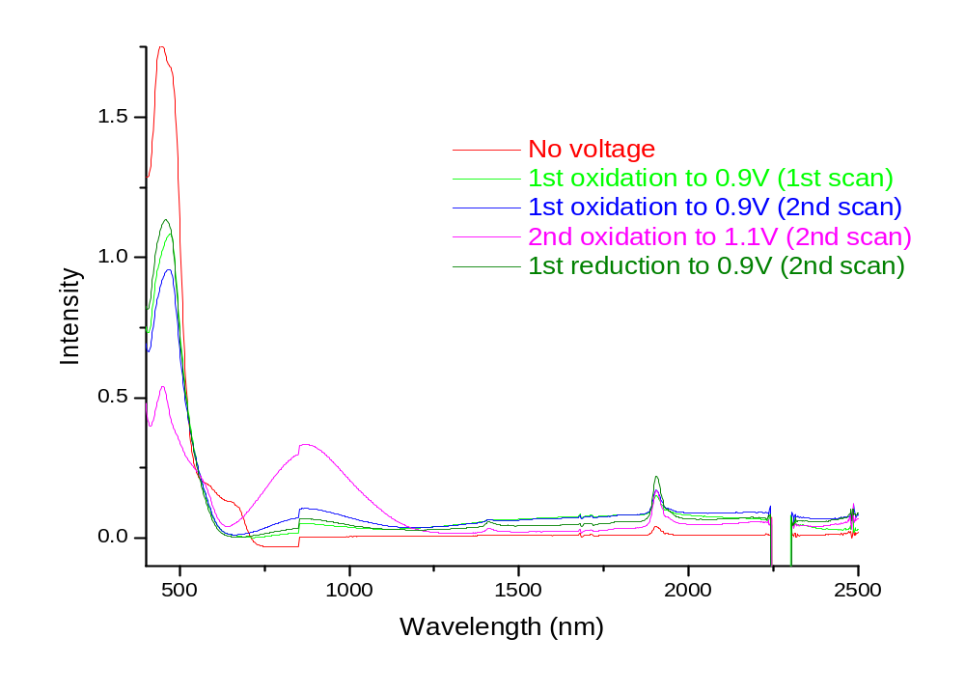
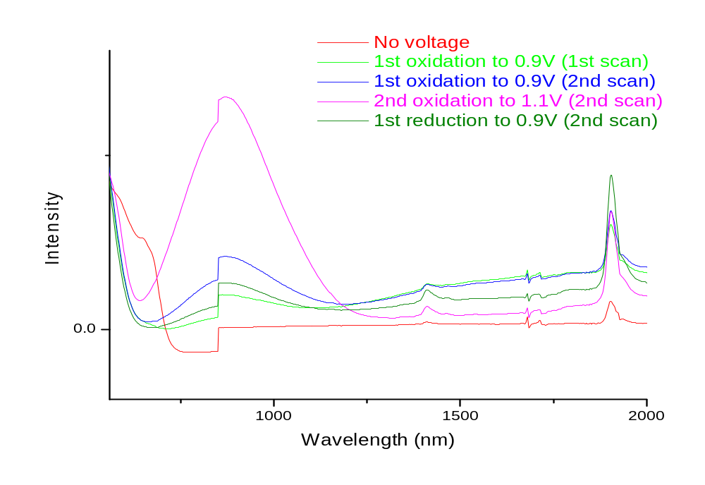
Figure 3: Dinuclear complex [Ru(bpy)₂(pytr-bpy)Os(bpy)₂]³⁺

More interestingly about this complex is the presence of an IT transition at approx: 1700 nm. This transition appears after the first oxidation occurs to form the Ru(II)/Os(III) complex and disappears after the second oxidation to form the Ru(III)/Os(III) complex. This band is not considered to be an LMCT transition. An LMCT type transition would most likely be present in the Ru(III)/Os(III) form of the complex due to the donation of electron density from the pyridine-triazole ligand into the ruthenium metal centre. This transition would not be observed for the Ru(II)/Os(III) form of the complex as the bipyridine would not donate electron density into the osmium metal centre.

The presence of this IT transition in this complex, which is not present in the analogous dinuclear complexes, suggests that communication is present between the two metal centers. The type of interaction has not yet been determined.

Further work is to be carried out into the spectroelectrochemical analysis of the remaining dinuclear complexes synthesized from chapter 6. These complexes are expected to demonstrate varying levels on interaction between the two metal centers. Those with a bis(pyridine-triazole) bridge are expected to have some communication as reported previously in the literature. The dinuclear complexes with bis(bipyridine) bridging ligands are expected to have a weak interaction, if any, between the metal centers due to the possibility of the excited state being located on the bridge.

Di Pietro, C: Serroni, S: Campagna, S: Gandolfi, M. T: Ballardini, R: Fanni, S: Browne, W. R: Vos, J. G, Inorg. Chem., 41, 2002, 2871

