Chapter 3: Synthesis and Characterization of the novel [M(bpy)₂(bpt)Ru(tpy)Cl]²⁺ type complexes.

Abstract:
Chapter 3 describes the synthesis of novel homonuclear and heteronuclear metal complexes using the conventional “complexes as metals / complexes as ligands” strategy. This classical approach has been used for many years now in the production of “designer” complexes for multiple applications. The complexes synthesized in this chapter were designed for a specific function. For this reason a Hbpt ligand has been used for interaction purposes between two metal centers and a terpyridine ligand will function as an “anchor” for these complexes onto a surface. We will investigate this strategy to identify were its advantages lie and were problems might occur in the development of larger metal complexes. It will also be the starting point of our comparison between the most appropriate methods for the synthesis of multi-component metal based systems.

The chapter includes characterization of the complexes synthesized using mass spectrometry, nuclear magnetic resonance, deuteriation and elemental analysis. The electronic and electrochemical properties are also investigated and compared with those model compounds obtained previously for Hage and co-workers.

3.1 Introduction
The synthetic strategy of “complexes as metals / complexes as ligands” is the model applied to the development of a step-wise synthesis of ruthenium /osmium based metal complexes with potential applications as diodes in molecular electronics. For a complex to function appropriately as a possible molecular electronic system it must possess certain criteria. Firstly, in order to carry a current these molecules must be either electron or hole conducting. While secondly they ideally should be linear in structure with a defined length in order to span the gap between two components in a circuit.

In this chapter we considered these specific criteria in choosing a candidate molecule as a possible molecular system. A possible model structure for a molecular diode was determined to be an osmium dinuclear complex (OsOs) with a Hbpt (3,5-bis(pyridin-2-yl)1,2,4-triazole) bridge and a functionalized tpy (2, 2’, 6’, 2”-terpyridine) anchor, as shown in figure 3.1.
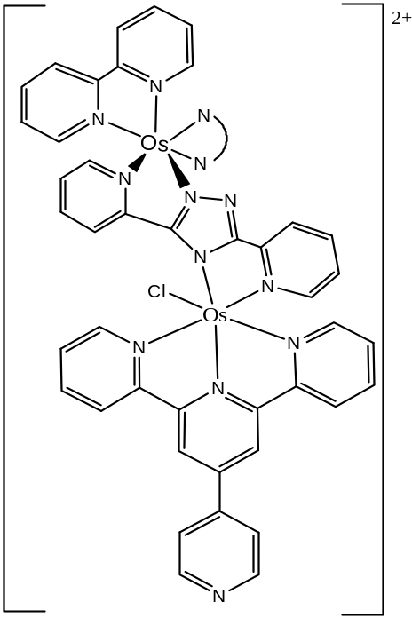

Figure 3.1: Candidate complex [Os(bpy)₂(bpt)Os(py-tpy)Cl]²⁺

As discussed in chapter 1 the osmium metal centre is preferred to the ruthenium metal centre for surface chemistry due to its lower redox potentials which allow osmium compounds to be used on surfaces such as gold or platinum. For communication purposes the extensively researched Hbpt ligand , was chosen as it has been shown to facilitate communication from one metal centre to the other and lastly, but most importantly, a functionalized (tpy) ligand was chosen as the “anchoring” compound on which to attach the designer complex onto a surface. As can be seen from figure 3.1, the model complex [Os(bpy)₂(bpt)Os(py-tpy)Cl]²⁺ contains the appropriate linear structure and when synthesized may be tested for its electron conducting capabilities.

Although the desired metal complex is of the type shown in figure 3.1, we synthesize the less complex non-functionalised [M(bpy)₂(bpt)Ru(tpy)Cl]²⁺ type compounds initially. The reason for this is associated with the unknown purity levels of [M(py-tpy)Cl₃] (were py-tpy is 4’(pyrid-4”’-yl) 2,2’,6’, 2” terpyridine) type complexes and increased purification problems associated with these compounds. As a paramagnetic compound we are unable to determine the purity level of this complex via NMR prior to its use as a precursor compound in the next step of the synthetic pathway. It was therefore decided to optimize the reaction conditions prior to introducing a [M(py-tpy)Cl₃] type complex into the synthetic procedure using the [M(tpy)Cl₃] analogue. The resulting ruthenium / osmium metal based complexes were of the type [M(bpy)₂(bpt)Ru(tpy)Cl]²⁺ .

The complexes to be synthesized are based on ruthenium (II) and osmium (II) metal ions and take the form [M(bpy)₂(bpt)Ru(tpy)Cl](PF₆)₂. The structures of the ligands utilized in the metal complex are detailed in figure 3.2.

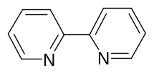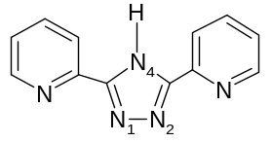
2,2’-bipyridine (bpy) 3,5-bis(pyridin-2-yl)-1,2,4-triazole (Hbpt)
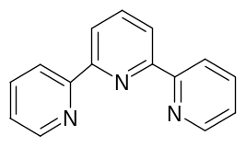
2,2’,6’,2”- terpyridine (tpy)

Figure 3.2: Ligands used in the syntheses of the complexes discussed in Chapter 3
All these ligands have been previously reported and form the backbone of a multitude of similar ruthenium (II) and osmium (II) complexes. However to the best of our knowledge there are no previous reports of all three ligands being simultaneously used in a large mixed ligand system.

The core part of chapter 3 is the discussion of the synthesis involved in production of the metal complexes of the ligands shown above in figure 3.2. It is a multi-step process and has been the traditional method for the synthesis of complicated metal complexes for many decades now. However firstly it is important to examine the synthesis and properties of the ruthenium and osmium complexes of these ligands shown in figure 3.2, before we introduce the synthetic approach and the properties of the [M(bpy)₂(bpt)Ru(tpy)Cl](PF₆)₂ complexes. Examination of the synthesis and properties of Hbpt and (tpy) type complexes will greatly ease the characterization of the new complexes introduced later in this chapter.

The first studies into the electrochemical and photochemical properties of (bpy) metal complexes was carried out by Crosby and co-workers in the late 1960’s and continued by Gafney and Adamson during the 1970’s. Since these initial investigations the study of the photochemistry and electronics of Ru-polypyridine complexes has increased exponentially. The interest in these properties is based on the strong π-acceptor abilities of the ligand which cause a stabilization of the filled d-orbitals by removing electron density from the metal. This results in an increase in the oxidation potentials of the complex and a blue shift in the observed absorption maximum. The electron absorption spectra of most bipyridine based complexes are dominated by an intense absorption band at approx: 450 nm and when used in dendrimer systems, such as those synthesized by Balzani et al, with 2,3-dpp (were dpp = diphenylphenanthroline), acting as bridging ligands they can be observed at approx: 620 nm. The oxidation potentials for complexes with bipyridine ligands have also been shown to generally be quite high and can range from approx: 1.0-1.8V, see table 3.1. ^{, 9}

As discussed in chapter 1 Balzani and co-workers have been heavily involved in studies into ruthenium polypyridyl type complexes since the early 1970’s, in both their synthesis and photophysical and photochemical properties.^{8,10} This work has spanned over many decades and ranges from the synthesis of large multinuclear complexes such as a dendrimers to chiral compounds to host guest systems. A greater discussion on such synthesis can be found in chapter 1, section 1.3 but here we shall illustrate an example of a host guest supramolecular species in figure 3.3.
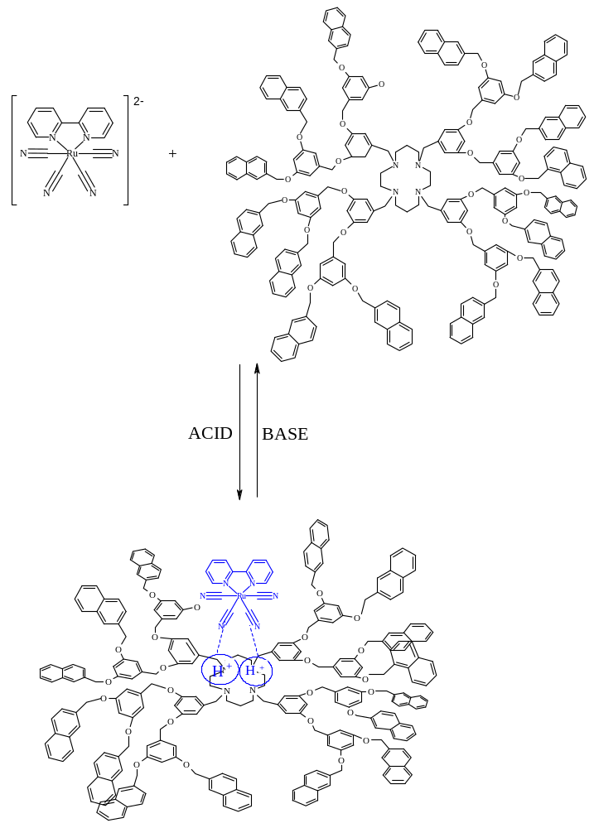
Figure 3.3: Schematic representations of the formation of the ruthenium complex “adduct” ⁹
In supramolecular systems the non-covalently interacting components can be assembled and disassembled by modulating the interactions which hold them together. This is what is observed in arrays such as the one shown in figure 3.3. Balzani and co-workers investigated the ability of the cyclam ligand in its protonated form to act as a host towards cyanide metal complexes. These studies have shown that upon addition of acid to an acetonitrile/dichloromethane solution of the starting materials an adduct is formed between the metal complex and the large cyclam core ligand. This new “adduct” results in a quenching of the fluorescence of the naphthyl units due to the efficient transfer of energy to the metal complex. The new “adduct” can again be disassembled by the addition of a base which will yield the starting materials.⁹ This is an example of controlled switching on/off of the luminescence of a compound by modulating the interaction occurring between itself and a metal complex within a supramolecular system.

The first ligand of interest within the complexes to be prepared is the extensively studied 1,2,4-tiazole and its derivatives. The first report of 1,2,4-triazole and bis(bpy) ruthenium complexes of the type [Ru(bpy)₂L₂]²⁺, were L = 1,2,4-triazole and 4-phenyl-1,2,4-triazole, was by Vos and co-workers in 1983. These triazolate ligands where then further developed by Hage and co-workers whose work is based primarily on the synthesis of 3-(pyridine-2’-yl)-1,2,4-triazoles (pytr) and 3-(pyrazin-2’-yl)-1,2,4-triazoles (pztr) whose metal complexes were studied due to their electronic and electrochemical properties.

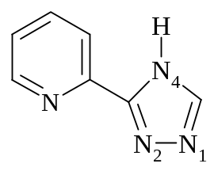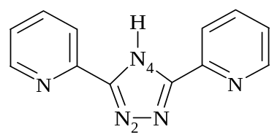
3-(pyridin-2-yl)-1,2,4-triazole (Hpytr) 3,5-bis(pyridin-2-yl)-1,2,4-triazole (Hbpt)

Figure 3.4: an example of some triazole ligands synthesized by both Hage et al and Vos et al ^{l2}

As noted in chapter 1, these ligands were studied due to their σ-donor properties and the different coordination geometries available for the metal ion owing to the different chemical environments of the nitrogen atoms present. The investigations found that the metal ion can bind via the N2 or N4 atom of the triazole ligand, as shown in figure 3.4 ¹³. The N4 site is known to be a stronger σ-donor than the N2 site. This is noticeable in the pK_{a} for the protonation of the free nitrogen in the complex, where the pK_{a} for the N4 bound complex is higher than that of the N2 bound complex. This difference in σ-donor strengths observed between the two sites has been proven to affect the electronic and electrochemical properties., However the most favorable coordination mode often depends on whether there are substituents present on the 5 member ring.

These triazolate ligands can also be further utilized as in the case of Hbpt, where it can function as a bridging ligand between two metal ions to form dinuclear complexes as in the form of [{Ru(bpy)₂}₂(bpt)](PF₆)₃.¹³ As noted in the introduction this ligand will be utilized in the synthesis of the dinuclear complexes in this chapter to function as a communication bridge between the two metal centres. The electron absorption spectra of the ruthenium complexes with σ-donor ligands such as the triazole based systems mentioned, is dominated by intense absorption bands between 450-470 nm and is due to the electron rich 5-membered triazole rings which result in the metal-ligand charge transfer (dπ-π*) occurring at lower energy. The ligand π-π* transitions are also observed at approx: 250-300 nm.¹³

The metal based oxidation potentials of these mononuclear complexes all occur within the range of 0.80 -1.0 V, which are all lower then the oxidation potential for [Ru(bpy)₃]²⁺. Similar to the electronic data these results can be rationalized by the σ-donor properties of the triazole ligands present, which causes an increased donation of electron density onto the metal ion. This results in these complexes being oxidized at lower potentials. However, the reduction potentials are normally similar to those observed for [Ru(bpy)₃]²⁺, suggesting a bipyridine reduction is observed.

The second ligand of relevance to this section is the terpyridine (tpy) ligand. This ligand and its analogues have been comprehensively studied by Sauvage et al and others due to their achiral nature, , compared with 2,2’-bipyridine and their ability to be functionalized in the 4’-position and to introduce an anchoring group onto surfaces as shown below in figure 3.5. The synthesis of metal terpyridine (tpy) complexes based on [Ru(tpy)₂]²⁺ have been discussed in section 1.3.1 and will not be discussed here further.

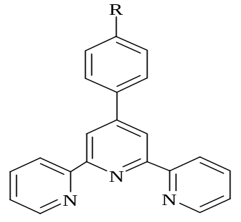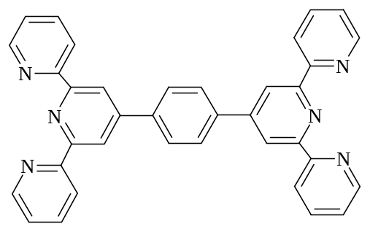
4-R-4’-phenyl-2,2’,6’2”-terpyridine 4’-phenyl-(2,2’,6’,2”-terpyridine)₂

Figure 3.5: Terpyridine ligands used in the preparation of metallic complexes.

The electron absorption spectra of the ruthenium complexes with terpyridine ligands is dominated by intense absorption bands between 470-495 nm due to the spin allowed d → π* metal-to-ligand charge transfer (¹MLCT) transition with the ligand centered π → π* transition bands occurring in the UV region. Generally there is a weak luminescence at room temperature but upon cooling to 77K a stronger luminescence is observed. The [Ru(tpy)₂]²⁺ type complexes are also electrochemically active. They exhibit a reversible Ru ^{II /III} oxidation process and a varying number of reversible or quasi-reversible reductive ligand-centered processes.²²

Complex | Absorption  λ_{max}/ nm  (ε 10⁴ ) | Luminescence  (λ_{max}/ nm) | Oxidation  (V vs. SCE) | τ  (RT)
2,2’-bipyridine Complexes

[Ru(bpy)₃]²⁺ | 450 (1.30) | 615 | 1.26 | 1 μs ²³
[Os(bpy)₃]²⁺ | 486 | 725 | 0.83 | 0.62 µs
1,2,4-Triazole Complexes

[Ru(bpy)₂ (pytr)]⁺ (N2) | 465 (1.10) | 650 | 0.83 -0.90 ¹³ | -
[Ru(bpy)₂ (bpt) ₂]⁺  (N2) | 475 (1.13) | 608 | 0.85 ¹⁵ | 0.16μs ¹³
[Os(bpy)₂ (bpt) ₂]⁺  (N2) | 486 (1.08), 610 (0.28) | 762 | 0.49 | 0.55 µs
2,2’,6, 2”-Terpyridine Complexes

[Ru(tpy)₂]²⁺ | 476Error: Reference source not found | 598 | 1.30 | 250 ps
[Ru(tpy)(bpy)Cl)₂]⁺ | 506 | 729 | 0.81 | -
[Os(tpy)₂]²⁺ | 477 (1.37), 657 (0.36)Error: Reference source not found | 718 | 0.97 | 269 ns

Table 3.1: Absorption, luminescence and oxidation potential data for mononuclear model compounds ^{13,} Error: Reference source not found

From the discussion of the various electronic properties available in the different types of ligands it is proposed a mixed ligand system could combine the most advantageous properties of each, and generate a complex with the optimum electrochemical and photophysical properties. For this reason the ligands - bipyridine, triazolate and terpyridine- are used as building blocks within the structure directed supramolecular assembly. Equations 1-3 demonstrate the general features of a structure directed synthesis:

(Eq 3.1):
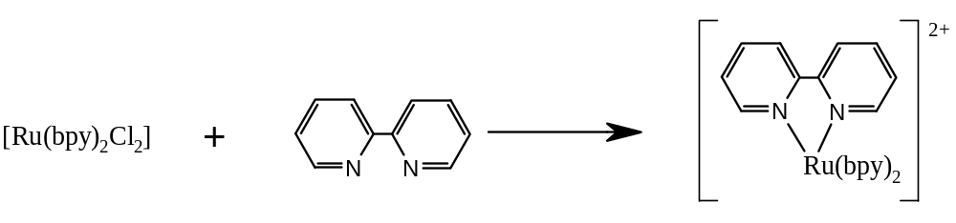
Mononuclear complexes are synthesized by the combining a metal ion (M) and free ligands (L), as shown in equation 3.1. If the target dinuclear complex is a symmetrical homometallic compound, the synthesis is relatively straightforward. It is sufficient to react the mono-nuclear metal precursor with the bridging ligand in 2:1 ratio, as illustrated in equation 3.2.

(Eq 3.2)
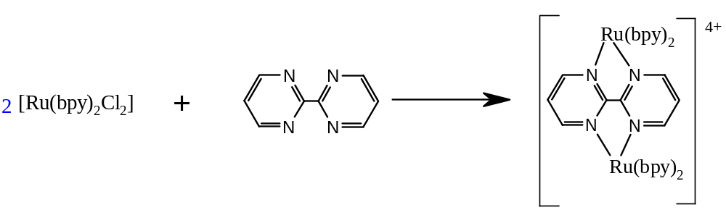

If the desired product is a dinuclear heterometallic complex the synthesis involves 2 steps, as shown in equation 3.3 and 3.4. Firstly the metal starting material is reacted with the excess ligand to form the metal-ligand complex. Any dinuclear complex by-product must then be removed before proceeding. This “complex” is then reacted with the second metal centre to form the desired product.

(Eq 3.3)
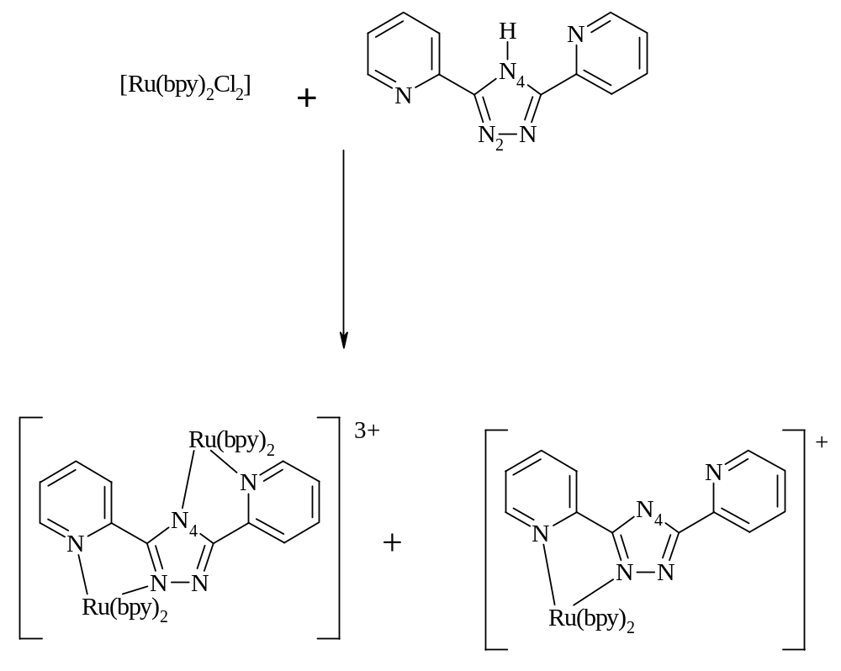

(Eq 3.4)

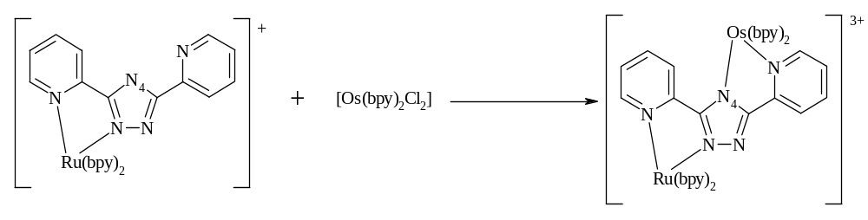

This is the traditional method used for the synthesis of metal complexes and the next section will detail the synthesis of a mixed ligand system using the method shown above in equations 3.1-3.4.

3.2 Experimental

3.2.1 Synthesis of Ligands

Hbpt
3,5-bis(pyridin-2-yl)1,2,4-triazole
This procedure has been modified slightly to that described by Mulhern, PhD Thesis, 2000, Dublin City University.
3,5-bis(pyridin-2-yl)-4-amino-1,2,4-triazole
A mixture of 2-cyanopyridine (8.11 g, 78 mmol) and hydrazine hydrate (4.99 g, 156 mmol) were heated at 100⁰C for 4.5 hour. The orange precipitate that formed was filtered, washed with cold ethanol (10 cm³) and diethyl ether (100 cm³). The orange dihydro-3,6-bis(pyridin-2-yl)-1,2,4,5-tetrazine was dissolved in 2M HCl (120 cm³) and boiled for 30 min. The solution was allowed to cool to room temperature and then made alkaline by the addition of ammonia. The solution was cooled to +4⁰C for 1 hour and then filtered. The tan precipitate was washed with alkaline H₂O and recrystallised from hot ethanol.
Yield: 3.98 g, 17.5 mmol, 45%.
¹H NMR (d₆- DMSO, 298K) δ 8.79 (d,), 8.20 (d), 8.02 (t), 7.88 (s), 7.43 (t).

3,5-bis(pyridin-2-yl)-1,2,4-triazole
The tan 3,5-bis(pyridin-2-yl)-4-amino-1,2,4-triazole (3.5 g, 15.7 mmol)was dissolved in boiling 5M nitric acid (17.5 cm³). The solution was cooled to 0⁰ C and an aqueous sodium nitrite solution (10.5 g in 17.5 cm³) was slowly added drop-wise with stirring until no further brown fumes were released. The solution was then boiled for 5 min and cooled to room temperature. The white product, which crashed out, was washed with alkaline H₂O and cold ethanol. The product was then recrystallised from ethanol.
Yield 3.0 g, 13.5 mmol, 85%
¹H NMR (d6-DMSO, 298K) δ; 8.73 (d, 2H, H6 + H6’, J = 5.2 Hz), 8.22 (d, 2H, H3 + H3’, J = 6.4 Hz), 8.05 (t, 2H, H4 + H4’, J = 6 Hz, J = 6.4 Hz), 7.52 (t, 2H, H5 + H5’, J = 5.2 Hz, J = 6.4 Hz).

3.2.2 Synthesis of Mononuclear Complexes

[Ru(bpy)₂(bpt)](PF₆).1/2H₂O¹³
This procedure has been modified slightly to that described by Hage et al.¹³
Hbpt (100 mg, 0.45 mmol) was dissolved in 15 cm³ hot ethanol/water (2:1 v/v).
cis-[Ru(bpy)₂Cl₂].2H₂O (118 mg, 0.22 mmol) was added in small portions to the dissolved ligand and the mixture was heated at reflux for 6 hour. The hot solution was filtered, evaporated to dryness after which 10 cm³ water and 1 drop ammonium was added to the dark red product. A solution of aqueous ammonium hexafluorophosphate was added to the filtrate to precipitate an orange product as a PF₆⁻ salt. This product was isolated by filtration, washed with water and dried with diethyl ether. The compound was purified using a neutral alumina column and eluted with acetonitrile.
Yield: 92 mg, 51%
¹H NMR ( CD₃CN, 298K) δ; 8.53 ( 1H, d, H6(1), J = 4.8 Hz), 8.43 (4H, m, H3), 8.15 (1H, d, H3(2), J = 6.4 Hz), 8.01 (1H, d, H3(1), J = 6.6 Hz), 7.92 (8H, m), , 7.89 (1H, t, H4(2), J= 6.4 Hz, J = 7.4 Hz), 7.75 (1H, t, H4(1), J = 6.6 Hz, J = 6.6 Hz), 7.52 (1H, d, H6(2), J = 5.6 Hz), 7.37 (4H,m), 7.23 (1H, t, H5(2), J = 7.4 Hz, J = 5.6 Hz), 7.14 (1H, t, H5(1), J = 4. 8 Hz, J = 6.6 Hz)
Elem Anal. C₃₂H₂₄N₉RuPF₆.1/2H₂O: Calc: C 48.67%, H 3.17%, N 15.96%
Found: C 48.41%, H 3.22%, N 15.91%

[Ru(d₈-bpy)₂(bpt)](PF₆).1/2H₂O
This procedure has been modified slightly to that described by Hage et al¹³
Hbpt (343 mg, 1.54 mmol) was dissolved in 15 cm³ hot ethanol/water (2:1 v/v).
cis-[Ru(d₈-bpy)₂Cl₂].2H₂O (400 mg, 0.77 mmol) was added in small portions to the dissolved ligand and the mixture was heated at reflux for 6 hour. The hot solution was filtered, evaporated to dryness after which 10cm³ water and 1 drop ammonium was added to the dark red product. A solution of aqueous ammonium hexafluorophosphate was added to the filtrate to precipitate an orange product as a PF₆⁻ salt. This product was isolated by filtration, washed with water and dried with diethyl ether. The compound was purified using a neutral alumina column and eluted with acetonitrile.
Yield: 188 mg, 31%
¹H NMR ( CD₃CN, 298K) δ; 8.50 (1H, d, H6(1), J = 4.8 Hz), 8.15 (1H, d, H3(2), J = 7.2 Hz), 8.01 (1H, d, H3(1), J = 7.6 Hz), 7.90 (1H, t, H4(2), J = 6.8 Hz, J = 7.2 Hz), 7.70 (1H, t, H4(1), J = 7.6 Hz, J = 6.6 Hz), 7.55 (1H, d, H6(2), J = 5.6 Hz), 7.20 (1H, t, H5(2), J = 5.6 Hz, J = 6.8 Hz), 7.15 (1H, t, H5(1), J = 4.8 Hz, J = 6.6 Hz).
Elem Anal. C₃₂H₈D₁₆N₉RuPF₆.1/2H₂O: Calc: C 47.70%, H 3.01%, N 15.65%
Found: C 48.41%, H 2.97%, N 15.49%

[Ru(tpy)Cl₃]
981 mg (4.1 mmol) of RuCl₃.2H₂O were dissolved in 150 cm³ of ethanol, the solution was refluxed and 1 equivalent of 2, 2’; 6’,2” terpyridine (tpy), dissolved in 20 cm³ of ethanol, were dropped in the reaction bulk. The reaction was heated for 2 hr. and filtered hot. A dark solid was collected and washed with ethanol, water and diethyl ether.
Yield: 681 mg, 80%.

[Os(bpy)₂(bpt)](PF₆).2H₂O
This procedure has been modified slightly to that described by Hage et al. ¹³
Hbpt (0.148 mmol) was dissolved in 9 cm³ of hot ethanol/water (1:1 v/v). cis-[Os(bpy)₂Cl₂].2H₂O (0.12 mmol) was added in small portions over approx 45min to the dissolved ligand and the mixture was left to heat at reflux for 38hr. The hot solution was filtered, evaporated to dryness after which 10 cm³ of water was added. A solution of aqueous ammonium hexafluorophosphate was added to the filtrate to precipitate a brown/green product. This product was isolated by filtration, washed with water and dried with diethyl ether. The compound was purified by column chromatography (stationary phase neutral alumina, mobile phase acetonitrile) to yield pure compound.
Yield: 38 mg, 43%
¹H NMR (CD₃CN, 298K) δ; 8.55 ( 1H, d, H6(1), J = 6 Hz), 8.43 (4H, m), 8.18 (1H, d, H3(2), J = 7.6 Hz), 7.92 (8H, m), 7.95 (1H, d, H3(1), J = 6.6 Hz), 7.88 (1H, t, H4(2), J = 6.4 Hz, J = 7.6 Hz ), 7.65 (1H, t, H4(1), J = 6.6 Hz, J = 7.6 Hz), 7.40 (1H, d, H6(2), J = 5.2 Hz), 7.15 (1H, t, H5(2), J = 6.4 Hz, J = 5.2 Hz), 7.37 (4H,m), 7.05 (1H, t, H5(1), J = 6 Hz, J= 7.6 Hz).
Elem Anal. C₃₂H₂₄N₉OsPF₆.2H₂O: Calc: C 42.43%, H 3.09%, N 13.92%
Found: C 42.94%, H 3.08%, N 13.80%

[Os(d₈-bpy)₂(bpt)](PF₆).H₂O
This procedure has been modified slightly to that described by Hage et al. ¹³
Hbpt (149 mg, 0.66 mmol) was dissolved in 9 cm³ of hot ethanol/water (1:1 v/v). cis-[Os(d₈-bpy)₂Cl₂].2H₂O (318 mg, 0.55 mmol) was added in small portions over approx 45min to the dissolved ligand and the mixture was left to heat at reflux for 38hr. The hot solution was filtered, evaporated to dryness after which 10 cm³ of water was added. A solution of aqueous ammonium hexafluorophosphate was added to the filtrate to precipitate a brown/green product. This product was isolated by filtration, washed with water and dried with diethyl ether. The compound was purified by column chromatography (stationary phase neutral alumina, mobile phase acetonitrile) to yield pure compound.
Yield: 40 mg, 9%
¹H NMR (CD₃CN, 298K) δ; 8.55 (1H, d, H6(1), J = 5.2 Hz), 8.15 (1H, d, H3(2), J = 8 Hz), 8.01 (1H, d, H3(1), J = 8 Hz), 7.75 (1H, t, H4(2), J = 7 Hz, J = 8 Hz), 7.72 (1H, d, H4(1), J = 8 Hz, J = 6 Hz), 7.42 (1H, H6(2), J = 5.6 Hz), 7.25 (1H, t, H5(2), J = 7 Hz, J = 5.6 Hz ), 7.15 (1H, t, H5(1), J = 6 Hz, J = 5.2 Hz).
Elem Anal. C₃₂H₈ D₁₆N₉OsPF₆.2H₂O: Calc: C 41.69%, H 2.61%, N 13.68%
Found: C 41.55%, H 2.65%, N 13.62%

[Os(tpy)Cl₃]
981 mg (4.1 mmol) of RuCl₃.2H₂O were dissolved in 150 cm³ of ethanol, the solution was refluxed and 1 equivalent of 2, 2’; 6’,2” terpyridine (tpy), dissolved in 20 cm³ of ethanol, was dropped in the reaction bulk. The reaction was heated for 2 h. and filtered hot. A dark solid was collected and washed with ethanol, water and diethyl ether.

[Os(py-tpy)Cl₃]
(NH₄)₂OsCl₆ (0.100 g, 0.022 mmol) and 1 equivalent of 4’(pyrid-4”’-yl) 2,2’; 6’, 2” terpyridine (0.70 g, 0.022 mmol) were dissolved in 4 cm³ of DMF. The solution was refluxed under argon for six hours. The reaction was cooled and a brown precipitate (NH₄Cl) was filtered off. Ethanol (10 cm³) was added to the solution and afterwards, diethyl ether (30 cm³). The reaction mixture was left at cool temperature overnight. A dark green-brown product precipitated. It was collected and washed with ethanol, water and diethyl ether. Yield 0.139 g, 71%.

3.2.3 Synthesis of Dinuclear Complexes

[Ru(bpy)₂(bpt)Ru(tpy)Cl](PF₆)₂.2H₂O
[Ru(tpy)Cl₃] (100 mg, 0.13 mmol) was dissolved in 10 cm³ ethanol/water (1:1 v/v). [Ru(bpy)₂(bpt)]PF₆.1/2H₂O (0.13 mmol) was added and the mixture was left to heat at reflux for 8 hour. The reaction was cooled to room temperature and evaporated to dryness after which 10 cm³ water was added. The product was isolated by the addition of aqueous NH₄PF₆. This product was isolated by filtration, washed with water and dried with diethyl ether. The compound was purified by column chromatography (stationary phase silica, mobile phase 80:20, Acetonitrile: Water, 0.05 M KNO₃) to yield pure compound
Yield: 40 mg, 33%.
¹H NMR (CD₃CN, 298K) δ; 10.02 (1H, d, H6(1), J = 5.6 Hz), 8.58 (2H, d, H6’ and H5’, J = 8.4 Hz), 8.7-8.5 (4H, m), 8.5 (2H, d, H3”, J = 8 Hz), 8.3-8.0 (8H, m), 8.2 (2H, t, H3’, J = 6.4 Hz, J = 6 Hz), 8.04 (2H, t, H4” and H4(1), J = 6.4 Hz, J = 6.6 Hz), 7.88 (1H, t, H4(2), J = 6.6 Hz, J = 8 Hz), 7.7 (2H, t, H4’, J = 4.4 Hz, J = 6 Hz), 7.65 (1H, d, H6”’, J = 5.2 Hz), 7.45 (1H, t, H5”’, J = 8 Hz, J = 8 Hz), 7.3-7.1 (4H, m), 7.37 (1H, d, H6(2), J = 6.4 Hz),7.28 (1H, t, H5(2), J = 6.6 Hz, J = 6.4 Hz), 7.15 (1H, t, H5(1), J = 6.4 Hz, J = 5.6 Hz), 6.98 (1H, d, H3(1), J = 6.6 Hz), 6.35 (1H, d, H3(2), J = 8 Hz).
Elem Anal. Ru₂C₄₇H₃₅N₁₂ClP₂F₁₂.2H₂O : Calc: C 42.39%, H 2.93%, N 12.62%
Found: C 42.35%, H 2.95%, N 12.53%

[Ru(d₈-bpy)₂(bpt)Ru(tpy)Cl](PF₆)₂.2H₂O
[Ru(tpy)Cl₃] (100 mg, 0.13 mmol) was dissolved in 10 cm³ ethanol/water (1:1 v/v). [Ru(d₈-bpy)₂(bpt)]PF₆.1/2H₂O (0.13 mmol) was added and the mixture was left to heat at reflux for 8 hour. The reaction was cooled to room temperature and evaporated to dryness after which 10 cm³ water was added. The product was isolated by the addition of aqueous NH₄PF₆. This product was isolated by filtration, washed with water and dried with diethyl ether. The compound was purified by column chromatography (stationary phase silica, mobile phase 80:20, Acetonitrile: Water, 0.05 M KNO₃) to yield pure compound
Yield: 15 mg, 11.5%
¹H NMR (CD₃CN, 298K) δ; 10.05 (1H, d, H6(1), J = 5.6 Hz), 8.58 (1H, d, H6’, J = 8 Hz), 8.49 (1H, d, H5’, J = 8 Hz), 8.36 (1H, d, H3”, J = 8 Hz), 8.28 (1H, d, H3’, J = 8 Hz,), 8.13 (2H, H3’, m), 8.06 (1H, t, H4 (1), J = 7 Hz, J = 6.6 Hz), 7.94 (1H, H4”, t, J = 8.4 Hz, J = 8 Hz), 7.82 (2H, H4’, q, J = 5.6 Hz, J = 6.4 Hz), 7.67 (1H, H4(2), t, J = 7 Hz, J = 6.6 Hz), 7.6 (1H, H6”’, d, J = 4.8 Hz), 7.45 (1H, H5”’, t, J = 6 Hz, J = 6 Hz), 7.37 (1H, H6(2), d, J = 6 Hz), 7.28 (1H, H5(1), t, J = 5.6 Hz, J = 6.6 Hz), 7.15 (1H, H5(2), t, J = 6.6 Hz, J = 6 Hz), 6.98 (1H, H3(1), t, J = 7 Hz), 6.35 (1H, H3(2), d, J = 7.2 Hz)
Elem Anal. Ru₂C₄₇H₁₉D₁₆ N₁₂ClP₂F₁₂.2H₂O; Calc: C 41.91%, H 2.89%, N 12.47%
Found: C 41.78%, H 2.97%, N 12.33%

[Os(bpy)₂(bpt)Ru(tpy)Cl](PF₆)₂.H₂O
[Ru(tpy)Cl₃] (50.6 mg, 0.11 mmol) was dissolved in 7cm³ ethanol/water (1:1 v/v). [Os(bpy)₂(bpt)]PF₆.1/2H₂O (100 mg, 0.11 mmol) was added and the mixture was heated at reflux for 27 hour. The reaction mixture was filtered hot, evaporated to dryness after which 10 cm³ of H₂O was added. The product was isolated by the addition of aqueous NH₄PF₆. This product was isolated by filtration, washed with water and dried with diethyl ether. The compound was purified by column chromatography (stationary phase silica, mobile phase 80:20, Acetonitrile: Water, 0.05 M KNO₃) to yield pure compound.
Yield: 10 mg, 8%

¹H NMR (CD₃CN, 298K) δ; 10.05 (1H, d, H6(1), J = 5.6 Hz), 8.58 (2H, d, H6’ and H5’, J = 8.2 Hz), 8.7-8.5 (4H, m), 8.50 (2H, d, H3”, J = 8 Hz), 8.30-8.05 (8H, m), 8.21 (2H, t, H3’, J = 5.4 Hz, J = 5.4 Hz), 8.00 (2H, t, H4”, J = 5.2 Hz, J = 4.4 Hz), 7.88 (1H, H4’, t, J = 4.8 Hz, J = 5.2 Hz), 7.70 (1H, t, H4(1), J = 7.2 Hz, J = 6.6 Hz), 7.65 (2H, t, H6”’ and H5”’, J = 6.6 Hz, J = 6 Hz), 7.50 (1H, dd, H6(2), J = 8 Hz), 7.3-7.1 (4H, m), 7.30 (1H, d, H5(1), J = 6.6 Hz, J = 5.6 Hz), 7.25 (1H, t, H4(2), J = 8 Hz, J = 8 Hz), 7.15 (1H, t, H5(2), J = 8 Hz, J = 6 Hz), 6.80 (1H, d, H3(1), J = 7.2 Hz), 6.30 (1H, H3(2), d, J = 6 Hz)

Elem Anal. OsRuC₄₇H₃₅N₁₂ClP₂F₁₂.H₂O: Calc: C 40.24%, H 2.64%, N 11.98%
Found: C 40.49%, H 2.75%, N 12.01%

[Os(d₈-bpy)₂(bpt)Ru(tpy)Cl](PF₆)₂.H₂O
[Ru(tpy)Cl₃] (50.6 mg, 0.11 mmol) was dissolved in 7 cm³ ethanol/water (1:1 v/v). [Os(d₈-bpy)₂(bpt)]PF₆.1/2H₂O (102 mg, 0.11 mmol) was added and the mixture was heated at reflux for 27 hour. The reaction mixture was filtered hot, evaporated to dryness after which 10 cm³ of H₂O was added. The product was isolated by the addition of aqueous NH₄PF₆. This product was isolated by filtration, washed with water and dried with diethyl ether. The compound was purified by column chromatography (stationary phase silica, mobile phase 80:20, Acetonitrile: Water, 0.05 M KNO₃) to yield pure compound.
Yield: 75 mg, 34%

¹H NMR (CD₃CN, 298K) δ; 10.55 (1H, d, H6(1), J = 5.6 Hz), 9.35 (1H, d, H6’, J = 8 Hz), 9.2 (1H, d, H5’, J = 8 Hz), 9.1 (1H, d, H3”, J = 8.4 Hz), 8.95 (1H, d, H3”, J = 8.8 Hz), 8.69 (1H, d, H3’, J = 5.2 Hz, J = 5.4 Hz), 8.65 (1H, d, H3’, J = 4.8 Hz, J = 4.8 Hz), 8.48 (2H, H4’, t, J = 6 Hz, J = 6.4 Hz), 8.45 (1H, t, H4(1) , J = 7.2 Hz, J = 7.2 Hz), 8.35 (1H, H6”’, d, J = 6.8 Hz, J = 8 Hz), 8.25 (1H, d, H5”’, J = 5.2 Hz), 8.1 (1H, t, H6(2) , J = 5.6 Hz), 8.05 (1H, d, H5(1), J = 7.2 Hz), 7.75 (2H, t, H4(2) J = 7.2 Hz, J = 8 Hz), 7.5 (1H, dd, H5(2), J = 5.6 Hz, J = 8Hz), 7.09 (1H, t, H3(1), J = 7.2 Hz, J =7.2 Hz), 6.95 (1H, d, H3(2), J = 5.6 Hz).

Elem Anal.;OsRuC₄₇H₁₉D₁₆ N₁₂ClP₂F₁₂.H₂O: Calc:C 39.81%,H 2.61%, N 11.85%
Found: C 39.68%, H 2.66%, N 11.77%

Attempted Syntheses:

[Ru(bpy)₂(bpt)Os(tpy)Cl](PF₆)₂
Reaction 1:
[Os(tpy)Cl₃] (102 mg, 0.2 mmol) was dissolved in 8 cm³ of ethylene glycol. [Ru(bpy)₂(bpt)]PF₆.1/2H₂O (150 mg, 0.2 mmol) was added to the mixture and left to reflux for 24hour. The reaction mixture was filtered hot and the product was isolated by the addition of aqueous NH₄PF₆. This product was isolated by filtration, washed with water and dried with diethyl ether. The product obtained was purified by column chromatography (stationary phase silica, mobile phase 80:20, Acetonitrile: Water, 0.05 M KNO₃) to yield the complex.
The desired product was not obtained

Reaction 2:

[Os(tpy)Cl₃] (260 mg, 0.5 mmol) was dissolved in 15 cm³ ethylene glycol. A few drops of N-ethylmorpholine were added to the reaction mixture. [Ru(bpy)₂(bpt)]PF₆.1/2H₂O (350 mg, 0.5 mmol) was then added and left to reflux under argon for 40 hour. The reaction mixture was filtered hot and the product was isolated by the addition of aqueous NH₄PF₆. This product was isolated by filtration, washed with water and dried with diethyl ether. The product obtained was purified by column chromatography (stationary phase silica, mobile phase 80:20, Acetonitrile: Water, 0.05 M KNO₃) to yield the complex.
The desired product was not obtained

[Os(bpy)₂(bpt)Os(tpy)Cl](PF₆)₂
[Os(tpy)Cl₃] (110 mg, 0.21 mmol) was dissolved in 10 cm³ ethylene glycol. [Os(bpy)₂(bpt)]PF₆.1/2H₂O (150 mg, 0.21 mmol) was added and the mixture was left to reflux for 125 hour. The reaction was filtered hot and the product was isolated by the addition of aqueous NH₄PF₆. This product was isolated by filtration, washed with water and dried with diethyl ether. The product obtained was purified by column chromatography (stationary phase silica, mobile phase 80:20, Acetonitrile: Water, 0.05 M KNO₃) to yield the complex.
The desired product was not obtained.

[Ru(bpy)₂(bpt)Os(py-tpy)Cl](PF₆)₂
To [Os(py-tpy)Cl₃] (50 mg, 0.08 mmol) in 7 cm³ of ethylene glycol [Ru(bpy)₂(bpt)]⁺ (51 mg, 0.08 mmol) in 7 cm³ ethylene glycol was added. The reaction mixture was heated to reflux for 3.5 days while monitored via thin layer chromatography. The reaction mixture was cooled to room temperature and filtered to remove any unreacted ligand. The product was isolated by the addition of aqueous NH₄PF₆. This product was isolated by filtration, washed with water and dried with diethyl ether. The product obtained was purified by column chromatography (stationary phase alumina, mobile phase 80:20, Acetonitrile: Water, 0.05 M KNO₃).
The desired product was not obtained

[Os(bpy)₂(bpt)Os(py-tpy)Cl](PF₆)₂
To [Os(py-tpy)Cl₃] (50 mg, 0.08 mmol) in 7 cm³ of ethylene glycol [Os(bpy)₂(bpt)]⁺ (60 mg, 0.08 mmol) in 7 cm³ ethylene glycol was added. The reaction mixture was heated to reflux for 4.5 days while monitored via thin layer chromatography. The reaction mixture was cooled to room temperature and filtered to remove any unreacted ligand. The product was isolated by the addition of aqueous NH₄PF₆. This product was isolated by filtration, washed with water and dried with diethyl ether. The product obtained was purified by column chromatography (stationary phase alumina, mobile phase 80:20, Acetonitrile : Water, 0.05 M KNO₃).
The desired product was not obtained.

3.3 Results and Discussion

3.3.1 Synthesis of Mononuclear and Dinuclear Complexes.
The synthesis of the homodinuclear compound [Ru(bpy)₂(bpt)Ru(tpy)Cl]²⁺ (RuRu) and heterodinuclear compound [Os(bpy)₂(bpt)Ru(tpy)Cl]²⁺ (OsRu) are represented schematically in figure 3.6 below.

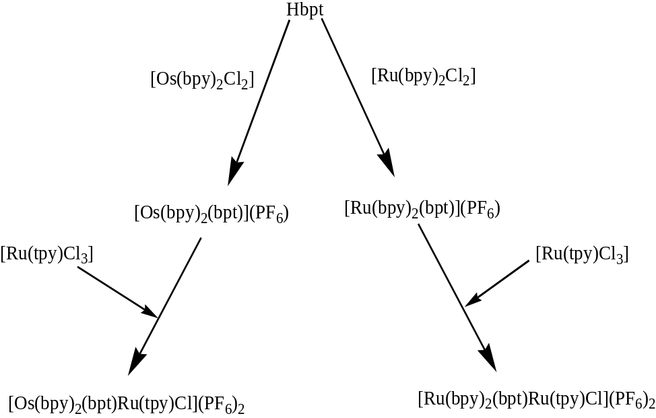

Figure 3.6: Synthetic pathway for the formation of the homonuclear RuRu and heteronuclear OsRu.

The preparation of the starting material [Ru(bpy)₂Cl₂].2H₂O for the synthesis of the ruthenium bipyridyl complexes was carried out with slight differences to literature methods. This reaction can be problematic, sometimes leading to the formation of carbonyl containing compounds, which must be removed before the compound is used. From here the synthesis of all Ru(II) compounds was relatively straightforward using the classical synthetic strategy of “complexes as metals / complexes as ligands”. The mononuclear compound [Ru(bpy)₂(bpt)]⁺ was formed by the addition of excess Hbpt to [Ru(bpy)₂Cl₂] and heating to reflux. Here it is necessary to dissolve the ligand completely before addition of [Ru(bpy)₂Cl₂], to limit the formation of any dinuclear complex by-product. As the reaction proceeds, the deep violet colour of the [Ru(bpy)₂Cl₂] solution is gradually replaced by an orange/red colour, which indicates the presence of the [Ru(bpy)₂(bpt)]⁺ complex. The ethanol was removed at this stage and the chloride counter ion replaced by a PF₆⁻ counter ion which led to the precipitation of the complex from the aqueous solution. The PF₆⁻ salts of this type of complex tend to be only sparingly water soluble, and soluble in many organic solvents, which greatly eases the isolation, purification and analysis of these compounds.

[Ru(tpy)Cl₃] was synthesized by the addition of equimolar quantities of 2,2, 6’,2”-terpyridine with [RuCl₃.H₂O] and then heating to reflux in ethanol until a dark red solution was observed. This complex was then purified by washing with water and diethyl ether. Despite it being a paramagnetic material and unable to undergo ¹H-NMR characterization the material was used in the following reaction without further purification.

The homodinuclear RuRu was synthesized by the addition of one equivalence of each relevant mononuclear ruthenium starting material and heating to reflux. [Ru(tpy)Cl₃] was generally added first and allowed to dissolve completely before adding the more soluble [Ru(bpy)₂(bpt)]⁺ . On formation of the RuRu dinuclear complex purification was required on Silica gel using 80/20, (v/v %) CH₃CN/H₂O saturated with KNO₃ as eluent.

The synthesis of the osmium (II) complexes proved more difficult than the analogous ruthenium (II) complexes. Initially great care was needed in the synthesis of the [Os(bpy)₂Cl₂] starting material as many impurities may be generated in situ, such as paramagnetic Os(III) species and [Os(bpy)₃]²⁺.

Formation of the complex [Os(bpy)₂(bpt)]⁺ was very similar to that of the ruthenium analogue. The reaction of the 1 equivalence of [Os(bpy)₂Cl₂] with 1.2 equivalence of Hbpt in a 1:1 (v/v) mixture of ethanol/water led to replacement of the chlorides, firstly by solvent molecules and then by the Hbpt ligand. The larger ligand field splitting for osmium, and therefore stronger metal-ligand interactions, led to reaction times being increased from 6 hr to 38 hr in the case of the mononuclear complex synthesis and from 8 hr to 24 hr in the case of the dinuclear complex synthesis. Purification of both the non-deuteriated and deuteriated complexes was also required.

This classic synthetic approach proved successful in producing the desired homo- and hetero- dinuclear complexes. However due to the necessity for purification after each reaction step overall yields from ligand to dinuclear complex where relatively low, approx: 15 % overall.

Extensive efforts were made to obtain the analogous [Os(bpy)₂(bpt)Os(tpy)Cl]²⁺ (OsOs) and [Ru(bpy)₂(bpt)Os(tpy)Cl]²⁺ (RuOs) complexes. However, any attempted syntheses of either the homodinuclear OsOs complex and the heterodinuclear RuOs complex were unsuccessful. It was determined that the mononuclear starting material [Os(tpy)Cl₃] was the probable cause for their unsuccessful synthesis.

The solubility of [Os(tpy)Cl₃] proved to be an initial problem. This complex does not dissolve in mild organic solvents, such as ethanol/water, as used in the synthesis of the previous dinuclear complexes. Subsequently ethylene glycol was the solvent of choice for all the reactions as [Os(tpy)Cl₃] became soluble in this at high temperatures. The attempted synthesis of the homodinuclear complex [Os(bpy)₂(bpt)Os(tpy)Cl]²⁺ was carried out in ethylene glycol with refluxing for 5 days. This extended heating was in line with similar reactions carried out in the formation of osmium dinuclear complexes.Error: Reference source not found The reaction was monitored via thin layer chromatography (TLC) and it was only after approx: 4.5-5days that the starting material was no longer present. Despite the vigorous conditions the desired homodinuclear complex was not formed, as was observed from the ¹H-NMR, where a very complex spectrum was observed with integration greater than that of the desired product. The mass spectrometry also illustrated a mixture of products.

In the attempted synthesis of the heterodinuclear complex [Ru(bpy)₂(bpt)Os(tpy)Cl]²⁺ two varying approaches were taken. The initial pathway involved the use of the same solvent and reactions conditions (except refluxing time) as in the synthesis of [Os(bpy)₂(bpt)Os(tpy)Cl]²⁺. This synthetic method proved unsuccessful with the formation of an unknown product. The second pathway involved the use of N-ethylmorpholine as a reducing agent, reacting under inert conditions and extending the refluxing period. It was thought that N-ethylmorpholine would reduce [Os(tpy)Cl₃] from Os(III) to Os(II) by capturing chlorides forming salts prior to the addition of the [Ru(bpy)₂(bpt)]⁺ complex. This however has been unsuccessful also, and the reaction did not proceed as expected.

Due to the notoriously difficult nature of coordinating ligands with osmium, extreme conditions are often employed, such as heating osmium salts or reacting at very high temperatures (i.e. ethylene glycol) for long periods. This however is not always suitable for chemically fragile ligands. Consequently more detailed and intricate synthetic pathways must be developed. The very high temperatures used for sustained periods of time, varying from 24-125 hours, are thought to have led to the degradation of one of the ligand /ligand-complexes present.

However, this problem was not just confined to this research lab. Upon personal communication with a Dr. S. Rau it was determined that prolonged reaction times (above 8 hours) led to scrambling of terpyridine type ligands in such reactions. The longer the reaction is heated at reflux temperature the more complex the product mixture becomes due to this scrambling effect and separation will be become almost impossible.

While the desired (OsOs) dinuclear complex was not obtained the other successfully synthesized complexes are characterized via mass spectrometry, NMR and CHN and this will be detailed in the next sections.

3.3.2 Mass Spectrometry of the Novel Dinuclear Complexes [Ru(bpy)₂(bpt)Ru(tpy)Cl](PF₆)₂ and [Os(bpy)₂(bpt)Ru(tpy)Cl](PF₆)₂

Mass Spectrometry provides qualitative and quantitative information about the atomic and molecular composition of inorganic and organic materials. At its simplest it is a technique for measuring the mass and therefore the molecular weight of a molecule. The mass spectrometer produces charged particles that consist of the parent ion and ionic fragments of the original molecule, and it sorts these ions according to their mass/charge ratio. In addition it is also possible to gain structural information about the molecule by analyzing the mass of the fragments produced when the molecule is broken apart.

Here the complexes were examined using electrospray mass spectrometry. This involves analyzing an ionized aerosol of the complex in question. The aerosol is achieved by passing the complex in solution (MeCN and MeOH) through a fine needle held at 47 eV at 80⁰C. This method has been used in various applications since the early part of the 1900’s. In electrospray larger droplets explode into smaller droplets and so on until the analyte enters the gas phase as an ion. The spectra are measured in the positive mode were the number of charged species normally observed reflect the number of basic sites on a molecule that can be protonated at low pH. This is a soft ionization technique, meaning the complex may remain intact and its molecular weight determined. This is in contrast to other techniques used such as fast atom bombardment (FAB).

Also it should be noted that molecular ions are not generally observed in the electrospray ionization process. A molecular ion is formed by the loss of an electron. In the electrospray process, ionization is accomplished by the loss or gain of a proton (or other adduct). However for the purposes of explanation in this chapter the peak of interest will be referred to as the molecular ion peak.

Ru Isotope | Relative Abundance (%)
95.9 | 18
97.9 | 6
98.9 | 40
99.9 | 40
100.9 | 54
101.9 | 100
103.9 | 59

Table 3.2: The seven isotopes of ruthenium and their corresponding relative abundances

Ruthenium has seven stable isotopes ranging in atomic mass from 95.9 to 103.9 as shown in table 3.2. The relative abundances of each isotope are also included. These isotopes, coupled with the isotope present for carbon and nitrogen produce a molecular ion with a unique fingerprint for each metal complex.

Complex | Molecular  Weight (-PF₆) | Theoretical  (m/z) | Observed  (m/z) | Fragments
[Ru(bpy)₂(bpt)Ru(tpy)Cl]²⁺ | 1004 | 502 | 502.5 | 370, 635.9
[Ru(d₈-bpy)₂(bpt)Ru(tpy)Cl]²⁺ | 1020 | 510 | 510 | 370, 652
[Os(bpy)₂(bpt)Ru(tpy)Cl]²⁺ | 1096 | 548 | 548.2 | 370, 724
[Os(d₈-bpy)₂(bpt)Ru(tpy)Cl]²⁺ | 1112 | 556 | 556.2 | 370, 742

Table 3.3: Observed m/z values for the dinuclear complexes synthesized.

The mass spectra of the dinuclear complexes [Ru(bpy)₂(bpt)Ru(tpy)Cl]²⁺ and [Os(bpy)₂(bpt)Ru(tpy)Cl]²⁺ and their deuteriated analogues are presented in figures 3.8 and figure 3.9. From table 3.3 above it is noted that the molecular ion peak is observed in all the spectra of the dinuclear complexes, although it is not the base peak. The relative intensity of the molecular ion peak is very weak in some cases compared with the base peaks present. It is only in the complex [Ru(bpy)₂(bpt)Ru(tpy)Cl]²⁺ that the molecular ion peak is also the base peak.

In all other mass spectra we observe the in-source fragmentation of the dinuclear complex occurring upon injection into the ion source. This fragmentation results in the observation of the [Ru(tpy)Cl]⁺ peak at 370 m/z and the [M+PF₆]-H⁺ mononuclear complex peak. The [M+PF₆]-H⁺ peak occurs due to the loss of a single PF₆ counterion from the dinuclear complex and then fragmentation of this complex, giving the neutral mononuclear complex [M+PF₆]. This species then becomes protonated at the triazole moiety to generate the positively charged species required to be detected by the mass spectrometer, as shown in figure 3.7. The reason we observe the mononuclear complex with the PF₆ counterion attached is due to the energy bombarding the molecule being insufficient to remove it. The removal of only one PF₆ counterion from a multinuclear complex has been observed before by Bignozzi et al.
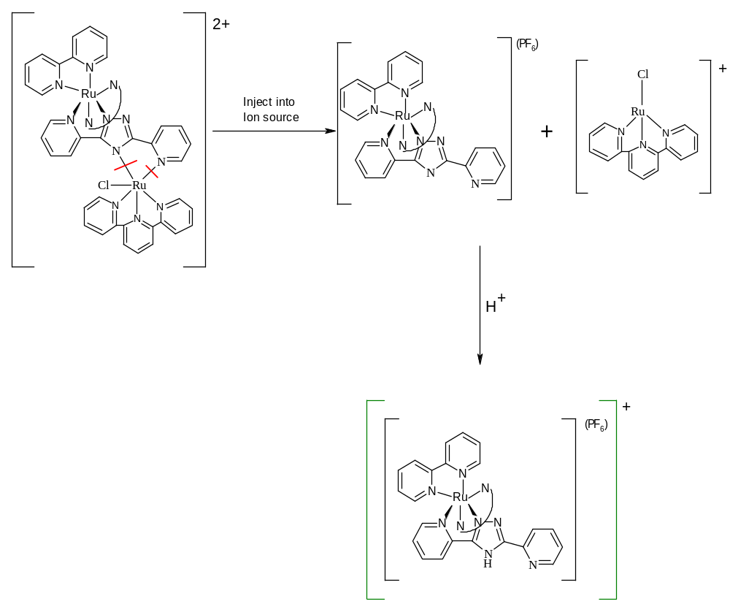Figure 3.7: Schematic representation of the fragmentation of the dinuclear complex [Ru(bpy)₂(bpt)Ru(tpy)Cl]²⁺

In the case of the complex [Ru(bpy)₂(bpt)Ru(tpy)Cl]²⁺ the molecular ion peak occurs at 502.5 m/z which is expected as the molecular weight of the dicationic complex is 1004.5. However, from figure 3.8 we observe the peaks representing the in-source fragmentation of the dinuclear complex also.

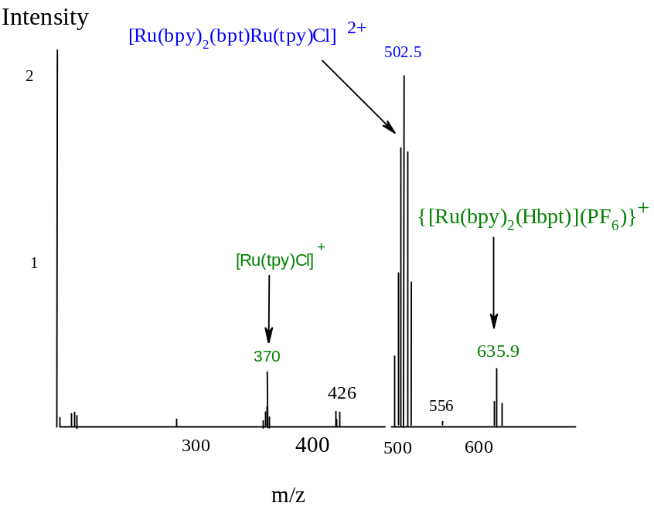
Figure 3.8: Mass Spec of [Ru(bpy)₂(bpt)Ru(tpy)Cl]²⁺ in MeOH.

The mass spectra of the remaining three dinuclear complexes are shown in figure 3.9. The spectrum of the OsRu heterodinuclear complex is dominated by 2 peaks, one at 370 m/z and the other at 725.9 m/z. A base peak at approx; 548 m/z was expected for the complex which would have represented the molecular ion peak for the doubly charged metal complex, similar to that observed for [Ru(bpy)₂(bpt)Ru(tpy)Cl]²⁺. This is observed but at very low intensity relative to the base peaks of the fragments. The two peaks representing the mass of the 2 mononuclear fragments are observed. The mass of {[Os(bpy)₂(Hbpt)](PF₆)}⁺ is 725 m/z with the mass of [Ru(tpy)Cl]⁺ being 370 m/z. As stated above, this indicates that the complex fragments directly upon injection into the mass spectrometer. This spectrum is not believed to suggest that it is only the precursor complexes present. While the mass of 725 m/z is that of the {[Os(bpy)₂(Hbpt)](PF₆)}⁺ starting material having been protonated, the mass of 370 m/z is not that of the second starting material, [Ru(tpy)Cl₃]. The m/z value for this precursor complex would be 441 m/z. Instead we observe the mass of a fragment formed upon fragmentation of the dinuclear complex.

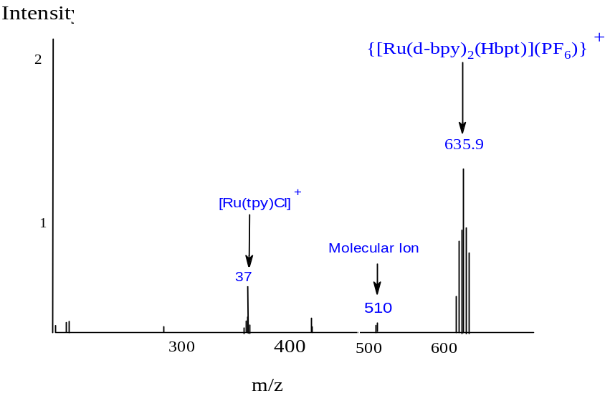
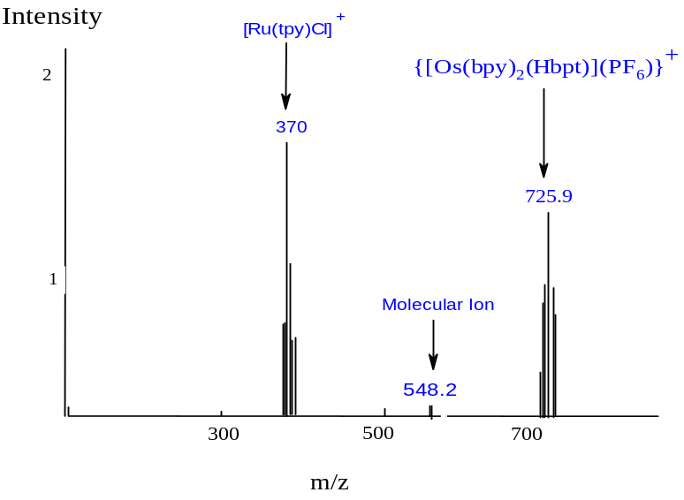
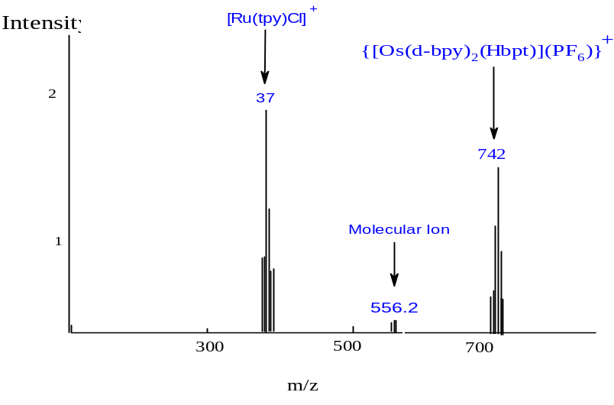
Figure 3.9: Mass Spec of [Ru(d₈-bpy)₂(bpt)Ru(tpy)Cl]²⁺ (top), [Os(bpy)₂(bpt) Ru(tpy)Cl]²⁺ (middle) and [Os(d₈-bpy)₂(bpt) Ru(tpy)Cl]²⁺ (bottom) in MeOH.
A similar situation is observed for both the deuteriated and non-deuteriated dinuclear complexes. In the case of [Ru(d₈-bpy)₂(bpt)Ru(tpy)Cl]²⁺, we observe the {[Ru(d₈-bpy)₂(Hbpt)](PF₆)}⁺ fragment at 652.3 mz/, while [Ru(tpy)Cl]⁺ is at 370 m/z. For [Os(d₈-bpy)₂(bpt)Ru(tpy)Cl]²⁺ obtain two strong peaks at m/z = 742 for {[Os(d₈-bpy)₂(Hbpt)](PF₆)}⁺ and m/z = 370 for [Ru(tpy)Cl]⁺.

There is a secondary method for the determination of the charge state of the complex and thus the mass of the complex of interest. Greater resolution of a molecular ion peak will show an isotope pattern. A singly charged ion will show isotopic peaks that differ by 1 mass unit, a doubly charged ion will show peaks that differ by 0.5 mass units and so on. An example of such as isotope is shown in figure 3.10, with the isotopic pattern for the complex [Ru(bpy)₂(bpt)Ru(tpy)Cl]²⁺.

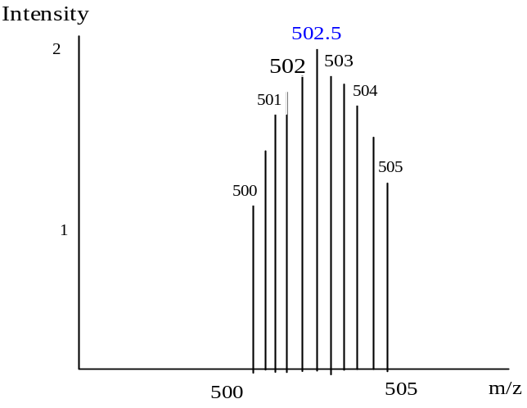

Figure 3.10: isotope pattern observed for the complex [Ru(bpy)₂(bpt)Ru(tpy)Cl]²⁺.

3.3.3 ¹H-NMR

NMR spectroscopy is an invaluable tool not only in the identification of compounds but also in the monitoring of reactions and the determination of purity. It is used extensively in this report and where practical, full assignment of ¹H-NMR spectra have been made using a combination of 1-dimensional and 2-dimensional studies.

¹H-NMR spectroscopy provided very useful information for the elucidation of the structures of the Ru(II) and Os(II) complexes synthesized. The interpretation of the ¹H-NMR of the dinuclear complexes did at times become difficult due to the large number of protons present in the aromatic region. Therefore it was necessary to investigate the ¹H-NMR of the mononuclear complexes first in order to assign the ¹H-NMR of the dinuclear complexes correctly.

In order to further simplify the ¹H spectra the deuteriated analogues of the complexes where synthesized and used as a tool to confirm peak assignment and the structures of complexes. For the asymmetric mononuclear complexes, up to sixteen non-equivalent protons may arise from the bipyridyl moieties and in dinuclear complexes sixteen, making complete unambiguous structural assignment extremely difficult. Deuteriation of bipyridyl ligand led to the removal of a number of protons and ultimately the broad signals representing these protons from the NMR spectra. As a result it only remained to assign the protons of 3,5-bis(pyridin-2-yl)1,2,4-triazole (Hbpt) ligand in the case of the mononuclear complexes and the protons of the 2,2’,6’,2”-terpyridine (tpy) and bpt⁻ ligands in the case of the dinuclear complexes.

3.3.3.1 ¹H-NMR of the Mononuclear Complex
Figure 3.11 shows the numbering of the N2 isomer of the mononuclear ruthenium (II) complex with its spectrum shown directly below in figure 3.12, along with its deuteriated analogue. The chemical shifts of the bpt – ligand are outlined in table 3.4. For simplicity to distinguish between the protons of pyridine ring 1 and pyridine ring 2 of the bpt⁻ ligand these protons will have the ring to which they are bound in brackets. For example H6(1) is H6 of pyridine ring 1. The bpy protons are number H3a – H6a. These protons occur in the expected range and will not be discussed here.
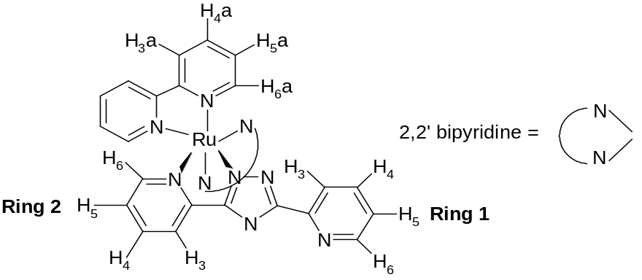

Figure 3.11: Labeling of the ruthenium mononuclear complex protons for ¹H-NMR assignment.
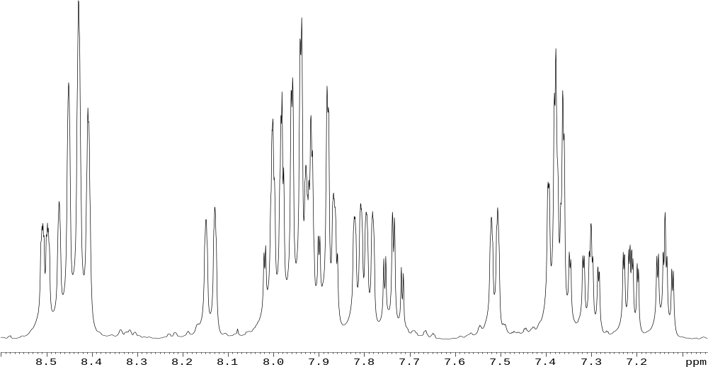
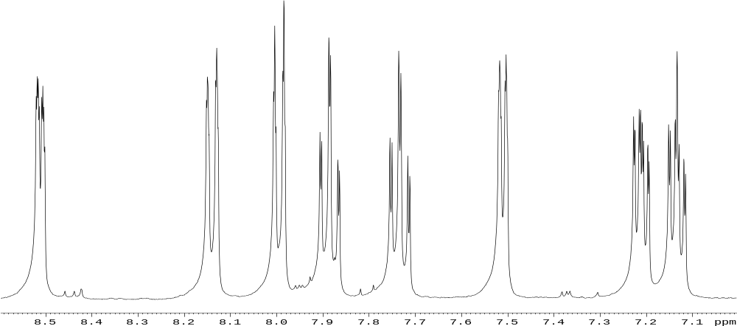
No bpy
¹H

Figure 3.12: ¹H NMR spectra of [Ru(bpy)₂(bpt)]⁺ (top) and [Ru(d₈-bpy)₂(bpt)]⁺ (bottom) in d₆-acetonitrile

Ring 1(Free) H3 H4 H5 H6
[Ru(bpy)₂(bpt)]⁺ 8.01 7.75 7.14 8.53
Free Ligand (-0.07) (-0.13) (-0.34) (-1.18)

[Os(bpy)₂(bpt)]⁺ 7.95 7.65 7.05 8.55
Free Ligand (-0.2) (-0.12) (-0.37) (-0.12)

Ring 2(Metal) H3 H4 H5 H6
[Ru(bpy)₂(bpt)]⁺ 8.14 7.89 7.23 7.52
Free Ligand (+0.32) (-0.24) (-0.25) (-0.17)

[Os(bpy)₂(bpt)]⁺ 8.18 7.88 7.15 7.40
Free Ligand (+0.03) (-0.35) (-0.47) (-1.31)

H3a H4a H5a H6a
Bpy ¹H of complex 8.43-8.49 7.92-8.13 7.37-7.42 7.96-8.1

Table 3.4: Chemical shifts in ppm of the bpt – protons of the non-deuteriated [Ru(bpy)₂(bpt)]⁺ and [Os(bpy)₂(bpt)]⁺ as measured in d₆-acetonitrile from figure 3.12. The other shifts present in the table represent the free Hbpt ligand¹³

In this section we concentrate on the bpt⁻ protons of the mononuclear complexes. As expected, due to the nature of coordination, there is a clear difference between the protons of the two pyridine rings of the bpt⁻ ligand, as shown in figures 3.11 and 3.12. The H6 proton of the metal bound pyridine (ring 2) experiences the ring current of an adjacent bpy and is strongly shifted upfield as a result. The proton H6(1) is present at around 8.53 ppm while H6(2) is observed at 7.53 ppm. This large difference between ring 1 and ring 2 for the H6 resonances demonstrates that the H6 proton present at 7.53 ppm must be assigned to the metal-bound pyridine as it is shifted over 1ppm upfield. This is due to through space interactions occurring between H6 and the bpy ring. In addition protons in close proximity to such large atoms, such as a metal ion, are greatly shielded from the induced magnetic field of the NMR and therefore require a greater applied magnetic field strength for resonance. The H6 proton of the free pyridine is shifted only 0.15 ppm upfield. In general there is a slight shift upfield for all the protons of the 2-pyridine rings of the bpt –.¹

When comparing these resonances with those reported by Hage¹³ a general upfield shift of 0.10 ppm is observed. This is due the use of different deuteriated solvents for analysis of the spectra. The chemical sifts detailed above were obtained from a sample in deuteriated acetonitrile, while those reported by Hage were carried out in deuteriated acetone.

Using 2-D COSY and the analogous deuteriated complex as shown in figure 3.12, it became possible to assign the chemical shifts for the remaining bpt⁻ protons, H3, H4 and H5, of the 2 pyridines rings. As can be seen from the comparison between the deuteriated and non-deuteriated mononuclear complexes the deuteriated species has resulted in the simplification of the ¹H-NMR spectrum and, therefore, assisted in the confirmation of the chemical shifts for the bpt⁻ protons, which are documented above in table 3.4. A general upfield shift in the resonances between the free Hbpt ligand and the coordinated bpt⁻ ligand are observed and is thought to be due to a combination of through space interactions between the two ligand species, bpt⁻ and bpy, and the general shielding effects of the metal ion.

Table 3.4 shows that there is little difference in the chemical shifts between the free pyridine rings of the ruthenium (II) and the osmium (II) complexes. In going to the metal bound pyridine ring a general shift upfield of the resonances is observed in the osmium (II) complex compared with the ruthenium (II) complex. This may be due to the larger shielding effect of the osmium complex due to its larger number of occupied orbital on it outer shell.^{6, 23}

3.3.3.2 ¹H-NMR of the Dinuclear Complex
The chemicals shifts of the ligands (tpy) and bpt⁻ in the dinuclear complexes are outlined in Table 3.5. The numbering of the ruthenium (II) complex is shown in figure 3. 13.
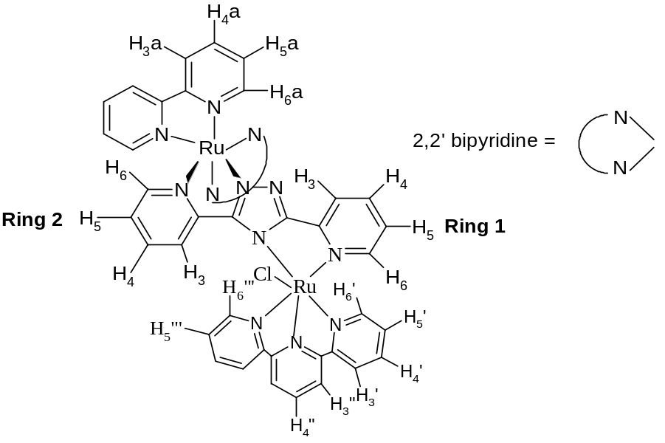
Figure 3.13: Numbering of the ruthenium dinuclear complex protons for ¹H-NMR.

It must first be outlined that there are two possible structural isomers of the dinuclear complexes to be discussed in this section. The observation of isomers being present first became clear upon deuteriation of the dinuclear complexes, as shown in figure 3.17, were previously “hidden” resonances were now observed. As can be observed from this spectrum two additional doublets are present with the removal of the broad bpy resonances. The two possible isomers are illustrated in figure 3.14. It should also be noted that we observe only one of the isomers in the ¹H-NMR spectrum and the reason for this will be discussed in detailed later in this section.
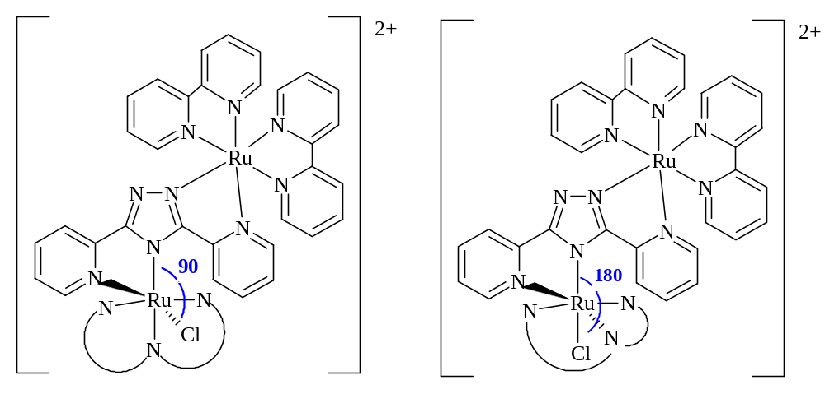
A B
Figure 3.14: Structural isomers of the ruthenium dinuclear complex.
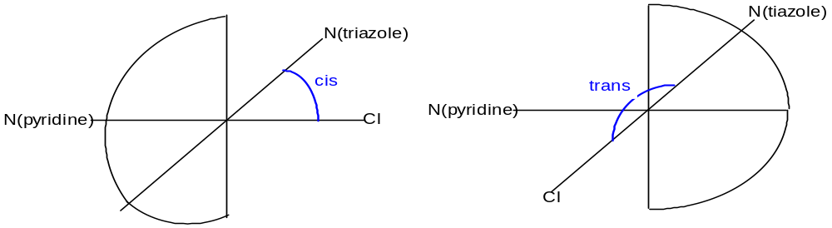
Figure 3.15: Representation of the possible coordination isomers present in the dinuclear complex.

These structural isomers arise from the uncertainty surrounding the coordination position of the chloride ion. As shown in figures 3.14 and 3.15 the chloride ion and the triazole ring of the bpt⁻ ligand can occupy two different coordination geometries. In case A the chloride ion and the triazole are at a 90⁰ angle to one another (cis), while in case B the chloride ion and the triazole are at an 180⁰ angle to one another (trans). From the ¹H-NMR spectra, shown in figures 3.16 and 3.17 we observe the integration of 35 protons, suggesting only one isomer is present. This indicates either isomer A or B is formed preferentially over the other.

A conclusive method for determining which isomer is formed preferentially is by calculating the coupling constants (J value) of the protons of interest. These spin-spin couplings occur because magnetic moments of nuclei interact with each other through the strongly magnetic electrons in the intervening bonds. The protons of interest are H6(1) and H3(2) as they are the protons which are most notably affected by the presence of the chloride ion. From figure 3.14 we observe that if the chloride ion is cis to the triazole ring of the bpt⁻ bridge it is H3(2) that is adjacent to it, while H6(1) is adjacent to the bpy system. However, if the chloride ion is trans to the triazole ring of the bpt⁻ bridge we observe the opposite case. The proton adjacent to the chloride ion is shifted downfield to approx: 10 ppm while the proton adjacent to a pyridine ring of the bpt⁻ system is shifted upfield to approx: 7.0 ppm due to the through space interaction.

Therefore by determining the J value for the proton at 10 ppm we can establish whether it represents H6 of ring 1 or H3 of ring 2. In a typical pyridine ring we observe H6 protons between at 5 - 6 Hz while H3 protons are observed between 7 - 9 Hz.Error: Reference source not found In the case of the RuRu dinuclear complex the signal at 10.02 ppm has a J value of 5.6 Hz indicating that it represents the H6 of ring 1 while the J value of the chemical shift at 7.37 ppm is 8 Hz confirming that it is H3 of ring 2. The same situation is observed in the heterodinuclear complex OsRu. This method confirms that we indeed observe isomer B where the chloride ion is 180⁰ from the triazole ring of the bpt⁻ ligand and the proton in close proximity to the chloride ion is H6 of pyridine ring 1.
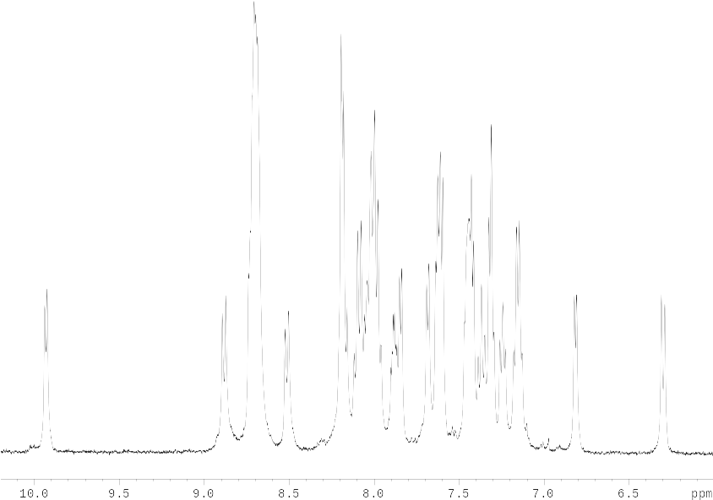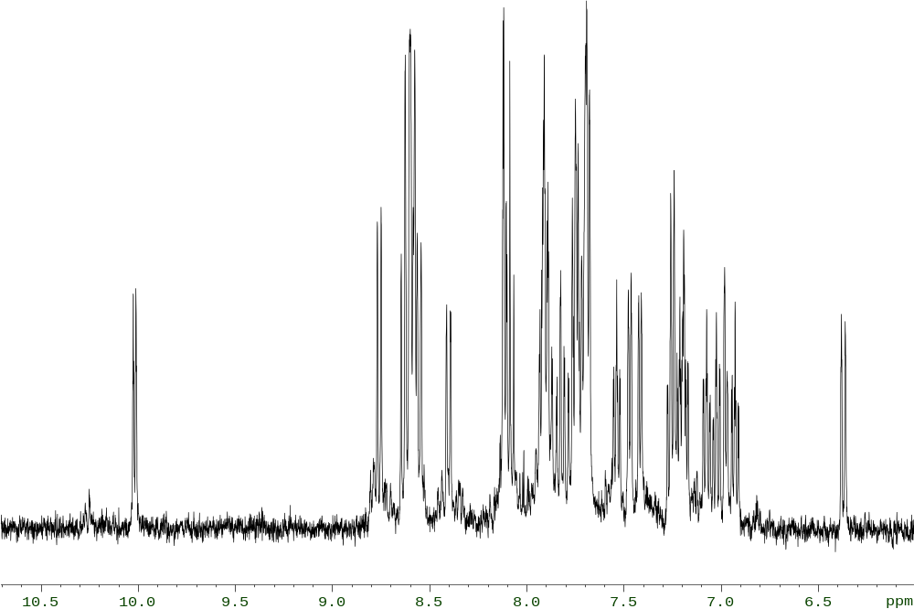
Figure 3.16: ¹H NMR spectra of [Ru(bpy)₂(bpt)Ru(tpy)Cl]²⁺ (top) in d₃-CD₃CN and[Os(bpy)₂(bpt)Ru(tpy)Cl]²⁺(bottom) in d₆-acetone
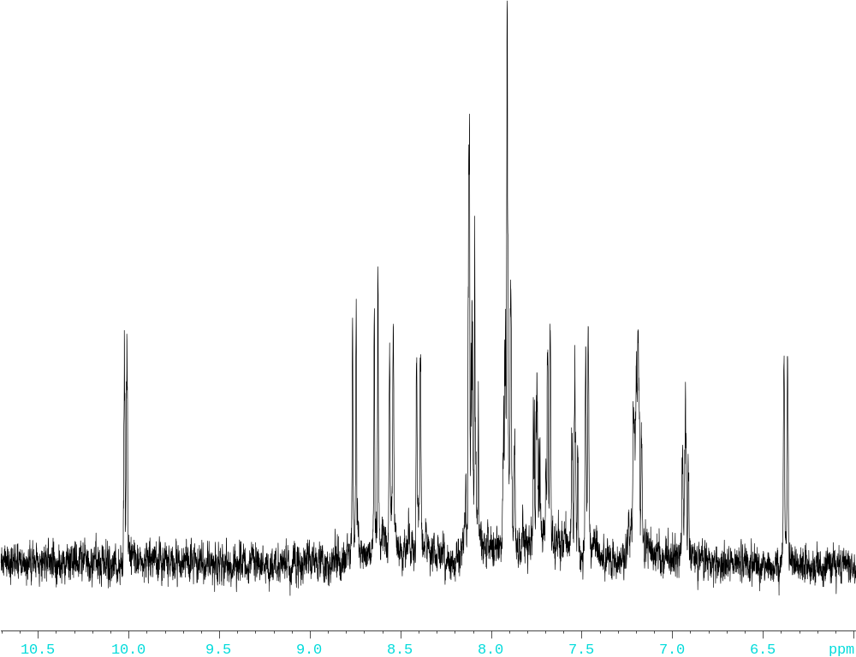

Figure 3.17 : ¹H-NMR spectra of [Os(bpy)₂(bpt)Ru(tpy)Cl]²⁺ (top) and [Os(d₈-bpy)₂(bpt)Ru(tpy)Cl]²⁺ (bottom) as measured in CD₃CN.
Ring 1 (bpt) H3 H4 H5 H6
RuRu 6.98 7.70 7.28 10.02
OsRu 6.80 7.50 7.30 10.05

Ring 2 (bpt) H3 H4 H5 H6
RuRu 6.37 7.88 7.15 7.37
OsRu 6.30 7.25 6.95 7.30

H3a H4a H5a H6a
bpy 8.5-8.7 8.0-8.2 7.1-7.3 8.05-8.3

Tpy H3’ H4’ H5’ H6’ H3” H4” H5”’ H6”’
RuRu 8.21 7.70 8.49 8.58 8.50 8.00 7.45 7.65
OsRu 8.20 7.88 8.55 8.54 8.30 8.05 7.35 7.65

Table 3.5: Chemical shifts in ppm of (bpy), (bpt) ⁻ and (tpy) protons of the dinuclear complexes as measured in CD₃CN.

As with the mononuclear complexes in both dinuclear metal complexes, [Ru(bpy)₂(bpt)Ru(tpy)Cl]²⁺ (RuRu) and [Os(bpy)₂(bpt)Ru(tpy)Cl]²⁺ (OsRu), the resonances of the bpy ligand are present in the range expected and will not be further discussed in this section. Once again the protons bound the different pyridine rings of the bpt⁻ ligand will be denoted with which pyridine ring it is in brackets, eg: H6(1) is H6 of pyridine ring 1.

The protons of the bpt – and the tpy ligands are more notably affected by the formation of the novel dinuclear complexes. The ¹H-NMR spectra of the dinuclear complexes are complicated, with overlap of certain ligand resonance’s being observed, as shown above in figure 3.16. Subsequently deuteriation plays a key role in determining the chemical shifts of the protons. As can be observed from figure 3.17 the removal of the complex signals representing the sixteen bpy protons allowed for easier assignment of the nineteen remaining protons of the (tpy) and bpt⁻ ligands within the aromatic region. In both dinuclear complexes the noticeable difference between the deuteriated and non-deuteriated spectra is the appearance of two extra doublets at approx: 8.55 ppm that was previously overshadowed by the (bpy) resonances in figure 3.17. The appearance of these doublets clarifies the unsymmetrical nature of the (tpy) ligand in the dinuclear complex and highlighted the possibility of structural isomer formation.

As both pyridine rings of the bpt – ligand are now metal bound the chemical shifts of most protons on these 2 pyridine rings are expected to be relatively similar. Despite this a COSY spectrum was instrumental in assigning the correct chemical shifts of some of the protons of the bpt – ligand, as they show a dramatic shift in resonance with respect to their mononuclear complexes. The most notable shift is observed in the H6(1). This was previously present at around 8.53 ppm for [Ru(bpy)₂(bpt)]⁺ and at 8.55 ppm for [Os(bpy)₂(bpt)]⁺, but has been dramatically shifted downfield to 10.02 ppm for [Ru(bpy)₂(bpt)Ru(tpy)Cl]²⁺ and 10.05 ppm for [Os(bpy)₂(bpt)Ru(tpy)Cl]²⁺. This is due to the presence of an adjacent chloride ion whose electronegative nature results in a downfield shift of the adjacent proton.

The H3(1) proton in both dinuclear complexes also experiences an upfield shift of approx 1.0 – 1.2 ppm. In going from [Ru(bpy)₂(bpt)]⁺ to [Ru(bpy)₂(bpt)Ru(tpy)Cl]²⁺ H3(1) is shifted from 8.15 ppm to 6.98 ppm and H3(2) is shifted from 8.18 ppm to 6.37 ppm. In the case of the OsOs complex the chemical shift is also considerable but the effect is smaller than that observed with the RuRu complex. The H3(1) proton is shifted from 7.95 ppm to 6.80 ppm in going from [Os(bpy)₂(bpt)]⁺ to [Os(bpy)₂(bpt)Ru(tpy)Cl]²⁺, and the H3(2) is shifted from 8.18 ppm to 6.30 ppm. This may be attributed to the H3 proton of ring 1 being in very close proximity to a pyridine of the bpt–, while the H3 proton in ring 2 is now adjacent to one of the pyridines of the tpy ligand. As a result both protons feel the ligand ring current in a diamagnetic anisotropic effect.

Despite having been unable to obtain a ¹H-NMR for [Ru(tpy)Cl₃] due to its paramagnetic property, it is still possible to compare the chemical shifts for (tpy) present in the dinuclear complexes with those observed in the free ligand. However due to the presence of a chloride atom in the dinuclear complex the protons of the (tpy) ligand are no longer symmetrical, as observed in figure 3.14. As we have now determine the position of the chloride ion to be at 180⁰ angle to the triazole system of the bpt⁻ ligand it is H6’ and H5’ of (tpy) which are now adjacent to a chloride ion while on the H6”’ and H5”’ are now adjacent to ring 2 of the bpt⁻ ligand. In the free (tpy) ligand the symmetrical H5 and H6 protons were observed between 7.2 – 7.4 ppm. Now however H6’” and H5’” are observed at approx: 8.5 ppm and 8.6 ppm respectively while H5’ and H6’ remain relatively unchanged.

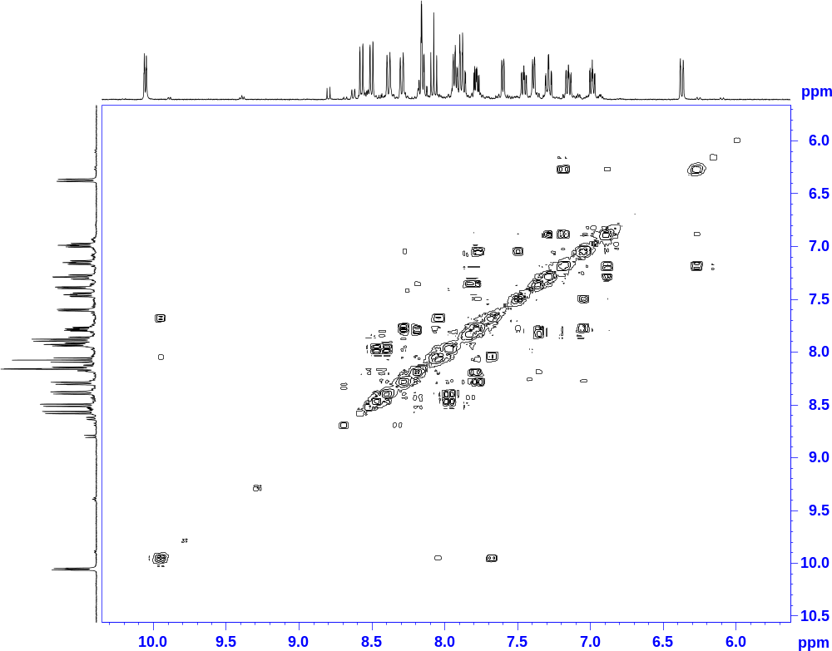
Figure 3.18: 2D COSY spectrum of the metal complex [Ru(d₈-bpy)₂(bpt)Os(tpy)Cl]²⁺

Apart from deuteriation the 2-dimensional COSY spectra also proved invaluable information (figure 3.18). The proton-proton correlation of the [Ru(d₈-bpy)₂(bpt)Os(tpy)Cl]²⁺ complex shown above allows for the assignment of neighbouring protons without the hindrance of large bipyridine signals overshadowing other resonances. By connecting signals through the diagonal intercept an overall picture of the ¹H-NMR of the metal complex is obtained. By combining all the data from the 1-dimensional and 2-dimensional NMR techniques a complete assignment of the protons within each complex was achieved.

3.3.4 UV-Vis Absorption and Emission Spectroscopy of Novel Metal Complexes and Model Compounds

The photophysics and spectroscopy of the ruthenium (II) polypyridyl dinuclear complexes have been studied. These studies provide information of the intramolecular interaction between the ligands and the metal centre present.

Complex | Absorption  λ_{max} /nm  (ε 10⁴M⁻¹cm⁻¹) | Emission  λ_{max} (nm) | τ / ns  (aerated)
[Ru(bpy)₂(bpt)]⁺ | 480 (1.13) | 686 | 160
[Os(bpy)₂(bpt)]⁺ | 495 (1.06), 610 (1.08) | 801 | 55
[Ru(bpy)₂(bpt)Ru(tpy)Cl]²⁺ | 431 (0.95), 463 (1.55) | 636 | 58
[Os(bpy)₂(bpt)Ru(tpy)Cl]²⁺ | 490 (0.69), 620 (0.40) | 776 | 13
[Ru(d₈-bpy)₂(bpt)Ru(tpy)Cl]²⁺ | 431 (1.77), 463 (1.27) | 636 | 60
[Os(d₈-bpy)₂(bpt)Ru(tpy)Cl]²⁺ | 490 (0.91), 620 (0.31) | 776 | 15
Model Compounds

[Ru(bpy)₃]²⁺ | 450 (1.3) | 615 | 800
[Os(bpy)₃]²⁺ | 468 (1.11) | 732 | 62
[Ru(tpy)₂]³⁺ | 475 (1.77) | 620 | 0.25
[Os(tpy)₂]³⁺ | 477 (13.75), 657 (0.36) | 718 | 269
[Ru(tpy)(bpy)Cl]⁺ | 506 (0.78)Error: Reference source not found | 729 | -
[Ru(bpy)₂(bpt)Ru(bpy)₂]³⁺ | 453 (2.26)¹³ | 648 | 100
[Os(bpy)₂(bpt)Os(bpy)₂]³⁺ | 442 (1.72), 460 (1.82), 475 (1.82), 600 (0.44)Error: Reference source not found | 762 | 33
[Ru(bpy)₂(bpt)Os(bpy)₂]³⁺ | 459 (2.38), 600 (-)Error: Reference source not found | 756 | 30
[Os(bpy)₂(bpt)Ru(bpy)₂]³⁺ | 453 (2.37), 580 (-),  670 (-)Error: Reference source not found | 762 | 25

Table 3.6: Photophysical properties of all ruthenium / osmium dinuclear complexes synthesized, along with specific model compounds, carried out in spectroscopic grade ACN.13, Error: Reference source not found
Table 3.6 above details some photophysical data of the mononuclear and dinuclear complexes, as well as some model compounds. The absorption spectra of the mononuclear and dinuclear ruthenium (II) and osmium (II) compounds to be discussed are presented in figures 3.19 and 3.20.
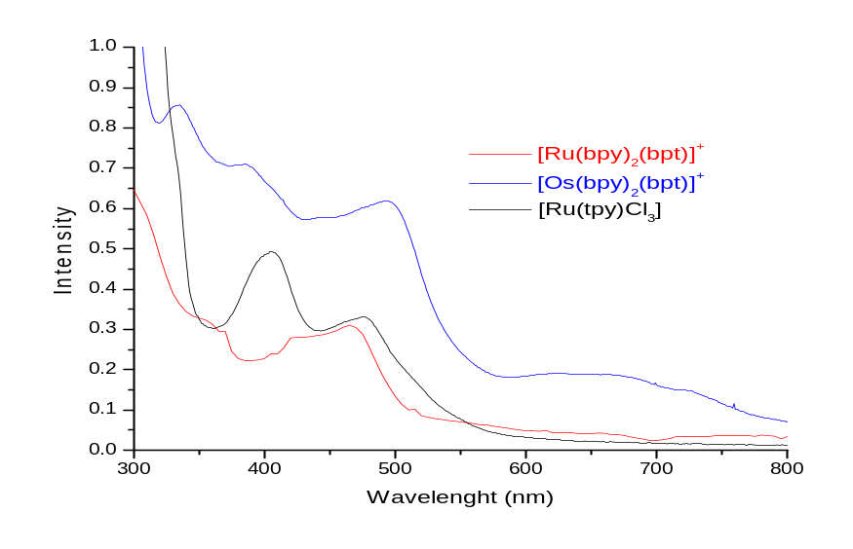
Figure 3.19: Electronic of the mononuclear Ru(II) and Os(II) complexes in CH₃CN.

The UV-vis absorption spectra of the 3 mononuclear complexes as shown in figure 3.19 are dominated by intense absorption bands in the visible region at 480 nm and 475 nm for the ruthenium complexes and 495 nm for the osmium, which are due to dπ-π* metal-ligand-charge-transfer (¹MLCT) transitions. The osmium complex also has another absorption band at 610 nm which is assigned as a formally forbidden triplet dπ-π* bpy ³MLCT transitions. The increase in spin-orbit coupling results in a greater mixing of the singlet and triplet states and a breakdown in the selection rules prohibiting changes in multiplicity. The absorption maxima observed are in keeping with those previously reported. ^{2, 13}

The wavelength at which the ¹MLCT transition occurs can be an indicator as to the electronic properties of the coordinated ligands. π-acceptor ligands will cause a blue shift of the absorption transitions due to the stabilization of the metal dπ orbitals, while the presence of σ-donating ligands, such as 1,2,4-triazoles, results in the ruthenium centre being more electron rich and this causes the ¹MLCT band to be shifted to the red (i.e. to lower energy).¹³
For the ruthenium mononuclear complex there is a red-shift in energy of the ¹MLCT in comparison with the parent [Ru(bpy)₃]²⁺. This shift of approx: 25-30 nm indicates the ligands present are better σ-donors compared with bipyridine.¹ Ligands with σ-donor properties results in a reduction in the t_{2g}-π* energy gap due to increased electron density placed on the metal centre. Consequently the MLCT transition will occur at lower energy. A similar situation is representative of the osmium mononuclear complex in comparison with [Os(bpy)₃]²⁺. The ¹MLCT transition of this complex has shifted to lower energy by approx: 25 nm.

A shift to lower energy is observed in the ¹MLCT absorption when replacing a Ru-containing unit with an Os-unit. This may be attributed to the higher energy of the 5d orbitals of Os compared with the 4d orbitals of Ru. For the osmium mononuclear complex there is also an additional band at 610-650 nm, which may be assigned to formally forbidden dπ-π* bpy MLCT transitions (figure 3.19)

The absorption spectra of the dinuclear complexes are shown in figure 3.20.
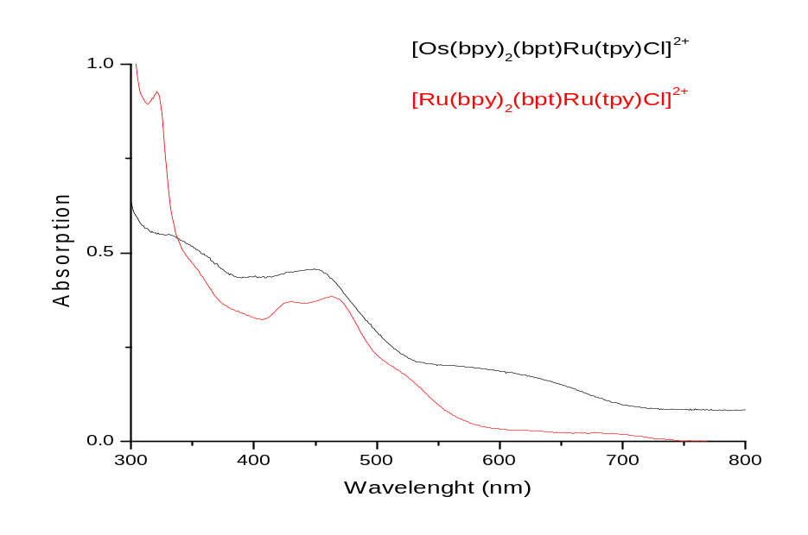
Figure 3.20: Electronic properties of [Ru(bpy)₂(bpt)Ru(tpy)Cl]²⁺ and [Os(bpy)₂(bpt)Ru(tpy)Cl]²⁺ as measured in CH₃CN.

In the case of both dinuclear complexes there is shift of the absorption bands to higher energy in comparison with their mononuclear analogues, from 480 nm – 463 nm in the case of [Ru(bpy)₂(bpt)Ru(tpy)Cl]²⁺ and 495 nm - 490 nm in the case of [Os(bpy)₂(bpt)Ru(tpy)Cl]²⁺ (see table 3.6). Upon coordination of the second metal ion to form the dinuclear complex, the σ-donor properties of the bridging bpt⁻ ligand were reduced, therefore increasing its π-acceptor abilities. This results in a stabilization of the metal orbitals causing the ¹MLCT to shift to higher energy were the absorption band is observed. As can bee seen in table 3.7 this observation is in keeping with those reported previously for the model compounds listed.Error: Reference source not found, Error: Reference source not found

The emission spectra of the mononuclear and dinuclear ruthenium (II) and osmium (II) compounds were also measured and are represented in figures 3.21 and 3.22 respectively.
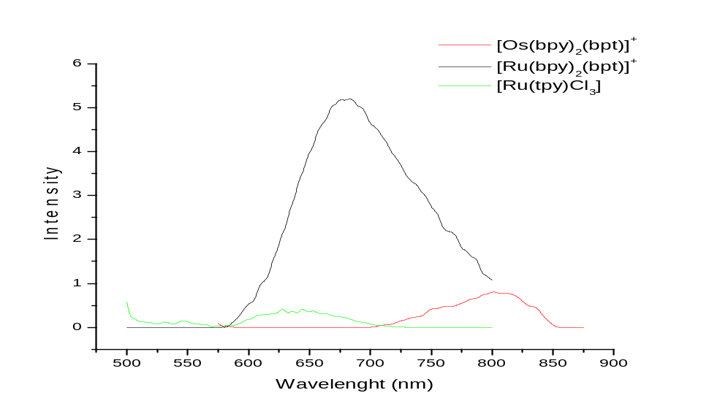
Figure 3.21: Emission of mononuclear complexes at 298K in acetonitrile.

The 2 mononuclear precursors exhibit luminescence at room temperature which originates from the ³MLCT. The luminescence properties of the complexes are given in table 3.6. Similar to the trend observed for the absorption sepectra, here we observe a shift to lower energy of the emission spectra for both dinuclear complexes when compared with the parent complex [Ru(bpy)₃]²⁺. This shift is in the range of 5 – 50 nm and occurs due to the increased σ-donor properties of the ligands present in the mononuclear complexes. As discussed above these properties result in electron density being donated onto the metal, and a reduction in the t_{2g}-π* energy gap. Consequently this ¹MLCT transition requires less energy.

As expected, the emission maximum of the osmium mononuclear complex occurs at lower energy than for the analogous ruthenium complex. This is a result of the smaller energy difference between the metal t_{2g} and bpy π* orbitals in osmium, than in ruthenium.Error: Reference source not found
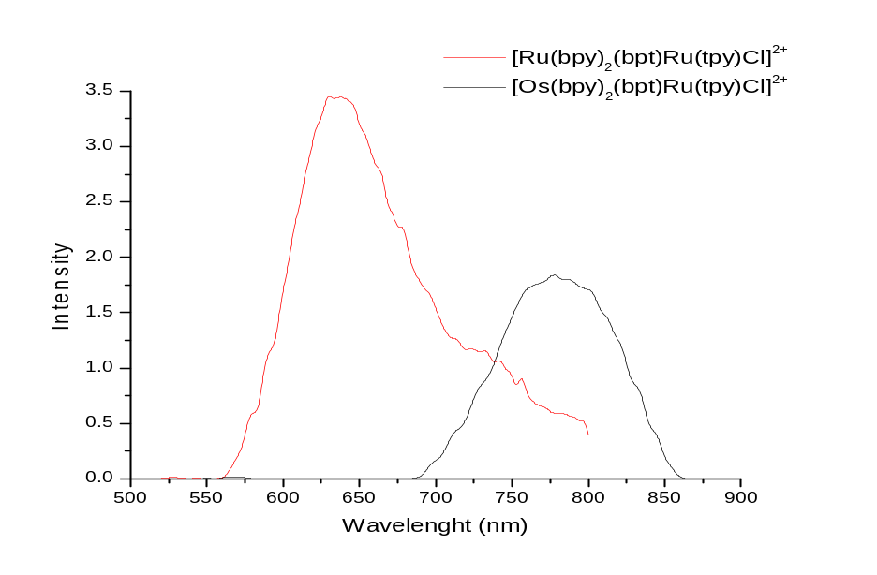
Figure 3.22: Emission properties of homonuclear [Ru(bpy)₂(bpt)Ru(tpy)Cl]²⁺ and heteronuclear [Os(bpy)₂(bpt)Ru(tpy)Cl]²⁺ as measured in MeCN.

Both dinuclear complexes exhibit room temperature emissions in acetonitrile. There is a shift of approx: 25 - 50 nm to the red in comparison to the mononuclear complexes. As noted above, this shift to higher energy can be explained by the fact that upon coordination of the second metal ion we observe a “sharing” of the σ-donor properties of the bpt⁻ bridging ligand. The bridge has become a weaker σ-donor resulting in a stabilization of the metal dπ orbitals and a reduction in the t_{2g}-³MLCT energy gap. As expected the osmium emission maxima occurs at lower energy than that of the ruthenium emission maxima as with the absorption spectra and for the same reasons.

From the emission maxima of these complexes it is possible to assign were the luminescence is based. In the [Ru(bpy)₂(bpt)Ru(tpy)Cl]²⁺ complex the emission is observed at 636 nm. This is in close proximity to [Ru(bpy)₃]²⁺ whose luminescence occurs at 615 nmError: Reference source not found, indicating that the luminescence may be [Ru(bpy)] based. This is also in keeping with the luminescence observed for the model compound [Ru(bpy)₂(bpt)Ru(bpy)₂]²⁺ shown in table 3.6. The luminescence of this model complex is 648 nm, with the luminescence being bpy based.¹³ If the emission maxima was that of the [Ru(bpy)] metal centre it is possible that the “shoulder” present in the emission spectra in figure 3.22 is that of a weak [Ru(tpy)-Cl] metal centre emission. This occurs in the region expected for a [Ru(N₅)Cl] complex, as shown in table 3.6.Error: Reference source not found This may indicate that a weak interaction is occurring between the two metal centres, with the emission being bpy based. With respect to the [Os(bpy)₂(bpt)Ru(tpy)Cl]²⁺ complex the emission wavelength is observed at approx: 775 nm. This is in close proximity to both the emission of the [Os(bpy)₃]²⁺ complex at 732 nm and the model compound [Ru(tpy)(bpy)Cl]⁺ at 729 nm which, makes assignment of this luminescence difficult. However, spectroelectrochemical results are expected to clarify this situation in section 3.3.5.

Overall in going from the mononuclear to the dinuclear complexes a shift to higher energy is observed in the absorption and emission data. This is due to the increased π-acceptor abilities of the dinuclear complex caused by the delocalization of the electron density on the bpt⁻ system over two metal centers rather than one and also the addition of a (tpy) ligand which is a known π-acceptor.

In comparing the absorption and emission data of the dinuclear complexes synthesized in this chapter with those previously synthesized by Hage^{1, 2} we observe an overall shift to lower energy of approx: 10 – 20 nm, see table 3.6. In both types of complexes there is a bridging bpt⁻ ligand present whose electron density is delocalized over two metal centers. However this difference in energy may be attributed to the presence of a chloride ion in the novel dinuclear complexes which is not present in the model complexes. This ion will donate extra electron density into the dinuclear system which will cause a reduction in the t_{2g} – π* energy gap and result in the MLCT transition occurring at lower energy.

At this stage the location of the excited state needs to be considered further. Based on earlier studies of the emission spectra it was found that the luminescence may be bpy or tpy based. This may be investigated by selective deuteriation of the ligand where the excited stated is located resulting in an increase in luminescence lifetimes being observed.
On going from the non-deuteriated to the deuteriated form of the complex we observe an increase from 58 ns- 60 ns with respect to [Ru(bpy)₂(bpt)Ru(tpy)Cl]²⁺ and from 13 ns -15 ns with respect to [Os(bpy)₂(bpt)Ru(tpy)Cl]²⁺. This accounts for an overall increase of approx: 3.5 % - 15 %, in aerated solutions. Although not a dramatic increase in luminescence lifetimes previous reports have noted that if the excited state is located on the (bpy) the lifetime will increase by approx: 10 % upon deuteriated. From the increase of 15 % in luminescence lifetime in going from the non-deuteriated to the deuteriated complex it is suggested that the excited state is possibly located on the bipyridine ligand in the complex [Os(bpy)₂(bpt)Ru(tpy)Cl]²⁺. When taken into consideration with the emission results shown above this data provides further evidence that the emission is boy based. However, these are not conclusive results and spectroelectrochemical analysis remains important in determining the location of the excited state.

For the dinuclear complex [Ru(bpy)₂(bpt)Ru(tpy)Cl]²⁺ the situation is more straight forward. Although only a short increase (3.5 %) in luminescence lifetimes is observed in going from the deuteriated to the non-deuteriated complex the excited state is not thought to be located on the (tpy) ligand. If this is the case a much shorter luminescence lifetime would be expected as the luminescence lifetimes of ruthenium (tpy) type complexes are known to be relatively short at room temperature.¹⁹ The luminescence lifetime reported, of 50 ns, is too long to be that of a (tpy) based emission at room temperature. Also as noted above examination of the emission of the dinuclear [Ru(bpy)₂(bpt)Ru(tpy)Cl]²⁺ complex shows a luminescence maximum at 636 nm which is in close proximity to the model compound [Ru(bpy)₂(bpt)Ru(bpy)₂]²⁺ and the parent complex [Ru(bpy)₃]²⁺. Both these compounds have a (bpy) based emission.¹³ This leads to the conclusion that, based on luminescence maxima and lifetimes, the emission is (bpy) based.

3.3.5 Electrochemical Properties
Cyclic voltammetry (CV) and spectroelectrochemistry were the electrochemical techniques used to characterize the two metal complexes. Many electrochemical investigations on mononuclear and polynuclear ruthenium (II) and osmium (II) complexes containing polypyridyl and triazole ligands have been previously reported and some relevant data have already been discussed in this chapter, section 3.1. From these studies it is generally accepted that oxidation processes are metal-centered while reduction processes are ligand centered. The cyclic voltammagram of the metal based oxidation processes are shown in figure 3.23 and figure 3.24.

Complex | E⁰ (V) (∆Ep)  {vs.SCE}
[Ru(bpy)₂(bpt)]⁺ | 0.85
[Os(bpy)₂(bpt)]⁺ | 0.49
[Ru(bpy)₂(bpt)Ru(tpy)Cl]²⁺ | 0.72 (0.07), 1.20 (0.08)
[Os(bpy)₂(bpt)Ru(tpy)Cl]²⁺ | 0.63 (0.08), 0.82 (0.09)
Model Compounds

[Ru(bpy)₃]²⁺ | 1.26Error: Reference source not found
[Os(bpy)₃]²⁺ | 0.83Error: Reference source not found
[Ru(tpy)₂]³⁺ | 1.30Error: Reference source not found
[Os(tpy)₂]³⁺ | 0.97Error: Reference source not found
[Ru(tpy)(bpy)Cl]⁺ | 0.81Error: Reference source not found
[Ru(bpy)₂(bpt)Ru(bpy)₂]³⁺ | 1.04, 1.34Error: Reference source not found
[Os(bpy)₂(bpt)Os(bpy)₂]³⁺ | 0.64, 0.85Error: Reference source not found
[Ru(bpy)₂(bpt)Os(bpy)₂]³⁺ | 0.73, 1.20Error: Reference source not found
[Os(bpy)₂(bpt)Ru(bpy)₂]³⁺ | 0.65, 1.30Error: Reference source not found

Table 3.7: Formal potentials for both the RuRu and OsRu dinuclear complexes at a platinum electrode in a 0.1M acetonitrile solution of TBABF₄ .Reference electrode vs. SCE
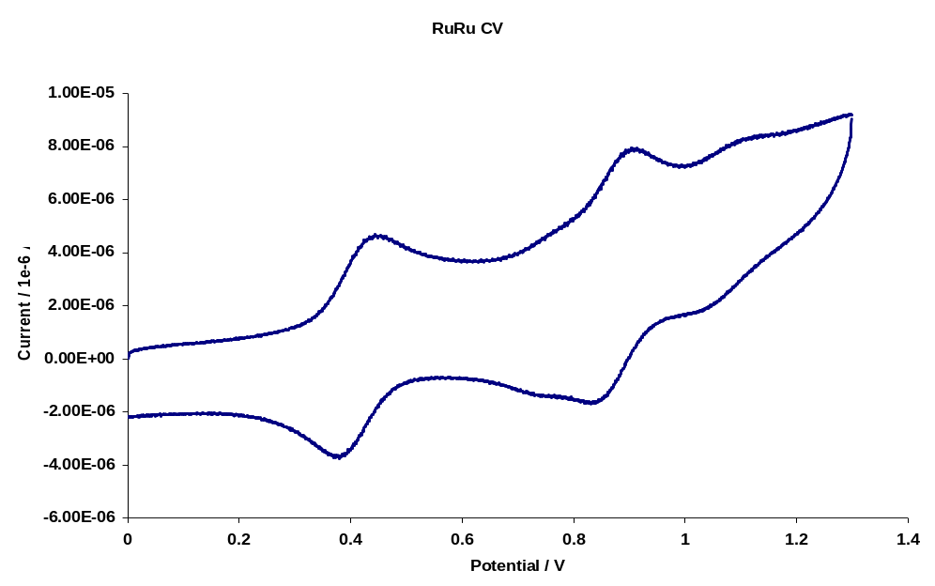

Figure 3.23: Cyclic voltammogram of the redox process of [Ru(bpy)₂(bpt)Ru(tpy)Cl]²⁺ , at a Pt-disk electrode in 0.1M TBABF₄ / acetonitrile solution at a scan rate of 0.1V/sec.Reference electrode vs. Ag/Ag⁺.

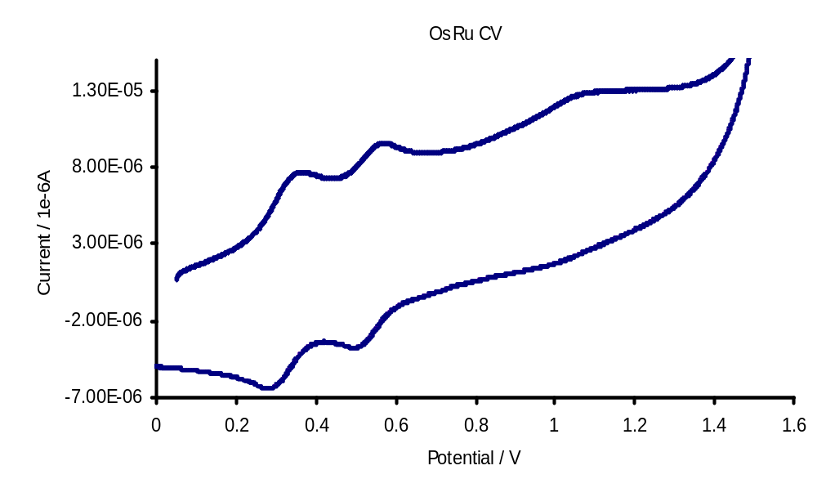

Figure 3.24: Cyclic Voltammogram of the redox process of [Os(bpy)₂(bpt)Ru(tpy)Cl]²⁺ at a Pt-disk electrode in 0.1M TBABF₄ / acetonitrile solution at a scan rate of 0.1V/sec. Reference electrode vs.Ag/Ag⁺

The waves in the anodic region of the cyclic voltammograms are assigned to metal-centered oxidation processes. Error: Reference source not found The oxidation potentials of the osmium compounds are approx. 200 mV less positive then those observed for the analogues ruthenium compounds, due to the lower binding energy of the Os (II) 5d orbitals compared with the Ru (II) 4d orbitals.

The results of the experiments on [Ru(bpy)₂(bpt)Ru(tpy)Cl]²⁺ and [Os(bpy)₂(bpt)Ru(tpy)Cl]²⁺ can be found in figure 3.23 and 3.24, along with table 3.7. The spectroelectrochemical data is shown in figures 3.25 and 3.26 / 3.27.

From the CV of the [Ru(bpy)₂(bpt)Ru(tpy)Cl]²⁺ complex in figure 3.23 a tentative assignment of the oxidations potentials was made. This was based on comparing the observed potentials with the mononuclear complexes and those reported previously for similar metal complexes. Using this data the first oxidation which occurs at 0.72 V is assigned as the [Ru(tpy)Cl] metal centre oxidation. This oxidation occurs at a much lower potentials then for the model compounds shown in table 3.8. It is expected the presence of a chloride ion on the (tpy) ligand results in a lower oxidation potential. The second oxidation potential is assigned to the [Ru(bpy)₂] metal centre and occurs at 1.20 V. This occurs in the expected range for ruthenium (bpy) type compounds. In order to confirm this interpretation we also measured the spectroelectrochemistry for the [Ru(bpy)₂(bpt)Ru(tpy)Cl]²⁺ complex, which are shown in figure 3.25.
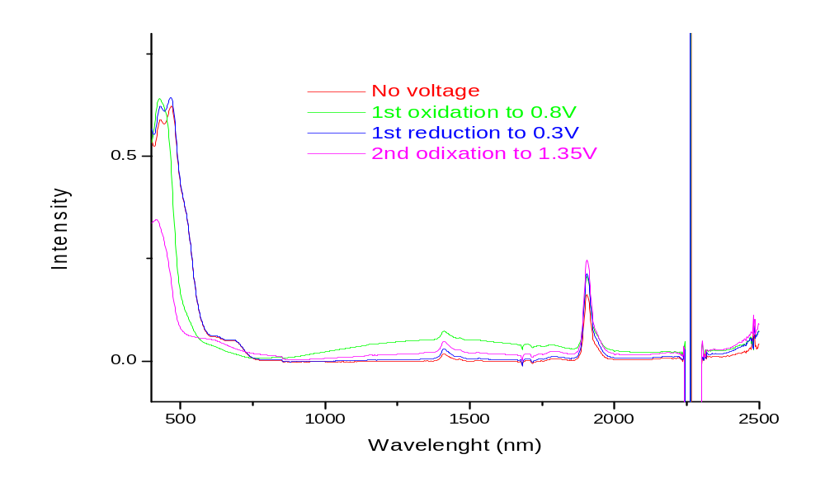
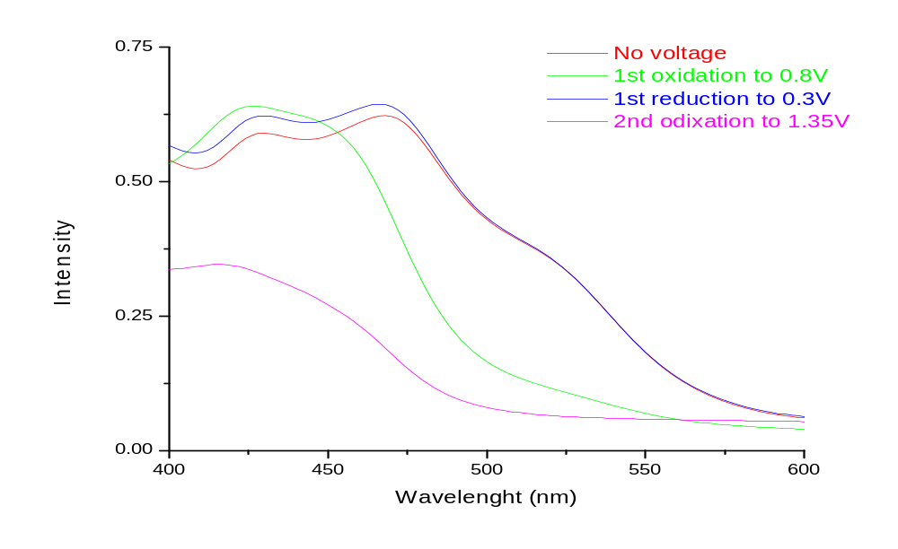
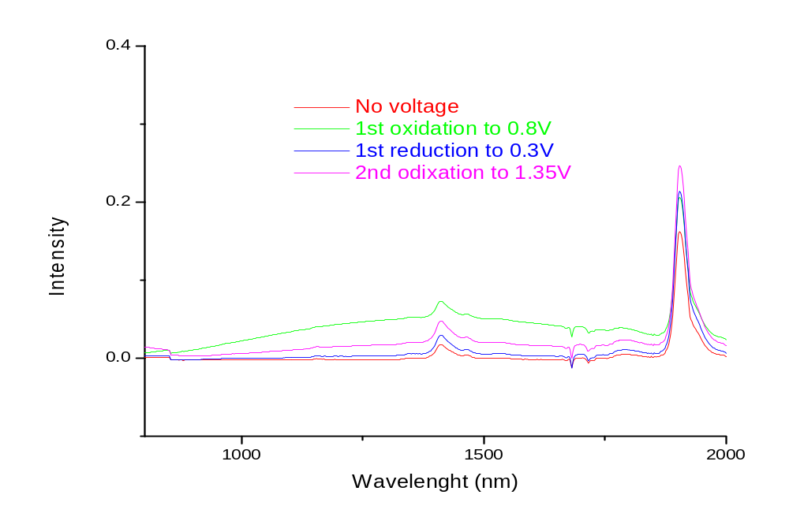
Figure 3.25: Near IR spectroelectrochemical spectrum for the dinuclear complex [Ru(bpy)₂(bpt)Ru(tpy)Cl]²⁺. Full spectrum (top) and expanded spectra (bottom)

The assignment of the oxidations potentials made above is confirmed by the measurement of the spectroelectrochemistry of the [Ru(bpy)₂(bpt)Ru(tpy)Cl]²⁺ complex. From figure 3.25 we observe upon oxidation of the first metal centre at 0.8 V, a decrease in the ¹MLCT transition at approx: 475 nm. A decrease is also observed in the “shoulder” of this ¹MLCT transition at approx: 510 nm. This “shoulder” is assigned to be that of the [Ru(N₅)Cl] metal centre as electronic spectra for a complex with a [Ru-Cl] metal centre have an indicative shoulder present at approx: 550 nm.^{32, 33} As observed from figure 3.25 as this transition decreases upon the first oxidation at 0.8 V it confirms that the [Ru(tpy)Cl] metal centre is oxidized first. The second oxidation occurs at 1.35 V and sees the complete disappearance of the ¹MLCT, as both metal centers present are now Ru(III). This second oxidation is assigned as that of the [Ru(bpy)₂] metal centre. This occurs at a lower oxidation potential then for the parent complex [Ru(bpy)₃]²⁺ but similar the ruthenium dinuclear model compound reported by Hage et al.¹³ A complete reduction of the complex is observed from figure 3.25, illustrating that the two metal oxidations are reversible.

Also in figure 3.25 another transition appearing at approx: 1400 nm is observed. This is assigned an IT transition as it is only present upon oxidation of the first metal centre to from the mixed valence Ru(II)/Ru(III) complex and is not present upon oxidation of the dinuclear complex to form the Ru(III)/Ru(III) species. If this transition is an LMCT band it would be expected to appear after oxidation of the first metal centre and continue to increase upon complete oxidation of the complex. This is not observed and leads to the conclusion that this transition is indeed an intervalence transition.

We now examine the heterodinuclear complex, [Os(bpy)₂(bpt)Ru(tpy)Cl]²⁺. From the CV in figure 3.24 we observe the oxidation potentials of this complex being in very close proximity to one another. Due to the difficulty in assigning these oxidation potentials both the UV-Vis and near IR spectroelectrochemistry analysis was carried out for this complex. Figure 3.26 shows the near UV-Vis data obtained for the complex [Os(bpy)₂(bpt)Ru(tpy)Cl]²⁺, while figure 3.27 shows the near IR results. A different approach was taken to analyze this complex compared with that discussed above for [Ru(bpy)₂(bpt)Ru(tpy)Cl]²⁺. Here we fully oxidize the complex and then gradually undergo reduction to monitor which electronic transitions reappear. From these results it is possible to determine which metal centre is oxidized second.
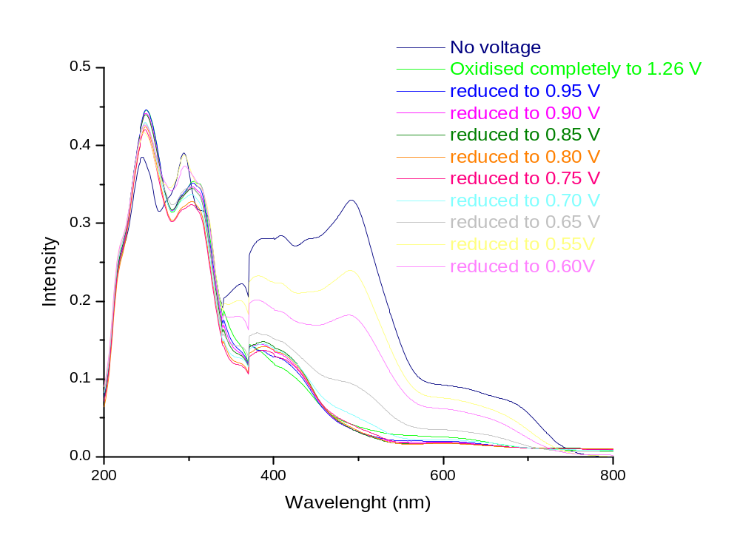
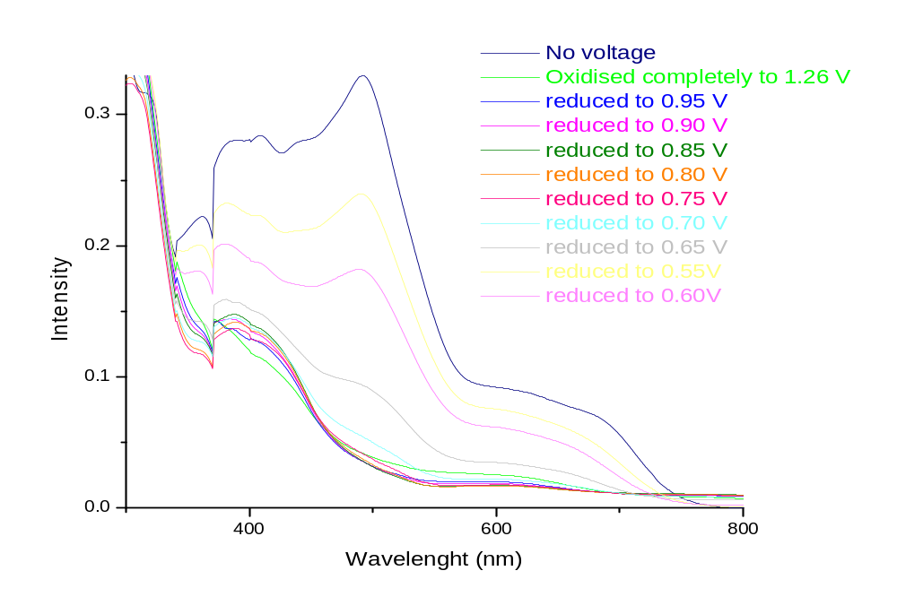
Figure 3.26: UV-vis spectroelectrochemical spectra for the complex [Os(bpy)₂(bpt)Ru(tpy)Cl]²⁺. Full spectrum (top) and expanded spectrum (bottom)

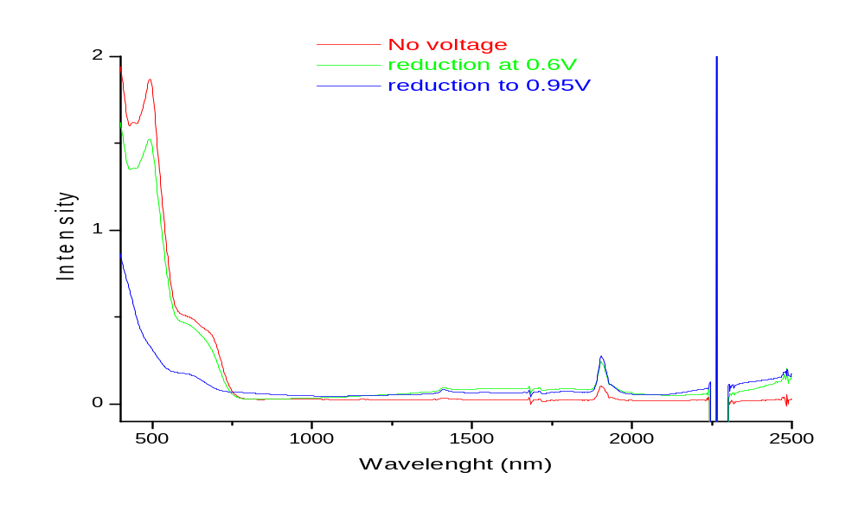
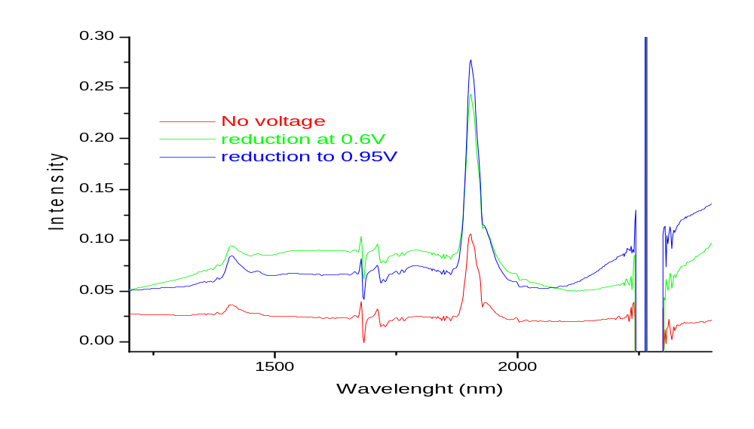
Figure 3.27: Near IR spectroelectrochemical spectra for the complex [Os(bpy)₂(bpt)Ru(tpy)Cl]²⁺. Full spectrum (top) and expanded spectrum (bottom)

However, having analyzed the spectra in figure 3.26 and 3.27, neither spectroelectrochemical method provided conclusive evidence of which metal centre was oxidized first. The results are mirrored in both sets of data whereby upon complete oxidation of the complex to 1.35 V we observe the disappearance of all MLCT transitions. These transitions include the ¹MLCT of the ruthenium and osmium metal centers at approx: 400 – 480 nm, the ¹MLCT transition of the [Ru-Cl] metal centre at approx: 500 - 520 nm, which appears as a “shoulder”, and the ³MLCT osmium transition at approx: 600 -620 nm.
With the gradual reduction of the complex an increase in the ¹MLCT transition of the ruthenium and osmium metal centers at 400-480 nm is observed. This trend continues from 0.9V to 0.6V. At 0.7V an increase is observed in the [Ru-Cl] ¹MLCT transition at approx: 500 - 520 nm. This is quickly followed by the reappearance of the osmium ³MLCT transition (600 – 620 nm) at 0.65V. These results indicate the [Ru-Cl] metal centre is oxidized second, as it is reduced first. However, due to the reappearance of the both the ¹MLCT [Ru-Cl] transition and the ³MLCT [Os(bpy)₂] transitions in quick succession to each other it is difficult to ascertain which metal centre is reduced first.

Nevertheless, based on the results obtained for the analogous ruthenium complex and comparison with various model compounds the oxidation at 0.63 V is assigned the [Os(bpy)₂] metal centre and the oxidation 0.82 V is assigned the [Ru(tpy)Cl] metal centre. The first oxidation potential occurs at 0.63 V (vs. SCE) and is initially assigned to the [Os(bpy)₂] unit which is very similar to that observed for the [Os(bpy)₂(bpt)Ru(bpy)₂]³⁺ model complex as shown in table 3.8. The second oxidation potential occurs at 0.82 V and is assigned to the [Ru(tpy)Cl] unit. As can be observed from table 3.8 this is in close proximity to the oxidation potential observed for the [Ru(N₅)Cl] model compound [Ru(tpy)(bpy)Cl]⁺.

Similar to the analogous ruthenium dinuclear complex discussed above an IT band is observed from figure 3.27 at approx: 1500 nm. For the same reasons as discussed for the previous complex, the transition for this complex is not considered to be an LMCT transition as it disappears upon complete oxidation to the Os(III)/Ru(III) complex. The presence of intervalence transitions in these complexes demonstrates a ground state interaction is occurring between the two metal centers present in the complex. To determine the type of interaction present in these complexes calculations are required. These however will be solved at a later stage and will not be included in this discussion.

3.4 Conclusion
Chapter 3 detailed the synthetic method available for the generation of symmetric / asymmetric mononuclear and dinuclear metal complexes utilising the method of “complexes as metals / complexes as ligands” strategy. Initially the dinuclear complexes [Ru(bpy)₂(bpt)Ru(tpy)Cl]²⁺ (RuRu) and [Os(bpy)₂(bpt)Ru(tpy)Cl]²⁺ (OsRu) and their deuteriated analogues where synthesized and their properties, such as absorption, emission and luminescence data obtained. With this data we observed an overall shift to lower energy of approx: 10 – 20 nm for the novel dinuclear complexes with respect to the model compounds shown in table 3.7.

In relation to the electrochemical properties of the metal complexes we observed the affect the bpt⁻ triazole system has on the lowering of the oxidation potentials of the mononuclear complexes and how it also lower the oxidation potentials of the dinuclear complexes with respect to other ruthenium and osmium bpt⁻ and (tpy) type complexes. The presence of an electron donating chloride ion in the dinuclear complexes also has an affect on the observed potentials of the dinuclear complexes. The presence of this ion on the [Ry(tpy)] metal centre had a σ-donor affect and resulted in observed oxidations potentials being lower then those previously reported for ruthenium (tpy) type complexes. The results obtained compared favorably with those reported previously by Hage ^{1, 2} and Sauvage ^{32, 33} for those model compounds.

The spectroelectrochemical analysis was also carried out to aid in the correct assignment of the oxidation potentials. These results confirmed the assignment of the potentials from the cyclic voltammatry and also highlighted the presence of an intervalence transition for both dinuclear complexes. This indicates there is communication between the two metal centers present. Calculations may be used to determine the type of communication occurring within these systems.

These results were taken in conjunction with the characterization tools of NMR, mass spectrometry and CHN to confirm the synthesis of these two heteroleptic complexes with properties similar to other families of ruthenium(II) and osmium(II) complexes. NMR proved invaluable in determining the presence of structural isomers and then in determination of which isomer was present using the coupling constants. The mass spectrometry also brought to light the in-source fragmentation of the dinuclear complexes upon injection into the mass spectrometer. The spectra observed the two component units of [Ru(tpy)Cl]⁺ and {[M(bpy)₂(Hbpt)](PF₆)}⁺. Only the complex, [Ru(bpy)₂(bpt)Ru(tpy)Cl]²⁺ showed the expected molecular ion peak with the fragments also observed from the spectrum.

The attempted synthesis of the metal complexes of the form [M(bpy)₂(bpt)Os(tpy)Cl]²⁺ and [M(bpy)₂(bpt)Os(py-tpy)Cl]²⁺ were also examined in this chapter. The initial aim was to synthesize a dinuclear complex with a 4’(pyrid-4”’-yl) 2,2’; 6’, 2” terpyridine (py-tpy) ligand present, as shown in figure 3.1, to allow for the possibility of anchoring such complexes onto a surface and subsequently their possible application in molecular electronics.

As discussed previously this synthesis proved unsuccessful with the mononuclear precursors being recovered after refluxing for 2 days. Further refluxing (3-5 days) led to the formation of a very impure product which we were unable to purify via conventional chromatography. However this problem was not just confined to this research lab. Upon personal communication³⁰ with Dr Sven Rau it was determined that prolonged reaction times (above 8 hours) led to scrambling of terpyridine type ligands in such reactions. The longer the reaction is heated at reflux temperature the more complex the product mixture becomes due to this scrambling effect and separation will be become almost impossible.

The model complex of [Os(bpy)₂(bpt)Os(py-tpy)Cl]²⁺ was not obtained using the synthetic techniques from this chapter. By the use of different synthetic techniques, such as cross-coupling reactions, it may be possible to synthesize the model complex in a different manner thereby overcoming many of the difficulties encountered here. Such synthetic techniques will be investigated and discussed in detail in chapter 4 and chapter 5.

3.5 Bibliography ? Hage, R: Haasnoot, J. G: Reedijk, J: Wang, R: Ryan, E: Vos, J. G: Spek, A. L: Duisenberg, A. J. M, Inorg. Chim. Acta., 1990, 92, 172
Hage R., Haasnoot J. G., Nieuwenhuis H. A., Reedijk J., Wang R., Vos J. G, Dalton Trans., 1991, 3271
Tasca S, PhD Thesis, Dublin City University, 2006
a) Krause, R. A, Inorg. Chim. Acta, 1977, 22, 209 (b) Balzani, V: Juris, A: Venturi, M, Chem. Rev., 1996, 96, 759 (c) Sauvage, J. P: Collin. J. P: Chambron, J. C: Guillerez, S: Coudret, Chem. Rev., 1994, 993 (d) Balzani, V. Juris, A. Campagna, S: Serroni, S, Acc Chem. Res. 1998, 31, 26. (e) Di Pietro, C; Serroni, S; Campagna, S; Gandolfi, M.T; Ballardini, R: Fanni, S; Browne, W.R; Vos, J.G, Inorg. Chem, 2002, 41, 2871
(a) Klassen, D. M: Crosby, G. A, J. Chem., Phys., 1965, 43, 1498 (b) Crosby, G. A: Watts, R. J: Carstens, Science, 1970, 170, 1195.
Gafney, A.D: Adamson, A. W, J. Am. Chem. Soc., 1972, 94, 8238.
Denti, G: Campagna, S: Serroni, S: Ciano: Balzani, V, J. Am. Chem. Soc., 1992, 114.
Barigelletti, F: Flamgni, L: Balzani, V; Collin, J. P: Sauvage, J. P: Sour, A: Constable, E. : Cargill Thompson, A.M. W, J. Am. Chem. Soc., 1994, 116, 7692
Balzani, V: Bergamini, G: Marchioni, F: Ceroni, P, Coord. Chem. Rev., 2006, 250, 1254
Belser, P: Bernherd, S: Jandrasics, E: Von Zelewsky, A: De Cola, L: Balzani, V, Coord. Chem. Rev, 1997, 159
Venturi, M: Marchioni, F: Ferrer, B: Balzani, V: Opris, D. M: Schulter A. D, Chem. Phys. Chem., 2006, 7, 229
Vos J. G., Haasnoot J. G., Vos G, Inorg. Chim. Acta, 1983, 162, 155
Hage, R, PhD. Thesis, Leiden University, 1991
Passaniti, P: Browne, W. R: Lynch, F. C: Hughes, D: Nieuwenhuyzen, M: James, P: Maestri, M: Vos, J. G, Dalton. Trans., 2002, 1740
Browne, W. R: O’Connor, C. M: Villani, C: Vos, J. G, Inorg. Chem., 2001, 40, 5461
Sauvage, J. P: Collin, J. P: Chambron J. C: Guillerez, S: Coudret, C, Chem. Rev., 1994, 94, 993.
Collin, J. P: Guillerez, S: Sauvage, J. P, J. Chem. Soc. Commun., 1989, 776
(a)Constable, E.C: Cargill Thompson, A. M. W, Dalton Trans., 1992, 3467
Sauvage, J. P: Collin, J. P: Chambron, J. P: Guillerez, J. C: Coudret, C: Balzani, V: Barigelletti, F: De Cola, L: Flamigni L, Chem. Rev., 1994, 94, 993
Crosby, G. A, Adv. Chem. Ser., 1976, 150, 149
Stone, M. L: Crosby, G. A, Chem. Phys. Lett, 1981, 79, 169.
Hacker, C. R: Gushurst, A. K. I: McMillin, D. R, Inorg, Chem., 1991, 30, 538.
Juris, A: Balzani, V: Barigelleti, F: Campagna, S: Belser, P: Von Zelewsky, Coord. Chem. Rev, 1988, 85
Mulhern , D. PhD Thesis, Dublin City University, 2003
Sullivan B. P., Salmon D. J., Meyer T. J, Inorg. Chem., 1978, 17, 3334
Schubert, U. S, Hofmeier, H, and Newkome, G. R, Modern Terpyridine Chemistry, 2006, Wiley-VCH, Verlag, GmbH & Co. KGaA, Weinheim
Personal communication: Dr. Sven Rau
Willard, H. H: Merritt, L. L Jr: Dean, J. A: Settle, F. A. Jr., Instrumental Methods of Analysis, 7th Ed, Wadsworth, 1988
Bignozzi, C. A: Bortolini, O: Curcuruto, O: Hamdan, M, Inorganica Chimica Acta, 1995, 223, 113
McMurry, J, Organic Chemistry, 5th Edition, , Brooks/Cole, 2000
Kalyanasundaram, K, Coord. Chem. Rev., 1962, 46, 159 & refs. Therein.
Barigelleti F., DeCola L., Balzani V., Hage R., Haasnoot J. G., Reedijk J., Vos J. G, Inorg. Chem., 1991, 30, 641
(a) Keyes, T. E: Weldon, F: Muller, E: Pechy, P: Gratzel, M: Vos, J. G, Dalton. Trans., 1995, 2705 (b) Keyes, T.E: O’Connor, C. M: O’Dwyer, U, Coates, C. G: Callaghan, P: McGarvey J. J: Vos, J. G, J. Phys., Chem. A., 1999, 103, 8915
Goldsby, K. A: Meyer, T. J, Inorg. Chem., 1984, 23, 3002

